ASSIGNMENT -1

QUE.1. CREATING SAMPLE TABLES AND INSERTING VALUES :

A. SALESPEOPLE

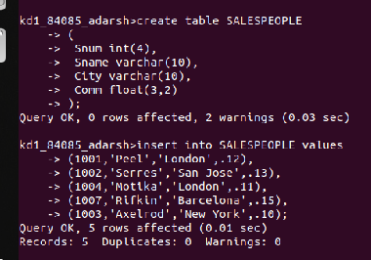

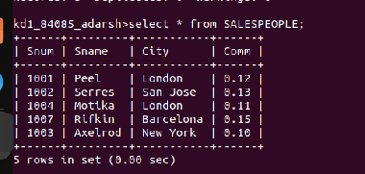

Screenshot 1- Salespeople create, insert and display table

B.CUSTOMERS

Screenshot 2 – Creating Customer Table

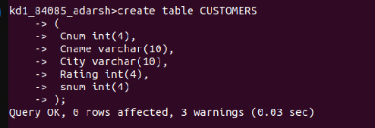

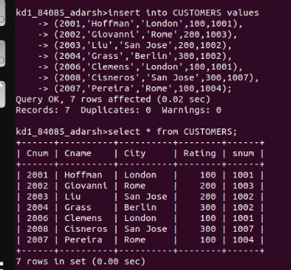

Screenshot 3 – Inserting and Display Customer Table

C.ORDERS

Screenshot 4 – Creating Orders Table

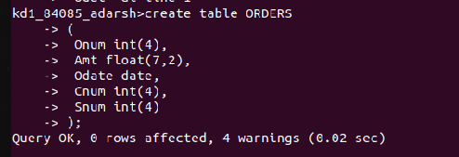

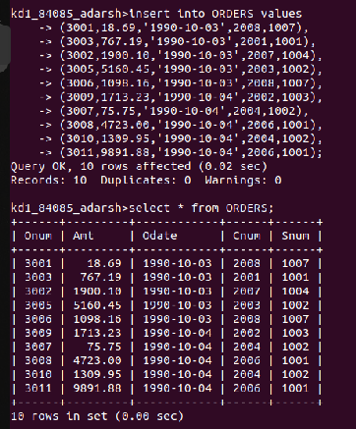

Screenshot 5- Inserting and Displaying Orders Table

