SQL ASSIGNMENT 11
Subqueries

1) Write a query that uses asubquery to obtain all orders for the customersnamed cineros.Assume you do not know his customer number (cnum).
Ans.

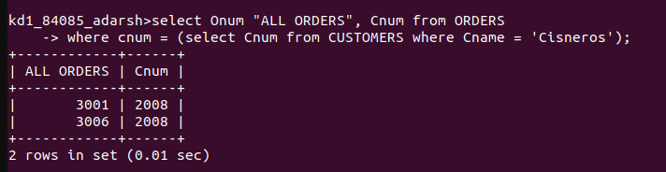

2) Write a query that produces the names and ratings of all customers who have above-average orders?
Ans.

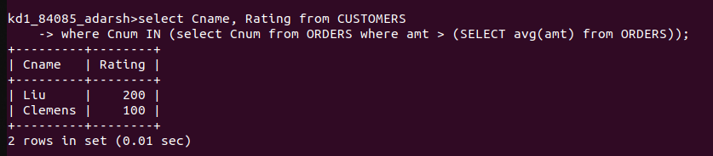

3) Write a query that selects the total amount in orders for each salesperson for whom this total is greater that the amount of the largest order in the table?
Ans.

