SQL ASSIGNMENT 12

Using the operators IN,ANY, and ALL

1)Write a query that creates all customers whose ratings are equal to or greater than any of serres’ customer?
Ans.

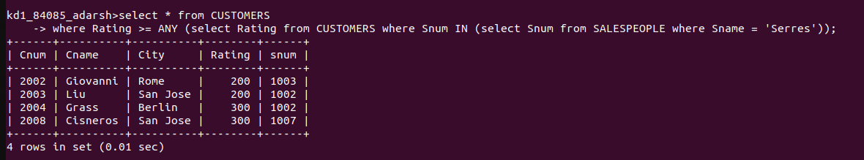

2) Write a query using Any or ALL that will find all salespeople who have no customers located in their city?
Ans.

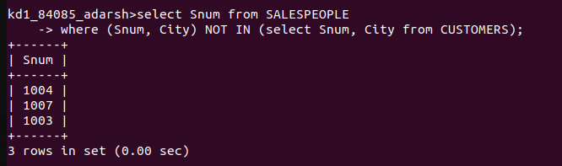

3) Write a query that selects all orders for amounts greater than any for all the customers in london?
Ans.

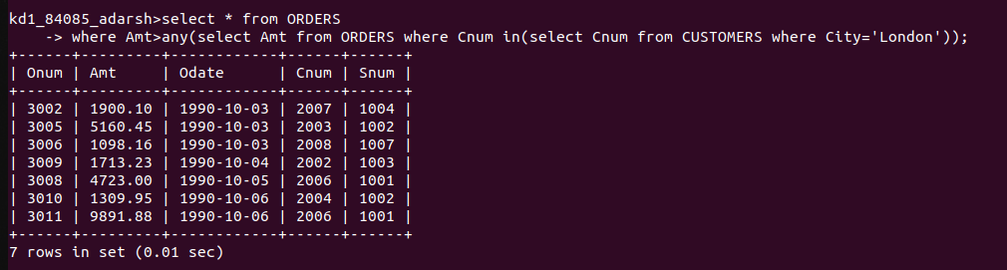

4) Write the above query using MIN or MAX?
Ans.

