SQL ASSIGNMENT 13
Using the union clause

1)Create the union of two queries that shows the names,cities,and ratings of all customers. Those with rating of 200 or greater will also have the words “high ratings”’ while the orders will have the words “low rating”?
Ans.

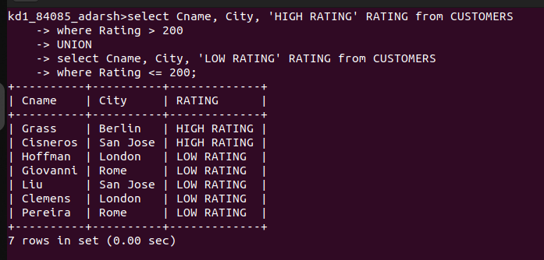

2) Write a command that produces the name and number of each salespeople and each customer with more than one current order. Put the result in alphabetical order.
Ans.
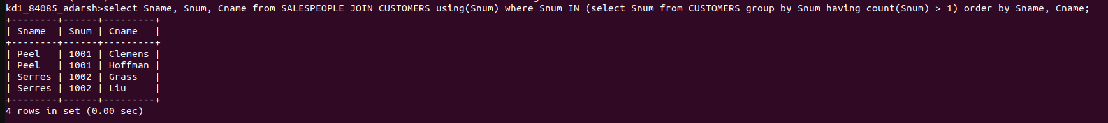

3) Form a union of three queries. Have the first select the snum of all salespeople in San Jose; the second, the cnums of all customers in san jose; and the third the onums of all orders on october 3. Retain duplicates between the last two queries but eliminate any redundancies between either of them and the first.
(Note: in the sample tables as given,these would be no such redundancy. This is besides the point.)
Ans.

