SQL ASSIGNMENT 14

Entering, Deleting, and changing field values.

1) Write a command that puts the following values, in their given order, into the salespeople table: city – San Jose, name – Blanco , comm – null , cnum – 1100?
Ans.

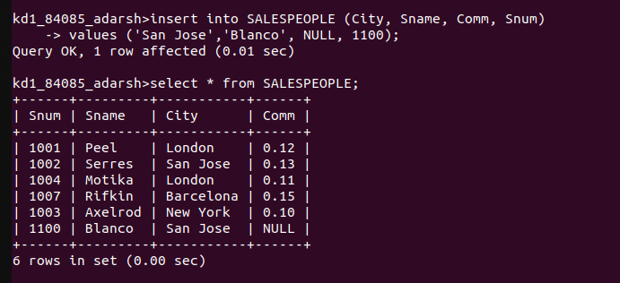

2)Write a command that removes all orders from customer clemens from the orders table?
Ans.

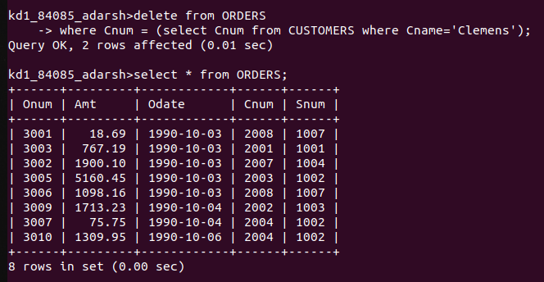

3) Write a command that increases therating of all customers in rome by 100?
Ans.

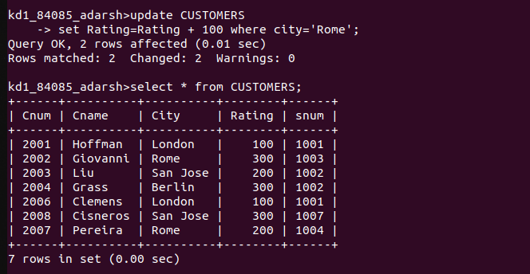

4) Salespeople Serres has left the company. Assign her customers to mokita?
Ans.

