SQL ASSIGNMENT 15

Using Subqueries with DML Commands
1) Assume there is a table called multicust, with all of the same column definitions as salespeople. Write a command that inserts all salespeople with more than one customer into this table?
Ans.
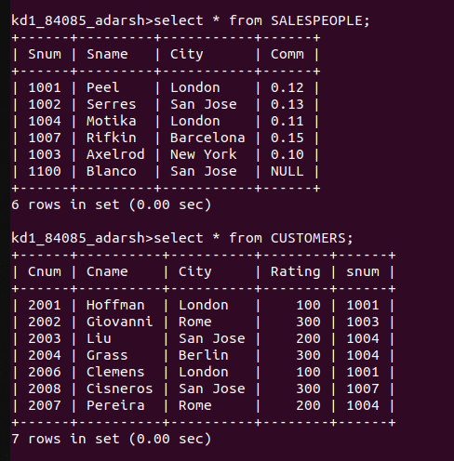

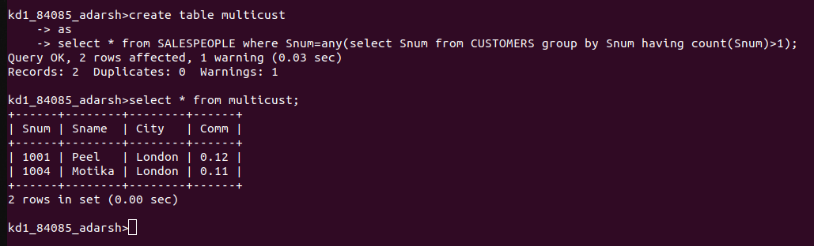

2)Write a command that deletes all customers with no current orders?
Ans.
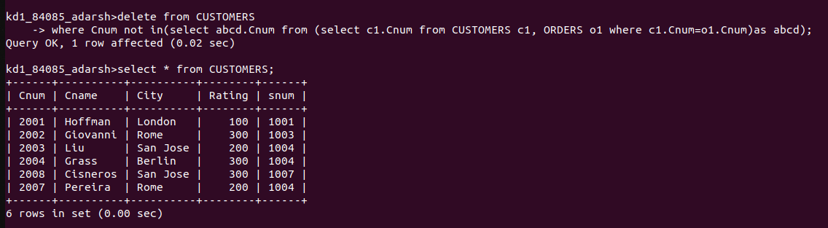

3) Write a command that increases by twenty percent the commission of all salespeople with total orders above Rs. 3000?
Ans.

