ASSIGNMENT NO. 4

Retriving information from tables.

1. Write a select command that produces the order number, amount, and date for all rows in the ORDERS table.

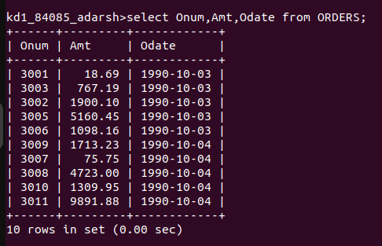

2. Write a query that produces all rows from the CUSTOMERS table for which the salespersons number is 1001.
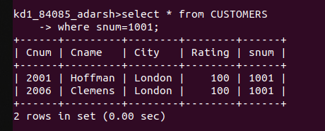

3. Write a query that displays the Salespeople table with the column in the following order: city, sname, snum, comm.

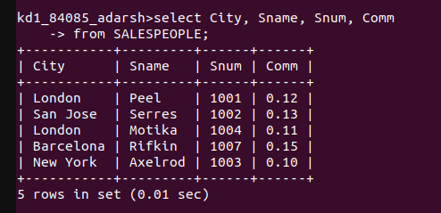

4. Write a select command that produces the rating followed by the name of each customer in San Jose.

