ASSIGNMENT – 5

RELATIONAL AND LOGICAL OPERATORS

1. Write a query that will give you all orders for more than Rs.1000

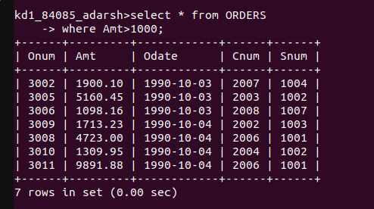

2. Write a query that will give you the names and cities of all salespeople in London with a commission above .10

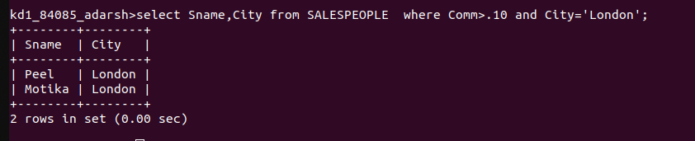

3. Write a query on the Customers Table whose output will exclude all customers with a rating <= 100, unless they are located in Rome.

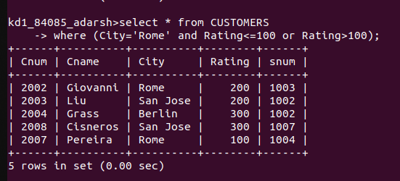

4. What will be the output from the following query?

Select * from ORDERS
where (amt < 1000 OR NOT(odate = ‘1990-10-03’ AND
cnum >2003));
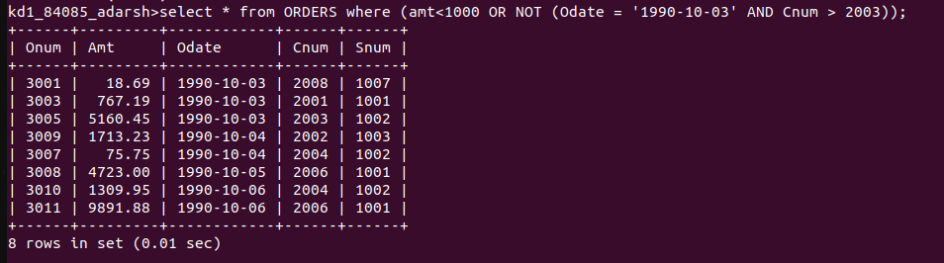

5. What will be the output of the following query?

select * from ORDERS
where NOT ((odate = ‘1990-10-03’ OR snum>1006) AND amt >=1500);
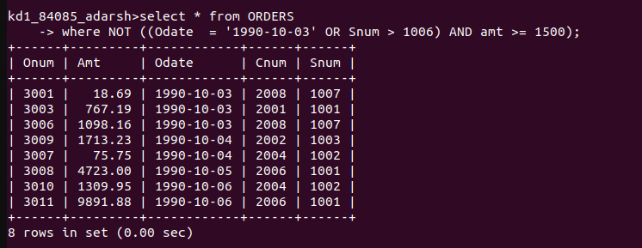

6. What is a simpler way to write this query?

Select snum, sname, city, comm from SALESPEOPLE
where (comm > .12 OR comm <.14);
