ASSIGNMENT – 6

USING SPECIAL OPERATORS IN CONDITIONS

1. Write two different queries that would produce all orders taken on October 3rd or 4th 1990

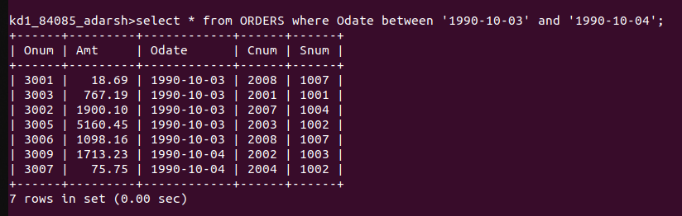

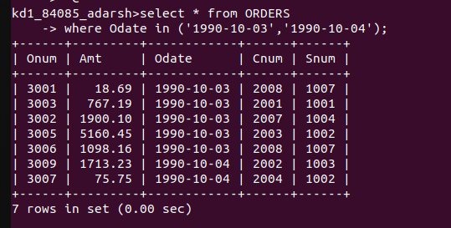

2. Write a query that selects all the customers serviced by Peel or Motika
(HINT: the snum field relates the two tables to one another)

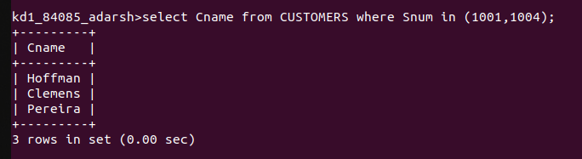

3. Write a query that will produce all the customers whose names begin with a letter from ‘A’ to ‘G’

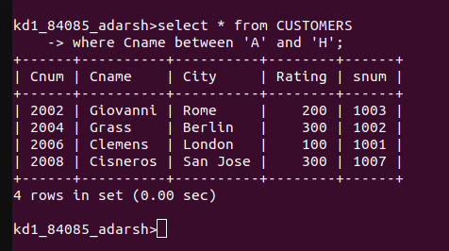

4. Write a query that selects all customers whose names begin with the letter ‘C’

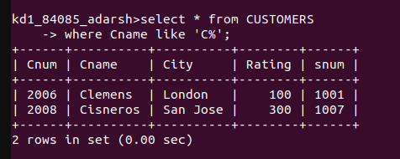

5. Write a Query that selects all orders except those with zeroes or NULLs in the amt field.

