ASSIGNMENT – 7

SUMMARIZING DATA WITH AGGREGATE FUCTIONS

1. WRITE A QUERY THAT COUNTS ALL ORDERS FOR OCTOBER 3.

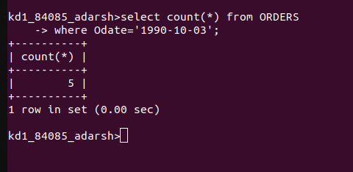

2. WRITE A QUERY THAT COUNTS THE NUMBER OF DIFFERENT NON-NULL CITY VALUES IN THE CUSTOMERS TABLE

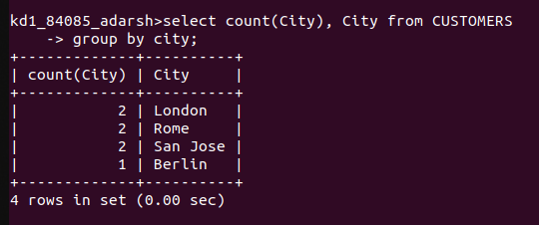

3. WRITE A QUERY THAT SELECTS EACH CUSTOMERS SMALLEST ORDER

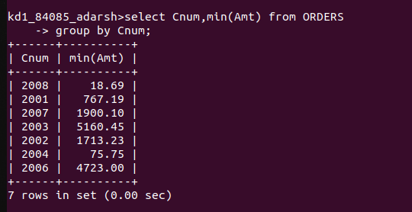

4. WRITE A QUERY THAT SELECTS THE FIRST CUSTOMER, IN ALPHABETICAL ORDER, WHOSE NAME BEGINS WITH G.

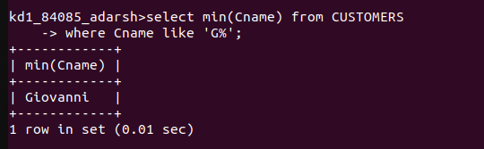

5. WRITE A QUERY THAT SELECTS THE HIGHEST RATING IN EACH CITY

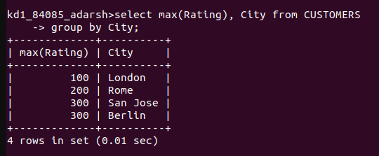

6. WRITE A QUERY THAT COUNTS THE NUMBER OF SALESPEOPLE REGISTERING ORDERS FOR EACH DAY.

