ASSIGNMENT – 8

FORMATTING QUERY OUTPUT

1.ASSUME EACH SALESPERSON HAS A 12% COMMISSION. WRITE A QUERY ON THE ORDERS TABLE THAT WILL PRODUCE THE ORDER NUMBER, THE SALEPERSON NUMBER, AND THE AMOUNT OF THE SALESPERSONS COMMISSION FOR THAT ORDER.

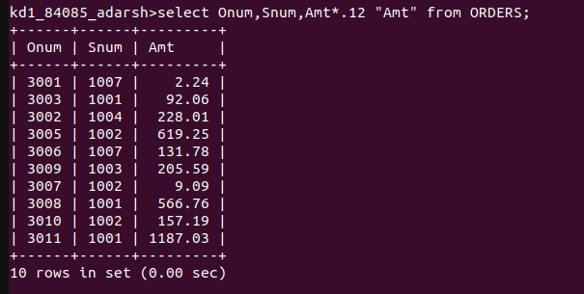

2. WRITE A QUERY ON THE CUSTOMERS TABLE THAT WILL FIND THE HIGHEST RATING IN EACH CITY. PUT THE OUTPUT IN THIS FORM:

FOR THE CITY (CITY), THE HIGHEST RATING IS : (RATING)

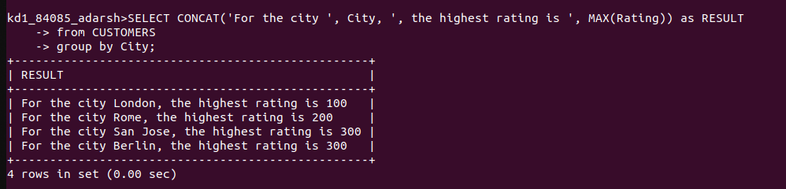

3. WRITE A QUERY THAT LISTS CUSTOMERS IN DESCENDING ORDER OF RATING. OUTPUT THE RATING FIELD FIRST , ALLOWED BY THE CUSTOMERS NAME AND NUMBER.

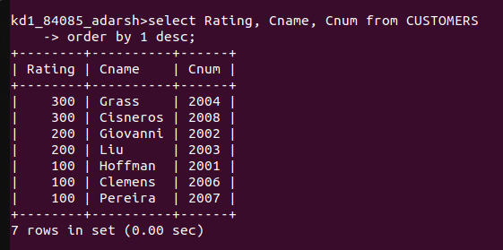

4. WRITE A QUERY THAT TOTALS THE ORDERS FOR EACH DAY AND PLACES THE RESULTS IN DESCENDING ORDER.

