ASSIGNMENT – 9

QUERYING MULTIPLE TABLES AT ONCE.

1. WRITE A QUERY THAT LISTS EACH ORDER NUMBER FOLLOWED BY THE NAME OF THE CUSTOMER WHO MADE THE ORDER.
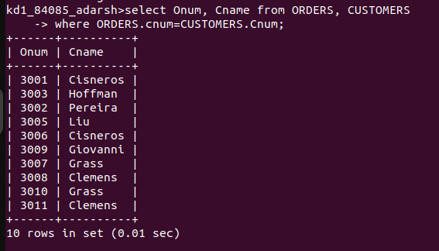

2. WRITE A QUERY THAT GIVES THE NAMES OF BOTH THE SALESPERSON AND THE CUSTOMER FOR EACH ORDER ALONG WITH THE ORDER NUMBER.

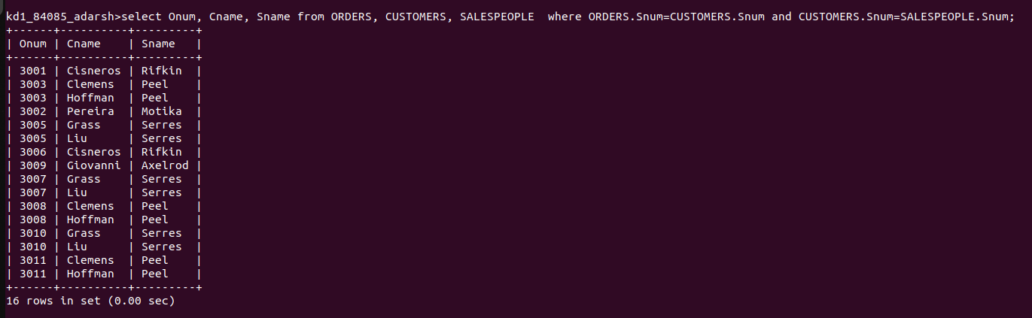

3. WRITE A QUERY THAT PRODUCES ALL CUSTOMERS SERVICED BY SALESPEOPLE WITH A COMMISSION ABOVE 12% . OUTPUT THE CUSTOMER’S NAME, THE SALESPERSON’S NAME, AND THE SALESPERSON’S RATE OF COMMISSION.
`
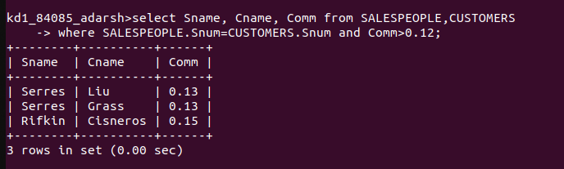

4. WRITE A QUERY THAT CALCULATES THE AMOUNT OF THE SALESPERSON’S COMMISSION ON EACH ORDER BY A CUSTOMER WITH A RATING ABOVE 100.
