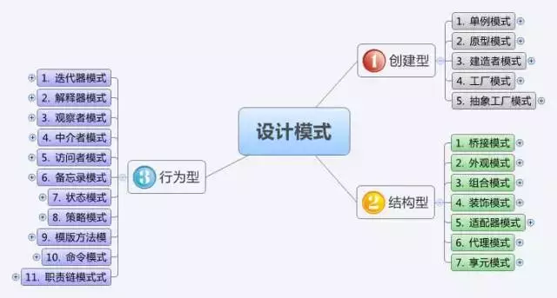

<http://scanlibs.com/design-patterns-explained-simply/>