PV Panel DPP Workshop  Build one mock Digital Product Passport in 15 minutes: start from the preloaded Chinese PV cell DPP, add Belgian assembly inputs, then read and export the result.  Scenario: PV panel assembly in Belgium  Linked upstream data: PV cell DPP from China  Workshop output: one complete panel DPP package |  | 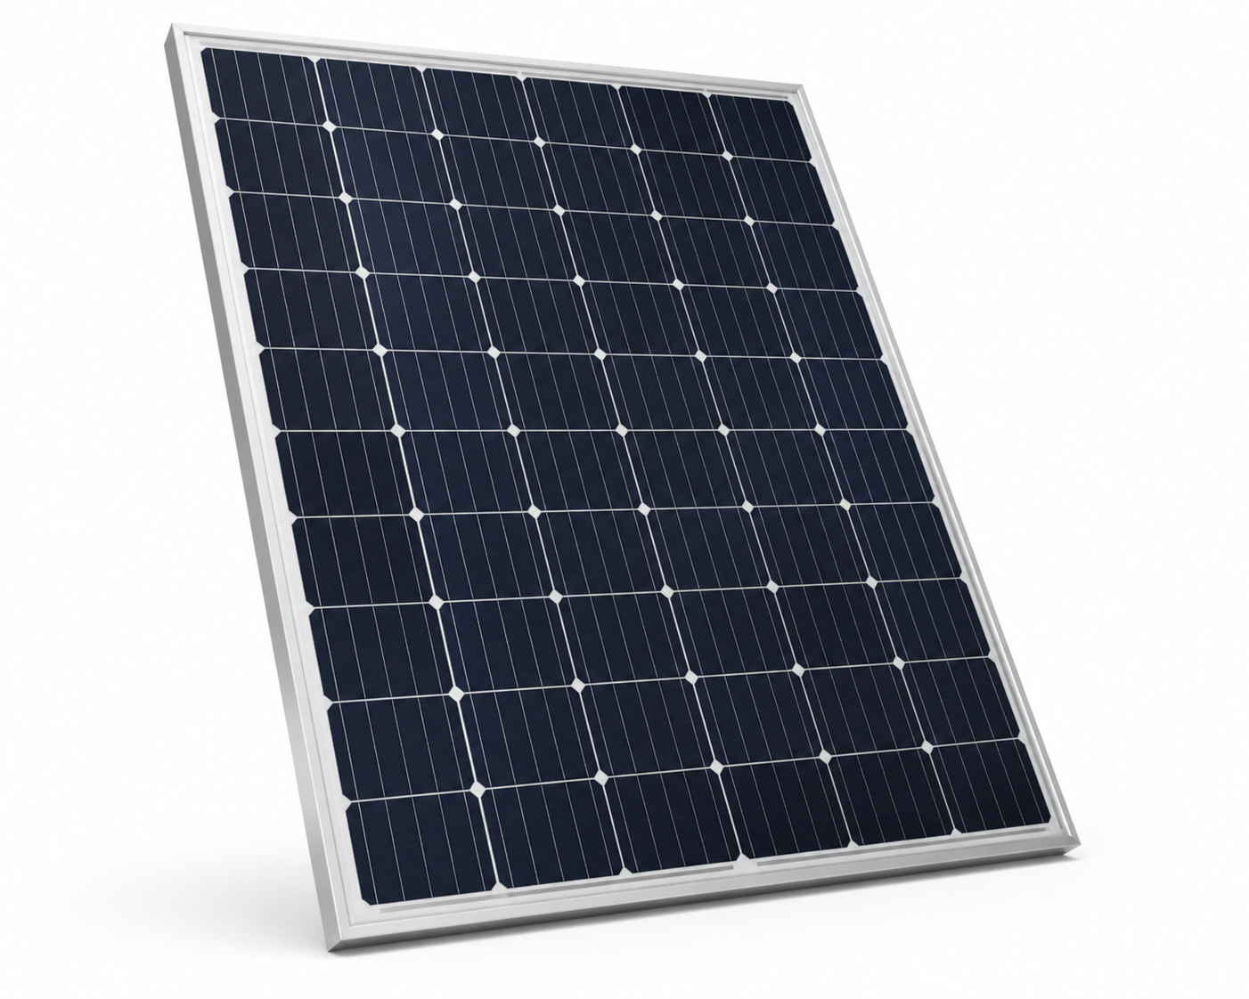
1 Product setup  Set the product identity, reporting role, assembly location, reference flow, and common stage. | 2 Inventory  Add each material or linked DPP row using the simplified quantities below. |  | 3 Results  Calculate the GWP100 result, separate upstream cell impact from own assembly rows, then export.
1 Product setup
PRODUCT NAME  PV panel | REPORTING / ASSEMBLY LOCATION  Belgium (BE)
REFERENCE FLOW  1 assembled PV panel | LIFECYCLE STAGE  Manufacturing / assembly
Important interpretation: the preloaded cell DPP covers production in CN. The panel DPP is assembled in BE. China-to-Belgium transport is a separate optional information row and is not calculated unless transport factors are added.
2 Inventory rows to add
Use these workshop-friendly quantities. The database entry names are intentionally pragmatic proxies where the exact activity is not available in the precalculated lookup.
Row | Quantity | Where | Database entry / note
Preloaded PV cell DPP | 0.94 m2 | CN | Linked DPP already loaded
Aluminium frame | 2.13 kg | BE | other non-ferrous metal products (market for)
Front glass | 8.81 kg | BE | glass and glass products - residual (market for)
Copper wiring | 103 g | BE | copper products (market for)
Silicone sealant | 122 g | BE | chemicals nec (market for)
Tin + lead solder | 13.6 g total | BE | lead, zinc and tin products (market for)
Plastic/polymer layers | 1.65 kg | BE | rubber and plastic products - residual
Process chemicals | 141 g | BE | chemicals nec (market for)
Packaging board | 763 g | BE | paper and paper products - residual
Assembly electricity | 14.0 kWh | BE | production of electricity (market for)
Optional logistics: CN to BE | custom tkm | CN -> BE | document now; calculate only when transport tkm factors are added
3 Results to read after calculation
Total panel impact  Complete GWP100 result for the assembled panel. | Upstream linked DPP  Impact imported from the Chinese PV cell passport. | Own assembly rows  Impact from the Belgian materials and electricity added in the exercise.
Facilitator checks before export
Location is explicit  CN for linked cell DPP, BE for assembly rows. | Proxy choices are visible  Participants can discuss where data is exact vs approximate. | Export is complete  Non-calculated rows remain in the DPP as traceable information.

