**ReqView Software**

**Requirements Specification**

**Example**

**Project: DEMO**

**Document: SRS**

**Author: Libor Bus, Eccam**

**Published on: 2021-09-03**

**ReqView**

**Requirements Management Tool for Software and Systems Development**

This document is an example of SRS exported from ReqView.

D

ownload ReqView

for

free and browse the

complete

example

project

. You will see how you can easily manage

end

-

to

-

end

requirements

traceability from user stories to SRS, tests, and architecture.

The

n, reuse templates based on

ISO/IEC/IEEE 29148

s

tandar

d and start capturing

requirements for your product within few minutes

.

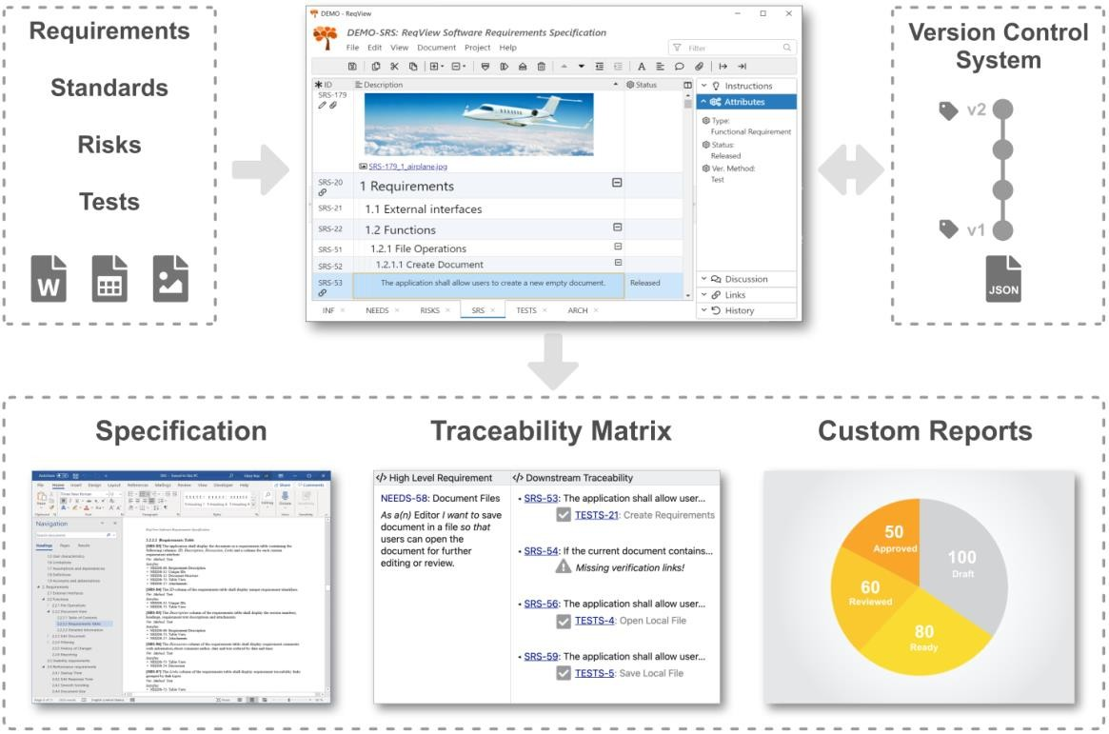

[**D**](https://reqview.com/download?utm_source=PDF&utm_medium=Web&utm_campaign=Examples)

[**o**](https://reqview.com/download?utm_source=PDF&utm_medium=Web&utm_campaign=Examples)

[**w**](https://reqview.com/download?utm_source=PDF&utm_medium=Web&utm_campaign=Examples)

[**n**](https://reqview.com/download?utm_source=PDF&utm_medium=Web&utm_campaign=Examples)

[**l**](https://reqview.com/download?utm_source=PDF&utm_medium=Web&utm_campaign=Examples)

[**o**](https://reqview.com/download?utm_source=PDF&utm_medium=Web&utm_campaign=Examples)

[**a**](https://reqview.com/download?utm_source=PDF&utm_medium=Web&utm_campaign=Examples)

[**d**](https://reqview.com/download?utm_source=PDF&utm_medium=Web&utm_campaign=Examples)

[**R**](https://reqview.com/download?utm_source=PDF&utm_medium=Web&utm_campaign=Examples)

[**e**](https://reqview.com/download?utm_source=PDF&utm_medium=Web&utm_campaign=Examples)

[**q**](https://reqview.com/download?utm_source=PDF&utm_medium=Web&utm_campaign=Examples)

[**V**](https://reqview.com/download?utm_source=PDF&utm_medium=Web&utm_campaign=Examples)

[**i**](https://reqview.com/download?utm_source=PDF&utm_medium=Web&utm_campaign=Examples)

[**e**](https://reqview.com/download?utm_source=PDF&utm_medium=Web&utm_campaign=Examples)

[**w**](https://reqview.com/download?utm_source=PDF&utm_medium=Web&utm_campaign=Examples)

**Table of Contents**

1. Introduction 4

1.1 Purpose 4

1.2 Scope 4

1.3 Product perspective 4

1.4 Product functions 5

1.5 User characteristics 5

1.6 Limitations 5

1.7 Assumptions and dependencies 5

1.8 Definitions 5

1.9 Acronyms and abbreviations 5

2. Requirements 6

2.1 External interfaces 6

2.2 Functions 6

2.3 Usability requirements 12

2.4 Performance requirements 12

2.5 Logical database requirements 12

2.6 Design constraints 12

2.7 Standards compliance 12

2.8 Software system attributes 12

3. Verification 13

4. Supporting information 13

5. References 13

**Revision History**

|  |  |  |  |
| --- | --- | --- | --- |
| **Name** | **Date** | **Reason For Changes** | **Version** |
| Libor Buš | June 10, 2016 | Export of Demo Software Requirements Specification from ReqView 2.1.0 | 1 |
| Libor Buš | June 12, 2019 | Export of Demo Software Requirements Specification from ReqView 2.6.2 | 2 |
| Tomas Novacek | June 23, 2020 | Update of Scope section | 3 |

# 1. Introduction

## 1.1 Purpose

The main purpose of this document is to provide a working example of a *Software Requirements Specification* (SRS) based on ISO/IEC/IEEE 29148:2018 standard.

**Note:** This is an example document, which is not complete.

## 1.2 Scope

This document specifies requirements for a simple application for [requirements management of software and system products.](https://www.reqview.com/?utm_source=PDF&utm_medium=Web&utm_campaign=Examples)

The application allows users to:

* [Capture requirements specifications](https://www.reqview.com/doc/edit-document?utm_source=PDF&utm_medium=Web&utm_campaign=Examples)
* [Manage requirements using custom attributes](https://www.reqview.com/doc/edit-document?utm_source=PDF&utm_medium=Web&utm_campaign=Examples#edit-attributes)
* [Set up requirements traceability](https://www.reqview.com/doc/requirements-traceability-links?utm_source=WebApp&utm_medium=Application&utm_campaign=Examples)
* [Browse the requirements traceability matrix](https://www.reqview.com/blog/requirements-traceability-matrix/?utm_source=PDF&utm_medium=Web&utm_campaign=Examples)
* [Comment and review requirements](https://www.reqview.com/doc/edit-document?utm_source=PDF&utm_medium=Web&utm_campaign=Examples#comment-requirements)
* [Filter](https://www.reqview.com/doc/review-document?utm_source=WebApp&utm_medium=Application&utm_campaign=Examples#filter-document-objects) [and search requirements](https://www.reqview.com/doc/review-document?utm_source=PDF&utm_medium=Web&utm_campaign=Examples#search-documents)
* [Import requirements from MS Word](https://www.reqview.com/doc/import-html-ms-word?utm_source=PDF&utm_medium=Web&utm_campaign=Examples) or [Excel](https://www.reqview.com/doc/import-csv-ms-excel?utm_source=PDF&utm_medium=Web&utm_campaign=Examples)
* [Export requirements to DOCX,](https://www.reqview.com/doc/export-docx?utm_source=PDF&utm_medium=Web&utm_campaign=Examples) [XLSX,](https://www.reqview.com/doc/export-xlsx?utm_source=PDF&utm_medium=Web&utm_campaign=Examples)  [PDF,](https://www.reqview.com/doc/export-pdf?utm_source=PDF&utm_medium=Web&utm_campaign=Examples) [HTML,](https://www.reqview.com/doc/export-html?utm_source=PDF&utm_medium=Web&utm_campaign=Examples) or [CSV](https://www.reqview.com/doc/export-csv?utm_source=PDF&utm_medium=Web&utm_campaign=Examples)
* [Analyze requirements coverage and impact of changes](https://www.reqview.com/doc/requirements-traceability-links?utm_source=PDF&utm_medium=Web&utm_campaign=Examples#traceability-reports)
* [Print requirements specifications](https://www.reqview.com/doc/review-document?utm_source=PDF&utm_medium=Web&utm_campaign=Examples#print-documents)

The application stores documents as human readable files with open file format.

The application runs offline without connection to any server.

**Note:** The application functionality corresponds to [ReqView](https://www.reqview.com/?utm_source=PDF&utm_medium=Web&utm_campaign=Examples) v1.0 released in 2015. Check all advanced requirements management features it offers now.

## 1.3 Product perspective

#### 1.3.1 System interfaces

The application runs in the latest version of Chrome or Firefox browser on Windows, Linux and Mac.

#### 1.3.2 User interfaces

The application GUI provides menus, toolbars, buttons, panes, containers, grids allowing for easy control by a keyboard and a mouse.

#### 1.3.3 Hardware interfaces 1.3.4 Software interfaces

The application allows import a structured MS Word document via HTML data format.

The application allows populating a MS Word document with project data via HTML data format.

The application allows import / export a list of requirements from / to MS Excel sheet via CSV data format.

The application stores project data in JSON format to enable easy integration with 3rd party applications.

**1.3.5 Communications interfaces 1.3.6 Memory constraints 1.3.7 Operations 1.3.8 Site adaptation requirements 1.3.9 Interfaces with services**

## 1.4 Product functions

Product functions are summarized in Section *2. User Stories of NEEDS* document.

## 1.5 User characteristics

## 1.6 Limitations

## 1.7 Assumptions and dependencies

## 1.8 Definitions

**Custom Attribute:** Additional requirement property capturing additional requirements properties such as requirements source, status, priority, verification method, fit criterion, ...,

**Document:** A structured requirements specification capturing textual requirements for a given product or service.

**Link:** A directed association between related requirements allowing to analyze requirements coverage, gaps and impact of changes.

**Link Type**: Property of traceability links allowing to analyze links with different semantic independently, e.g., satisfaction and verification links.

## 1.9 Acronyms and abbreviations

**CSV:** Comma Separated Values

**DNF:** Disjunctive Normal Form

**ID:** Identifier

**GUI:** Graphical User Interface

**HTML:** Hypertext Markup Language

**SRS:** Software Requirements Specification

# 2. Requirements

## 2.1 External interfaces

## 2.2 Functions

#### 2.2.1 File Operations

##### 2.2.1.1 Create Document

**[DEMO-SRS-53]** The application shall allow users to create a new empty document.

**[DEMO-SRS-54]** If the current document contains unsaved changes then the application shall allow users to save the changes before closing the document.

**2.2.1.2 Open File**

**[DEMO-SRS-56]** The application shall allow users to open a document from a chosen file.

**2.2.1.3 Save Local File**

**[DEMO-SRS-59]** The application shall allow users to save the opened document into a file.

##### 2.2.1.4 Document Template

**[DEMO-SRS-61]** The application shall allow users to create a document template file from the opened document.

**[DEMO-SRS-62]** Document templates shall store structure of document sections and definition and values of requirement attributes.

**[DEMO-SRS-63]** The application shall allow users to create a new document from a chosen document template file preserving the structure of document sections and the definition and values of requirement attributes.

##### 2.2.1.5 Import

**[DEMO-SRS-72]** The application shall allow users to import a MS Word document preserving structure of document sections and paragraphs, rich text description of requirements and images. **[DEMO-SRS-73]** The application shall allow users to import a MS Excel table of requirements preserving section headings, levels, unformatted text description of requirements and values of custom attributes.

##### 2.2.1.6 Export

**[DEMO-SRS-76]** The application shall allow users to export the displayed document view to HTML.

**[DEMO-SRS-77]** The application shall allow users to export requirements to CSV.

#### 2.2.2 Document View

##### 2.2.2.1 Table of Contents

**[DEMO-SRS-80]** The application shall display the table of contents containing section headings organized according to their document tree hierarchy.

**[DEMO-SRS-81]** When user clicks on a document section in the table of contents then the application shall focus the section in the requirements table.

##### 2.2.2.2 Requirements Table

**[DEMO-SRS-83]** The application shall display the document in a requirements table containing the following columns: *ID*, *Description*, *Discussion*, *Links* and a column for each custom requirement attribute.

**[DEMO-SRS-84]** The *ID* column of the requirements table shall display unique requirement identifiers.

**[DEMO-SRS-85]** The *Description* column of the requirements table shall display the section numbers, headings, requirement text descriptions and attachments.

**[DEMO-SRS-86]** The *Discussion* column of the requirements table shall display requirement comments with information about comment author, date and text ordered by date and time.

**[DEMO-SRS-87]** The *Links* column of the requirements table shall display requirement traceability links grouped by link types.

**[DEMO-SRS-88]** The application shall allow users to change width of each requirements table column.

**[DEMO-SRS-190]** The application shall allow users to reorder requirements table columns.

**[DEMO-SRS-89]** The application shall allow users to show and hide requirements table columns except the *ID* column.

**[DEMO-SRS-90]** The application shall allow users to sort all requirements table columns except the *Discussion* and *Links* columns by ascending or descending order.

##### 2.2.2.3 Detailed Information

**[DEMO-SRS-92]** The application shall allow users to show and hide a pane displaying detailed information about custom attributes, discussion, traceability links or history of changes of the selected requirement.

**[DEMO-SRS-93]** While the custom attributes pane is shown, the application shall display values of all assigned custom attributes for the selected requirement.

**[DEMO-SRS-94]** While the discussion pane is shown, the application shall display all comments for the selected requirement ordered by date and time.

**[DEMO-SRS-96]** While the discussion pane is shown, the application shall allow users to expand or collapse a selected comment or all displayed comments.

**[DEMO-SRS-97]** While a displayed discussion comment is expanded, then the application shall display the date, time, author and description of the comment.

**[DEMO-SRS-98]** While a displayed discussion comment is collapsed, then the application shall display the date, time and author of the comment.

**[DEMO-SRS-99]** While the links pane is shown, the application shall display all traceability links starting in or leading to the selected requirement grouped by link types and ordered by ID of the linked object.

**[DEMO-SRS-142]** When user clicks on a traceability link then the application shall focus the linked requirement.

#### 2.2.3 Edit Document

##### 2.2.3.1 Document Structure

**[DEMO-SRS-106]** The application shall allow users to create a new requirement and place it in any document section.

**[DEMO-SRS-107]** When users creates a new requirement the application shall assign it a unique ID which cannot be changed.

**[DEMO-SRS-108]** The application shall allow users to copy selected requirements or document sections within the document.

**[DEMO-SRS-109]** The application shall allow users to move selected requirements or document sections within the document.

**[DEMO-SRS-110]** The application shall allow users to mark selected requirements or document sections as deleted.

**[DEMO-SRS-111]** The application shall allow users to undelete selected deleted requirements or document sections.

**[DEMO-SRS-112]** The application shall allow users to permanently remove selected deleted requirements or document sections from the document.

##### 2.2.3.2 Requirement Attributes

**[DEMO-SRS-114]** The application shall allow users to edit the heading of the selected section.

**[DEMO-SRS-115]** The application shall allow users to edit the text description of the selected requirement.

**[DEMO-SRS-116]** The application shall allow users to paste an HTML content copied from MS Word, Excel or other application into the text description of the selected requirement.

##### 2.2.3.3 Custom Attributes

**[DEMO-SRS-119]** The application shall allow users to define custom requirement attributes and assign them a unique ID which cannot be changed.

**[DEMO-SRS-121]** The application shall allow users to set a type of each custom attribute as follows: boolean, integer number, real number, string, date, enum or XHTML.

**[DEMO-SRS-191]** The application shall allow users to set one or more values for custom attributes of enumeration type.

**[DEMO-SRS-122]** When a user changes the type of a custom attribute then the application shall automatically convert all values of the attribute to the new type.

**[DEMO-SRS-157]** If the automatic conversion fails for any attribute value, then the application shall prevent the change of custom attribute type.

**[DEMO-SRS-120]** The application shall allow users to set an optional name of each custom attribute.

**[DEMO-SRS-192]** The application shall allow users to remove custom attributes.

**[DEMO-SRS-193]** When a user removes a custom attribute then the application shall unset values of the attribute in all requirements.

**[DEMO-SRS-165]** The application shall allow users to edit custom attributes of the selected requirement.

##### 2.2.3.4 Attachments

**[DEMO-SRS-124]** The application shall allow users to attach one or more images or documents (PDF, Word, Excel, Powerpoint, Visio, …) to the selected requirement.

**[DEMO-SRS-126]** When a new attachment is added to the document then the application shall generate its unique attachment ID as a combination of the requirement ID and the original attachment file name.

**[DEMO-SRS-127]** The application shall allow users to save attachment files to the local file system.

**[DEMO-SRS-128]** The application shall allow users to update content of requirement attachments from a selected file.

**[DEMO-SRS-129]** The application shall allow users to permanently remove attachments from the document.

##### 2.2.3.5 Comments

**[DEMO-SRS-132]** The application shall allow users to comment the selected requirement.

**[DEMO-SRS-133]** When a user creates a new comment then the application shall record the current date and time and the author of the comment.

##### 2.2.3.6 Traceability Links Configuration

**[DEMO-SRS-135]** The application shall allow users to define link types and assign them a unique ID which cannot be changed.

**[DEMO-SRS-156]** The application shall allow users to set for each link type its name and role name of the source and target requirements.

**[DEMO-SRS-138]** The application shall allow users to remove link types.

**[DEMO-SRS-161]** When a user removes a link type then the application shall remove all traceability links of the link type from the document.

##### 2.2.3.7 Traceability Links

**[DEMO-SRS-137]** The application shall allow users to create directed traceability links of a chosen link type between selections of requirements or document sections.

**[DEMO-SRS-139]** The application shall allow users to change the link type of a selected link traceability.

**[DEMO-SRS-140]** The application shall allow users to revert direction of a selected traceability link.

**[DEMO-SRS-141]** The application shall allow users to permanently remove a selected traceability link from the document.

##### 2.2.3.8 Auto Save

**[DEMO-SRS-144]** The application shall automatically persist all document changes and restore them when it is restarted.

**[DEMO-SRS-160]** When user closes the document the application shall clear all persisted document data.

#### 2.2.4 Filtering

##### 2.2.4.1 Requirements Filter

**[DEMO-SRS-147]** The application shall allow users to filter requirements according to a condition in disjunctive normal form (DNF).

**[DEMO-SRS-148]** The application shall allow users to enter a filtering condition matching document sections by their number or heading.

**[DEMO-SRS-149]** The application shall allow users to enter a filtering condition matching requirements by their text description or a custom attribute.

**[DEMO-SRS-150]** The application shall allow users to filter requirements with missing traceability links of a given type.

##### 2.2.4.2 Full Text Search

**[DEMO-SRS-152]** The application shall allow users to search requirements matching one or more given keywords in an string or xhtml attribute.

**[DEMO-SRS-153]** While the search mode is active the application shall highlight the matched requirements and allow user to select the next or previous matched requirement in the document.

#### 2.2.5 History of Changes

**[DEMO-SRS-159]** When a user changes a requirement the application shall record the current date and time and the author of the change.

**[DEMO-SRS-101]** The application shall display all changes of the selected requirement ordered by date and time.

**[DEMO-SRS-102]** Each displayed requirement change shall contain author, date & time and description of the change.

**[DEMO-SRS-103]** The application shall allow users to expand and collapse all changes in the *History* pane.

#### 2.2.6 Reporting

**[DEMO-SRS-163]** The application shall allow users to print the displayed requirements table.

**[DEMO-SRS-164]** The application shall allow users to create a PDF containing the displayed requirements table.

## 2.3 Usability requirements

## 2.4 Performance requirements

#### 2.4.1 Startup Time

**[DEMO-SRS-174]** The application should display the opened document within 10s after it is started.

#### 2.4.2 Edit Response Time

**[DEMO-SRS-171]** The application should display updated values within 1s after user triggers the edit operation.

#### 2.4.3 Smooth Scrolling

**[DEMO-SRS-173]** While a user scrolls the requirements table, the application should not display scrolling jerks longer than 200ms.

#### 2.4.4 Document Size

**[DEMO-SRS-170]** The application shall allow users to open documents up to 10000 objects and 100 file attachments with total size up to 100MB.

## 2.5 Logical database requirements

**[DEMO-SRS-194]** The application shall encrypt the persistent application data.

## 2.6 Design constraints

## 2.7 Standards compliance

## 2.8 Software system attributes

**[DEMO-SRS-195]** The application shall run in the latest version of Chrome or Firefox browsers.

**[DEMO-SRS-176]** The application shall not send any project data to the Internet.

**[DEMO-SRS-199]** The application shall sanitize any data input or imported by users.

# 3. Verification

Verification tests are specified in *[DEMO-TESTS]* document.

# 4. Supporting information

# 5. References

**[DEMO-NEEDS]:** ReqView User Needs

**[DEMO-TESTS]:** ReqView Verification Tests