Game Design Document

Fill up the Following document

1. Write the title of your project.

Pac-Maniac

1. What is the goal of the game?

The game is mostly like classic game that everybody knows PAC-MAN,

And the goal of the game is also same to eat all the pallets in the maze.

1. Write a brief story of your game?

The story of the game is that the there is the small brother Pac-man

That is like Pac man but he can shoot fireballs to and now he be defeat-

Ing ghosts instead.

1. Which are the playing characters of this game?

* Playing characters are the ones which respond to the user based on the input from the user
* Cars, monkeys, dinos, wizards etc, are the playing characters in the game.

|  |  |  |
| --- | --- | --- |
| Number | Character Name | What can this character do? |
| 1 | Pac-Maniac | Can eat ghosts and shoot fireballs |
| 2 | - | - |
| 3 | - | - |
| 4 | - | - |
| 5 | - | - |
| 6 | - | - |
| 7 | - | - |
| 8 | - | - |

1. Which are the Non Playing Characters of this game?

* Non Playing characters are the ones which don't have an action or a behaviour when the user interacts with the game.
* Hurdles, stones, bananas, coins, etc are non playing characters in the game.

|  |  |  |
| --- | --- | --- |
| Number | Character Name | What can this character do? |
| 1 | Pac-Man | Can eat ghosts |
| 2 | Red ghost | Follow Pac man and Pac maniac and eat them |
| 3 | Pink ghost | Stand behind and then eat Pacs quickly |
| 4 | Blue ghost | Roam in the particular paths |
| 5 | Orange ghost | Roam in corners |
| 6 | - | - |
| 7 | - | - |
| 8 | - | - |

Draw your imagination of this game. What does this game look like?

* Draw the game either on your computer or on paper,
* Add images of scenes of the game to show each of the playing and non-playing characters at least once.

Images below ->

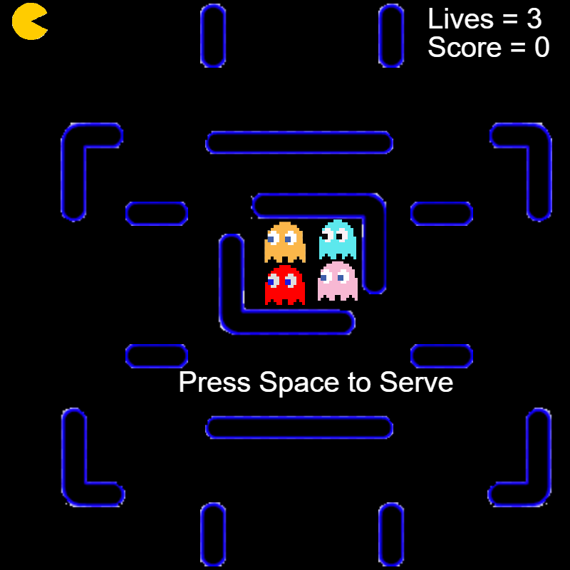

How do you plan to make your game engaging?

The game is very exciting because of a new adventure of Pac man

But this you will be Pac-Maniac.