**TryHackMe Confidential Room Write-up**

<https://tryhackme.com/room/confidential>

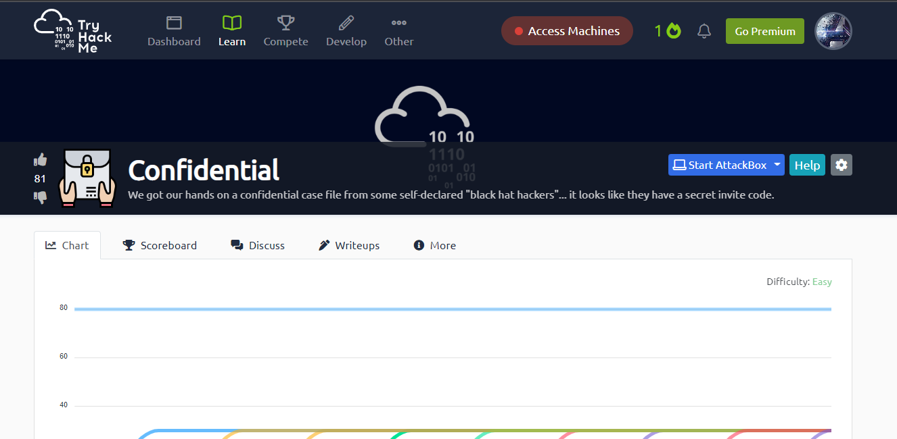This is Basic room covering the concept of digital Forensics and using some of its basic methodology of retrieving information from files.

Here we are given a pdf file in home directory of our deployed machine.

We start with “pdfinfo” command to throughput the vital info related to it.

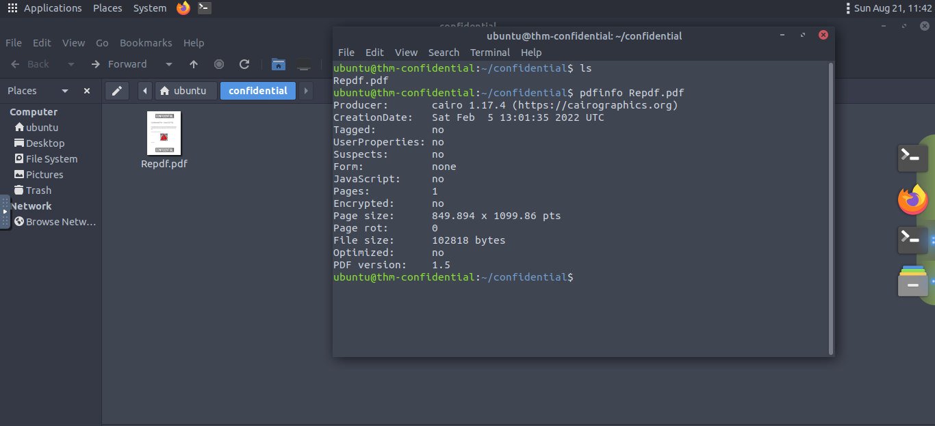But didn't got any relevant information.

Now inspecting the pdf file we see superimposition of an image over our QR code.

There i got idea to use pdfimages a command line utility to extract images from pdf files

Type following command:

**ubuntu@thm-confidential:~/confidential$ pdfimages -f 1 -png Repdf.pdf confidential**

This command basically extract all images from given pdf file and our directory will appear something like this:

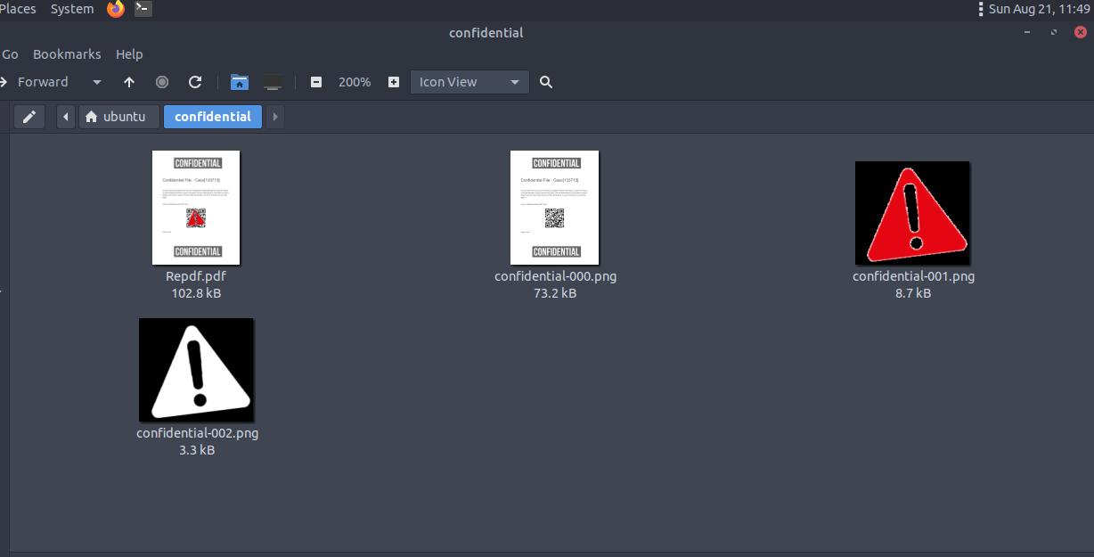Now open file confidential-000.png and scan up the QR code to retrieve flag:

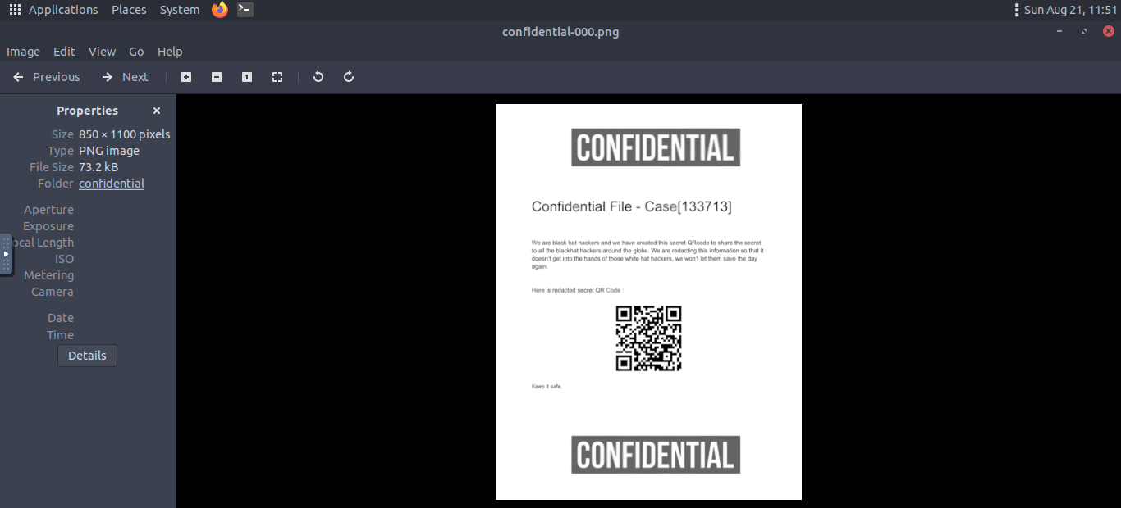Voila We have completed the challenge.