**Artificial Intelligence and Machine**

**Learning**

Project Report

Semester-IV (Batch-2022)

Car Price Prediction

Submitted By: - Supervised By: - Shubham Singhal

|  |  |  |
| --- | --- | --- |
| Harshit Sharma | 2210991641 | G11 |
| Harshvardhan Singh | 2210991647 | G11 |
| Himanshu Kumar | 2210991661 | G11 |
| Harsh Sinha | 2210991625 | G11 |

**Department of Computer Science and Engineering**

**Chitkara University Institute of Engineering & Technology, Chitkara University, Punjab**

**Table of Contents:**

|  |  |  |
| --- | --- | --- |
| **Sr. no.** | **Content** | **Page No.** |
| **1.** | **Introduction :- Background, Objectives, Significance** | 3-6 |
| **2.** | **Problem Definition and Requirements :- Problem Statement, Software Requirements, Hardware Requirements, Data Sets** | 7-8 |
| **3.** | **Proposed Design / Methodology:- Schematic Diagram, File Structure, Algorithms Used** | 9-12 |
| **4.** | **Results :- Screenshots, Metrics** | 13-15 |
| **5.** | **References** | 16 |

**1.)Introduction:-**

* 1. **Background:**

In today's automotive market, the pricing of vehicles is a complex and dynamic process influenced by numerous factors ranging from manufacturing costs to consumer preferences. The ability to accurately predict car prices is of paramount importance for various stakeholders, including manufacturers, dealerships, and consumers. However, due to the multifaceted nature of the automotive industry and the multitude of variables involved, traditional methods of price estimation often fall short in providing precise forecasts.

In light of this challenge, the integration of Artificial Intelligence (AI) and Machine Learning (ML) techniques presents a promising approach to enhance the accuracy and reliability of car price prediction. By leveraging vast datasets encompassing historical sales data, market trends, economic indicators, and vehicle specifications, AI algorithms can discern intricate patterns and relationships, thereby enabling more informed pricing decisions.

The aim of this project is to develop a robust AI-driven model capable of predicting car prices with a high degree of accuracy. By harnessing advanced ML algorithms such as regression analysis, ensemble methods, and neural networks, our objective is to create a predictive framework that not only captures the inherent complexities of the automotive market but also adapts to evolving trends and dynamics.

Through this project, we endeavor to harness the transformative potential of AI and ML to revolutionize car price prediction, thereby empowering stakeholders with actionable intelligence and driving efficiency and transparency in the automotive marketplace.

* 1. **Objectives:**

The primary objective of this project is to develop an AI-driven predictive model for car price estimation. Specifically, our goals include:

1. Accuracy Enhancement: Implementing advanced ML algorithms to improve the accuracy of car price predictions, ensuring that the model can generate reliable forecasts with minimal margin of error.
2. Data Integration: Incorporating diverse datasets encompassing historical sales data, market trends, economic indicators, and vehicle specifications to capture the complex interplay of factors influencing car prices.
3. Adaptability: Designing the model to adapt to evolving market dynamics and consumer preferences, thereby ensuring its relevance and effectiveness over time.
4. Stakeholder Empowerment: Empowering manufacturers, dealerships, and consumers with actionable insights derived from the predictive model, facilitating optimized pricing strategies, transparent negotiations, and informed purchasing decisions.
5. Contribution to Research: Contributing to the advancement of AI and ML research by addressing the challenges inherent in forecasting complex systems, thereby fostering innovation and driving actionable insights in diverse domains beyond the automotive sector.

By achieving these objectives, the project aims to revolutionize car price prediction, driving efficiency, transparency, and competitiveness in the automotive marketplace while laying the groundwork for future advancements in predictive analytics

* 1. **Significance:**

The significance of this project are:-

1. Industry Innovation: This project represents a significant leap forward in leveraging AI and ML technologies to enhance pricing strategies within the automotive industry. By pioneering advanced predictive modeling techniques, it sets a precedent for innovation and efficiency in pricing methodologies.
2. Market Competitiveness: The accurate prediction of car prices is crucial for maintaining competitiveness in the automotive market. By providing stakeholders with reliable forecasts, the project enables manufacturers and dealerships to optimize pricing strategies, stay ahead of market trends, and effectively respond to consumer demands.
3. Consumer Empowerment: Transparent pricing is essential for fostering trust and satisfaction among consumers. By offering accurate price predictions, the project empowers consumers to make informed purchasing decisions, ensuring fairness and transparency in the buying process.
4. Economic Impact: The automotive industry plays a pivotal role in the global economy. By optimizing pricing strategies and streamlining operations, the project contributes to the overall efficiency and sustainability of the automotive sector, thereby fostering economic growth and stability.
5. Research Advancement: Beyond its immediate applications, the project contributes to advancing the field of AI and ML research. By addressing the complexities of predictive analytics in a real-world context, it generates valuable insights and methodologies that can be applied across diverse industries and domains.
6. Societal Implications: The project's outcomes have broader societal implications, including promoting fairness and transparency in commercial transactions and driving technological advancements that benefit society as a whole. By fostering innovation and efficiency, it contributes to the betterment of society and the advancement of human knowledge and capabilities.

In summary, the significance of this project extends beyond the automotive industry, impacting stakeholders, economies, and society at large by harnessing the power of AI and ML to revolutionize pricing strategies and drive progress in predictive analytics.

**2.) Problem Definition and Requirements:-**

**2.1 Problem Statement:**

The challenge lies in accurately predicting car prices amidst dynamic market conditions. Traditional methods lack precision, leading to suboptimal pricing decisions. This project aims to develop an AI-driven model for precise price forecasting. Key aspects include enhancing prediction accuracy, integrating diverse data sources efficiently, ensuring model adaptability to changing market dynamics, meeting stakeholder needs, and upholding ethical and regulatory standards. By addressing these challenges, the project seeks to revolutionize car price prediction, empowering stakeholders with actionable insights and fostering transparency and fairness in the automotive marketplace.

**2.2 Software Requirements:**

The software requirements for this project include:

Programming Language: Python

Development Environment: Jupyter Notebook, Spyder

Libraries: scikit-learn, TensorFlow, Keras, pandas, NumPy, Matplotlib

**2.3 Hardware Requirements:**

The hardware requirements for this project are minimal and include a standard computer with sufficient processing power and memory to run the chosen algorithms and process large datasets.

**2.4 Data Sets:**

The project will utilize publicly available car price datasets, such as the Kaggle Used Cars Price Prediction by 15 models dataset, comprising a mix of new and old car models for training and testing the AI models.

**3.)** **Proposed Design / Methodology:-**

**3.1 Schematic Diagram:**

The schematic diagram illustrates the flow of the project, starting with data collection from various sources such as historical sales records, market trends, and economic indicators. Preprocessing techniques are applied to clean and normalize the data. The processed data is then fed into the AI-driven predictive model, which utilizes advanced machine learning algorithms to generate accurate car price predictions. Finally, the model's outputs are evaluated and validated against real-world data, ensuring its effectiveness and reliability.

3.2 File Structure:

The project adopts a modular and organized file structure to facilitate code development, experimentation, and collaboration. The file structure is structured as follows:

* Data: This directory contains the raw car price datasets obtained from reputable sources, such as Kaggle or other institutions. It also includes any additional datasets or resources used for feature engineering or model training.
* Notebooks: This directory contains Jupyter Notebooks, serving as the primary development environment for exploratory data analysis (EDA), data preprocessing, model training, and evaluation. Each notebook is dedicated to a specific task or stage of the project, ensuring modularity and reproducibility.
* Scripts: This directory contains Python scripts encapsulating reusable functions, classes, and utilities utilized throughout the project. These scripts facilitate code organization, modularity, and maintainability, enabling seamless integration into the overall system architecture.
* Models: This directory stores serialized machine learning models trained on the car price data. Each model is saved in a standardized format (e.g., pickle, HDF5) for easy retrieval and deployment in production environments.
* Visualizations: This directory contains visualizations generated during exploratory data analysis, model evaluation, and performance monitoring. These visualizations include histograms, scatter plots, confusion matrices, ROC curves, and precision-recall curves, providing insights into the data distribution, model performance, and decision boundaries.
* Configuration: This directory contains configuration files specifying hyperparameters, settings, and environmental variables required for model training, evaluation, and deployment. These configuration files enable reproducible experiments and facilitate parameter tuning and optimization.
* Tests: This directory comprises unit tests, integration tests, and end-to-end tests validating the correctness, robustness, and performance of the implemented functionalities. Test suites are executed automatically using continuous integration (CI) tools like Travis CI or Jenkins, ensuring code quality and reliability throughout the development lifecycle.
* Results: This directory stores intermediate and final results generated during data preprocessing, model training, and evaluation. It includes metrics, logs, and output files summarizing the performance of trained models, facilitating comprehensive analysis and comparison.
* Dependencies: This directory contains dependency files specifying project dependencies, libraries, and versions required for reproducible environment setup and execution. Dependency management tools like pipenv or conda environment files are used to manage dependencies efficiently and avoid conflicts.

By adopting this structured file organization, the project ensures clarity, maintainability, and scalability, enabling seamless development, experimentation, and deployment of the car price prediction .

**3.3 Algorithms Used:**

The car price prediction system employs a combination of traditional machine learning algorithms and deep learning architectures to analyse transaction data and identify price patterns effectively. The following algorithms are utilized in the project:

* Logistic Regression: A simple yet effective algorithm for binary classification, logistic regression is employed to model the probability of a transaction being fraudulent based on its features.
* Decision Trees: Decision tree-based algorithms, including Random Forests and Gradient Boosting, are utilized to capture complex nonlinear relationships and interactions between features in the transaction data.
* Neural Networks: Deep learning architectures, such as Multilayer Perceptrons (MLPs) and Convolutional Neural Networks (CNNs), are employed to learn hierarchical representations of transaction data and extract discriminative features for fraud detection.

These algorithms are selected based on their suitability for the credit card fraud detection task, considering factors such as interpretability, scalability, and performance. Hyperparameter tuning, cross-validation, and ensemble methods are employed to optimize model performance, mitigate overfitting, and enhance generalization capabilities.

Moreover, advanced techniques such as anomaly detection, clustering, and semi-supervised learning may be explored to complement the supervised learning approaches and improve the price prediction system. Ensemble methods, including model stacking and model blending, may also be employed to combine the strengths of multiple algorithms and enhance overall prediction accuracy and reliability.

By leveraging a diverse set of algorithms and techniques, the project aims to develop a comprehensive car price prediction system capable of effectively predicting in real-time.

**4.)** **Result: -**

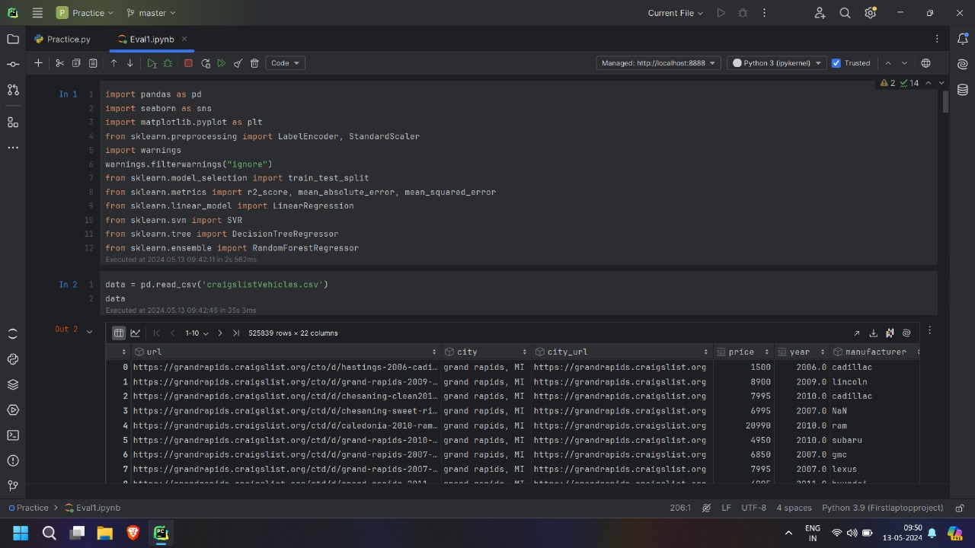

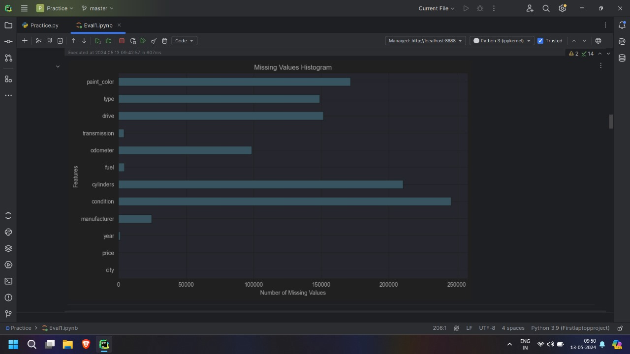

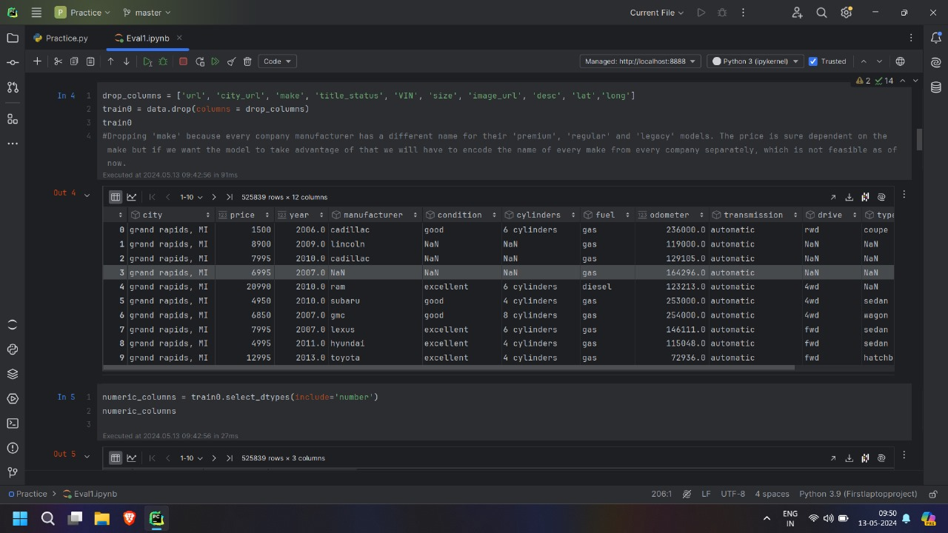

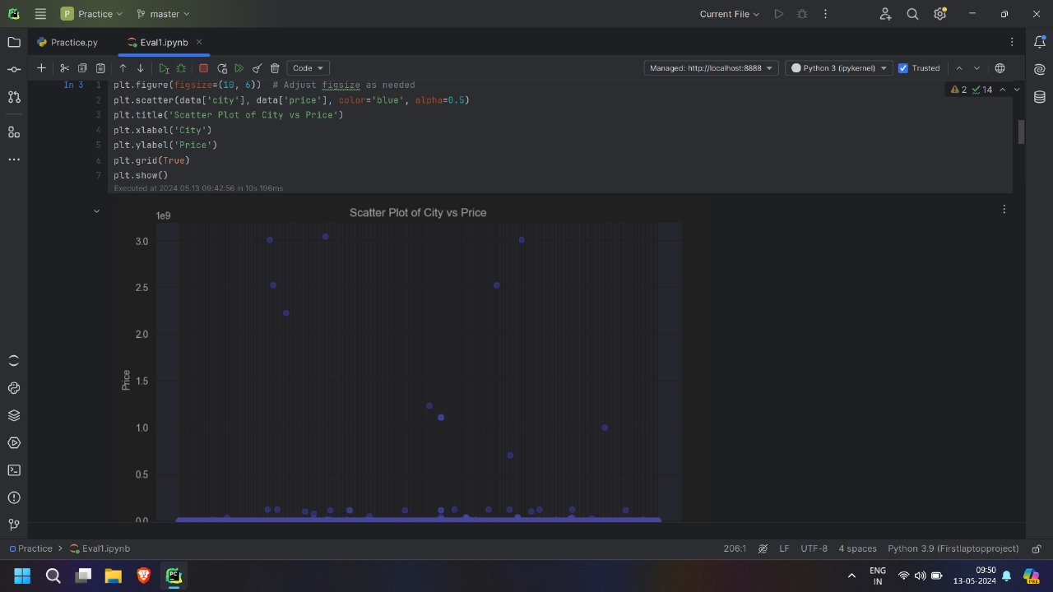

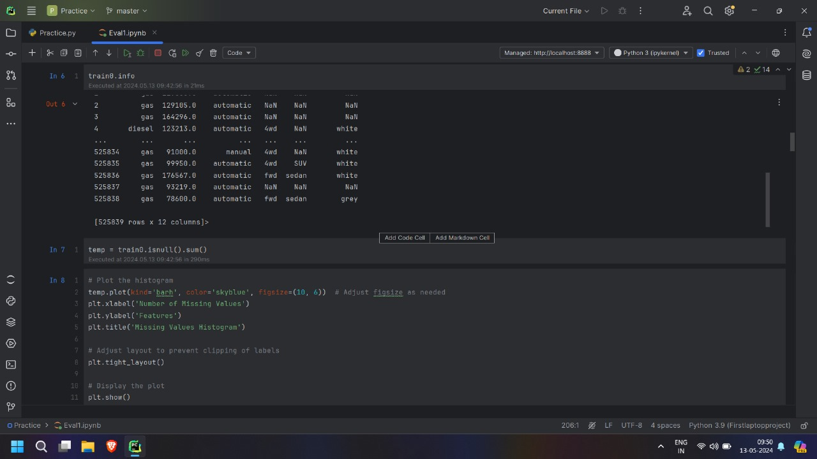

**5.) References:-**

* [**https://www.kaggle.com/code/vbmokin/used-cars-price-prediction-by-15-models/notebook**](https://www.kaggle.com/code/vbmokin/used-cars-price-prediction-by-15-models/notebook)
* [**https://scikit-learn.org/**](https://scikit-learn.org/)
* [**https://stackoverflow.com/**](https://stackoverflow.com/)
* [**www.google.com**](http://www.google.com/)