**Functional Specification Document (FSD)**

**Grocery Order Placement**



**Revision History**

|  |  |  |  |  |
| --- | --- | --- | --- | --- |
| Version | Purpose | Author | Reviewer | Release Date |
| V.1 | Initial Document | Shivam Gupta/Vaidehi Yerekar | Rutika Jadhav | 02 Jan 2024 |

**Table of Contents**

1. Introduction/Background 4

2. Functional Requirements: 4

**2.1 Business Need: 4**

**2.2 High-Level Requirements: 4**

3. Functional Workflow 5

**3.1 High-Level Diagram 5**

**3.2 Detailed Functional Requirements 6**

4. Key Assumptions & Dependencies 7

5. Inputs 7

**5.1 Pre-requisites: 7**

**5.2 Inputs Required: 7**

6. Exceptions Handling 8

7. Out of Scope for RPA 8

**1.Introduction/Background**

In today's fast-paced world, consumers often have limited time for traditional in-store grocery shopping. The ability to place grocery orders online provides convenience, saving time and effort that can be allocated to other priorities.

Online grocery platforms typically offer a broader and more diverse selection of products compared to physical stores. Users can explore various brands, compare products, and discover new items without the constraints of physical shelf space.

The Grocery Order Placement project addresses several needs and challenges in the context of modern consumer preferences and lifestyle dynamics. The Grocery Order Placement project aims to automate the process of ordering non-vegetable grocery items from Jio mart, a popular online grocery store. Read non-vegetable grocery items from the input file.

This Functional Specification Document covers functional specification of the current process being followed by the users.

**2. Functional Requirements:**

* 1. **Business Need:**

The Grocery Order Placement project aims to streamline the process of ordering non-vegetable grocery items by automating the retrieval of item details from the Jio Mart website, selecting top 5 unique brands, recording the details in an Excel file, and notifying concerned individuals about the selected items. This will enhance the efficiency of grocery shopping for users and ensure timely delivery of products.

**2.2 High-Level Requirements:**

1. Read a predefined input file containing pin-code and list of non-vegetable grocery items.

2.Navigate to the Jio Mart website (https://www.jiomart.com/) to retrieve item details as required.

3. Extract the following details for each item:

* Quantity
* Brand name
* Discount value
* Price
* Delivery date

4. Identify and select the top 5 unique brands based on the retrieved item details.

5. Enter the details of the selected items into an Excel file.

Excel columns: Item, Quantity, Brand name, Discount Value, Price, Delivery date

6. Sort the data in the Excel file based on delivery dates in ascending order.

7. Send notifications to concerned individuals with the details of the selected items.

**3. Functional Workflow:**

**3.1 High-level Diagram:**

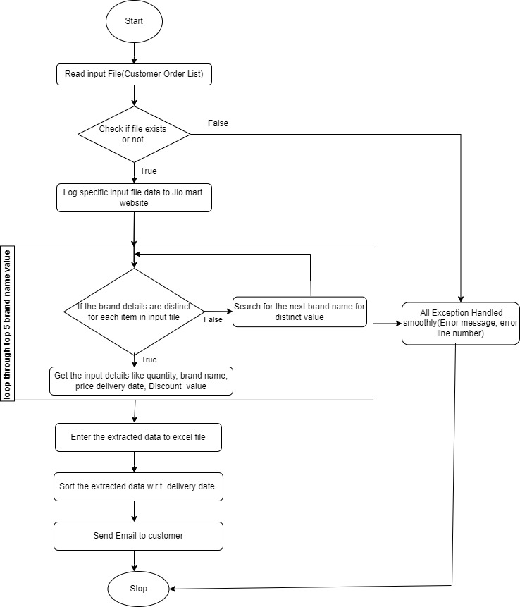

**3.2 Detailed Functional Requirements:**

**Step 1: Read Grocery Items from Input File**

Read the non-vegetable grocery items from the input file. The system should be able to read a specified input file containing non-vegetable grocery items.

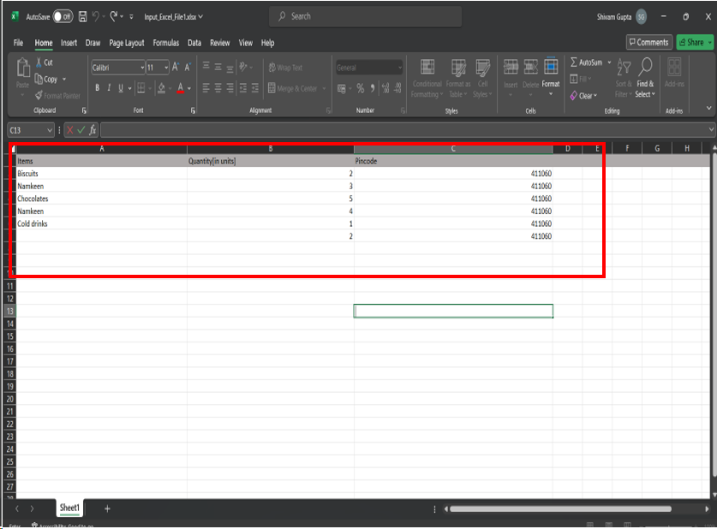

**Step 2: Navigate to Jio Mart by Entering Required Customer Input Detail**

Navigate to the Jio Mart website (<https://www.jiomart.com/>) and enter location and item name in field to retrieve item details.

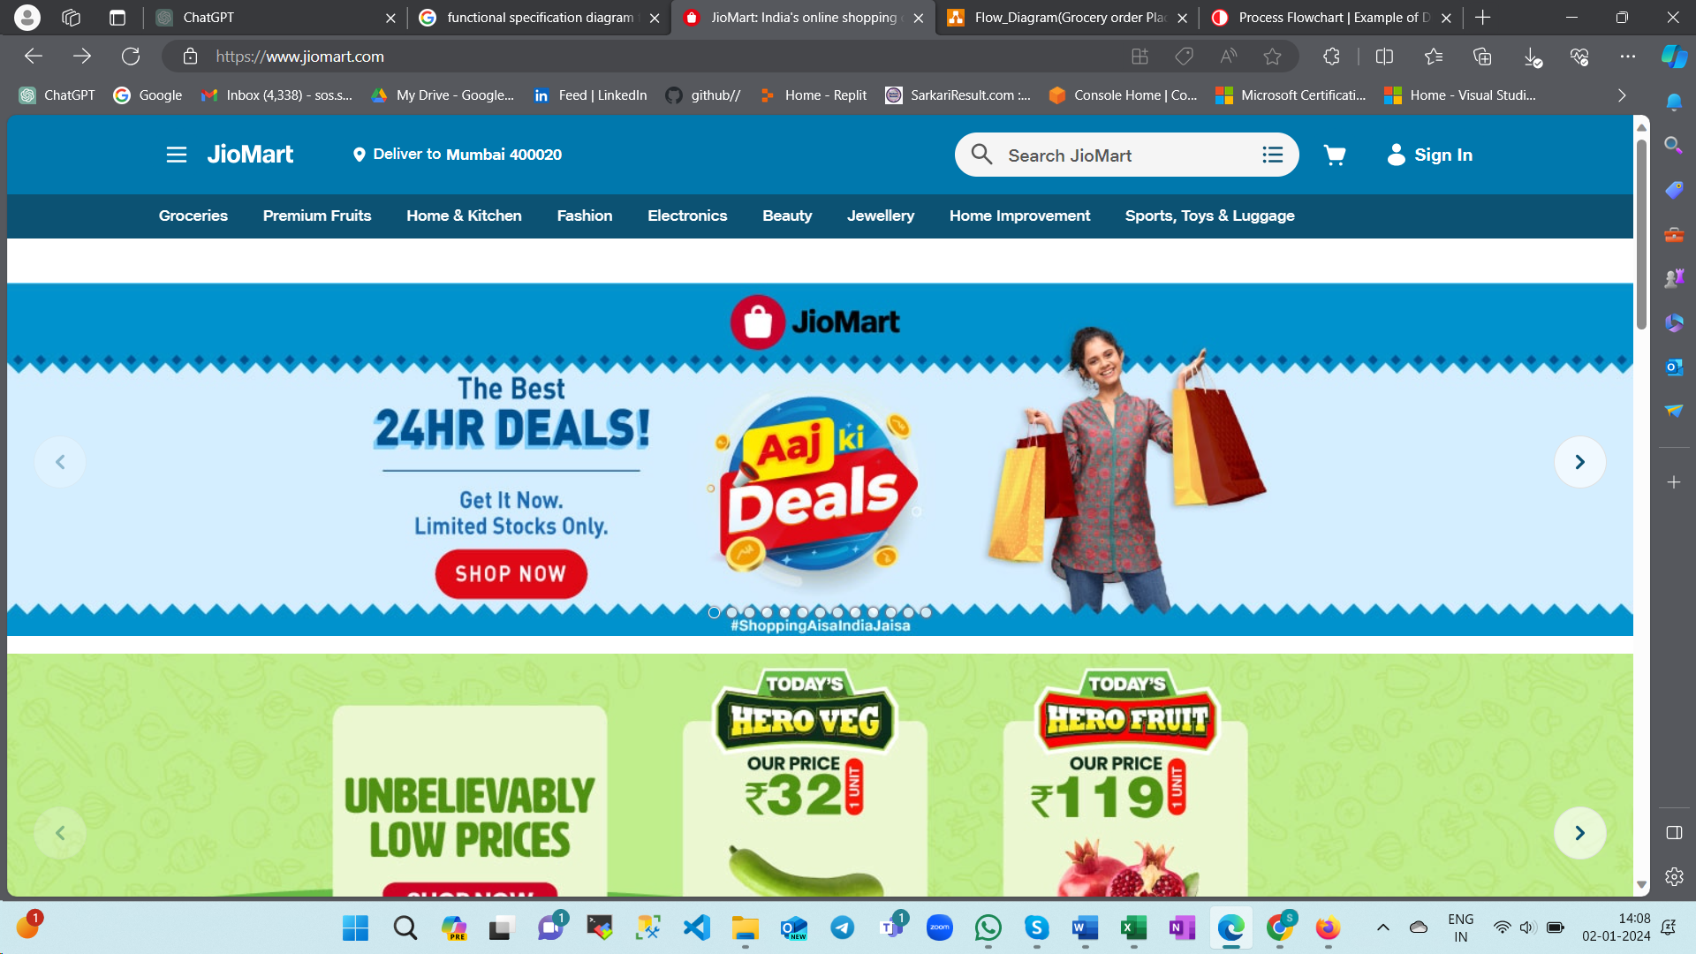

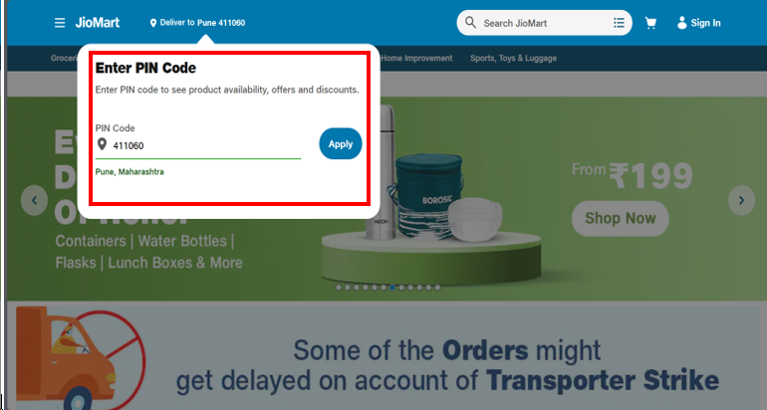

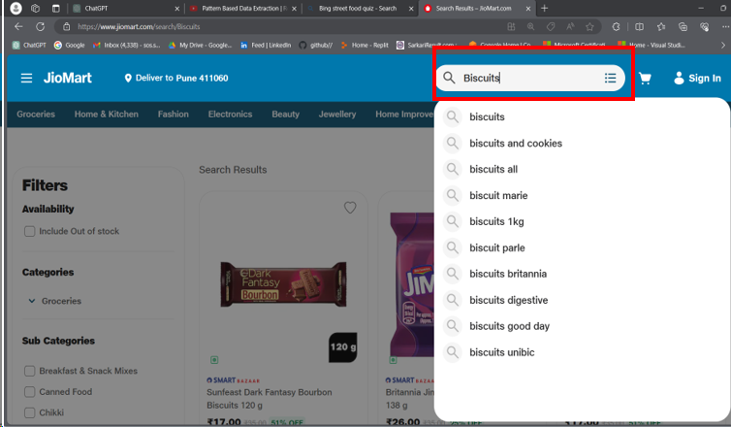

**Step 3: Extract Item Details From [**[JioMart: India's online shopping destination](https://www.jiomart.com/)**]**

* Quantity
* Brand Name
* Discount Value
* Price
* Delivery Date

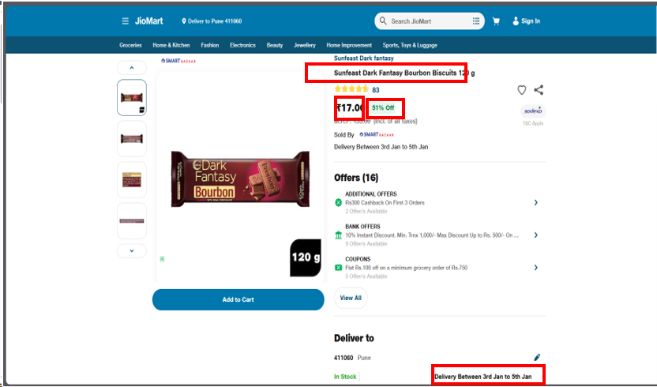

**Step 4: Select Top 5 Unique Brand Products**

Review the extracted details from the Jio Mart website, considering factors such as product features, customer reviews, and popularity. Identify the top 5 unique brand products that align with your criteria.

**Step 5: Enter Details in Excel File**

Create an Excel file or open an existing one to record the details of the selected top 5 unique brand products.

**Step 6: Sort Data Based on Delivery Dates**

Once the dates are entered, use the sorting functionality in Excel to arrange the data based on delivery dates.

**Step 7: Send Details to Concerned People**

After sorting the data, prepare to share the information with concerned individuals. This could involve exporting the Excel file to a format suitable for sharing, such as CSV.

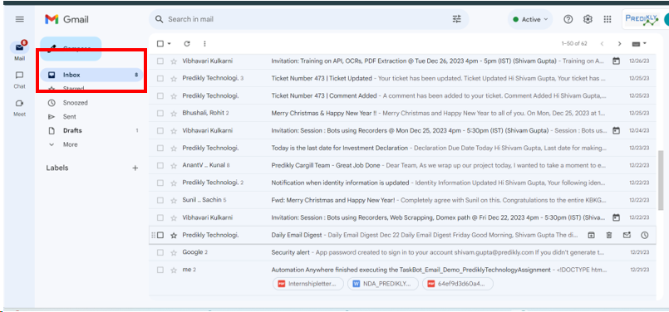

**4. Key Assumption & Dependencies**

The following are the dependencies to run an automated solution:

1. The input file format is standardized and contains accurate information about non-vegetable grocery items.
2. Continuous and stable internet connectivity is essential for the system to access (https://www.jiomart.com/) and retrieve relevant information. Any network issues may disrupt the prescription fulfilment process.
3. Provide necessary information in email attachments in the form of Excel sheet. Inaccurate or incomplete data may lead to errors in grocery item selection.
4. Any changes or disruptions in the email system may impact the project.

The following assumptions are made during the development of an automated solution:

1. Assuming that the information retrieved from (https://www.jiomart.com/) including quantity, brand names, discount value, price, delivery date is accurate and up-to-date
2. Assuming stable and uninterrupted internet connectivity for accessing and retrieving non-vegetable grocery product’s information from (https://www.jiomart.com/) website.
3. No extra columns other than the Items, Quantity [in units] and Pin code can be added to the input file.
4. Selected file formats will be considered in Excel format.
5. Sorting will be decided based on the delivery date of items.
6. For each placed order details will be send to concern people via email.

**5. Inputs:**

**5.1 Prerequisites:**

* Access to a computer or server with internet connectivity.
* Proper authorization to read files from the local system.
* Microsoft Excel installed for data entry.
* Access to an email service for communication.

**5.2 Inputs Required:**

* Non-vegetable Grocery Items List (Input File):
* Format: A text or CSV file containing a list of non-vegetable grocery items.

**6.Exception Handling:**

Proposed solution should have mechanism to handle exceptions and logged errors generated during process execution. Error logging is expected in text file which developer will refer for adding exception handling scenarios in solution

1. Verify that the input file exists. Handle errors if the input file format is incorrect or if it contains invalid data.
2. Implement robust error handling for website navigation issues.
3. Ensure the Excel file is accessible and writable. Handle exceptions related to Excel file format and data entry.
4. Implement checks to handle scenarios where there are fewer than 5 unique brands available.
5. Handle potential issues during the sorting process, such as invalid date formats.
6. Implement proper error handling for email sending failure.
7. **Out of Scope for RPA:**

* The project does not involve automating the payment processing step.
* Creating or logging into user accounts on the Jio Mart website is not within the scope.
* Managing inventory levels or updating stock information is not part of this project.
* Interaction with customer support services is out of scope for this automation.
* Any personalization or customization of user preferences on the website is not considered.