**Solution Design Document**

**Grocery Order Placement**



**Revision History**

|  |  |  |  |  |
| --- | --- | --- | --- | --- |
| Version | Purpose | Author | Reviewer | Release Date |
| V.1 | Initial Document | Mr. Shivam Gupta  Ms. Vaidehi Yerekar | Ms. Rutika Jadhav | 03 Jan. 2024 |

**Table of Contents**

**1. Introduction/Background 4**

**2. Functional Requirements Overview 4**

**2.1 Current Process 4**

**2.2 Future Process 4**

**3. Proposed Solution 5**

**3.1 BOTs Design 5**

**3.1.1 BOT Scope 5**

**3.1.2 BOT Goal and Objective 5**

**3.1.3 Design Details 6**

**3.1 BOT Workflow 7**

**3.2 Interventions Required 8**

**4 Technical Design: 8**

**4.1 Technical Architecture 8**

**4.2 Target System 8**

**5 Non-Functional Requirements 9**

**5.1 Security 9**

**5.2 Availability Requirements 10**

**5.3 Volume and Performance Expectations 10**

**6 Key Assumptions & Dependencies 10**

**1.Introduction/Background:**

Jio-mart is an online grocery platform operated by Reliance Retail, a subsidiary of Reliance Industries Limited, which is one of the largest conglomerates in India. Jio Mart aims to provide customers with a convenient way to order groceries and other household essentials online. Jio Mart provides 50,000+ grocery products at discounted rates at your doorstep.

The client is looking for an automated solution to get the details of non-vegetable grocery items to enhance the efficiency of current manual process. This document covers functional specification of the current process being followed by the users.

**2. Functional Requirements Overview:**

* 1. **Current Process:**

1. An email with the subject line "Item name" has been received in the email inbox.
2. Attachment will be downloaded to particular location.
3. Customer reads the grocery list items input excel file from the location on local device.
4. User navigates to the <https://www.jiomart.com>
5. User searches distinct brand name one by one for each field name ‘item’ mentioned in input excel file
6. User will fetch all details (like: quantity, price, delivery date, brand name, discount value) of unique brand name for each item mentioned in input excel file.
7. User extract those details (such as: Discount, price etc) in separate excel file.
8. User will sort excel data with respect to delivery dates mentioned for each brand name
9. User will send email to concerned people/customer having sorted excel files as an attachment.
   1. **Future Process:**
10. An email with the subject line "Item name" has been received in the email inbox.
11. Attachment will be downloaded to particular location.
12. Bot reads the grocery(non-vegetable) items from the input excel file.
13. Bot will navigate to the <https://www.jiomart.com>
14. Bot will search the item from the input excel file on the basis of Pin-code and non-vegetable item name.
15. Bot will get the details (Quantity, Brand name, Discount value, Price, Delivery date)
16. Bot will select top 5 product details.
17. Bot log these details in an output excel file.
18. Bot will search for next item.
19. Bot will sort data with respect to delivery dates.
20. Bot will send the output excel file as an attachment over email to concerned individuals.

**3. Proposed Solution**

**3.1 BOTs Design:**

**3.1.1 Bot Scope:**

Customer will send excel file through email and attachment will be downloaded to particular location. Read input grocery item from an Excel file. Then, it open site (https://www.jiomart.com) website. After that, it enters the pin-code of particular customer & search the item. A list of items will appear on first webpage having different brand names for that search item. User then navigate each item on website on the basis of unique brand name. If the brand name is unique then user will fetch details & will repeat same process for five unique brand names. Then those extracted details are fetched to separate Excel file. Then after extracting all item detail the extracted excel file is sorted on the basis of the field name ‘delivery date’ & final sorted data is stored on same/separate excel file. finally, at last sorted excel file will be send to respective customer.

The bot will focus on automating the process of reading, selecting, and organizing grocery items from the Jio-mart website.

**3.1.2 Bot Goal and Objective:**

The goal is to streamline the grocery order placement process by reducing manual efforts and increasing efficiency.

Customer is looking for BOT to achieve below goals.

1. Bot is able to read and write in an excel file.
2. Bot is able to capture product details.
3. Speed – Reduce man hours for file processing activities by 50%
4. Bot is able to send mail to concerned individual with attached excel file.

**3.1.3 Design Details:**

* 1. **Main BOT**: This is parent bot. This bot is calling child task bot responsible to execute modular functionality.
  2. **Email Listener BOT:** This bot is responsible to receive emails from customer.
  3. **Access Control BOT:** This bot is responsible to open the website and checks status of website.
  4. **Spreadsheet Data Interpreter, Web Scout and Data entry BOT:** This bot is responsible for reading data from the excel file and stores it into a record, for searching for the item from the record and capture the useful details and for writing data into excel file.
  5. **Automated Sorting BOT:** This bot is responsible to sort the extracted output file.
  6. **Email Dispatch BOT:** This bot is responsible for sending email with attached input file to the concerned users.

Packages used in bot development:

* 1. Browser Package: To open the website
  2. Task Bot Package: To achieve modularization child bots are created. To execute child bot from main/parent bot task bot package is used.
  3. Comment Package: To add comments.
  4. Number Package: Package used for performing actions on number.
  5. Excel Advanced Package: Package used for excel operations like creating status report, maintaining logs, etc.
  6. Email Package: This is used to send email with output file as an attachment.
  7. Delay Package: To delay the screen for specific time+
  8. Error Handler Package: Used for exception handling.
  9. If Package: Package is used for conditional scenario handling.
  10. Recorder Package: is used to capture and enter data.
  11. Loop Package: is used to loop through the list of items.
  12. Log File Package: is used to log the details about bot.

**3.2 Bot Workflow:**

High level workflow of the Grocery Order Placement is given below.

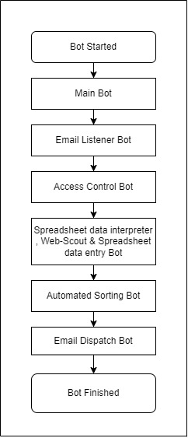

**3.3 Bot Detailed Workflow**

**1. Flow diagram for Email Listener Bot is given below:**

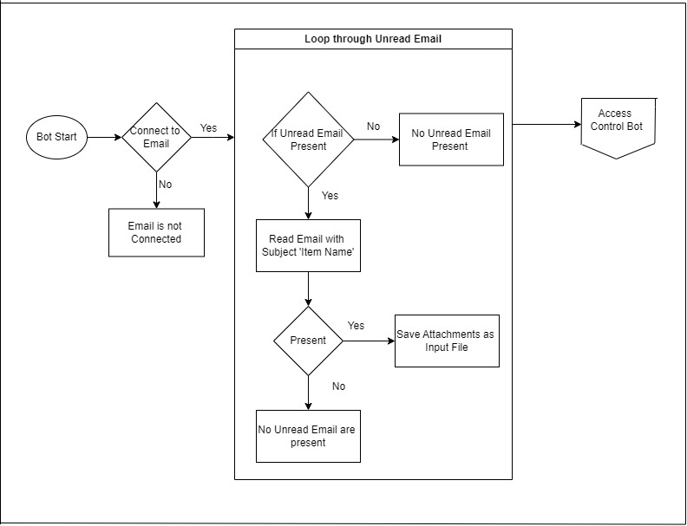

1. **Flow diagram for Access Control Bot is given below:**

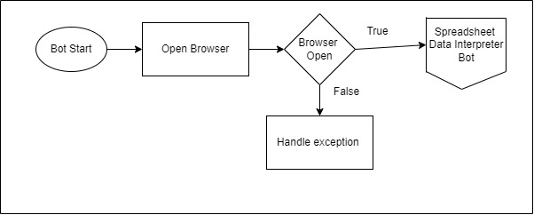

1. **Flow diagram for Spreadsheet data interpreter , Web-Scout & Spreadsheet data entry Bot is given below:**

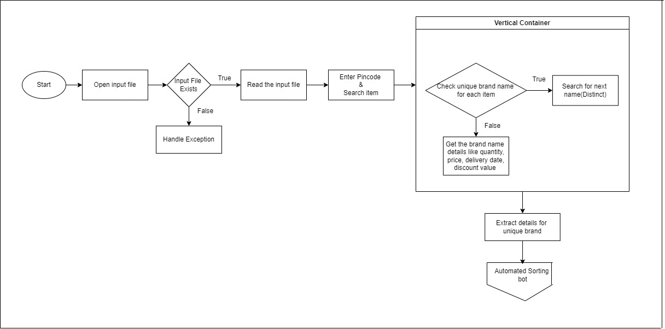

1. **Flow diagram for Automated Sorting Bot is given below:**

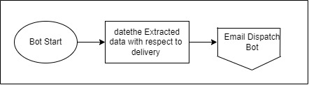

1. **Flow diagram for Email Dispatch Bot is given below:**

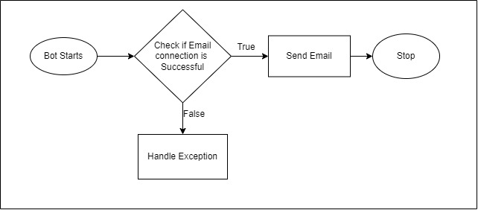

**3.4 Interventions Required:**

Yes

**4. Technical Design:**

**4.1 Technical Architecture:**

The system will utilize a client-server architecture with web scraping, automation, and Excel functionalities.

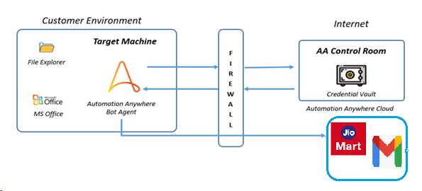

**4.2 Target System:**

|  |  |
| --- | --- |
|  | Bot Creator/Runner (Includes Analytics) |
| **Operating System** | Windows 10 & above |
| **Hard Disk Space** | 100 GB or more free space |
| **RAM** | 8 GB |
| **Automation Anywhere Version** | Automation Anywhere360(latest version) |
| **System Resolution** | HD(1920 x 1080) and above. 1080p recommended |
| **Credential Management** | Part of Control Room |

|  |  |
| --- | --- |
| Application Pre-Requisites on all Creators | Application Pre-Requisites on all Runners |
| Automation Anywhere Bot Agent | Automation Anywhere Bot Agent |
| Microsoft Office (Excel) | Microsoft Office (Excel) |
| Email Acccess | Email Access |

**Environment Design:**

This process requires only 2 Bot creators.

There is a single environment that will be used for DEV.

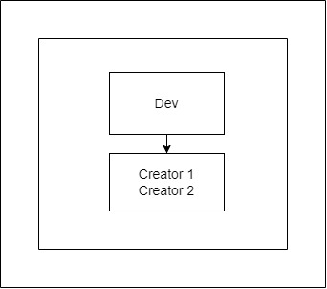

**Folder and File Structure:**

|  |  |
| --- | --- |
| **Folder Directory** | **Description** |
| C:\Grocery Order Placement\Output\AuditLogFile.txt | This file will store detail of execution. |
| C:\Grocery Order Placement\Output\ErrorLogFile.txt | This file will contain error logs |
| C:\Grocery Order Placement\Input\Input_Excel_File1.xlsx | This file is used to read input. |
| C:\Grocery Order Placement\Input\Config\config.xlsx | This file will store configuration item required for bot execution. |
| C:\Grocery Order Placement\Output\ExtractedOutputFile.xlsx | This file is used to log the products detail |

**5. Non-Functional Requirements:**

**5.1 Security:**

Bot requires an Email ID & password to send email to the client. There is a need to keep these details secure in a vault at the centralized location so that the bot runner can access these details. Also, any updates in these details required to be done can be done without making any changes to the Bot.

To fulfil this requirement Automation Anywhere provides a centralized vault named “Credential Vault” in the control room. Automation Anywhere Credential Vault is the secured storage of credentials of applications that are automated by the Automation Anywhere platform. Credential Vault allows adherence to enterprise-level information and security standards.

The Bot uses this Credential Vault having Email Id and Password as attributes to log in or access the required applications.

**5.2 Availability Requirements:**

BOT should be available 24x7 subject to the availability of all dependent systems. The system should be available during scheduled order placement times.

**5.3 Volume and Performance Expectation:**

The bot should handle a reasonable volume of grocery items and execute within an acceptable time frame. As per information from the business, Volume and performance expectations are given be below.

|  |  |  |
| --- | --- | --- |
|  | Parameters | Values |
| Volume | Items in input file  Number of emails send for each purchase | Around 3  1 Email |
| Performance | Manual time to complete per request  Expectations from bot | 30-40 minutes  Around 1 to 10 minutes |

**7.Key Assumptions and Dependencies:**

The BOT execution will be dependent on the following factors:

1. Enterprise A360 was installed successfully and has sufficient licenses for the control room, creator, and runner. Creator and runner machines have a successful installation of A360.
2. Configuration of the machine on which BOT is running should be equal to or above recommended configuration.

The recommended configuration is

|  |  |  |  |
| --- | --- | --- | --- |
| **Processor** | **RAM** | **Storage** | **Network** |
| Intel Core i3 2.6 GHz with 4 multi-cores or higher.  64 Bit system | 4 GB Minimum,  8 GB Recommended | 32 GB Add 100 through 150 KB per Automation Anywhere script.  Add 40 through 50 GB per long-term project | 8Mbps (Minimum)  20Mbps or higher (Recommended) |

3. Availability of email credentials through Automation Anywhere credential vault.

4. The bot should have access to the email account.

1. Email credentials details to send email to the client.
2. A bot should have access to local drive to download documents and perform file operations.
3. A bot should have access to Jio Mart account.

Following assumptions are made while the development of this BOT:

1. Assuming that the information retrieved from (https://www.jiomart.com/) including quantity, brand names, discount value, price, delivery date is accurate and up-to-date
2. Assuming stable and uninterrupted internet connectivity for accessing and retrieving non-vegetable grocery product’s information from (https://www.jiomart.com/) website.
3. No extra columns other than the Items, Quantity [in units] and Pin code can be added to the input file.
4. Selected file formats will be considered in Excel format.
5. Sorting will be decided based on the delivery date of items.
6. For each placed order details will be sent to concern people via email.

­­­­­­