**Functional Specification Document**

**Hotel Booking System**



|  |  |  |  |  |  |
| --- | --- | --- | --- | --- | --- |
| Version | Purpose | | Author | Reviewer | Release Date |
| V.1 | | Initial Document Overview | Shivam Gupta/Madhav Lomash | Rutika Jadhav | 15 January 2024 |
| V.2 | | Changes in functional workflow/ & Document format | Shivam/Madhav Lomash | Rutika Jadhav | 15 January 2024 |
| V.3 | | Changes in Document format | Shivam/Madhav Lomash | Rutika Jadhav | 15 January 2024 |

**Revision History**

**Table of Contents**

**1.** **Introduction/Background** 4

**2.** **Functional Requirements:** 4

**2.1** **Business Need:** 4

**2.2** **High-Level Requirements:** 4

**3.** **Functional Workflow** 5

**3.1** **High-Level Diagram** 5

**3.2** **Detailed Functional Requirements** 6

**4.** **Key Assumptions & Dependencies** 7

**5.** **Inputs** 7

**5.1** **Pre-requisites:** 7

**5.2 Inputs Required:** 7

**6.** **Exceptions Handling** 8

**7.** **Out of Scope for RPA** 8

# **1. Introduction:**

Trivago is a hotel metasearch engine that aggregates data from multiple online distribution channels to enable price comparison in one place. The website allows users to compare accommodation prices and offers provided by many different online booking sites.

Trivago works with many booking sites worldwide, including online travel agencies, as well as accommodation chains and independent hotels.

Trivago's search function is designed to enable individual users to find their ideal hotel. The personalized matching algorithms help travelers to get a comprehensive understanding of the hotel and its value proposition. This makes them more likely to complete a booking on the advertiser's site.

Trivago is now looking for an automated solution to read emails from its dedicated customers to search for available hotels based on ratings from previous customers, Price Per Night, city availability, etc.

This document covers the functional specification of the current process being followed by the users.

# **2. Functional Requirements:**

## **2.1 Business Need:**

With increasing customer demands, Trivago is now planning to design an automated solution that will mitigate manual errors and reduce the time to choose a “user-preferred destination” which is done through its current business process.

The improved business solution through RPA is designed to download the files in pdf format and perform all the current business operations in a more efficient way using automation anywhere 360 tools.

Thus, the tasks such as check-in check-out, and amenities required can be automated which leads to saving time, and resources and scaling the current business process without a proportional increase in staffing and other logistics required to operate the current business process.

## **2.2 High-Level Requirements:**

1. Once the system receives an email with the subject "Reference Documents" and any attachments, it will be triggered.
2. Read the email with the subject "Reference Documents".
3. Extract email attachment details such as destination, check-in check-out, price, etc. & save to Excel file.
4. Navigate to the “Trivago” website (<https://www.trivago.in/>) by entering the required details(destination, check-in date, number of days, number of adults and children, and required rooms ).
5. From the available hotels (on the first web page of “Trivago”), extract the particular details such as Hotel Name, City, Ratings, Price, Website from which hotel booking will be done, etc.
6. Sort the above-extracted details (i.e. Hotel Name, City, Ratings, Price) in ascending order of “price per night” for all available hotels.
7. Send the sorted Excel data via email to the respective client.

# **3.** **Functional Workflow:**

* 1. **High-Level Diagram:**

This section covers high level functional flow of Hotel Booking System being covered in the scope.

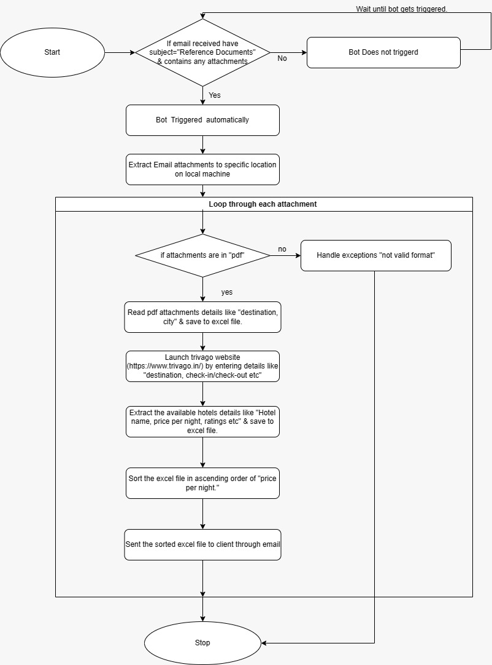

* 1. **Detailed Functional Requirements:**

**Step 1:** Download attachment(s) From email having the specific subject” Reference Documents” (from email triggered automatically)

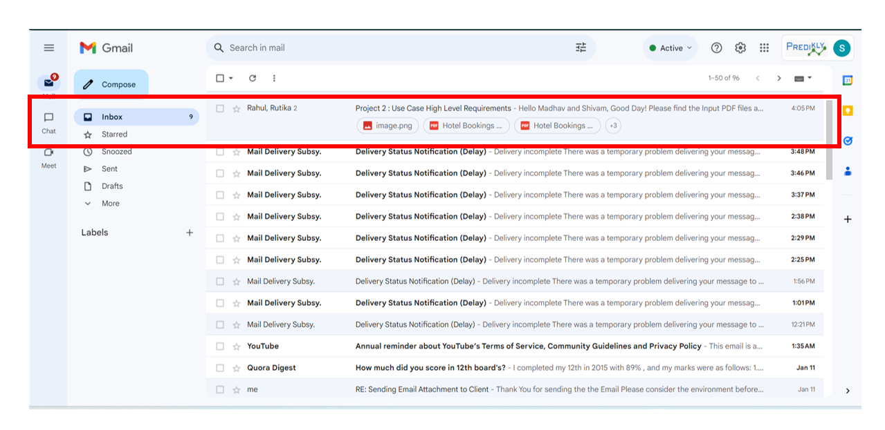

**Step 2:** Save attachments to specific location/folder

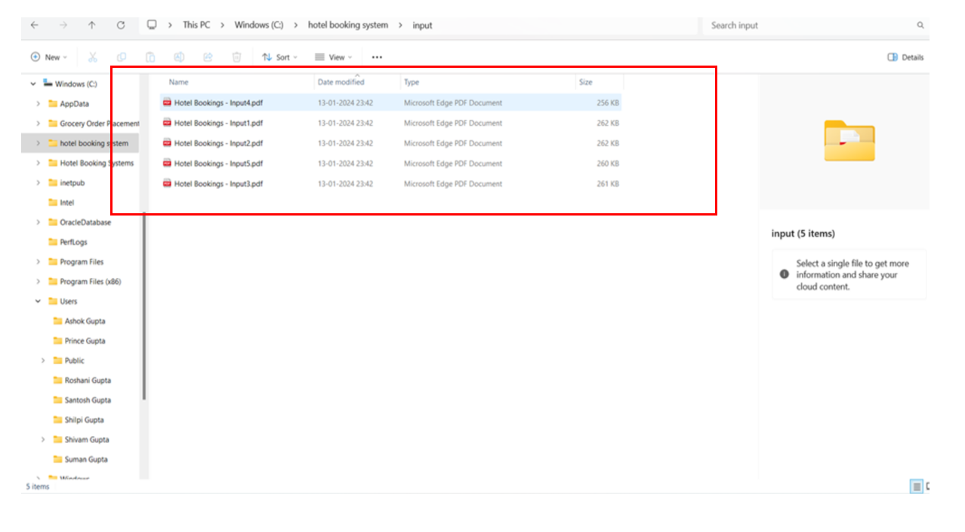

**Step 3:** Extract necessary details (i.e. Destination, check-In etc.) from the attachment (in PDF) in specific folder.

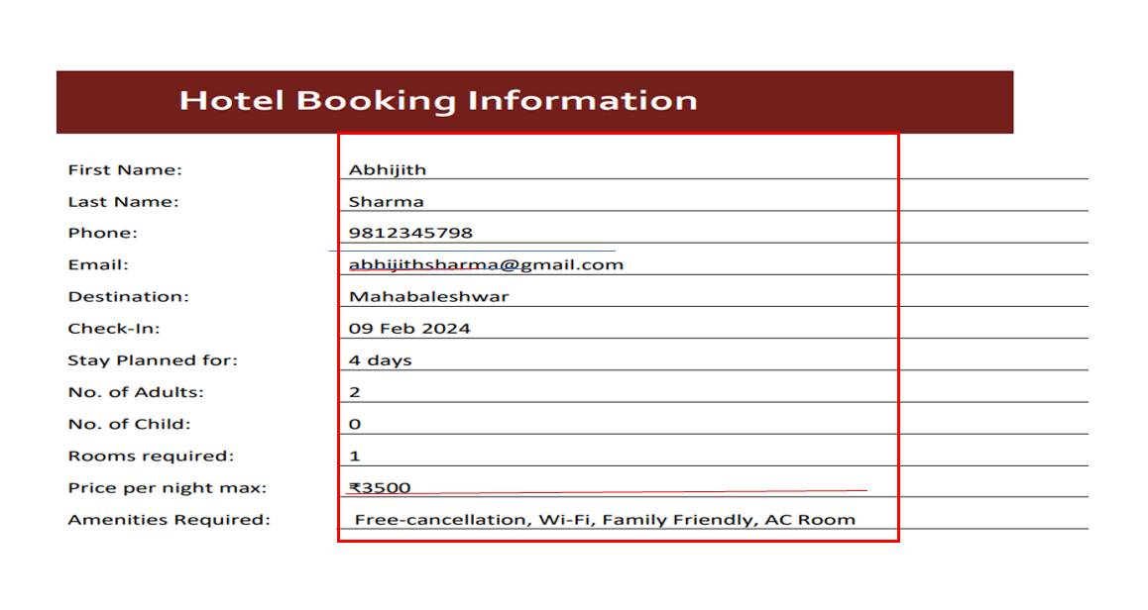

**Step 4:** Save the extracted details (i.e. First Name, Destination, Check-In, no of adults etc.)

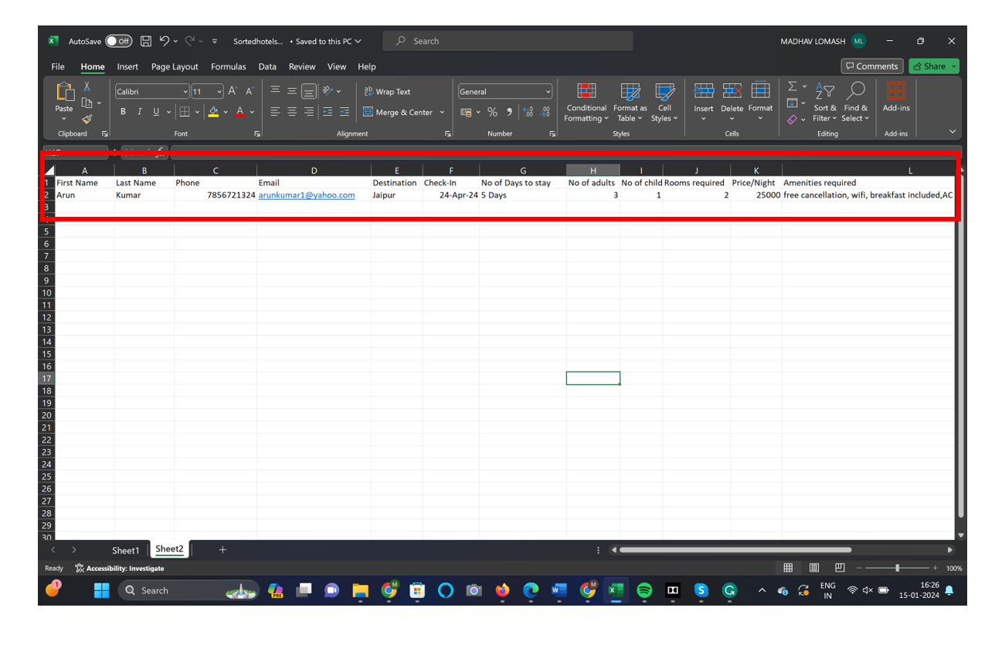

**Step 5:** Navigate to (<https://www.trivago.in/>) by entering all required details (i.e. Location, Check-In, Check-Out , Guest and rooms) from extracted details.

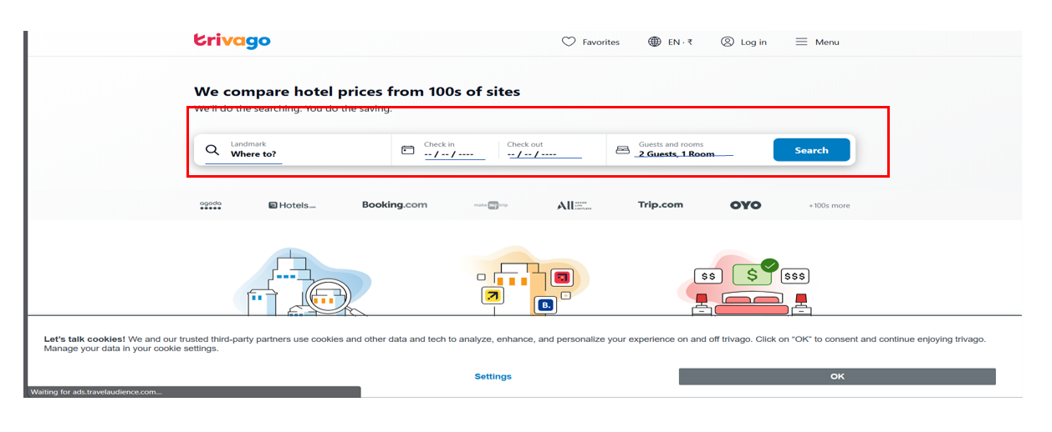

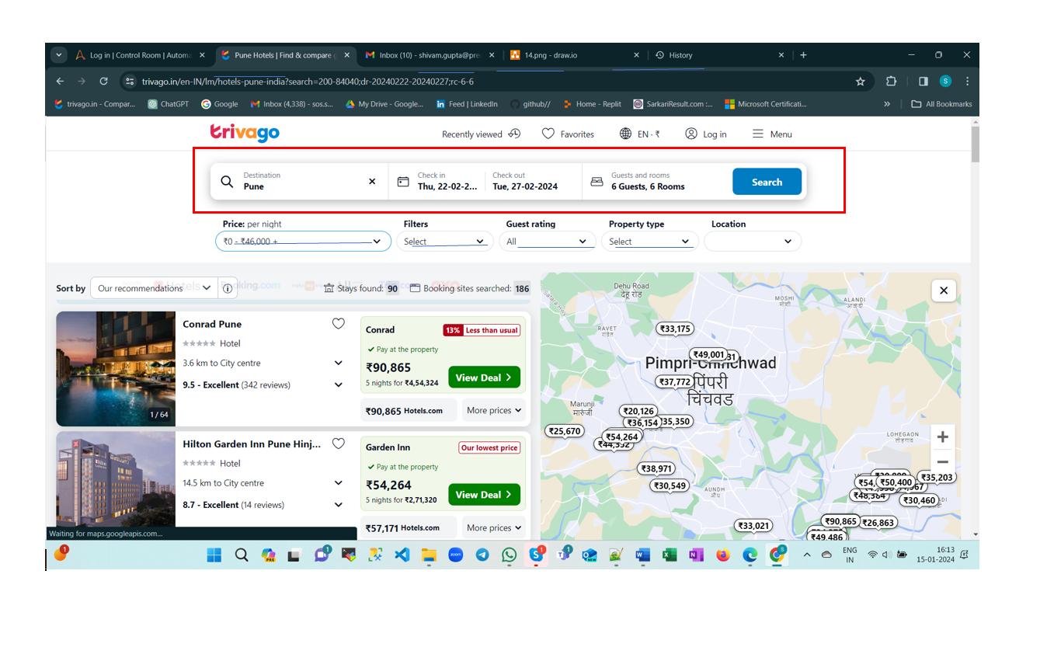

**Step 6:** Select & save all the required details (i.e. hotel name, price per night, ratings etc.) for each hotel available in excel file.

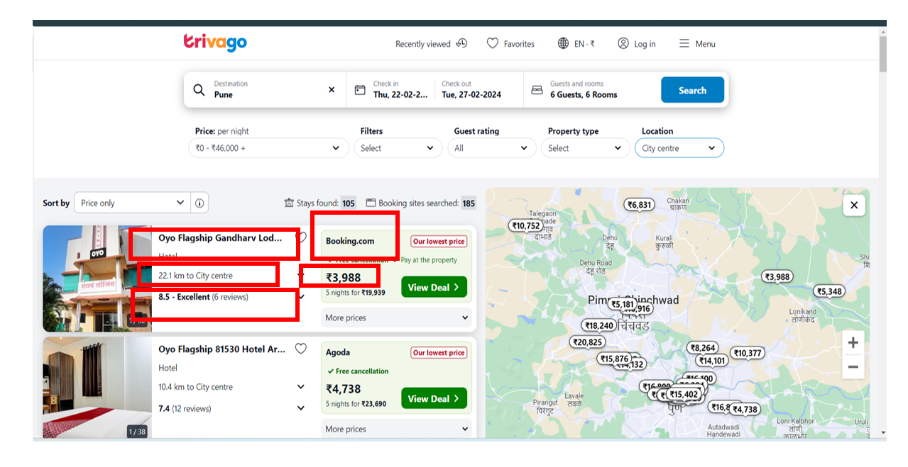

**Step 7:** Sort the saved details based on “price per night”

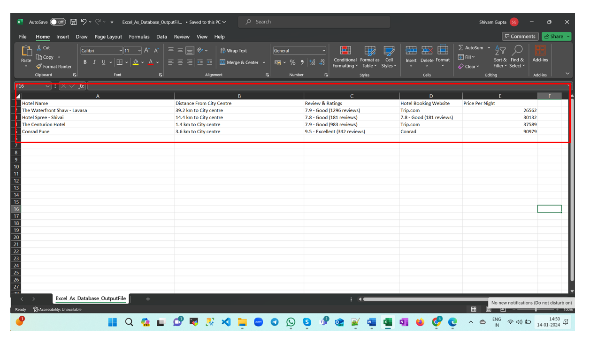

**Step 8:** Send the sorted excel details to respective client via email

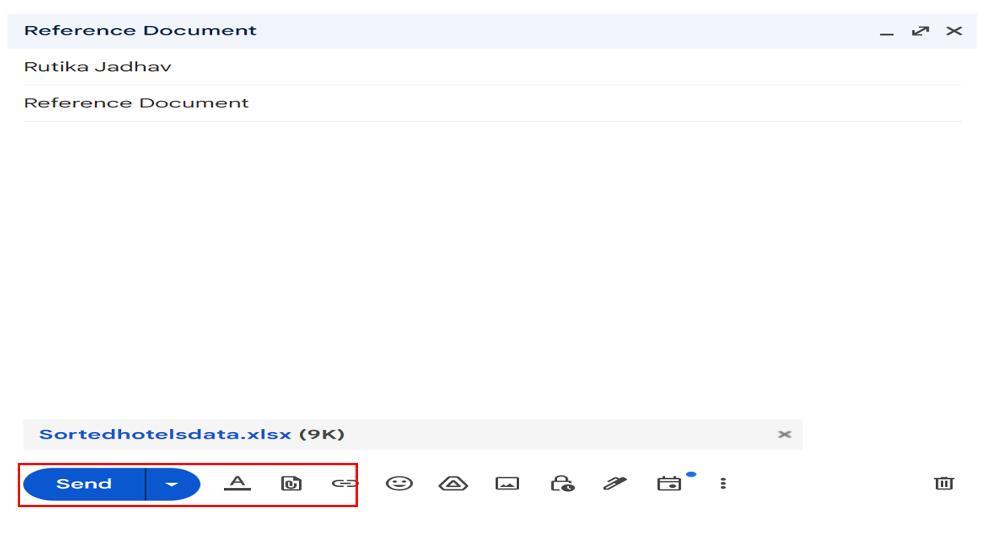

# **4.Key Assumptions & Dependencies:**

Following are the dependencies made while the development of automated solution:

1. It is necessary to have access to the local drive-in order to perform file operations.
2. It is important to have a stable internet connection.
3. The Trivago website should be functional and accessible.
4. Access to the email account is necessary.
5. Excel needs to be operational on the device. It is necessary to have access to local drive-in order to perform the operations

Following assumptions are made while the development of automated solution:

1. There are no filters applied to the Inbox.
2. All unread emails received on same day are consider.
3. Total file size should not exceed 200 MB.
4. Emails are sorted by subject line and attachments are included.

# **5. Inputs:**

## **5.1 Pre-requisites:**

1. Microsoft Excel is installed for data entry.
2. Saved Attachments (PDF file) to specific location/folder.
3. Access to a local drive to perform file operations.
4. Access to Email service for mail connectivity.

## **5.2 Inputs Required:**

1. Format: PDF file containing a list of details required for hotel booking.
2. Valid email credentials are required for successful email operation.
3. Valid input details/ forms data required for search results (same case for date range).

# **6.** **Exceptions Handling:**

1. Secure attachments (required PDF documents having password protected data) cannot be handled.
2. Website may undergo in maintenance phase/ non-responsive mode in this scenario user may have to wait for the webpage to be in response mode (about a delay of 1 minute).
3. Valid/invalid input details are for desired search results otherwise show results search criteria do not match.
4. Email attachments might contain different file formats (i.e. .xlsx, .png, .doc, etc). such attachments should be handled as “invalid attachment type”

# **7.** **Out of Scope for RPA:**

1. Bot will not trigger those emails without specific subjects & attachments.
2. Emails moved to other folders (e.g. Junk, deleted, etc.) are not considered.
3. The login feature on Trivago is not considered.
4. Accessing details through the map feature on Trivago is not considered.
5. Accessing Check-in/check-out details through features” tonight, this weekend, etc”

It is not considered.

1. Filtering “location” is not considered (i.e. popular site, maximum distance, and distance from particular address).