**Instructions on how to get the EBCDIC Component Working**

1) In Talend Studio: Go to Window->Show View->Modules. Select the Modules view for Talend. Click on the little icon to "Import external jars" and select the cobolX.jar attached to this email. See the below screenshot to show you how to do it.

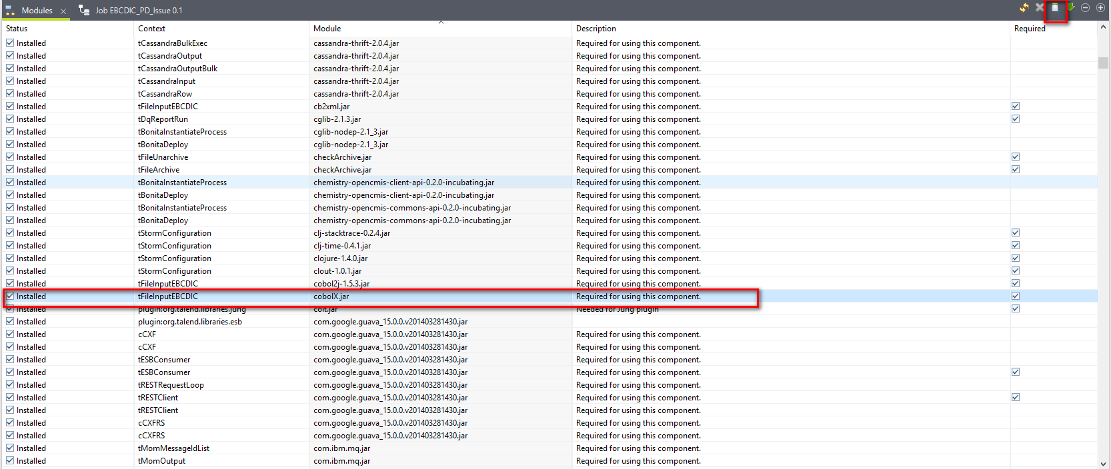

The jar is freely available here <https://github.com/Talend/tdi-studio-se/blob/maintenance/5.6/main/plugins/org.talend.libraries.ebcdic/lib/cobolX.jar>

2) Edit the file tFileInputEBCDIC_begin.javajet in the tFileInputEBCDIC component. Delete line 17 from the file (<%@ include file="../templates/Log4j/Log4jFileUtil.javajet"%>). Save the file.

3) Restart your studio, if needed.