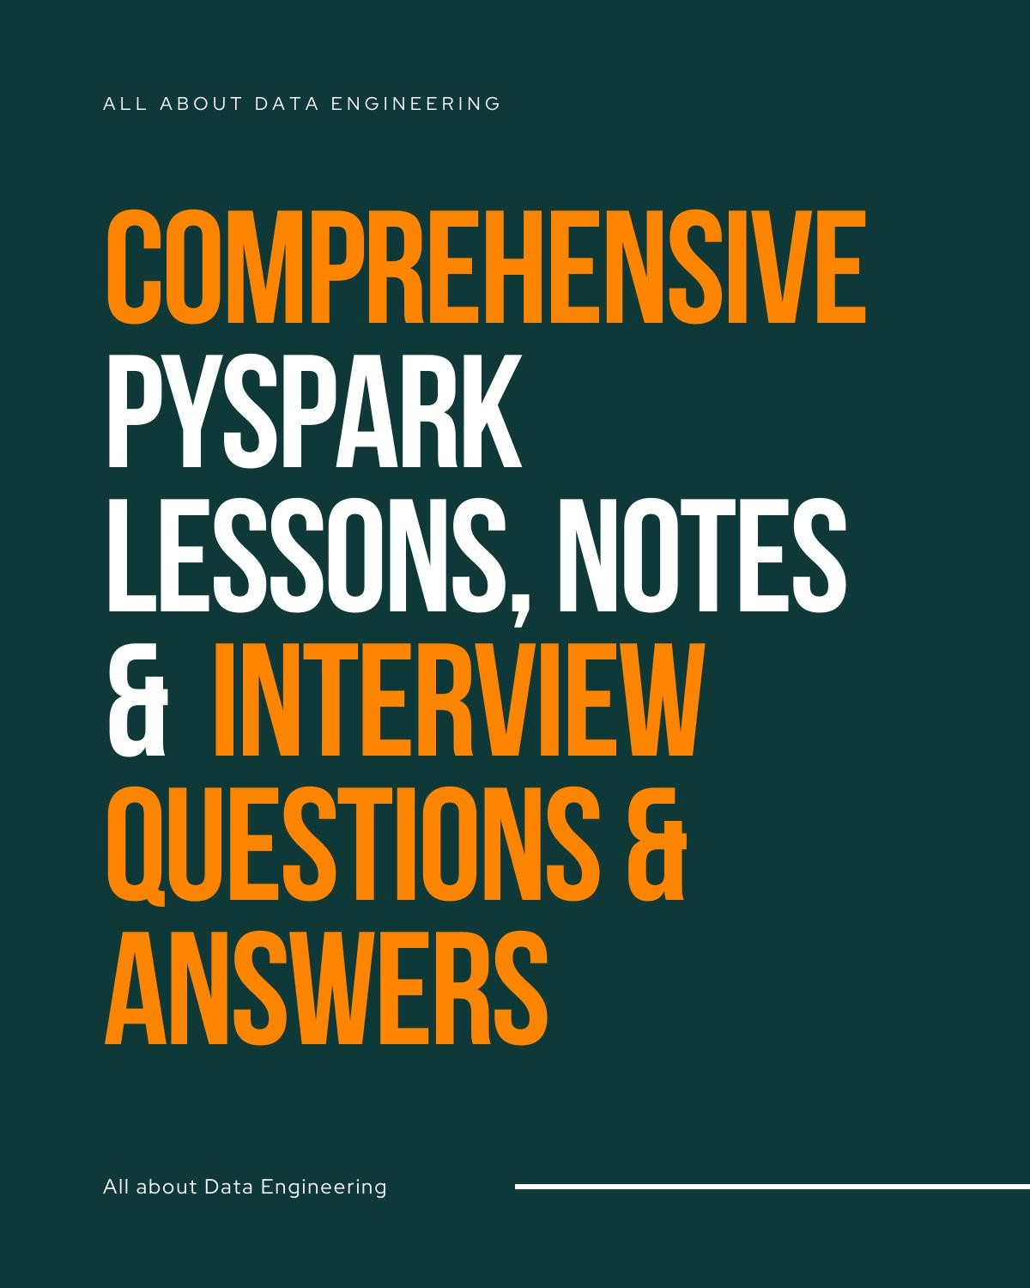

APACHE SPARK INTERVIEW QUESTIONS

ABHINANDAN PATRA DATA ENGINEER

- What is Apache Spark?
Apache Spark is an open-source, distributed computing system that provides an interface for programming entire clusters with implicit data parallelism and fault tolerance. It is designed to process large-scale data efficiently.

Why Apache Spark?
Apache Spark is used because it is faster than traditional big data tools like Hadoop MapReduce due to its in-memory processing capabilities, supports multiple languages (Scala, Python, R, Java), provides libraries for various tasks (SQL, machine learning, graph processing, etc.), and has robust fault tolerance.

What are the components of the Apache Spark Ecosystem?
The main components are:

  - Spark Core: The foundational engine for large-scale parallel and distributed data processing.
  - Spark SQL: For structured data processing.
  - Spark Streaming: For real-time data processing.
  - MLlib: A library for scalable machine learning.
  - GraphX: For graph and graph-parallel computation.

What is Spark Core?
Spark Core is the general execution engine for the Spark platform, responsible for tasks such as scheduling, distributing, and monitoring applications.

Which languages does Apache Spark support?
Apache Spark supports:

  - Scala
  - Python
  - Java
  - R
  - SQL

How is Apache Spark better than Hadoop?
Spark is better in several ways, including faster processing due to in-memory computation, ease of use with APIs for various programming languages, flexibility with built-in libraries for diverse tasks, and a rich set of APIs for transformations and actions.

What are the different methods to run Spark over Apache Hadoop?
Spark can run on Hadoop in the following modes:

  - Standalone: Using its cluster manager.
  - YARN: Hadoop’s cluster manager.
  - Mesos: Another cluster manager.

What is SparkContext in Apache Spark?
SparkContext is the entry point for any Spark application. It acts as a connection to the Spark cluster, allowing Spark jobs to be executed.

What is SparkSession in Apache Spark?
SparkSession is the unified entry point to work with DataFrames, Datasets, and SQL in Apache Spark. It replaces SQLContext and HiveContext.

SparkSession vs. SparkContext in Apache Spark
SparkSession is a combination of SQLContext, HiveContext, and SparkContext to provide a single point of entry to interact with Spark.

What are the abstractions of Apache Spark?
The primary abstractions are:

  - RDD (Resilient Distributed Dataset)
  - DataFrames
  - Datasets

How can we create RDD in Apache Spark?
RDDs can be created in three ways:

  - Parallelizing a collection in your program.
  - Referencing a dataset in an external storage system (e.g., HDFS, S3, etc.).
  - Transforming an existing RDD.

Why is Spark RDD immutable?
RDDs are immutable to provide fault tolerance and support functional programming principles, allowing Spark to rebuild lost data from the lineage information.

Explain the term paired RDD in Apache Spark.
Paired RDDs are RDDs where each element is a pair (key-value). They are used for operations like aggregation, grouping, and joins.

How is RDD in Spark different from Distributed Storage Management?
RDD is an in-memory data structure optimized for processing, while Distributed Storage (like HDFS) focuses on data storage and retrieval.

Explain transformation and action in RDD in Apache Spark.
  - Transformation: Lazy operations that define a new RDD without executing until an action is called (e.g., map, filter).
  - Action: Triggers the execution of transformations (e.g., count, collect).

What are the types of Apache Spark transformations?
Transformations can be narrow (e.g., map, filter) or wide (e.g., groupByKey, reduceByKey).

Explain the RDD properties.
RDD properties include:

  - Immutability: Once created, RDDs cannot be changed.
  - Partitioned: Distributed across various nodes in the cluster.
  - Lazy evaluation: Operations are computed when an action is called.
  - Fault tolerance: Recomputed using lineage information.

What is a lineage graph in Apache Spark?
A lineage graph tracks the sequence of transformations that created an RDD, used for recomputing lost data due to node failures.

Explain the terms Spark Partitions and Partitioners.
  - Partitions: Logical division of data in RDDs, physically stored across nodes.
  - Partitioner: Determines how data is distributed across partitions (e.g.,
HashPartitioner, RangePartitioner).

By default, how many partitions are created in RDD in Apache Spark?
By default, Spark creates partitions based on the number of cores available or the input file's HDFS block size.

What is Spark DataFrames?
DataFrames are distributed collections of data organized into named columns, similar to tables in a relational database.

What are the benefits of DataFrame in Spark?
Benefits include optimizations (Catalyst query optimizer), improved performance, and easier manipulation using SQL-like syntax.

What is Spark Dataset?

A Dataset is a distributed collection of data that provides type safety and object-oriented programming interfaces.

What are the advantages of datasets in Spark?
Advantages include compile-time type safety, optimizations through Tungsten, and the ability to leverage JVM object serialization.

What is Directed Acyclic Graph (DAG) in Apache Spark?
A DAG in Spark represents a sequence of computations performed on data, where each node is an RDD and edges represent transformations. It's used to optimize execution plans.

What is the need for Spark DAG?
The DAG allows Spark to optimize execution by scheduling tasks efficiently, minimizing data shuffling, and managing dependencies.

What is the difference between DAG and Lineage?
  - DAG: Represents the entire execution plan of a Spark application.
  - Lineage: Tracks transformations on a particular RDD, useful for fault recovery.

What is the difference between Caching and Persistence in Apache Spark?
  - Caching: Default storage level is in-memory (MEMORY_ONLY).
  - Persistence: Allows choosing different storage levels (disk, memory, etc.) for storing RDDs.

What are the limitations of Apache Spark?
Limitations include high memory consumption, limited built-in libraries compared to Hadoop, not suitable for small data or real-time streaming without specific tools.

Different Running Modes of Apache Spark
Spark can run in:

  - Local mode: Single machine.
  - Standalone mode: Using its cluster manager.
  - YARN mode: On Hadoop’s cluster manager.
  - Mesos mode: On Mesos cluster manager.
  - Kubernetes mode: On Kubernetes.

What are the different ways of representing data in Spark?
Data can be represented as:

  - RDDs (Resilient Distributed Datasets)

  - DataFrames
  - Datasets

What is Write-Ahead Log (WAL) in Spark?
Write-Ahead Log is a fault-tolerance mechanism where every received data is first written to a log file (disk) before processing, ensuring no data loss.

Explain Catalyst Query Optimizer in Apache Spark.
Catalyst is Spark SQL's query optimizer that uses rule-based and cost-based optimization techniques to generate efficient execution plans.

What are shared variables in Apache Spark?
Shared variables are variables that can be used by tasks running on different nodes:

  - Broadcast variables: Efficiently share read-only data across nodes.
  - Accumulators: Used for aggregating information (e.g., sums) across tasks.

How does Apache Spark handle accumulated metadata?
Spark stores metadata like lineage information, partition data, and task details in the driver and worker nodes, managing it using its DAG scheduler.

What is Apache Spark's Machine Learning Library?
MLlib is Spark's scalable machine learning library, which provides algorithms and utilities for classification, regression, clustering, collaborative filtering, and more.

List commonly used Machine Learning Algorithms.
Common algorithms in Spark MLlib include:

  - Linear Regression
  - Logistic Regression
  - Decision Trees
  - Random Forests
  - Gradient-Boosted Trees
  - K-Means Clustering

What is the difference between DSM and RDD?
  - DSM (Distributed Storage Management): Focuses on data storage across clusters.
  - RDD (Resilient Distributed Dataset): Focuses on distributed data processing with fault tolerance.

List the advantage of Parquet file in Apache Spark.

Advantages of Parquet files:

  - Columnar storage format, optimized for read-heavy workloads.
  - Efficient compression and encoding schemes.
  - Schema evolution support.

What is lazy evaluation in Spark?
Lazy evaluation defers execution until an action is performed, optimizing the execution plan by reducing redundant computations.

What are the benefits of Spark lazy evaluation?
Benefits include:

  - Reducing the number of passes over data.
  - Optimizing the computation process.
  - Decreasing execution time.

How much faster is Apache Spark than Hadoop?
Apache Spark is generally up to 100x faster than Hadoop for in-memory processing and up to 10x faster for on-disk data.

What are the ways to launch Apache Spark over YARN?
Spark can be launched over YARN in:

  - Client mode: Driver runs on the client machine.
  - Cluster mode: Driver runs inside YARN cluster.

Explain various cluster managers in Apache Spark.
Spark supports:

  - Standalone Cluster Manager: Default cluster manager.
  - Apache Mesos: A general-purpose cluster manager.
  - Hadoop YARN: A resource manager for Hadoop clusters.
  - Kubernetes: For container orchestration.

What is Speculative Execution in Apache Spark?
Speculative execution is a mechanism to detect slow-running tasks and run duplicates on other nodes to speed up the process.

How can data transfer be minimized when working with Apache Spark?
Data transfer can be minimized by:

  - Reducing shuffling and repartitioning.
  - Using broadcast variables.
  - Efficient data partitioning.

What are the cases where Apache Spark surpasses Hadoop?
Apache Spark outperforms Hadoop in scenarios involving iterative algorithms, in-memory computations, real-time analytics, and complex data processing workflows.

What is an action, and how does it process data in Apache Spark?
An action is an operation that triggers the execution of transformations (e.g., count, collect), performing computations and returning a result.

How is fault tolerance achieved in Apache Spark?
Fault tolerance is achieved through lineage information, allowing RDDs to be recomputed from scratch if a partition is lost.

What is the role of the Spark Driver in Spark applications?
The Spark Driver is responsible for converting the user's code into tasks, scheduling them on executors, and collecting the results.

What is a worker node in an Apache Spark cluster?
A worker node is a machine in a Spark cluster where the actual data processing tasks are executed.

Why is Transformation lazy in Spark?
Transformations are lazy to build an optimized execution plan (DAG) and to avoid unnecessary computation.

Can I run Apache Spark without Hadoop?
Yes, Spark can run independently using its built-in cluster manager or other managers like Mesos and Kubernetes.

Explain Accumulator in Spark.
An accumulator is a variable used for aggregating information across executors, like counters in MapReduce.

What is the role of the Driver program in a Spark Application?
The Driver program coordinates the execution of tasks, maintains the SparkContext, and communicates with the cluster manager.

How to identify that a given operation is a Transformation or Action in your program?
Transformations return RDDs (e.g., map, filter), while actions return non-RDD values (e.g.,
collect, count).

Name the two types of shared variables available in Apache Spark.
  - Broadcast Variables
  - Accumulators

What are the common faults of developers while using Apache Spark?
Common faults include:

  - Inefficient data partitioning.
  - Excessive shuffling and data movement.
  - Inappropriate use of transformations and actions.
  - Not leveraging caching and persistence properly.

By Default, how many partitions are created in RDD in Apache Spark?
The default number of partitions is based on the number of cores available in the cluster or the HDFS block size.

Why do we need compression, and what are the different compression formats supported?
Compression reduces the storage size of data and speeds up data transfer. Spark supports several compression formats:

  - Snappy
  - Gzip
  - Bzip2
  - LZ4
  - Zstandard (Zstd)

Explain the filter transformation.
The filter transformation creates a new RDD by selecting only elements that satisfy a given predicate function.

How to start and stop Spark in the interactive shell?
To start Spark in the interactive shell:

  - Use spark-shell for Scala or pyspark for Python. To stop Spark:
  - Use :quit or Ctrl + D in the shell.

- Explain the sortByKey() operation.
sortByKey() sorts an RDD of key-value pairs by the key in ascending or descending order.

- Explain distinct(), union(), intersection(), and subtract()

transformations in Spark.
  - distinct(): Returns an RDD with duplicate elements removed.
  - union(): Combines two RDDs into one.
  - intersection(): Returns an RDD with elements common to both RDDs.
  - subtract(): Returns an RDD with elements in one RDD but not in another.

- Explain foreach() operation in Apache Spark.
foreach() applies a function to each element in the RDD, typically used for side effects like updating an external data store.

- groupByKey vs reduceByKey in Apache Spark.

  - groupByKey: Groups values by key and shuffles all data across the network, which can be less efficient.
  - reduceByKey: Combines values for each key locally before shuffling, reducing network traffic.

- Explain mapPartitions() and mapPartitionsWithIndex().

  - mapPartitions(): Applies a function to each partition of the RDD.
  - mapPartitionsWithIndex(): Applies a function to each partition, providing the partition index.

What is map in Apache Spark?
map is a transformation that applies a function to each element in the RDD, resulting in a new RDD.

- What is flatMap in Apache Spark?
flatMap is a transformation that applies a function to each element, resulting in multiple elements (a flat structure) for each input.

- Explain fold() operation in Spark.
fold() aggregates the elements of an RDD using an associative function and a "zero value" (an initial value).

- Explain createOrReplaceTempView() API.

createOrReplaceTempView() registers a DataFrame as a temporary table in Spark SQL, allowing it to be queried using SQL.

- Explain values() operation in Apache Spark.
values() returns an RDD containing only the values of key-value pairs.

Explain keys() operation in Apache Spark.
keys() returns an RDD containing only the keys of key-value pairs.

- Explain textFile vs wholeTextFiles in Spark.

  - textFile(): Reads a text file and creates an RDD of strings, each representing a line.
  - wholeTextFiles(): Reads entire files and creates an RDD of (filename, content) pairs.

- Explain cogroup() operation in Spark.
cogroup() groups data from two or more RDDs sharing the same key.

Explain pipe() operation in Apache Spark.
pipe() passes each partition of an RDD to an external script or program and returns the output as an RDD.

- Explain Spark coalesce() operation.
coalesce() reduces the number of partitions in an RDD, useful for minimizing shuffling when reducing the data size.

- Explain the repartition() operation in Spark.
repartition() reshuffles data across partitions, increasing or decreasing the number of partitions, involving a full shuffle of data.

- Explain fullOuterJoin() operation in Apache Spark.
fullOuterJoin() returns an RDD with all pairs of elements for matching keys and null for non-matching keys from both RDDs.

- Explain Spark leftOuterJoin() and rightOuterJoin() operations.

  - leftOuterJoin(): Returns all key-value pairs from the left RDD and matching pairs from the right, filling with null where no match is found.
  - rightOuterJoin(): Returns all key-value pairs from the right RDD and matching pairs
from the left, filling with null where no match is found.
- Explain Spark join() operation.

join() returns an RDD with all pairs of elements with matching keys from both RDDs.

- Explain top() and takeOrdered() operations.
  - top(): Returns the top n elements from an RDD in descending order.
  - takeOrdered(): Returns the top n elements from an RDD in ascending order.

- Explain first() operation in Spark.
first() returns the first element of an RDD.

- Explain sum(), max(), min() operations in Apache Spark.
These operations compute the sum, maximum, and minimum of elements in an RDD, respectively.

- Explain countByValue() operation in Apache Spark RDD.
countByValue() returns a map of the counts of each unique value in the RDD.
- Explain the lookup() operation in Spark.
lookup() returns the list of values associated with a given key in a paired RDD.
- Explain Spark countByKey() operation.
countByKey() returns a map of the counts of each key in a paired RDD.

- Explain Spark saveAsTextFile() operation.
saveAsTextFile() saves the RDD content as a text file or set of text files.

- Explain reduceByKey() Spark operation.
reduceByKey() applies a reducing function to the elements with the same key, reducing them to a single element per key.

- Explain the operation reduce() in Spark.
reduce() aggregates the elements of an RDD using an associative and commutative function.

Explain the action count() in Spark RDD.
count() returns the number of elements in an RDD.

Explain Spark map() transformation.

map() applies a function to each element of an RDD, creating a new RDD with the results.

Explain the flatMap() transformation in Apache Spark.
flatMap() applies a function that returns an iterable to each element and flattens the results into a single RDD.

What are the limitations of Apache Spark?
Limitations include high memory consumption, not ideal for OLTP (transactional processing), lack of a mature security framework, and dependency on cluster resources.

What is Spark SQL?
Spark SQL is a Spark module for structured data processing, providing a DataFrame API and allowing SQL queries to be executed.

Explain Spark SQL caching and uncaching.
  - Caching: Storing DataFrames in memory for faster access.
  - Uncaching: Removing cached DataFrames to free memory.

Explain Spark Streaming.
Spark Streaming is an extension of Spark for processing real-time data streams.

What is DStream in Apache Spark Streaming?
DStream (Discretized Stream) is a sequence of RDDs representing a continuous stream of data.

Explain different transformations in DStream in Apache Spark Streaming.
Transformations include:

  - map(), flatMap(), filter()
  - reduceByKeyAndWindow()
  - window(), countByWindow()
  - updateStateByKey()

What is the Starvation scenario in Spark Streaming?
Starvation occurs when all tasks are waiting for resources that are occupied by other long-running tasks, leading to delays or deadlocks.

Explain the level of parallelism in Spark Streaming.

Parallelism is controlled by the number of partitions in RDDs; increasing partitions increases the level of parallelism.

What are the different input sources for Spark Streaming?
Input sources include:

  - Kafka
  - Flume
  - Kinesis
  - Socket
  - HDFS or S3

Explain Spark Streaming with Socket.
Spark Streaming can receive real-time data streams over a socket using
socketTextStream().

Define the roles of the file system in any framework.
The file system manages data storage, access, and security, ensuring data integrity and availability.

How do you parse data in XML? Which kind of class do you use with Java to parse data?
To parse XML data in Java, you can use classes from the javax.xml.parsers package, such as:

  - DocumentBuilder: Used with the Document Object Model (DOM) for in-memory tree representation.
  - SAXParser: Used with the Simple API for XML (SAX) for event-driven parsing.

What is PageRank in Spark?
PageRank is an algorithm used to rank web pages in search engine results, based on the number and quality of links to a page. In Spark, it can be implemented using RDDs or DataFrames to compute the rank of nodes in a graph.

What are the roles and responsibilities of worker nodes in the Apache Spark cluster? Is the Worker Node in Spark the same as the Slave Node?
  - Worker Nodes: Execute tasks assigned by the Spark Driver, manage executors, and store data in memory or disk as required.
  - Slave Nodes: Worker nodes in Spark are commonly referred to as slave nodes. Both terms are used interchangeably.

How to split a single HDFS block into partitions in an RDD?

When reading from HDFS, Spark splits a single block into multiple partitions based on the number of available cores or executors. You can also use the repartition() method to explicitly specify the number of partitions.

On what basis can you differentiate RDD, DataFrame, and DataSet?
  - RDD: Low-level, unstructured data; provides functional programming APIs.
  - DataFrame: Higher-level abstraction with schema; optimized for SQL queries and transformations.
  - Dataset: Combines features of RDDs and DataFrames; offers type safety and object-oriented programming.

SPARK BASED TOPICS KEYWORDS:

Spark Intro:
- Spark : In-memory processing engine
- Why spark is fast: Due to less I/O disc reads and writes
- RDD: It is a data structure to store data in spark
- When RDD fails: Using lineage graph we track which RDD failed and reprocess it
- Why RDD immutable : As it has to be recovered after its failure and to track which RDD failed
- Operations in spark: Transformation and Action
- Transformation: Change data from one form to another, are lazy.
- Action: Operations which processes the tranformations, not lazy. creates DAG to remember sequence of steps.
- Broadcast Variables: Data which is distributed to all the systems. Similar to map side join in hive
- Accumulators: Shared copy in driver, executors can update but not read. Similar to counters in MR
- MR before Yarn: Job tracker (scheduling &monitoring), task manager (manages tasks in its node)
- Limitations of MR: Unable to add new clusters(scalable), resource under-utilization, only MR jobs handled
- YARN: Resource manager(scheduling), application master(monitoring & resource negotiation), node manager (manages tasks in its node)
- Uberization: Tasks run on AM itself if they are very small

- Spark components: Driver (gives location of executors) and executors(process data in memory)
- Client Mode: Driver is at client side
- Cluster Mode: Driver is inside AM in the cluster
- Types of transformation: Narrow and Wide
- Narrow: Data shuffling doesn’t happen (map, flatMap,
filter)
- Wide: Data shuffling happens (reduceByKey, groupByKey)
- reduceByKey() is a transformation and reduce() is an action
- reduceByKey(): Data is processed at each partition, groupByKey() : Data is grouped at each partition and complete processing is done at reducer.
- Repartition: used to increase/decrease partitions. Use it for INCREASE
Coalesce: used to decrease partitions and optimized as data shuffling is less

SPARK DATAFRAMES:

- Cache() : It is used to cache the data only in memory. Rdd.cache()
- Persist() : it is used to cache the data in different storage levels (memory, disc, memory & disc, off heap). Rdd.persist(StorageLevel. )
- Serialization: Process of converting data in object form into bytes, occupies less space

- De-Serialization: Process of converting data in bytes back to objects, occupies more space.
- DAG : Created when an action is called, represents tasks, stages of a job
- Map : performs one-to-one mapping on each line of input
- mapPartitions: performs map function only once on each partition
- Driver: converts high level programming constructs to low level to be fed to executors (dataframe to rdd)
- Executors: Present in memory to process the rdd
- Spark context: creates entry point into spark cluster for spark appl
- Spark session: creates unified entry point into spark cluster
- Data frame: it is a dataset[row] where type error caught only at run time
- Data set: it is a dataset[object] where type error caught at compile time
- Modes of dealing with corrupted record: permissive, malformed, fail fast
- Schema types: implicit, infer, explicit (case class, StructType, DDL string)

SPARK OPTIMIZATIONS

  - Spark optimization:
    - Cluster Configuration : To configure resources to the cluster so that spark jobs can process well.

    - Code configuration: To apply optimization techniques at code level so that processing will be fast.
  - Thin executor: More no. of executors with less no. of resources. Multithreading not possible, too many broadcast variables required. Ex. 1 executor with each 2 cpu cores, 1 GB ram.
  - Fat executor: Less no. of executors with more amount of resources. System performance drops down, garbage collection takes time. Ex 1 executor 16 cpu cores, 32 GB ram.
  - Garbage collection: To remove unused objects from memory.
  - Off heap memory: Memory stored outside of executors/ jvm. It takes less time to clean objects than garbage collector, used for java overheads (extra memory which directly doesn’t add to performance but required by system to carry out its operation)
  - Static allocation: Resources are fixed at first and will remain the same till the job ends.
  - Dynamic Allocation: Resources are allocated dynamically based on the job requirement and released during job stages if they are no longer required.
  - Edge node: It is also called as gateway node which is can be accessed by client to enter into hadoop cluster and access name node.
  - How to increase parallelism :
    - Salting : To increase no. of distinct keys so that work can be distributed across many tasks which in turn increase parallelism.
    - Increase no. of shuffle partitions
    - Increase the resources of the cluster (more cpu cores)
  - Execution memory : To perform computations like shuffle, sort, join
  - Storage memory : To store the cache
  - User memory : To store user’s data structures, meta data
etc.
  - Reserved memory : To run the executors

  - Kyro Serializer: Used to store the data in disk in serialized manner which occupies less space.
  - Broadcast join: Used to send the copies of data to all executors. Used when we have only 1 big table.
  - Optimization on using coalesce() rather than repartition while reducing no. of partitions
  - Join optimizations:
    - To avoid or minimize shuffling of data
    - To increase parallelism
      - How to avoid/minimize shuffling?
        - Filter and aggregate data before shuffling
        - Use optimization methods which require less shuffling ( coalesce() )
  - How to increase parallelism ?

Min (total cpu cores, total shuffle partitions, total distinct keys)
    - Use salting to increase no. of distinct keys
    - Increase default no. of shuffle partitions
    - Increase resources to inc total cpu cores
  - Skew partitions : Partitions in which data is unevenly distributed. Bucketing, partitioning, salting can be used to handle it.
  - Sort aggregate: Data is sorted based on keys and then aggregated. More processing time
  - Hash aggregate: Hash table is created and similar keys are added to the same hash value. Less processing time.
  - Stages of execution plan :
    - Parsed logical plan (unresolved logical plan) : To find out syntax errors

    - Analytical logical plan (Resolved logical plan) : Checks for column and table names from the catalog.
    - Optimized logical plan (Catalyst optimization) : Optimization done based on built in rules.
    - Physical plan : Actual execution plan is selected based on cost effective model.
    - Conversion into Rdd : Converted into rdd and sent to executors for processing.

**Note:
1 hdfs block = 1 rdd partition = 128mb
1 hdfs block in local=1 rdd partition in local spark cluster= 32mb 1 rdd ~ can have n partitions in it
1 cluster = 1 machine
N cores = N blocks can run in parallel in each cluster/machine N stages = N - 1 wide transformations
N tasks in each stage= N partitions in each stage for that rdd/data frame




Must Know Pyspark Coding Before Your Next Databricks Interview

Document by – Siddhartha Subudhi Visit my LinkedIn profile




- Find the second highest salary in a DataFrame using PySpark.
Scenario: You have a DataFrame of employee salaries and want to find the second highest salary. from pyspark.sql import Window
from pyspark.sql.functions import col, dense_rank

windowSpec = Window.orderBy(col("salary").desc())
df_with_rank = df.withColumn("rank", dense_rank().over(windowSpec))
second_highest_salary = df_with_rank.filter(col("rank") == 2).select("salary") second_highest_salary.show()

- Count the number of null values in each column of a PySpark DataFrame. Scenario: Given a DataFrame, identify how many null values each column contains. from pyspark.sql.functions import col, isnan, when, count

df.select([count(when(isnan(c) | col(c).isNull(), c)).alias(c) for c in df.columns]).show()

- Calculate the moving average over a window of 3 rows.
Scenario: For a stock price dataset, calculate a moving average over the last 3 days. from pyspark.sql import Window
from pyspark.sql.functions import avg

windowSpec = Window.orderBy("date").rowsBetween(-2, 0)
df_with_moving_avg = df.withColumn("moving_avg", avg("price").over(windowSpec)) df_with_moving_avg.show()

- Remove duplicate rows based on a subset of columns in a PySpark DataFrame. Scenario: You need to remove duplicates from a DataFrame based on certain columns. df = df.dropDuplicates(["column1", "column2"])
df.show()




- Split a single column with comma-separated values into multiple columns.
Scenario: Your DataFrame contains a column with comma-separated values. You want to split this into multiple columns.
from pyspark.sql.functions import split

df_split = df.withColumn("new_column1", split(df["column"], ",").getItem(0)) \
.withColumn("new_column2", split(df["column"], ",").getItem(1)) df_split.show()

- Group data by a specific column and calculate the sum of another column. Scenario: Group sales data by "product" and calculate the total sales. df.groupBy("product").sum("sales").show()

- Join two DataFrames on a specific condition.
Scenario: You have two DataFrames: one for customer data and one for orders. Join these DataFrames on the customer ID.
df_joined = df_customers.join(df_orders, df_customers.customer_id == df_orders.customer_id, "inner") df_joined.show()

- Create a new column based on conditions from existing columns.
Scenario: Add a new column "category" that assigns "high", "medium", or "low" based on the value of the "sales" column.
from pyspark.sql.functions import when
df = df.withColumn("category", when(df.sales > 500, "high")
.when((df.sales <= 500) & (df.sales > 200), "medium")
.otherwise("low"))
df.show()




- Calculate the percentage contribution of each value in a column to the total.
Scenario: For a sales dataset, calculate the percentage contribution of each product's sales to the total sales. from pyspark.sql.functions import sum, col
total_sales = df.agg(sum("sales").alias("total_sales")).collect()[0]["total_sales"] df = df.withColumn("percentage", (col("sales") / total_sales) * 100)
df.show()

- Find the top N records from a DataFrame based on a column. Scenario: You need to find the top 5 highest-selling products. df.orderBy(col("sales").desc()).limit(5).show()

- Write PySpark code to pivot a DataFrame.
Scenario: You have sales data by "year" and "product", and you want to pivot the table to show "product" sales by year.
df_pivot = df.groupBy("product").pivot("year").sum("sales") df_pivot.show()

- Add row numbers to a PySpark DataFrame based on a specific ordering. Scenario: Add row numbers to a DataFrame ordered by "sales" in descending order. from pyspark.sql.window import Window
from pyspark.sql.functions import row_number
windowSpec = Window.orderBy(col("sales").desc())
df_with_row_number = df.withColumn("row_number", row_number().over(windowSpec)) df_with_row_number.show()





- Filter rows based on a condition.
Scenario: You want to filter only those customers who made purchases over ₹1000. df_filtered = df.filter(df.purchase_amount > 1000)
df_filtered.show()

- Flatten a JSON column in PySpark.
Scenario: Your DataFrame contains a JSON column, and you want to extract specific fields from it. from pyspark.sql.functions import from_json, col
from pyspark.sql.types import StructType, StructField, StringType schema = StructType([
StructField("name", StringType(), True), StructField("age", StringType(), True)
])
df = df.withColumn("json_data", from_json(col("json_column"), schema)) df.select("json_data.name", "json_data.age").show()

- Convert a PySpark DataFrame column to a list.
Scenario: Convert a column from your DataFrame into a list for further processing. column_list = df.select("column_name").rdd.flatMap(lambda x: x).collect()

- Handle NULL values by replacing them with a default value. Scenario: Replace all NULL values in the "sales" column with 0. df = df.na.fill({"sales": 0})
df.show()

- Perform a self-join on a PySpark DataFrame.
Scenario: You have a hierarchy of employees and want to find each employee's manager.
df_self_join = df.alias("e1").join(df.alias("e2"), col("e1.manager_id") == col("e2.employee_id"), "inner") \
.select(col("e1.employee_name"), col("e2.employee_name").alias("manager_name")) df_self_join.show()




- Write PySpark code to unpivot a DataFrame.
Scenario: You have a DataFrame with "year" columns and want to convert them to rows. from pyspark.sql.functions import expr
df_unpivot = df.selectExpr("id", "stack(2, '2021', sales_2021, '2022', sales_2022) as (year, sales)") df_unpivot.show()

- Write a PySpark code to group data based on multiple columns and calculate aggregate functions. Scenario: Group data by "product" and "region" and calculate the average sales for each group. df.groupBy("product", "region").agg({"sales": "avg"}).show()

- Write PySpark code to remove rows with duplicate values in any column. Scenario: You want to remove rows where any column has duplicate values. df_cleaned = df.dropDuplicates()
df_cleaned.show()

- Write PySpark code to read a CSV file and infer its schema.
Scenario: You need to load a CSV file into a DataFrame, ensuring the schema is inferred. df = spark.read.option("header", "true").option("inferSchema", "true").csv("path_to_csv") df.show()

- Write PySpark code to merge multiple small files into a single file.
Scenario: You have multiple small files in HDFS, and you want to consolidate them into one large file. df.coalesce(1).write.mode("overwrite").csv("output_path")






- Write PySpark code to calculate the cumulative sum of a column. Scenario: You want to calculate a cumulative sum of sales in your DataFrame. from pyspark.sql.window import Window
from pyspark.sql.functions import sum

windowSpec = Window.orderBy("date").rowsBetween(Window.unboundedPreceding, 0) df_with_cumsum = df.withColumn("cumulative_sum", sum("sales").over(windowSpec)) df_with_cumsum.show()

- Write PySpark code to find outliers in a dataset.
Scenario: Detect outliers in the "sales" column based on the 1.5 * IQR rule. from pyspark.sql.functions import expr
q1 = df.approxQuantile("sales", [0.25], 0.01)[0]
q3 = df.approxQuantile("sales", [0.75], 0.01)[0] iqr = q3 - q1
lower_bound = q1 - 1.5 * iqr upper_bound = q3 + 1.5 * iqr
df_outliers = df.filter((col("sales") < lower_bound) | (col("sales") > upper_bound)) df_outliers.show()

- Write PySpark code to convert a DataFrame to a Pandas DataFrame.
Scenario: Convert your PySpark DataFrame into a Pandas DataFrame for local processing. pandas_df = df.toPandas()



（）






每个文件行，字符，名字叫，生成开始








Hadoop vs. Spark Architecture

Aspect | Hadoop | Spark
Storage | Uses HDFS for storage | Uses in-memory processing for speed
Processing | MapReduce is disk-based | In-memory processing improves performance
Integration | Runs independently or with Hadoop ecosystem | Can run on top of Hadoop; more flexible
Complexity | More complex setup and deployment | Simpler to deploy and configure
Performance | Slower for iterative tasks due to disk I/O | Better performance for iterative tasks


RDD vs. DataFrame vs. Dataset

Aspect | RDD | DataFrame | Dataset
API Level | Low-level, more control | High-level, optimized with Catalyst | High-level, type-safe
Schema | No schema, unstructured | Uses schema for structured data | Strongly typed, compile-time type safety
Optimization | No built-in  optimization | Optimized using Catalyst | Optimized using Catalyst, with type safety
Type Safety | No type safety | No compile-time type safety | Provides compile-time type safety
Performance | Less optimized for performance | Better performance due to optimizations | Combines type safety with optimization


Aspect | Action | Transformation
Execution | Triggers execution of the Spark job | Builds up a logical plan of data operations
Return Type | Returns results or output | Returns a new RDD/DataFrame
Evaluation | Eager evaluation; executes immediately | Lazy evaluation; executed when an action is triggered
Computation | Involves actual computation (e.g., collect()) | Defines data transformations (e.g., map())
Performance | Can cause data processing; affects performance | Does not affect performance until an action is called


Map vs. FlatMap
Aspect | Map | FlatMap
Output | Returns one output element per input element | Can return zero or more output elements per input
Flattening | Does not flatten output | Flattens the output into a single level
Use Case | Suitable for one-to-one transformations | Suitable for one-to-many transformations
Complexity | Simpler, straightforward | More complex due to variable number of outputs
Examples | map(x => x * 2) | flatMap(x => x.split(" "))

GroupBykey vs ReduceBykey
Aspect | GroupByKey | ReduceByKey
Operation | Groups all values by key | Aggregates values with the same key
Efficiency | Can lead to high shufling | More efficient due to partial aggregation
Data Movement | Requires shufling of all values | Minimizes data movement through local aggregation
Use Case | Useful for simple grouping | Preferred for aggregations and reductions
Performance | Less efficient with large datasets | Better performance for large datasets


Aspect | Repartition | Coalesce
Partitioning | Can increase or decrease the number of partitions | Only decreases the number of partitions
Shuffling | Involves full shufle | Avoids full shufle, more efficient
Efficiency | More expensive due to shufling | More efficient for reducing partitions
Use Case | Used for increasing partitions or balancing load | Used for reducing partitions, typically after filtering
Performance | Can be costly for large datasets | More cost-effective for reducing partitions


Cache
Vs Presist

Aspect | Cache | Persist
Storage Level | Defaults to MEMORY_ONLY | Can use various storage levels (e.g., MEMORY_AND_DISK)
Flexibility | Simplified, with default storage level | Offers more options for storage levels
Use Case | Suitable for simple caching scenarios | Suitable for complex caching scenarios requiring different storage levels
Implementation | Easier to use, shorthand for MEMORY_ONLY | More flexible, allows custom storage options
Performance | Suitable when memory suffices | More efficient when dealing with larger datasets and limited  memory


Aspect | Narrow Transformation | Wide Transformation
Partitioning | Each parent partition is used by one child partition | Requires data from multiple partitions
Shuffling | No shufling required | Involves shufling of data
Performance | More efficient and less costly | Less efficient due to data movement
Examples | map(), filter() | groupByKey(), join()
Complexity | Simpler and faster | More complex and slower due to data movement


Collect vs Take

Aspect | Collect | Take
Output | Retrieves all data from the RDD/DataFrame | Retrieves a specified number of elements
Memory Usage | Can be expensive and use a lot of memory | More memory-efficient
Use Case | Used when you need the entire dataset | Useful for sampling or debugging
Performance | Can cause performance issues with large data | Faster and more controlled
Action Type | Triggers full data retrieval | Triggers partial data retrieval

Broadcast Variable vs Accumulator
Aspect | Broadcast Variable | Accumulator
Purpose | Efficiently shares read-only data across tasks | Tracks metrics and aggregates values
Data Type | Data that is shared and read-only | Counters and sums, often numerical
Use Case | Useful for large lookup tables or configurations | Useful for aggregating metrics like counts
Efficiency | Reduces data transfer by broadcasting data once | Efficient for aggregating values across tasks
Mutability | Immutable, read-only | Mutable, can be updated during computation


Aspect | Spark SQL | DataFrame API
Interface | Executes SQL queries | Provides a programmatic interface
Syntax | Uses SQL-like syntax | Uses function-based syntax
Optimization | Optimized with Catalyst | Optimized with Catalyst
Use Case | Preferred for complex queries and legacy SQL code | Preferred for programmatic data manipulations
Integration | Can integrate with Hive and other SQL databases | Provides a unified interface for different data sources


Spark Streaming Vs Structured Streaming

Aspect | Spark Streaming | Structured Streaming
Processing | Micro-batch processing | Micro-batch and continuous processing
API | RDD-based API | SQL-based API with  DataFrame/Dataset support
Complexity | More complex and lower-level | Simplified with high-level APIs
Consistency | Can be less consistent due to micro-batches | Provides stronger consistency guarantees
Performance | Can be slower for complex queries | Better performance with optimizations

Shufle vs MapReduce
Aspect | Shuffle | MapReduce
Operation | Data reorganization across partitions | Data processing model for distributed computing
Efficiency | Can be costly due to data movement | Designed for batch processing with high I/O
Performance | Affects performance based on the amount of data movement | Optimized for large-scale data processing but less efficient for iterative tasks
Use Case | Used in Spark for data redistribution | Used in Hadoop for data processing tasks
Implementation | Integrated into Spark operations | Core component of the Hadoop ecosystem


Aspect | Union | Join
Operation | Combines two DataFrames/RDDs into one | Combines rows from two  DataFrames/RDDs based on a key
Data  Requirements | Requires same schema for both DataFrames/RDDs | Requires a common key for joining
Performance | Generally faster as it does not require key matching | Can be slower due to key matching and shufling
Output | Stacks data vertically | Merges data horizontally based on keys
Use Case | Appending data or combining datasets | Merging related data based on keys


Executor vs Driver
Aspect | Executor | Driver
Role | Executes tasks and processes data | Coordinates and manages the Spark application
Memory | Memory allocated per executor for data processing | Memory used for managing application execution
Lifecycle | Exists throughout the application execution | Starts and stops the Spark application
Tasks | Runs the tasks assigned by the driver | Schedules and coordinates tasks and jobs
Parallelism | Multiple executors run in parallel | Single driver coordinates multiple executors

Checkpointing vs Caching
Aspect | Checkpointing | Caching
Purpose | Provides fault tolerance and reliability | Improves performance by storing intermediate data
Storage | Writes data to stable storage (e.g., HDFS) | Stores data in memory or on disk (depends on storage level)
Use Case | Used for recovery in case of failures | Used for optimizing repeated operations
Impact | Can be more costly and slow | Generally faster but not suitable for fault tolerance
Data | Data is written to external storage | Data is kept in memory or disk storage for quick access


Aspect | ReduceByKey | AggregateByKey
Operation | Combines values with the same key using a function | Performs custom aggregation and combinatory operations
Efficiency | More efficient for simple aggregations | Flexible for complex aggregation scenarios
Shuffling | Involves shufling but can be optimized | Can be more complex due to custom aggregation
Use Case | Suitable for straightforward aggregations | Ideal for advanced and custom aggregations
Performance | Generally faster for simple operations | Performance varies with complexity


SQL Context vs Hive Context vs Spark Session

Aspect | SQL Context | Hive Context | Spark Session
Purpose | Provides SQL query capabilities | Provides integration with Hive for SQL queries | Unified entry point for Spark functionality
Integration | Basic SQL capabilities | Integrates with Hive Metastore | Combines SQL, DataFrame, and Streaming APIs
Usage | Legacy, less functionality | Supports HiveQL and Hive UDFs | Supports all Spark functionalities including Hive
Configuration | Less flexible and older | Requires Hive setup and configuration | Modern and flexible, manages configurations
Capabilities | Limited to SQL queries | Extends SQL capabilities with Hive integration | Comprehensive access to all Spark features


Aspect | Broadcast Join | Shuffle Join
Operation | Broadcasts a small dataset to all nodes | Shufles data across nodes for joining
Data Size | Suitable for small datasets | Suitable for larger datasets
Efficiency | More efficient for small tables | More suited for large datasets
Performance | Faster due to reduced shufling | Can be slower due to extensive shufling
Use Case | Use when one dataset is small relative to others | Use when both datasets are large


Spark Context vs Spark Session
Aspect | Spark Context | Spark Session
Purpose | Entry point for Spark functionality | Unified entry point for Spark functionalities
Lifecycle | Created before Spark jobs start | Manages the Spark application lifecycle
Functionality | Provides access to RDD and basic Spark functionality | Provides access to RDD,  DataFrame, SQL, and Streaming APIs
Configuration | Configuration is less flexible | More flexible and easier to configure
Usage | Older, used for legacy applications | Modern and recommended for new applications


Aspect | Structured Streaming | Spark Streaming
Processing | Micro-batch and continuous processing | Micro-batch processing
API | SQL-based API with  DataFrame/Dataset support | RDD-based API
Complexity | Simplified and high-level | More complex and low-level
Consistency | Provides stronger consistency guarantees | Can be less consistent due to micro-batches
Performance | Better performance with built-in optimizations | Can be slower for complex queries


Partitioning vs Bucketing
Aspect | Partitioning | Bucketing
Purpose | Divides data into multiple partitions based on a key | Divides data into buckets based on a hash function
Usage | Used to optimize queries by reducing data scanned | Used to improve join performance and maintain sorted data
Shuffling | Reduces shufling by placing related data together | Reduces shufle during joins and aggregations
Data Layout | Data is physically separated based on partition key | Data is organized into fixed-size buckets
Performance | Improves performance for queries involving partition keys | Enhances performance for join operations

- Why Spark processing is faster than MapReduce jobs?
- Spark vs Mapreduce
- Why Spark was Developed ?
- What is spark ?
- What is PySpark?
- What are the characteristics of PySpark?
- Feature of Spark and Advantages & Disadvantages of pyspark ?
- What is Spark Driver ?
- PySpark Architecture ?
- PySpark Modules & Packages:
- Spark Components?
- What is SparkContext?
- What is SparkSession Explained ?
- SparkContext vs SparkSession
- Repartition() vs Coalesce() ?
- Difference between Cache and Persist ?
- What is Unpersist ?
- What is diffrance between brodcast variable and Accumulator variable ?
- What is shuffling in spark ?
- difrance between Groupbykey() vs reduceByKey() vs aggregateByKey() vs sortBy() vs sortByKey()
- What is RDD ?
- How to Create RDD ?
- Types of RDD ?
- When to use RDDs?
- What is RDD Operations Transformations and RDD Actions ?
- map vs flatmap vs filter ?
- collect vs collectlAslist vs select()
- Why DF is faster than RDD?
- RDDs vs. Dataframes vs. Datasets ?
- Pivot and Unpivot a Spark Data Frame ?
- What is Spark Schema ?
- Groupby clause ?
- What is Spark SQL DataFrame ?
- Why DataFrame?
- Is PySpark faster than pandas?
- What is DAG and lineage graph, RDD lineage?
- What is paired RDD?
- What is skewness?
- How to mitigate skewed data?
- Optimization Techniques in spark :
- How to read CSV File Using delimiter ‘,’?
- What is Star Schema & snowflake Schema Differentiate Star & Snowflake?
- What is Data Skewness?
- What is catalyst optimizer?
- Explain Serialization and Deserialization?
- What are PySpark serializers?
- Salting Techniques?
- Explain MapPartition in Spark?
- How to track failed Jobs in Spark?

- What is Broadcast Join?
- deployment Mode ? Cluster mode and Client Mode
- Spark Submit Command?
- Orc vs Parquet vs Csv vs Json
- Deal with bad data :
- Why out of memory issue occure ?
- How to Remove Duplicate Rows ?
- Create SparkContext & sparkSession
- How to Create RDD :
- Create (Read) Spark DataFrame from CSV ,Txt ,JSON,XML

- Why Spark processing is faster than MapReduce jobs?
  - Spark processes data in-memory (RAM) computation .
  - Hadoop MapReduce has to persist data back to the disk after every Map or Reduce action.

- Spark vs Mapreduce
- Spark : is an open-source distributed system for handling Big Data workloads.
  - It improves query processing performance on varying data sizes by using efficient query execution and in-memory caching.
- Hadoop MapReduce : MapReduce is a Java-based distributed computing programming model within the Hadoop framework. [HDFS : hadoop file system : Mapper Reducer ]
  - MapReduce can also be used for dealing with large data sets that don’t fit in memory. Mapper is responsible for sorting all the available data, while Reducer is in charge of aggregating it and turning it into smaller chunks

Spark | Hadoop MapReduce
In - memory computation . 100x time in memory and 10 times faster on disk than MapRduce. store data in memeory.  Spark takes a lot of RAM to operate effectively. | MapReduce reads and writes from disk . store data in disk.  MapReduce does not provide data caching
It can process real-time data,batch data. | It can process only batch data.
Apache Spark can schedule all its tasks by itself, | Hadoop MapReduce requires external schedulers like Oozie.
It is data analytics engine. | It is basic data processing engine.
Apache Spark – Scala, Java, Python, R, SQL. | Primarily Java, other languages like C, C++, etc.
- Why Spark was Developed ?
  - The biggest problem in any big data project is to achieve the “Scale”.
  - The RDBMS databases like Oracle, sql server etc are the oldest approaches of storing and processing the data. But as data grows, they are unable to scale accordingly.
  - Stateless machine – read and write to disk before or after each map and reduce stages. This repeated performance of disk I/O took its toll: large MR jobs could run for hours, or even days.
  - Only support batch processing – Not good for streaming, Machine Learning or interactive sql like queries.

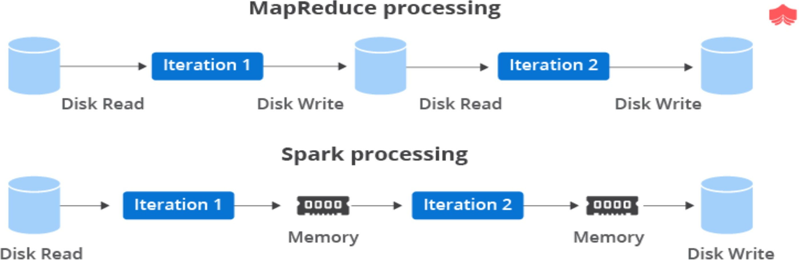

- What is spark ?
Spark is a unified analytics engine mainly designed for large-scale distributed data processing
- What is PySpark?
  - PySpark is a Spark library written in Python to run Python applications using Apache Spark
capabilities, using PySpark we can run applications parallelly on the distributed cluster (multiple nodes).
  - python + spark = pyspark
  - Spark basically written in Scala.
  - later on due to its industry adaptation it’s API PySpark released for Python using Py4J.
  - Py4J is a Java library.
  - that is integrated within PySpark and allows python to dynamically interface with JVM objects, hence to run PySpark you also need Java to be installed along with Python, and Apache Spark.

- What are the characteristics of PySpark? There are 4 characteristics of PySpark:
- Abstracted Nodes: This means that the individual worker nodes can not be addressed.
- Spark API: PySpark provides APIs for utilizing Spark features.[ high-level APIs in Java, Scala, Python and R ]
- Map-Reduce Model: PySpark is based on Hadoop’s Map-Reduce model this means that the programmer provides the map and the reduce functions.
- Abstracted Network: which means that only possible communication is implicit communication.
- Feature of Spark and Advantages & Disadvantages of pyspark ?
  - Speed: Spark helps to run an application in Hadoop cluster, up to 100 times faster in memory, and 10 times faster when running on disk.
  - Supports multiple languages: Spark provides built-in APIs in Java, Scala, or Python.
  - Real-time stream processing: Spark is designed to handle real-time data streaming.
  - It is flexible: Spark can run independently in cluster mode, and it can also run on Hadoop YARN, Apache Mesos, Kubernetes, and even in the cloud.
  - Fault Tolerance : It can recover the failure itself, Self-recovery property in RDD.
  - Lazy Evaluation: Spark does not evaluate any transformation immediately.execution will not start until an action is triggered.
  - In Memory Computing: It provides faster execution for iterative jobs. Keeping the data in-memory improves the performance by an order of magnitudes.
  - Cost efficient: Apache Spark is an open source software, it comes inbuilt for stream processing.

Advantages pyspark | Disadvantages pyspark
In-memory, distributed processing engine. | Slow- Python is slow as compared to Scala when it comes to performance.

100x faster than traditional systems. | Hard to express- PySpark is generally considered hard.
It used to process real-time data using Streaming and Kafka. | Spark takes a lot of RAM to operate effectively.
Open-source community,Supports multiple languages. | it need mid and high level hardware.
- What is Spark Driver ? def :
  - pyspark works using the master(i.s driver) – slave (i.e. worker) architecture in which the spark system
uses a group of machines known as a cluster. [Hadoop YARN,Standalone, Apache Mesos,Kubernetes ]
  - These machines coordinate with each other across their network to get the work done.
  - we need a solo machine that controlled these clusters such a machine is a Spark driver. DRIVER
  - Driver is a Java process. This is the process where the main() method are runs Python program. It executes the user code and creates a SparkSession or SparkContext and the SparkSession is responsible to create DataFrame, DataSet, RDD, execute SQL, perform Transformation & Action, etc.
- PySpark Architecture ?
  - Apache Spark is a unified analytics engine for large-scale data processing.”
  - It is an in-memory computation processing engine and is processed in parallel.
  - Apache Spark works in a master-slave architecture where the master is called “Driver” and slaves are called “Workers”.
  - The Spark architecture depends upon two abstractions:
- RDD : group of data items that can be stored in-memory on worker nodes.
[RDD : Resilient: Restore the data on failure. Distributed: Data is distributed among different nodes. Dataset:
Group of data ]
- Directed Acyclic Graph (DAG):It is a finite direct graph that performs a sequence of computations on
data.
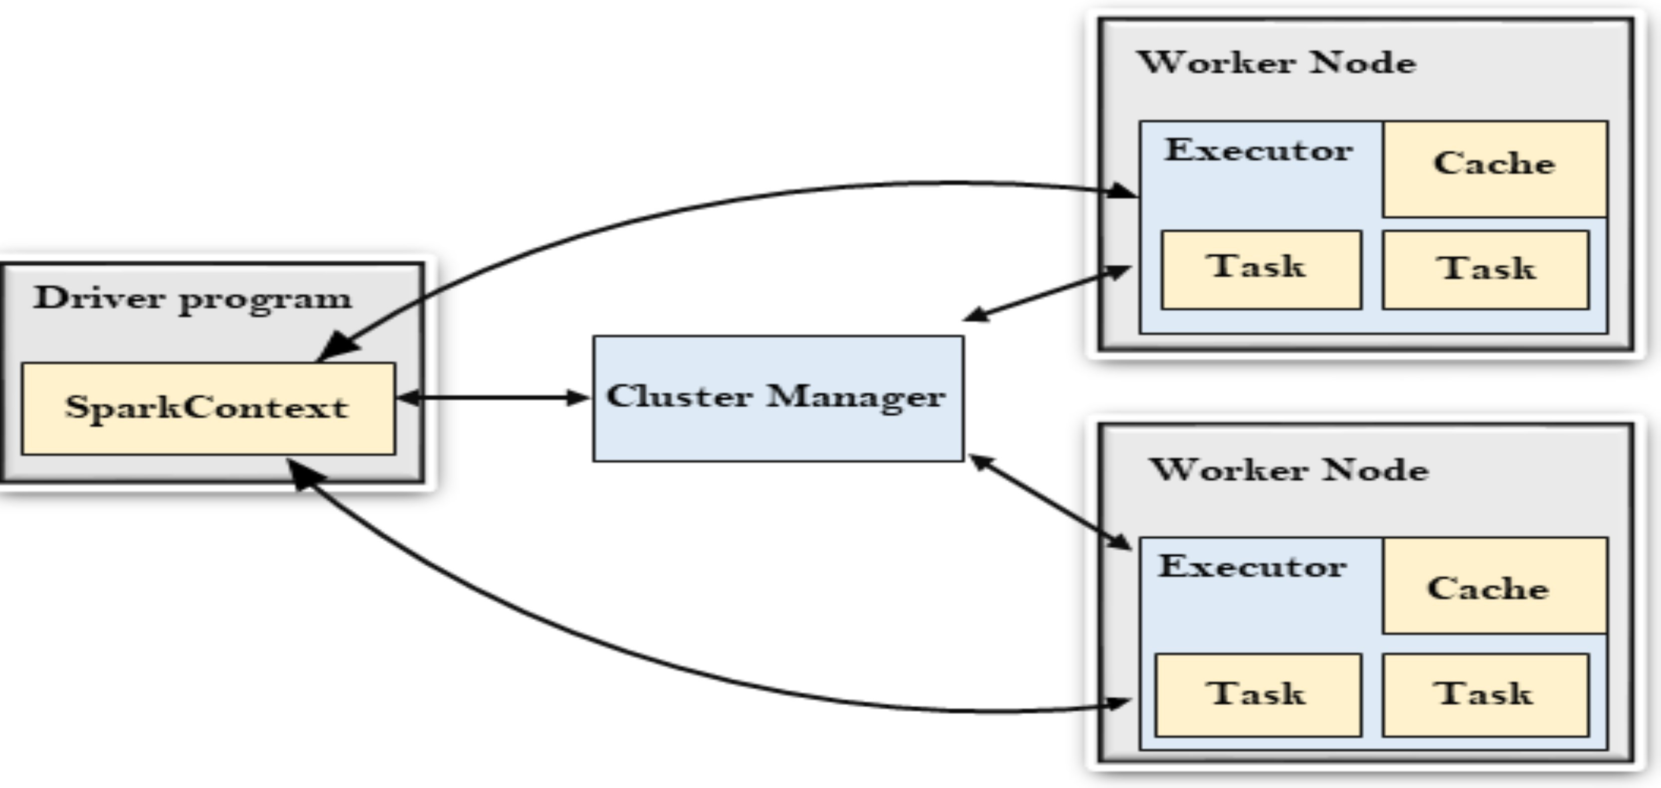
When you run a Spark application,
Spark Driver creates a context that is an entry point to your application, and all operations (transformations and actions) are executed on worker nodes, and the resources are managed by Cluster Manager.

- Driver Program :
  - The Driver Program is a process that runs the main() function of the application .
  - creates the SparkContext or spark session .
  - The purpose of SparkContext is to coordinate the spark applications, running as independent sets of processes on a cluster.
  - To run on a cluster,the SparkContext connects to a different type of cluster managers.
  - then perform the following tasks: -
- It acquires executors on nodes in the cluster.
- Then, it sends your application code to the executors.
- application code can be defined by JAR or Python files passed to SparkContext.
- At last, the SparkContext sends tasks to the executors to run.

- Cluster Manager:
  - The role of the cluster manager is to allocate resources across applications.
  - The Spark is capable enough of running on a large number of clusters.
  - It consists of various types of cluster managers, such as Hadoop YARN, Apache Mesos and Standalone Scheduler.
  - Here, the Standalone Scheduler is a standalone spark cluster manager that facilitates to install Spark on an empty set of machines.
- Worker Node:
  - Worker Node is a slave node,Its role is to run the application code in the cluster.

- Executor:
  - An executor is a process launched for an application on a worker node.
  - It runs tasks and keeps data in memory or disk storage across them.
  - It read and write data to the external sources.
  - Every application contains its executor.

- Task
  - A unit of work that will be sent to one executor.

- Cluster Manager Types ?
- Standalone – a simple cluster manager included with Spark that makes it easy to set up a cluster.
- Apache Mesos – Mesons is a Cluster manager that can also run Hadoop MapReduce and PySpark applications.
- Hadoop YARN – the resource manager in Hadoop 2. This is mostly used, cluster manager.
- Kubernetes – an open-source system for automating deployment, scaling, and management of containerized applications.
- local – which is not really a cluster manager, “local” for master() in order to run Spark on your laptop/computer.
- PySpark Modules & Packages:
  - PySpark SQL is the module in Spark. that manages the structured data and it natively supports Python programming language.
  - PySpark provides APIs that support heterogeneous data sources to read the data for processing with

Spark Framework.
  - Packages: It is simple directory having collection of modules.
- PySpark RDD (pyspark.RDD)
- PySpark DataFrame and SQL (pyspark.sql)
- PySpark Streaming (pyspark.streaming)
- PySpark MLib (pyspark.ml, pyspark.mllib)
- PySpark GraphFrames (GraphFrames)
- PySpark Resource (pyspark.resource) It's new in PySpark 3.0.
- Spark Components?
- Spark Core :
  - The Spark Core is the heart of Spark and performs the core functionality.
  - It holds the components for task scheduling, fault recovery and memory management.
- Spark SQL :
  - It provides support for structured data.
  - It also supports various sources of data like Hive tables, Parquet, and JSON.
- Spark Streaming:
  - it supports scalable and fault-tolerant processing of streaming data.
  - It accepts data in mini-batches and performs RDD transformations on that data.
- MLlib:
  - it is a Machine Learning library that contains various machine learning algorithms.
  - It is nine times faster than the disk-based implementation used by Apache Mahout.
- GraphX:
  - The GraphX is a library that is used to manipulate graphs and perform graph-parallel computations. It facilitates to create a directed graph.
- What is SparkContext?
  - SparkContext is available since Spark 1.x , it is entry point to PySpark functionality.
  - it is used to communicate with the cluster and to create an RDD,accumulator,broadcast variables.
Note: that you can create only one SparkContext per JVM,in order to create another first you need to stop the existing one using stop() method.
  - Create SparkContext :
from pyspark import SparkContext sc = SparkContext("local", "Spark") print(sc.appName)  Stop sparkcontext: sc.stop() | from pyspark import SparkConf, SparkContext conf = SparkConf( ) conf.setMaster("local").setAppName("Spark") sc = SparkContext.getOrCreate(conf) print(sc.appName)

- What is SparkSession Explained ?
  - SparkSession was introduced in version 2.0.
  - It is an entry point to underlying PySpark functionality in order to programmatically create PySpark RDD, DataFrame.
  - Create SparkSession from builder :

import pyspark
from pyspark.sql import SparkSession
spark = SparkSession.builder.master( "local[1]" ) \
.appName( ' Spark ' ) \
.getOrCreate()
SparkSession.builder () :
  - Return SparkSession.Builder class.This is a builder for SparkSession.
  - master(), appName() and getOrCreate() are methods of SparkSession.Builder.
master() – If you are running it on the cluster you need to use your master name as an argument to master().usually,it would be either yarn or mesos depends on your cluster setup.
Use local[x] - when running in Standalone mode. x should be an integer value and should be greater than 0; this represents how many partitions it should create when using RDD, DataFrame, and Dataset.Ideally, x value should be the number of CPU cores you have.
For standalone use - spark://master:7077
appName() – Sets a name to the Spark application that shows in the Spark web UI. If no application name is set, it sets a random name.
getOrCreate() – This returns a SparkSession object if already exists.Creates a new one if not exist.
# check UI : http://localhost:4040/jobs/
- SparkContext vs SparkSession

SparkContext | SparkSession
SparkContext is available since Spark 1.x | SparkSession was introduced in version 2.0.
SparkContext is an entry point to Spark programming with RDD and to connect to Spark Cluster. | SparkSession has been introduced and became an entry point to start programming with DataFrame and Dataset.
- Repartition() vs Coalesce() ?
  - Spark repartition() and coalesce() are very expensive operations .
  - that cause shuffle the data across many partitions hence try to minimize repartition as much as possible.
Repartition() | Coalesce()
repartition() is used to increase or decrease the partitions. it suport RDD,DF,Dataset  i.e wide transformation. | coalesce() is used to only decrease the number of partitions in RDD.  narrow transformation.
Repartition can be used :  _when you want your output partitions to be of equally distributed chunks.  _perform a shuffle of data and create partitions | No shufling and negligible narrow transformation.  This is optimized or improved version of  repartition()
rdd1 = rdd.repartition(6) print(rdd1.getNumPartitions()) | rdd2 = rdd.coalesce(4) print(rdd2.getNumPartitions())

repartition:
df1 = df.repartition(4).withColumn("partition_id",spark_partition_id()) df.rdd.getNumPartitions()

repartation column basis :
df1 = df.repartition(4,"DEPARTMENT_ID").withColumn("partition_id",spark_partition_id()) df.rdd.getNumPartitions()
coalesce :
df2 = df1.rdd.coalesce(4,True).toDF().withColumn("partition_id",spark_partition_id()) df2.rdd.getNumPartitions()

- Difference between Cache and Persist ?
Spark Cache and persist are optimization techniques.
Both caching and persisting are used to save the Spark RDD, Dataframe, and Dataset’s.
Cache() | Persist()
RDD cache() method default saves it to memory. | RDD persist() method is used to store it to the user-defined storage level.
Cache() technique we can save intermediate results in memory only. (MEMORY_ONLY). | Persist() technique we can save the intermediate results in 5 storage.  (Memory_only, Memory_and_disk, Disk_only , memory_only_ser,  Memory_and_disk_ser).
Syntax :  cache() : Dataset.this.type | Syntax :  - persist() : Dataset.this.type  - persist(newLevel : org.apache.spark.storage.StorageLevel) : Dataset.this.type
Advantages Caching and Persistence :
Cost efficient – Spark computations are very expensive hence reusing the computations are used to save cost.
Time efficient – Reusing the repeated computations saves lots of time.

- What is Unpersist ?
  - Unpersist : We can also unpersist the persistence DataFrame or Dataset to remove from the memory or storage.
  - Syntax:
  - unpersist() : Dataset.this.type
  - unpersist(blocking : scala.Boolean) : Dataset.this.type

- What is diffrance between brodcast variable and Accumulator variable ?

Brodcast variable | Accumulator variable
Broadcast variables are read-only shared variables | Accumulators are write-only shared variables
which can be used to cache a value in memory on all nodes. | add() function is used to add/update a value in accumulator

Broadcast variables used to give every node a copy of a large input dataset in an efficient manner. | accumulator variable is used by multiple workers and returns an accumulated value.
broadcastVar = spark.sc.broadcast( [0, 1, 2, 3] )  broadcastVar.value o/p : [0, 1, 2, 3] | accum = spark.sparkContext.accumulator(0) rdd = spark.sparkContext.parallelize([1,2,3,4,5]) rdd.foreach(lambda x:accum.add(x)) print(accum.value) o/p : 15

- What is shuffling in spark ?
  - Reallocation of data between multiple Spark stages.
  - Shuffling is a mechanism Spark uses to redistribute the data across different executors and even across machines.
  - Spark shuffling triggers for transformation operations like gropByKey(), reducebyKey(), join(), groupBy(), repartition() , cogroup() e.t.c
  - Spark shuffle is a very expensive operation as it moves the data between executors or even between worker nodes in a cluster so try to avoid it when possible.
  - When you have a performance issue on Spark jobs, you should look at the Spark transformations that involve shuffling.
- difrance between Groupbykey() vs reduceByKey() vs aggregateByKey() vs sortBy() vs sortByKey()

gropByKey() | reduceByKey() | aggregateByKey()
both work with PairRDD (key,value) and both returns GroupedData object. both used group the datasets based on the key to perform an aggregation.
groupByKey() is just to group your dataset based on a key.  It will result in data shuffling when RDD is not already partitioned.  It is expesive operation.here more shufling so out of memory issues.  It is not used combiner .  In which data shuffle first then merged So the performance of groupByKey is not efficient. | reduceByKey() is something like aggregation (within the partition) and then grouping which will result in shuffling but very less comapred to groupByKey()  It gives better performance when compared to groupByKey.  because reduceByKey uses combiner.  So before shuffling the data first merged then shuffle. | aggregateByKey() is logically same as reduceByKey() but it lets you return result in different type.  In another words, it lets you have a input as type x and aggregate result as type y.  For example (1,2),(1,4) as input and (1,"six") as output.
sortBy() :
is used to sort the data by value efficiently in pyspark. It is a method available in rdd. It uses a lambda expression to sort the data based on columns.
sortByKey() : is used to sort the values of the key by ascending or descending order. sortByKey() function operates on pair RDD (key/value pair)
- What is RDD ?
Resilient Distributed Dataset [RDD : Resilient: Restore the data on failure. Distributed: Data is distributed among different nodes. Dataset: Group of data ]
  - RDDs is a fault-tolerant collection of elements that can be operated on in parallel.

  - RDDS is immutable , fault-tolerant distributed collection of dataset.
  - It is work on low level APIs.
  - Each record in RDD is divided into logical partitions, which can be computed on different nodes of the cluster.
Benefits :
- In-Memory Processing :loads data from disk and process in memory and keeps the data in memory.
- Immutability :RDDs are created you cannot modify.When apply transformations on RDD, PySpark creates a new RDD.
- Fault Tolerance : any RDD operation fails, it automatically reloads the data from other partitions.
- Lazy Evolution :Spark will not start the execution of the process until an ACTION.

Limitations :
- No Input Optimization Engine
- RDDs is that the execution process does not start instantly.
- RDD lacks enough storage memory.
- The run-time type safety is absent in RDDs.

- How to Create RDD ?
- parallelizing an existing collection .
- referencing a dataset in an external storage system( HDFS,S3 etc)

parallelizing () | rdd = sc.parallelize([1,2,3,4,5,6,7,8,9,10]) print(rdd.collect())
external storage  system | rdd2 = spark.sparkContext.textFile("/path/NameFile.txt")
  - Create empty RDD : rdd = spark.sparkContext.emptyRDD
  - Creating empty RDD with partition : rdd2 = spark.sparkContext.parallelize([ ],10)
  - Using wholeTextFiles() : rdd3 =spark.sparkContext.wholeTextFiles("/path/textFile.txt")

- Types of RDD ?
PairRDDFunctions or PairRDD – Pair RDD is a key-value pair ,ShuffledRDD,DoubleRDD – SequenceFileRDD ,HadoopRDD ,ParallelCollectionRDD

- When to use RDDs?
  - When we want to do low-level transformations on the dataset.
  - It does not automatically infer the schema of the ingested data, we need to specify the schema of each and every dataset when we create an RDD.
- What is RDD Operations Transformations and RDD Actions ?
- Transformations : Transformations are lazy operations.
[It is a function that produces new RDD from the existingSpark will not start the execution of the process until an ACTION ]
such as flatMap(), map(), reduceByKey(), filter()
- Actions – operations that trigger computation and return RDD values.

such as collect() , count() , first() , max() etc.
  - Their are two type : Narrow and Wider Transformation
- Narrow Transformation :is compute data that live on a single partition.
like map() , flatMap() ,filter()
- Wider Transformation : is compute data that live on many partitions. like groupByKey() ,aggregateByKey() ,repartition() etc.

Narrow transformations: | Wide transformations:
compute data that live on a single  partition.[like map() and filter()] | compute data that live on many partitions.
Narrow transformations transform data  without any shuffle involved. | it involve a shuffle of the data between the  partitions.
Narrow transformations convert each input  partition to only one output partition. | Wide transformations convert input  partition to only many output partition.
Functions such as map(), mapPartition(),  flatMap(), filter(), union() | groupByKey(), aggregateByKey(),  aggregate(), join(), repartition().

- map vs flatmap vs filter ?
map() | flatMap() | filter()
Spark map function expresses a  one-to-one transformation | Spark flatMap function expresses  a one-to-many transformation. | transformation is used to filter  the records in an RDD.
used to apply lambda function on every element of RDD/DataFrame.  it returns a new RDD . | it is similar to map() it returns a new RDD.

- collect vs collectlAslist vs select()
collect() | collectAsList() | select ()
collect() is an action that returns the entire data set in an Array to the driver. | collectAsList() action function is similar to collect() but it returns Java  util list. | select() is a transformation that returns a new DataFrame and holds the  columns that are selected.
it is used to retrieve the action output when you have very small result set and calling . | it is used to retrieve all the elements of the RDD/DataFrame/Dataset (from all nodes) to the driver node | It used to select the single, multiple, column by the index, all columns from the list and also the nested columns from the  DataFrame.
- Why DF is faster than RDD?
RDD – RDD API is slower to perform simple grouping and aggregation operations.
DataFrame – DataFrame API is very easy to use. It is faster for exploratory analysis, creating aggregated statistics on large data sets.
DataSet – In Dataset it is faster to perform aggregation operation on plenty of data sets.

- RDDs vs. Dataframes vs. Datasets ?
RDD | DataFrame | DataSet

RDD is a distributed collection of data elements without any schema. | It is also the distributed collection organized into the named columns | It is an extension of Dataframes with more features like type-safety and object-oriented  interface.
No in-built optimization engine  for RDDs. | It uses a catalyst optimizer for  optimization. | It also uses a catalyst optimizer  for optimization purposes.
Here, we need to define the schema manually. | It will automatically find out the schema of the dataset. | It will also automatically find out the schema of the dataset by  using the SQL Engine.
RDD is slower than both Dataframes and Datasets to perform simple operations like  grouping the data. | It provides an easy API to perform aggregation operations. It performs aggregation faster  than both RDDs and Datasets | Dataset is faster than RDDs but a bit slower than Dataframes.
- Pivot and Unpivot a Spark Data Frame ?
  - Spark pivot() function is used to pivot/rotate the data from one DataFrame/Dataset column into multiple columns (transform row to column)
  - Unpivot is used to transform it back (transform columns to rows).
  - Pivot() is an aggregation where one of the grouping columns values transposed into individual columns with distinct data.

- What is Spark Schema ?
  - Spark schema is the structure of the DataFrame or Dataset, we can define it using StructType class which is a collection of StructField that define the column name(String), column type (DataType), nullable column (Boolean) and metadata (MetaData)
  - Create Schema using StructType & StructField.
  - Create Nested struct Schema
  - df.printSchema()

- Groupby clause ?
groupBy() : it is used to collect group of data. in DF, RDD etc. and perform aggregate functions on the grouped data.
like count(), mean(),max(),min(),sum(),avg(),agg()
- What is Spark SQL DataFrame ?
  - DataFrames are datasets,which is ideally organized into named columns.
  - Dataframe is used, for processing of a large amount of structured data.
  - contains rows with a schema,It is more powerful than RDD
  - There are several features those are common to RDD distributed computing capability, immutability, in-memory, resilient.
  - It’s API is available on several platforms, such as Scala, Java, Python, and R as well.

- Why DataFrame?
  - dataframe is one step ahead of RDD.
  - There is no built-in optimization engine in RDD.RDD cannot handle structured data.
  - DF provides memory management and optimized execution plan.
  - Dataframes are able to process the data in different sizes, like the size of kilobytes to petabytes on a single node cluster to large cluster.

  - PySpark DataFrame from data sources like TXT, CSV, JSON, ORV, Avro, Parquet, XML formats by reading from HDFS, S3, DBFS, Azure Blob file systems e.t.c.

- Is PySpark faster than pandas?
  - yes pandas run operations on a single node whereas PySpark runs on multiple machines.
  - PySpark processes operations many times faster than pandas
  - PySpark supports parallel execution of statements in a distributed environment.
  - i.e on different cores and different machines which are not present in Pandas.

- What is DAG and lineage graph, RDD lineage? DAG :
  - Directed Acyclic Graph which has no perticular direction.
  - It is collection of task with directional dependancy.
Directed – Means which is directly connected from one node to another. This creates a sequence
Acyclic – Defines that there is no cycle or loop available.
Graph – it is a combination of vertices and edges.

Lineage graph :all the dependencies between the RDDs will be logged in a graph, rather than the actual data. This graph is called the lineage graph.
RDD lineage : RDD are immutable in nature, transformations always create new RDD without updating an existing one hence, this creates an RDD lineage.

- What is paired RDD?
Pair RDD stores the elements/values in the form of key-value pairs. It will store the key-value pair in the format (key,value).
Distributed key-value pairs are represented as Pair RDDs in Spark.

- What is skewness?
The state of partitions where data is unevenly distributed. This is common problem with big data after shuffling.
Key distribution is not uniform (highly skewed), causing some partitions to be very large and not allowing spark to process data in parallel
- How to mitigate skewed data?
SALTING is a technique that adds random values to the join keys, then spark can partition data evenly.
- Optimization Techniques in spark :
- Serialization:
  - Pysaprk By default use bytecode serializer
  - It can use Kyro serializer as well. It offers 10x faster speed than bytecode serializer
  - We need to set serializer properties
- API Selection:
What dataset is there and what we are using as on the basis of this we need to take care of selection.
- For RDD:For low level operation,Less optimization technique is available in it

- For Dataframe: It is catalyst optimizer ,Low garbage collection (GC) overhead
- Dataset:Highly type safe,User tungsten for serializer
- Type Safety: It means compiler will validate types while compiling and throw an error if you try to assign a wrong type of variable
- Advanced Variables (Broadcast variable and accumulator):
  - When one dataset is small and the other is very large then we can use broadcast join.
  - It broadcasted dataset is available for each partition in the spark so operation will get quickly executed.
  - The PySpark Accumulator is a shared variable that is used with RDD and DataFrame to perform sum and counter operations similar to Map-reduce counters.
- Cache and Persist:
cache() is available always in memory persist() can be available in memory and disk
- By Key operations:
  - I mean to say I will try to avoid the groupByKey() so that data will not get shuffled too much so that operation cost will be saved.
- Sometimes out of memory error can occur by such type of operations
- I will also try to use mapper to avoid the direct shuffling when there is a necessity to use the groupByKey() operation.
  - I will try to use reduceByKey() which aggregates the data and then performs the transformation.
- File format selection:
  - Parquet will provide compression.
  - Parquet is having metadata along with actual data.
When you create parquet file you will see metadata file on the same directory along with file.
- How to read CSV File Using delimiter ‘,’?
df = spark.read.options (delimiter=',') .csv("C:/path/filename.csv")
- What is Star Schema & snowflake Schema Differentiate Star & Snowflake? Snowflake schema:
Snowflake Schema is an extension of a Star Schema, and it adds additional
dimensions. The dimension tables are normalized which splits data into additional tables.
Star Schema:
In data warehouse, in which the centre of the star can have one fact table and a
number of associated dimension tables
Star Schema | Snowflake Schema:
In star schema, The fact tables and the dimension tables are  contained. | While in snowflake schema, The fact tables, dimension tables as well as sub dimension tables  are contained.
Star schema is a top-down model. | While it is a bottom-up model.
It has high data redundancy | While it has low data redundancy.
- What is Data Skewness?
Skewness is the statistical term, which refers to the value distribution in a given dataset. When we
say that there is highly skewed data, it means that some column values have more rows and some column very few i.e the data is not properly/evenly distributed. Data Skewness affects the performance and parallelism in any distributed system.
Solution: we need to divide table into two parts. The first part will contain all the rows that don’t

have a null key and the second part will contain all the data with no null values
- What is catalyst optimizer?
Spark SQL is one of the newest and most technically involved components of Spark. It powers both
SQL queries and the new Data Frame API. At the core of Spark SQL is the catalyst optimizer. We use Catalyst’s general tree transformation framework in four phases:
- analyzing a logical plan to resolve references,
- logical plan optimization,
- physical planning,
- code generation to compile parts of the query to Java bytecode.
In the physical planning phase, Catalyst may generate multiple plans and compare them based on cost. All other phases are purely rule-based. Each phase uses different types of tree nodes; Catalyst includes libraries of nodes for expressions, data types, and logical and physical operators. We now describe each of these phases.
- Explain Serialization and Deserialization?
Serialization refers to converting objects into a stream of bytes and vice-versa (de-serialization) in
an optimal way to transfer it over nodes of network or store it in a file/memory buffer.
In distributed systems, data transfer over the network is the most common task. If this is not handled efficiently, you may end up facing numerous problems, like high memory usage, network bottlenecks, and performance issues.
There are 2 types of serialization supported in spark:
- Java serialization: default serialization, easy but slow.
- Kryo Serialization - 10 times faster than default serialization.

- What are PySpark serializers?
  - The serialization process is used to conduct performance tuning on Spark.
  - The data sent or received over the network to the disk or memory should be persisted.
  - PySpark supports serializers for this purpose.
  - It supports two types of serializers, they are:
PickleSerializer: (by default)
  - This serializes objects using Python’s PickleSerializer ( class
  - pyspark.PickleSerializer ).
  - This supports almost every Python object.
MarshalSerializer:
  - This performs serialization of objects.
  - We can use it by using class pyspark.MarshalSerializer .
  - This serializer is faster than the PickleSerializer but it supports only limited types.
- Salting Techniques?
The idea here is to divide larger partitions into smaller ones using “salt” (our own created
newcolumn) but it also comes with side effect of getting smaller partitions divided into even more smaller ones.
This strategy is more of guaranting execution of all tasks (avoiding OOM’s errors) and NOT a uniform duration of each task.

- Explain MapPartition in Spark?
This is exactly the same as map ();the difference being, Spark mapPartitions() provides
a facility to do heavy initializations (for example Database connection) once for each partition instead of doing it on every DataFrame row. This helps the performance of the job when you dealing with heavy-weighted initialization on larger datasets.
- How to track failed Jobs in Spark?
When a Spark job or application fails, you can use the Spark logs to analyse the failures. The
application UI provides links to the logs in the Application UI and Spark Application UI. If you are running the Spark job or application from the Analyse page, you can access the logs via the Application UI and Spark Application UI.
- What is Broadcast Join?
It is a join operation of a large data frame with a smaller data frame in PySpark Join model.
It reduces the data shuffling by broadcasting the smaller data frame in the nodes of PySpark cluster.
The data is sent and broadcasted to all nodes in the cluster.
This is an optimal and cost-efficient join model that can be used in the PySpark application.
- deployment Mode ? Cluster mode and Client Mode

Cluster | Client
In Cluster Mode, the Driver & Executor both run inside the Cluster.  This is the approach used in Production use cases. | In Client Mode ,Driver is outside of the Cluster.  The Executors will be running inside the Cluster.
In cluster mode, the Spark driver runs inside an application master process which is managed by YARN on the cluster. and the client can go away after initiating the application. | client mode only the driver runs locally and all tasks run on cluster worker nodes  client mode is majorly used for interactive and debugging purposes.
spark-submit --deploy-mode cluster --driver-memory xxxx ........ | spark-submit --deploy-mode client --driver-memory xxxx ......
- Spark Submit Command?
./bin/spark-submit \
--master <master-url> \
--deploy-mode <deploy-mode> \ python_file_code.py
master: The master URL for the cluster (e.g. spark://23.195.26.187:7077)
- Orc vs Parquet vs Csv vs Json
CSV | JSON | Parquet | Avro
comma-separated values | key-value pairs,  in a partially structured format. | It is a columnar format Only the required columns will be  retrieved/read, | It is a row-based format that has a high degree of splitting.

CSV is a row-column based.  CSV provides a simple  scheme; | JSON consumes more memory due to repeatable column  names; | data are stored in columns, they can be highly compressed. | data is stored in binary format, which minimizes file size and  maximizes efficiency.
properties of CSV files is that they are only splittable when it is a raw, uncompressed file or when splittable compression format is used such as bzip2 or  lzo | JSON supports lists of objects,  JSON is not very splittable; | parquet files are binary files that contain metadata about their contents. | support for schema evolution by managing added, missing, and changed fields.
CSV allows you to work with flat data. | Poor support for special characters; JSON is not very  splittable; | good choice for heavy workloads | handling large amounts of records as it is easy to add new rows.
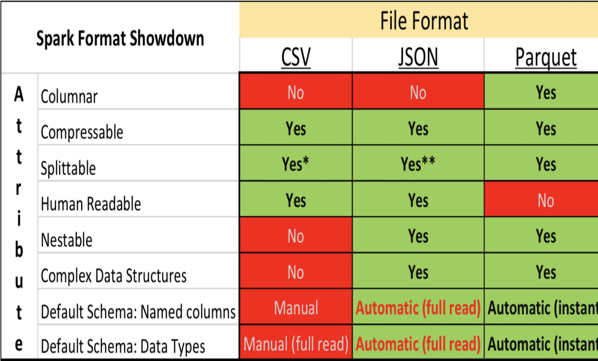

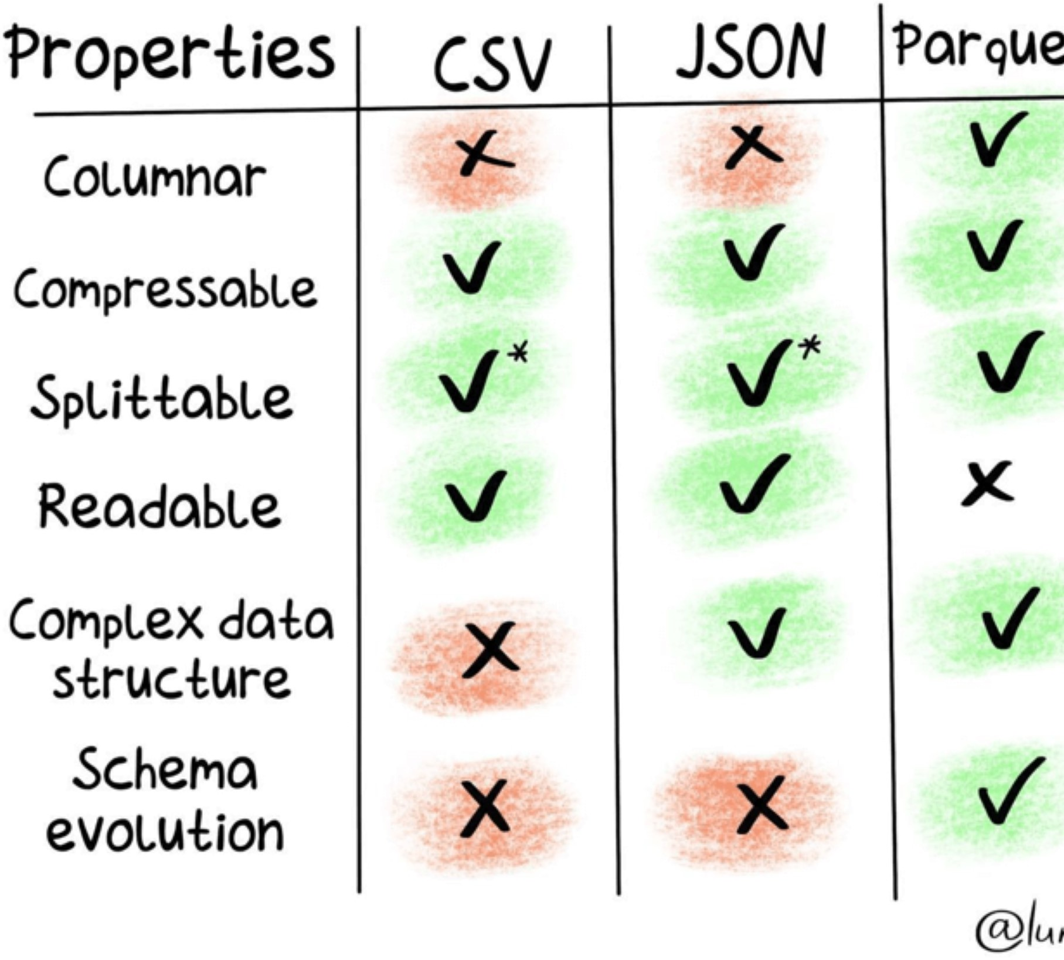

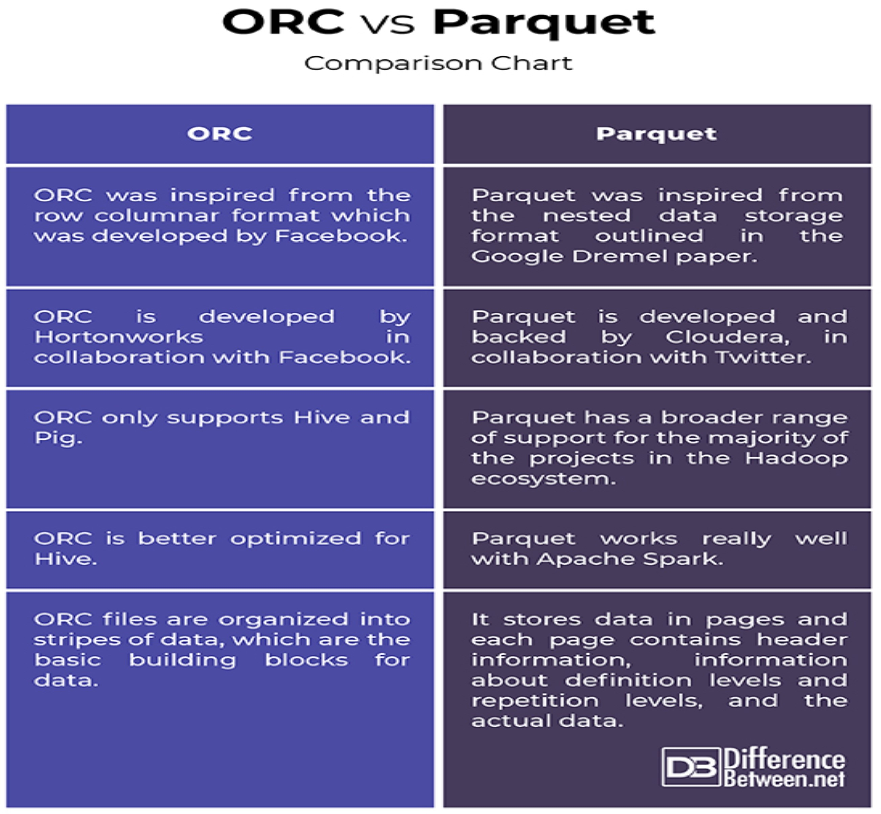

- Deal with bad data : when df reading or creating with specified schema, if posible that data in file does not match with schema.
- PREMISSIVE : it allow bad records. and store in specific column .
- DROPMALFORMD : it dont allow bad records
- FAILFAST : stop when it meet corrupt records
df = spark.read .schema(df_schema).option(columnNameOfCorruptRecord","_corrupt_record") \
.option("mode","PERMISSIVE") \
.csv("path\\filename.csv",header = True,inferSchema = True)
df.show() >>>> show whole data bada + good record in add new column ( u need to add new
column with help struct methode)
df.filter("_corrupt_record" is null).show() >>> show valid data df.filter("_corrupt_record is not null ") >>> get only bad data
df.drop("_corrupt_record ") >>> delete column
- Why out of memory issue occure ?
# OutOfMemory at the Executor Level formula :
Total executor memory = total RAM per instance / number of executors per instance
# reasons : out of memory issue occure due to incorrect usage of Spark Inefficient queries ,High concurrency Incorrect configuration.

solution :out of memory issue occure
- it can occur across cluster driver and excuter memoery handling tech. driver memory
--driver-memory <XX>G #or
--conf spark.driver.memory = <XX>G
handling tech. executer memory
--executer -memory <XX>G #or
--conf spark.executer.memory = <XX>G
#or
spark.driver.maxResultSize
- coalesce() and repartation
- brodcast variable ()
- serilization
- How to Remove Duplicate Rows ?
Duplicate rows could be remove or drop from Spark SQL DataFrame using distinct() and dropDuplicates() functions,

distinct() can be used to remove rows that have the same values on all columns

dropDuplicates() can be used to remove rows that have the same values on multiple selected columns. Use distinct() – Remove Duplicate Rows on :
# Distinct all columns + count deleted record

DF = dataframe.distinct() print("Distinct count: ",DF.count()) DF.show()

Use dropDuplicate() – Remove Duplicate Rows on DataFrame
DF2 = dataframe.dropDuplicates() print("Distinct count: ",DF2.count()) DF2.show()

Create SparkContext : Create SparkSession from builder :

from pyspark import SparkContext sc = SparkContext("local", "Spark") print(sc.appName)

Stop sparkcontext: sc.stop()

from pyspark import SparkConf,
SparkContext
conf = SparkConf( ) conf.setMaster("local").setAppNam e("Spark")
sc = SparkContext.getOrCreate(conf) print(sc.appName)
from pyspark import SparkContext,SparkConf from pyspark.sql import SparkSession
from pyspark.sql.functions import * from pyspark.sql import Window from pyspark.sql.types import *
import pyspark
from pyspark.sql import SparkSession
spark = SparkSession.builder.master( "local[1]" ) \
.appName( ' Spark ' ) \
.getOrCreate()

# find partitions : print("Number of partition : ", rdd.getNumPartitions())

  - How to Create RDD :
parallelizing () | rdd = sc.parallelize([1,2,3,4,5,6,7,8,9,10]) print(rdd.collect())
external storage  system | rdd2 = spark.sparkContext.textFile("//path//NameFile.txt")
Create empty  RDD :with partition : | rdd = spark.sparkContext.emptyRDD  rdd2 = spark.sparkContext.parallelize([ ],10)
Using  wholeTextFiles() : | rdd3 =spark.sparkContext.wholeTextFiles("/path/textFile.txt")

  - To convert DataSet or DataFrame to RDD just use rdd() method
rdd=df.rdd print(rdd.collect())
  - Convert RDD back to DataFrame by using toDF()
df2 = rdd2.toDF(["name","bonus"]) df2.show()
  - How to Create DF :
Spark Create DataFrame from RDD : using toDF() df = rdd.toDF()
Using Spark createDataFrame() : from SparkSession
df= spark.createDataFrame(rdd).toDF(columns:_*)

Create Spark DataFrame from List and Seq
import spark.implicits. df = data.toDF()

#From Data (USING createDataFrame)
df = spark.createDataFrame(data).toDF(columns:_*)
Create (Read) Spark DataFrame from CSV ,Txt ,JSON,XML

CSVdf2 = spark.read.csv(r"/path/filename.csv", header = True,inferSchema = True).show() Txtdf3 = spark.read.text(r"/path/filename.txt").show()
JSONdf4 = spark.read.json(r"/path/filename.json").show()

XMLdf5 = spark.read .format("com.databricks.spark.xml")
.option("rowTag", "person")
.xml(r "/path/filename . xml")
parqDF = spark.read.parquet(r"/path/filename . parquet").show()

withColumn() : it is a transformation function of DataFrame which is used to change the value, convert the datatype of an existing column, create a new column, and many more.

- Change DataType using PySpark withColumn() : need to use cast() function along with withColumn().
df.withColumn("salary",col("salary").cast("Integer")).show()
- Update The Value of an Existing Column
df2=df.withColumn("salary", df.salary*3) df2.show()
- Update Column Based on Condition : updates gender column with value Male for M, Female for F
from pyspark.sql.functions import when
df3 = df.withColumn("gender", when(df.gender == "M","Male") \
.when(df.gender == "F","Female") \
.otherwise(df.gender)) df3.show()
- Update DataFrame Column Data Type : updates salary column to String type.

df4=df.withColumn("salary",df.salary.cast("String")) df4.printSchema()
root
|-- firstname: string (nullable = true)
|-- lastname: string (nullable = true)
|-- gender: string (nullable = true)
|-- salary: string (nullable = true)

- withColumnRenamed to Rename Column on DataFrame
- withColumnRenamed() to rename a DataFrame column, we often need to rename one column or multiple (or all) columns on PySpark DataFrame

  - PySpark withColumnRenamed() Syntax:
withColumnRenamed(existingName, newNam)
  - existingName – The existing column name you want to change
  - newName – New name of the column
  - Returns a new DataFrame with a column renamed. ex :
df.withColumnRenamed("dob","DateOfBirth").printSchema()

- PySpark withColumnRenamed – To rename multiple columns
ex:
df2 = df.withColumnRenamed("dob","DateOfBirth") \
.withColumnRenamed("salary","salary_amount") df2.printSchema()
- Using PySpark DataFrame withColumn – To rename nested columns
from pyspark.sql.functions import *
df4 = df.withColumn("fname",col("name.firstname")) \
.withColumn("mname",col("name.middlename")) \
.withColumn("lname",col("name.lastname")) \
.drop("name") df4.printSchema()
- How to Filter Rows with NULL Values ?
  - filter rows with NULL/None values on columns we can checking IS NULL or IS NOT NULL conditions.
  - using filter() or where() functions of DataFrame we can filter rows with NULL values by checking isNULL()

- Filter Rows with NULL Values in DataFrame :[ state is column name ]
df.filter("state is NULL").show() df.filter("state is NULL").show()
df.filter(col("state").isNull()).show()

- Filter Rows with NULL on Multiple Columns
df.filter("state IS NULL AND gender IS NULL").show()

df.filter(df.state.isNull() & df.gender.isNull()).show()
- Filter Rows with IS NOT NULL or isNotNull
isNotNull() is used to filter rows that are NOT NULL in DataFrame columns.
from pyspark.sql.functions import col df.filter("state IS NOT NULL").show() df.filter("NOT state IS NULL").show() df.filter(df.state.isNotNull()).show()
df.filter(col("state").isNotNull()).show()
- PySpark SQL Filter Rows with NULL Values :
df.createOrReplaceTempView("DATA")

spark.sql("SELECT * FROM DATA where STATE IS NULL").show()

spark.sql("SELECT * FROM DATA where STATE IS NULL AND GENDER IS NULL").show()

spark.sql("SELECT * FROM DATA where STATE IS NOT NULL").show()
- Count of Not null in DataFrame single column
from pyspark.sql.functions import col

print(df.filter(col("FIRST_NAME").isNotNull()).count())
- Count of Not null in DataFrame muiltiple columns
from pyspark.sql.functions import col, when, count df.select([count(when(col(c).isNotNull() , c)).alias(c) for c in df.columns]).show()

- Filter startsWith(), endsWith() :
  - startsWith() – Returns Boolean value true when DataFrame column value starts with a string specified as an argument to this method, when not match returns false.
  - endsWith() – Returns Boolean True when DataFrame column value ends with a string specified as an argument to this method, when not match returns false.

import org.apache.spark.sql.functions.col df.filter(col("name").startsWith("James")).show()
+ + +
| id| name|
+ + +
| 1|James Smith|
+ + +

df.filter(! col("name").startsWith("James")).show()
df.filter( col("name").startsWith("James") === false).show()
+ + +
| id| name|
+ + +
| 2| Michael Rose|
| 3|Robert Williams|
| 4| Rames Rose|
| 5| Rames rose|
+ + +
Spark Filter endsWith() :
df.filter(col("name").endsWith("Rose")).show()
+ + +
| id| name|
+ + +
| 2|Michael Rose|
| 4| Rames Rose|
+ + +

//NOT ends with a string :

df.filter(! col("name").endsWith("Rose")).show() df.filter(col("name").endsWith("Rose")==false).show()
+ + +
| id| name|
+ + +
| 1| James Smith|
| 3|Robert Williams|
| 5| Rames rose|
+ + +
Using Spark SQL Expression :
df.createOrReplaceTempView("DATA")

//Starts with a String
spark.sql("select * from DATA where name like 'James%'").show()

//NOT starts with a String
spark.sql("select * from DATA where name not like 'James%'").show()

Drop column one or multiple : using drop()
# df2 = df.drop("FIRST_NAME") # df2.printSchema()

df.drop("FIRST_NAME","LAST_NAME","EMAIL").printSchema()

  - transform() Function : Available since Spark 3.0
# Syntax
DataFrame.transform(func: Callable[[…], DataFrame], *args: Any, **kwargs: Any) →
pyspark.sql.dataframe.DataFrame

  - func – Custom function to call.
  - *args – Arguments to pass to func.
  - *kwargs – Keyword arguments to pass to func. Create Custom Functions :

# Custom transformation 1 :
from pyspark.sql.functions import upper

def to_upper_str_columns(DF):
return DF.withColumn("name",upper(DF.name))
ex: df2 = empDF.transform(to_upper_str_columns).show() # Custom transformation 2 :
def reduce_price(df,reduceBy):
return df.withColumn("newsalary",df.salary - reduceBy) ex: empDF. .transform(reduce_price,(1000)).show()

# PySpark transform() Usage
df2 = empDF.transform(to_upper_str_columns) \
.transform(reduce_price,(1000)).show()

# Custom transformation 3 :
def apply_discount(df):
return df.withColumn("discounted_fee", \ df.new_fee - (df.new_fee * df.discount) / 100)

ex : df .transform(apply_discount).show()

- Get number of rows and columns of PySpark dataframe

- df.count(): This function is used to extract number of rows from the Dataframe.
- df.distinct().count(): This functions is used to extract distinct number rows which are not duplicate/repeating in the Dataframe.
- len(df.columns): This function is used to count number of items present in the list.

DataFrame : repartition vs coalesce :
find data frame partation : (128 mb data by default) : df.rdd.getNumPartitions() from pyspark.sql.function
import spark_partition_id

repartition:
df1 = df.repartition(4).withColumn("partition_id",spark_partition_id()) df.rdd.getNumPartitions()

repartation column basis :
df1 = df.repartition(4,"DEPARTMENT_ID").withColumn("partition_id",spark_partition_id()) df.rdd.getNumPartitions()

coalesce :
df2 = df1.rdd.coalesce(4,True).toDF().withColumn("partition_id",spark_partition_id()) df2.rdd.getNumPartitions()

df1.rdd.glom().collect()

