

Project Documentation

Table of Contents
1. IDEA OF THE PROJECT 3
2. TEAM MEMBERS 3
3. PROJECT DESCRIPTION 3
4. PERFORMED TASKS 4
5. BLOCK DIAGRAM 5

IDEA OF THE PROJECT
Our project is to make an application where the subject of a digital will, will be digital assets (crypto, stocks, property rights) using blockchain! But first what is a digital will? This is a legal document that explains how to distribute your property when you die.

TEAM MEMBERS
№ | Roles in the team
 | Atanas Atanasov – Scrum trainer
 | Kaloyan Georgiev – Back-end developer
 | Nikolay Stoyanov – Back-end developer
 | Ivo Badalov – Back-end developer

PROJECT DESCRIPTION
№ | Description
1 | Idea in general.  Our assignment was to create a app(game or site) related to digital will.
2 | How can you access the project?  You can find our project on GitHub.  https://github.com/ADAtanasov21/Business-planers.git
3 | Teamwork.  Our main communication platform is Microsoft Teams. Everyone works equally and everyone works when they have time.
4 | What technologies are used?  The technologies used are Visual Studio as our code editor, GitHub for collaborative work, Microsoft Teams for communication, PowerPoint for making a presentation, Word for making a documentation and Excel for making the QA documentation.

PERFORMED TASKS
№ | Completed tasks
1 | Decide the idea of the project.  Everybody gave their idea for the project and then we chose the best one.
2 | Start working.  We all started working on the code
3 | Make the README file.  Make the README to look good and everything to work
4 | Finish the game.  We finished the game without having any issues
5 | Make the documentation.  The documentation gives us information about the team and the project itself
6 | Make the presentation.  We have created a short presentation that gives us information about our team, the idea, the stages of realization and the programs that have been used

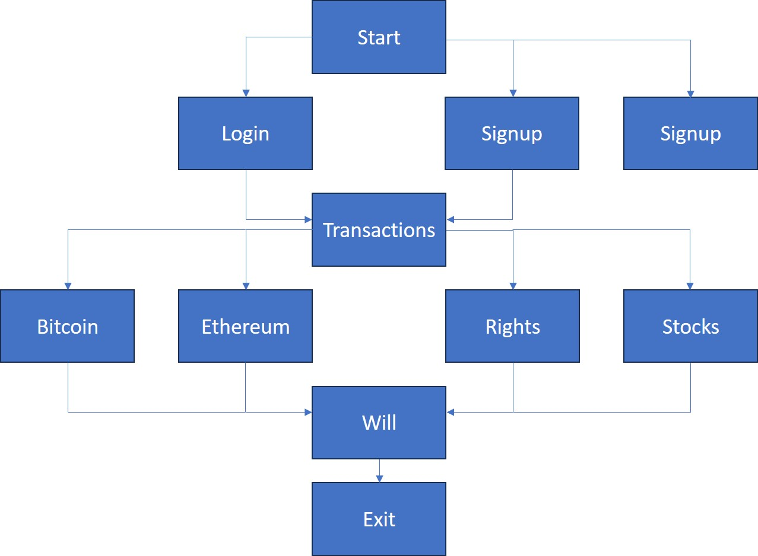
BLOCK DIAGRAM

