Nested queries are a way to perform complex queries by embedding one query within another. The outer query can apply some conditions on the results of the inner query.

There are mainly two types of nested queries:

* **Independent Nested Queries:** In independent nested queries, query execution starts from innermost query to outermost queries. The execution of inner query is independent of outer query, but the result of inner query is used in execution of outer query. Various operators like IN, NOT IN, ANY, ALL etc are used in writing independent nested queries.

**Co-related Nested Queries:** In co-related nested queries, the output of inner query depends on the row which is being currently executed in outer query.

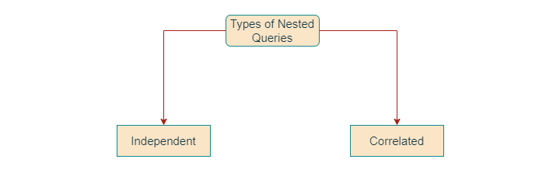

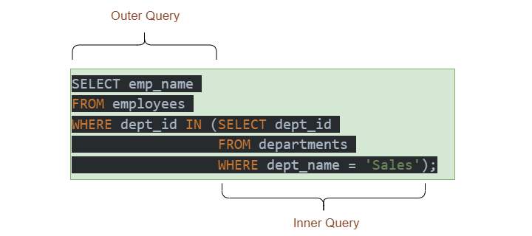

SELECT column1, column2, ...

FROM table1

WHERE column1 IN ( SELECT column1

FROM table2

WHERE condition );

Examples

employees table

|  |  |  |
| --- | --- | --- |
| **emp_id** | **emp_name** | **dept_id** |
| 1 | John | 1 |
| 2 | Mary | 2 |
| 3 | Bob | 1 |
| 4 | Alice | 3 |
| 5 | Tom | 1 |

Table: departments table

|  |  |
| --- | --- |
| **dept_id** | **dept_name** |
| 1 | Sales |
| 2 | Marketing |
| 3 | Finance |

Table: sales table

|  |  |  |
| --- | --- | --- |
| **sale_id** | **emp_id** | **sale_amt** |
| 1 | 1 | 1000 |
| 2 | 2 | 2000 |
| 3 | 3 | 3000 |
| 4 | 1 | 4000 |
| 5 | 5 | 5000 |
| 6 | 3 | 6000 |
| 7 | 2 | 700 |

Find the names of all employees in the Sales department.

SELECT emp_name

FROM employees

WHERE dept_id IN (SELECT dept_id

FROM departments

WHERE dept_name = 'Sales');

Find the names of all employees who have made a sale.

SELECT emp_name

FROM employees

WHERE EXISTS (SELECT emp_id

FROM sales

WHERE employees.emp_id = sales.emp_id);

Find the names of all employees who have made sales greater than $1000.

SELECT emp_name

FROM employees

WHERE emp_id = ALL (SELECT emp_id

FROM sales

WHERE sale_amt > 1000);