CUSTOMER BEHAVIOR REPORT

Aman Dubey
26/4/2026
Cutomer behavior using Python, postgreSQL, PowerBI

- Project Overview

This project analyzes customer shopping behavior using transactional data from 3900 purchases from various product categories. The goal is to uncover insights into spending pattern, customer segment, product preferences, and subscription behavior to guide strategic subscription decision.

- Dataset Summary

- Columns: 3900
- Rows: 18
- Key Features:
- Customer demography (Age, Gender, Location, Subscription Status)
- Purchase Detail (Item Purchased, Purchased Category, Purchased Amount, Season, Size, Color)
- Shopping Behavior (Discount Applied, Promo code used, Previous Purchases, Frequency of Purchases, Review Rating, Shipping Type)
- Missing Data: None

- Exploratory Data Analysis

We Begin with data preparation and cleaning in Python.
- Data Loading: Importing dataset using Pandas.
- Initial Exploration: Used df.info() to check the structure and df.describe(include = "all") for statistical summary (inlcuding categorical columns).
- 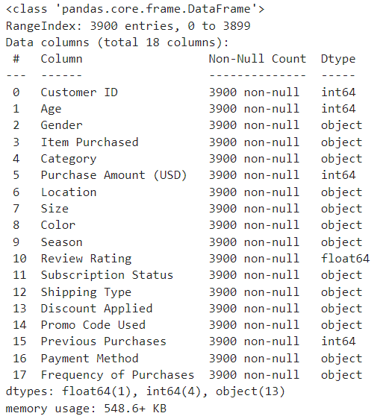
- 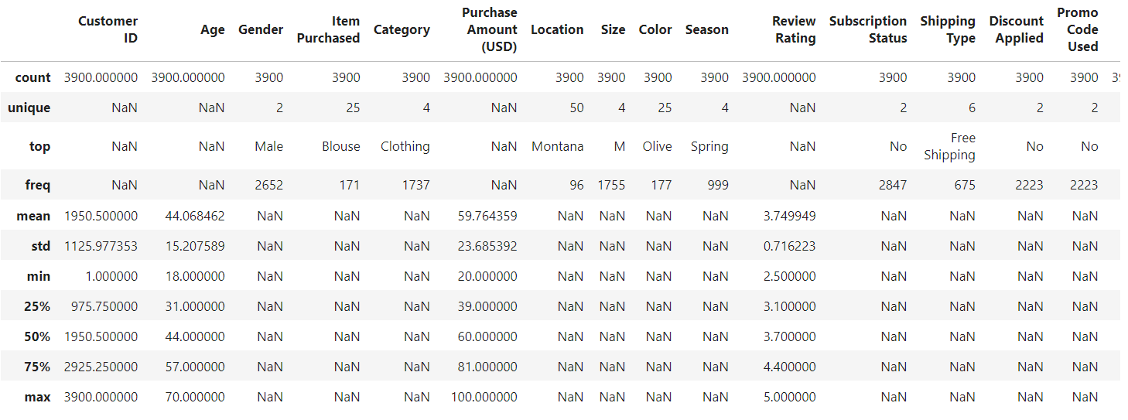

- Missing Data Handling: We checked for missing values in all the columns using df.isnull().sum().
- 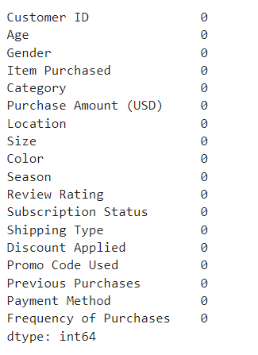

- Column Standardization: Rename columns to snake case, for better readability and documentation.
- Feature Engineering:
  - Created “age_group” column by binning customer age.
  - Created “purchase_frequency_date” column by column from purchase date.
- Data Consistency check: Verified if “discount_applied” and “promo_code_used” were redundant; dropped “promo_code_used”.
- Database Integration: Connected Python script to PostgreSQL and loaded the clean data frame into the database for SQL analysis.

- Data Analysis using SQL

We performed structured analysis in PostgreSQL to answer kwy business questions.

- Revenue by Gender: Compared total revenue generated by male vs female customers.

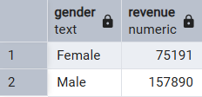

- High-Spending Discount Users: Identified customers who use discount but still spend above average purchase amount.

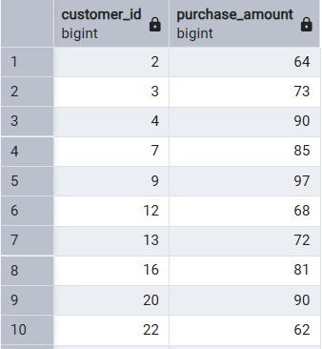
Total rows: 839 : (only top 10 are shown)

- Top 5 products by rating: Found products with the highest average review rating.

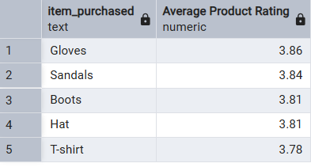

- Shipping Type Comparison: Compared average purchased amount between standard and express shipping

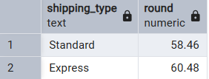

- Subscribers VS Non - Subscribers: Compare average spend and total revenue across subscription status

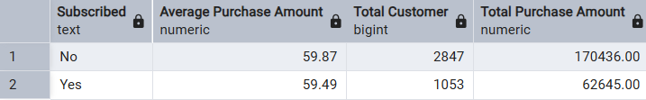

- Discount - Dependant Products: Identified 5 products with the highest percentage of discount percentage.

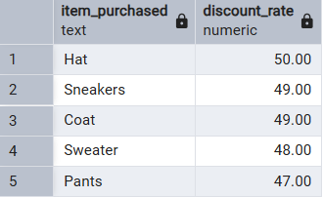

- Customer Segmentation: Classified customers into New, Returning and Loyal.

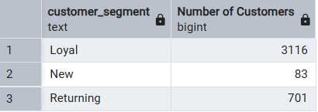

- Top 3 Product Per Category: Listed the most purchased products within each category.

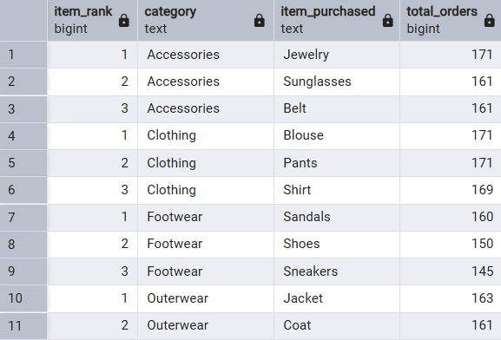

- Repeat Buyers and Subscription: Checked whether customers with more than 5 purchases will likely subscribe.

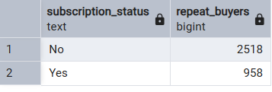

- Revenue By Age: Calculate total revenue contribution of each age group.

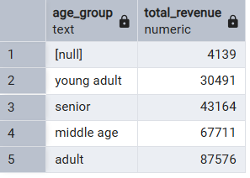

- Dashboard in PowerBI

Finally we make an interactive PowerBI to present insights visually.

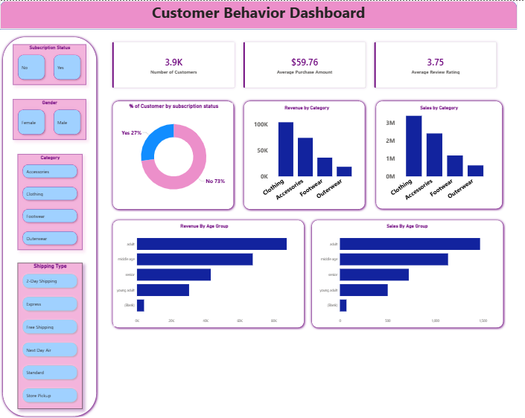

- Business Recommendation

- Boost subcription Recommendation: Promote exclusive benefits for subscribers.

- Customer Loyalty Program: Reward repeat Buyers to move them into the “Loyal” segment.

- Review Discount Policy: Balance sales boosts with margin control.

- Product Positioning: Highlight top-rated and best selling products in the campaigns.

- Targeted Marketing: Focus efforts on High revenue age groups and express shipping users.

