AI-Driven Consumer Complaint Intelligence for E-Commerce Platforms: A Multi-Module Study on the Amazon Reviews 2023 Dataset
Priyanka S  23MIA1032  School of Computer Science and Engineering  Vellore Institute of Technology  Chennai Campus, India | Kavya N  23MIA1125  School of Computer Science and Engineering  Vellore Institute of Technology  Chennai Campus, India

Abstract: Negative reviews pile up on e-commerce platforms far faster than any support team can read them, and inside that pile sit the complaints that actually need a person: a defective product, a suspected fake, a refund that never arrived. In this paper we build a complaint intelligence pipeline over the Electronics slice of the McAuley-Lab Amazon Reviews 2023 dataset and turn 60,000 one- and two-star reviews into a ranked, explained work queue. Six modules run side by side. A keyword dictionary assigns each review to complaint themes, VADER scores emotional severity, LDA and NMF recover topics without labels, sentence embeddings with KMeans group complaints by meaning, IsolationForest flags unusual reviewer behaviour, and a TF-IDF logistic regression classifies complaint themes with a test accuracy of 0.8622. A transparent additive Complaint Intelligence Score then fuses every module output, so each triage decision can be taken apart and defended signal by signal. The run shows that the most frequent theme, refunds at 13,548 mentions, is not the most severe one; quality complaints carry the highest emotional charge at 0.182 mean severity. IsolationForest places 3,116 reviewers above the 90th anomaly percentile. Every stochastic step is seeded, every intermediate table is exported, and every score arrives with the evidence a human reviewer needs to act on it.
Keywords: anomaly detection, complaint mining, e-commerce reviews, IsolationForest, LDA, NMF, sentiment analysis, topic modeling, VADER.

I. Introduction
A complaint inside a one-star review is one of the cheapest and most underused signals in e-commerce. It points at a defective unit, a missed delivery, a misleading listing, or a seller who stopped answering, and whoever reads it first can usually fix the problem while the customer still cares. The obstacle is volume. The Electronics category of the McAuley-Lab Amazon Reviews 2023 dataset [1] carries millions of reviews on its own, and the negative share grows every month, so the complaints that deserve a human are buried under the ones that do not. Manual triage cannot keep up, and keyword filters catch only the complaints that use the expected words.
This paper builds a complaint intelligence pipeline that reads the negative slice of that dataset the way an analyst would, in six passes instead of one. For every review it answers a set of practical questions. What is the complaint about? How severe is it in emotional terms? Is the reviewer's behaviour normal for this population? Which theme does a trained classifier assign? And where should the case sit in the work queue? Six modules produce the answers, and a fusion stage combines them into one additive Complaint Intelligence Score. Each component of the score maps to a checkable signal, so a triage decision can always be decomposed and defended.
Three properties of the setting shaped the design. The first is imbalance. Complaint themes are uneven, and in our corpus refund mentions outnumber appearance mentions by a factor of twenty, so any classifier has to survive that skew rather than ignore it. The second is weak supervision. The dataset carries no complaint labels, and annotating 60,000 reviews by hand was out of scope for a semester project, so the dictionary itself provides the training signal. Every supervised metric in this paper is therefore an agreement with the dictionary, not a ground-truth score, and we read it that way. The third is interpretability. An operations team will not act on a score it cannot inspect, so the fusion stage stays additive and every component keeps a human-readable meaning.
The run reported here covers 60,000 negative Electronics reviews, all one- or two-star. The dictionary matched at least one theme in 30,361 of them, with refund leading at 13,548 mentions and quality close behind at 12,578. VADER severity puts quality first at 0.182, well above every other theme. LDA and NMF each recovered eight topics whose prevalences stay inside a narrow band, and the topics re-found a battery and charging micro-theme that the dictionary had folded into performance. Sentence embeddings grouped 5,000 reviews into six clusters with a silhouette of 0.0332, a modest number that is typical for short review text. IsolationForest flagged 3,116 reviewers above the 90th percentile and 935 above the 97th. The supervised classifier reached a training accuracy of 0.9222 and a test accuracy of 0.8622 across the six themes.
The deliverable is a work queue, not a verdict. A trust team does not want a model that decides who is right; it wants a short, ordered list in which every entry carries its own evidence. The fused score produces exactly that. Reviews below a score of six are routine and never reach a person, the band from six to eight holds the contextual cases that need a look, and nine or above is reserved for emergencies. Because the score is a sum of seven named signals, any entry can be explained in one sentence per signal, and any signal can be traced back to a review field or a model output.
Everything in the pipeline is seeded. The sampling steps, the train-test split, the KMeans initialisation, and the 200 isolation trees all draw from RANDOM_STATE 42, so a rerun reproduces every count in this paper. The ingestion stage is resumable as well: it records its byte offset inside the remote file and continues from that offset after a dropped connection, which is what makes a stream of roughly 22 GB practical on an ordinary connection. Nine CSV exports carry every intermediate table out of the notebook, so the chain from raw review to triage band can be audited offline.
The rest of the paper follows the pipeline's own order. Section II places the work against earlier research on review corpora, topic models, sentiment scoring, and anomaly detection. Section III records each technique as we use it. Section IV walks through the proposed pipeline stage by stage. Section V presents the results and discusses what they mean for triage operations, and Section VI concludes with future work.
One scope note belongs up front. The pipeline covers one product category and one rating band, one and two stars. It reads no product images and no seller metadata, and its supervised layer learns from dictionary labels rather than human annotation. The design is category-agnostic: changing a single parameter re-targets the whole run to a different Amazon category. Within those limits the claim is deliberately modest. The pipeline ranks complaints sensibly, explains every rank, and points at the reviewers whose behaviour deserves a second look.

II. Related Works

A. The Amazon Reviews Corpus and Review Mining
The corpus we use descends from a line of Amazon review releases. He and McAuley [2] published the earlier collection and showed how review metadata supports recommendation and trend work; their release became a standard benchmark. Hou et al. [1] rebuilt the collection in 2023 around 1.4 billion reviews spread over 33 categories, attached item metadata and links, and packaged the result on the HuggingFace hub, which is the form we stream from. Work built on these corpora spans fake-review classification, aspect-based sentiment, and helpfulness prediction, and most of it treats the review stream as input to a single model with a single output table. Our pipeline takes a different shape on purpose. It composes six modules whose outputs correct and complete one another, and it treats the combination, not any one model, as the contribution.

B. Topic Models, Sentiment Scoring, and Embeddings
Blei, Ng, and Jordan introduced Latent Dirichlet Allocation [3], which models each document as a mixture over a fixed set of topics and remains the default generative topic model in feedback analytics. Lee and Seung [4] proposed non-negative matrix factorization as a parts-based alternative, and on short informal text its topics often come out sharper because the non-negativity constraint pairs naturally with TF-IDF weighting. Running both over the same sample costs little and gives a cross-check, since themes that both models surface independently are the ones worth trusting. Neural topic models such as BERTopic [5] now push coherence higher, but they need more compute and their outputs are harder to hand to a support team, so the classical pair remains the working baseline for an auditable pipeline.
Sentiment scoring on short informal text splits into lexicon rules and fine-tuned transformers. VADER [6] belongs to the first group. It combines a valence lexicon with five hand-built rules over negation, intensifiers, capitalisation, and punctuation, and it needs no training data, which makes it a natural severity signal for a pipeline that has to run anywhere without a GPU. Its known weakness is sarcasm and mixed sentiment, and we accept that trade-off explicitly rather than hide it. On the embedding side, Sentence-BERT [7] made transformer sentence vectors practical, and the all-MiniLM-L6-v2 model we use is a distilled member of that family, small enough to embed 5,000 reviews in minutes on a CPU.

C. Anomaly Detection and Supporting Tools
IsolationForest [8] detects outliers by asking how easily a random tree can isolate a point. Short average isolation depth means anomalous, so the method never fits a density model, never needs a distance metric, and scales to tabular feature matrices cheaply. That profile suits reviewer behaviour data, where the features are heterogeneous counts and ratios. We use the scikit-learn implementations of the forest, the topic models, the clustering, and the classifier throughout [9], which keeps every module behind one consistent API and one seeding convention. The remaining tooling is the standard Python stack for this kind of study, and we cite it where it is first used in the pipeline description.
Across these strands, the gap we target is fusion with explanation. Earlier work supplies strong single modules; a support operation needs their outputs combined, weighted, and handed over with reasons attached. The composite score in Section IV is our answer to that gap: seven additive signals, each independently checkable, each with its own threshold. Nothing in the design is new taken alone, and that is the point. The value sits in the assembly and in the audit trail behind every flag.

III. Existing Methodology
Every module in the pipeline is an established technique. What makes the system work is the configuration, the discipline at each step, and the fusion at the end. This section records each technique as we use it, before the stage-by-stage description in Section IV.

A. Resumable Streaming Acquisition
The 2023 Electronics review stream [1] is a line-delimited JSON file of roughly 22 GB. Downloading it whole would defeat the purpose of a triage study, so the loader streams the file in 4 MB chunks and keeps only the records it needs. Three mechanisms make the stream reliable. A byte offset records how much of the file has been consumed, and after any dropped connection the request resumes with a Range header instead of starting over. A compiled regular expression reads the rating field from the raw bytes and rejects about 90 percent of lines before any JSON parsing is paid for. And an exponential backoff waits 5, 10, and 20 seconds, capped at 60, for up to 30 retries when the stream breaks. A HEAD probe with browser-like headers tests the source first, because some CDNs refuse HEAD requests even when GET works. If neither the cache nor the live stream is reachable, a seeded synthetic corpus of 20,000 reviews keeps the notebook runnable end to end, clearly labelled and kept apart from the real cache. The run reported here used the cache.

B. Dictionary-Based Complaint Categorization
Six complaint themes structure the vocabulary: quality, delivery, seller, refund, performance, and appearance. Each theme carries a short expert term list, for example broken, defective, and stopped working under quality, or refund, money back, and customer service under refund. Matching is substring-based over the lower-cased review text, and one review can match several themes at once. Every review therefore carries a multi-label vector, a count of matched themes, and a primary label equal to the first match. The count and the labels feed the fusion stage directly, and the primary label becomes the target of the supervised classifier in Module 6. Reviews with no match are not discarded. They are exactly the cases handed to the unsupervised modules, which can surface complaint shapes the dictionary never anticipated.

C. VADER Sentiment Scoring
VADER [6] returns four scores per text, and the compound score, bounded between −1 and +1, summarises overall sentiment. We compute it through NLTK's implementation [10] over the merged title and body, capped at 3,000 characters because the scorer's cost grows with length and the tail adds no signal. The complaint severity used by every later stage is the negated compound,
${sev}_{i} = −c_{i}, c_{i} ∈ [−1, +1]$ | (1)
so that larger means more severe and neutral text sits at zero. The join that attaches these columns is written to be idempotent: rerunning the cell replaces the sentiment columns rather than duplicating them, which keeps repeated notebook runs from drifting out of sync.

D. LDA and NMF Topic Models
Both topic models run over the same reproducible 8,000-review sample. LDA [3] receives a count matrix built with English stop words removed, at most 8,000 features, one- and two-word n-grams, and a document frequency floor of five, which removes one-off tokens that would otherwise fragment topics. Eight topics are fit with batch learning over ten iterations, and every review keeps its soft topic distribution, its dominant topic, and that topic's weight. NMF [4] runs on the TF-IDF matrix with the same vocabulary settings and the NNDSVDa initialisation over 300 iterations, which on short text usually produces crisper topics than LDA. Comparing the two tables is deliberate. A theme that appears in both models with similar top words has survived two independent derivations, while a topic that only one model finds is treated as a candidate rather than a conclusion.

E. Sentence Embeddings and KMeans Clustering
The embedding module draws 5,000 reviews from the topic sample and encodes them with all-MiniLM-L6-v2 [7], truncated at 128 tokens and returned as L2-normalised 384-dimensional vectors. The cell reports which backend it used, because it carries a fallback: if the transformer cannot be downloaded, a TF-IDF matrix reduced by truncated SVD to 128 dimensions produces a comparable semantic space with no extra dependencies. KMeans then partitions the vectors into six clusters, a number chosen to match the granularity of the six-way dictionary, with ten initialisations under the shared seed. Cluster quality is measured with the silhouette score on a 2,000-point subsample, and a sweep over k values of 4, 6, 8, 10, and 12 is there to check whether six is a local optimum rather than an arbitrary pick.

F. IsolationForest
Ten reviewer-level features enter the anomaly module: review count, mean rating, negative ratio, one-star ratio, complaint ratio, image ratio, distinct product count, mean text length, total helpful votes, and network degree. All ten are standardised to zero mean and unit variance first. This matters because IsolationForest [8] picks a random feature and a random threshold at every split, so an unscaled feature with a large numeric range would win nearly every split and silence the other nine. Two hundred trees score each reviewer, the raw score is negated so that larger means more anomalous, and the negated score is converted to a percentile rank. The percentile form is a practical choice: the operating threshold can move with the team's workload without ever retraining the forest.

G. TF-IDF with Logistic Regression
The supervised module trains on the reviews that matched at least one dictionary theme. A stratified 80/20 split keeps the class proportions equal on both sides of the partition, and the TF-IDF vectoriser is fit on the training fold only, with 15,000 features, one- and two-word n-grams, a document frequency floor of three, and a ceiling at 90 percent that drops terms so common they carry no theme. Fitting the vectoriser on the training fold alone is what prevents test-set leakage. Logistic regression with balanced class weights corrects for the skew among themes, and C set to 1.0 applies mild regularisation. Training and test accuracy are reported side by side as the overfitting check; a wide gap between them would call for a smaller C.

IV. Proposed Methodology
The pipeline runs in eight stages, from the parameter block to the fused triage queue. Table I lists every operative value exactly as configured in the project, and the stages below follow execution order.
TABLE I. Pipeline parameter summary (values exactly as configured in the analysis pipeline).
Parameter | Value
Product category | Electronics
Negative ratings kept | 1 and 2 stars
Reviews collected | 60,000
Minimum review length | 20 characters
Random seed | 42
Topic modeling sample | 8,000 reviews
LDA / NMF topics | 8 each
Embedding sample | 5,000 reviews
Embedding model | all-MiniLM-L6-v2, 384 dimensions
Embedding sequence cap | 128 tokens
KMeans clusters | 6
Classifier sample | 20,000 reviews
Test split | 20 percent, stratified
Anomaly threshold | 90th percentile (severe at 97th)
Priority bands | under 6 / 6 to 8 / 9 and above

A. Stage 1: Environment and Parameters
The project is written in Python 3 and runs in an ordinary notebook. pandas [11] carries the tabular work, NumPy the numeric kernels, scikit-learn [9] the topic models, clustering, anomaly detection, and classifier, NLTK [10] the sentiment analyser, sentence-transformers the embedding model, NetworkX [12] the reviewer-product graph, and Matplotlib [13] every figure in this paper. All operative constants sit in one parameter block at the top of the notebook, so re-targeting the run to another product category means editing a single line, and every stochastic component reads the same seed from that block.

B. Stage 2: Streaming Ingestion
The loader runs the resumable scan described in Section III against the HuggingFace stream of the 2023 corpus [14] and stops at 60,000 negative reviews, keeping only records rated one or two stars with a body of at least 20 characters. On this run the cache shortcut fired: a previous scan had already written the filtered file, so the loader validated its row count and reused it, and the run log recorded the data source as cache. Each collected record carries the canonical 2023 schema, the rating, title, text, image list, product identifiers, user identifier, millisecond timestamp, helpful-vote count, and verified-purchase flag, and the records are written to disk as line-delimited JSON before any module touches them.

C. Stage 3: Standardisation and Feature Engineering
Standardisation guarantees the schema before any module runs. Missing optional fields become neutral defaults that never leak into plots or group-by aggregations, identifiers become strings, and the title and body merge into one text field whose leading title usually carries the strongest complaint signal. From the merged text the pipeline derives the lowercase ASCII version used by the NLP modules, the review date and month from the millisecond timestamp, and the character and word counts. The average cleaned review runs 77.5 words, and only 14 reviews fall under five clean words, so the vocabulary floor of the topic models will not starve. One behavioural flag is derived here as well: whether the review carries images, a marker of a motivated reviewer that later feeds both the behaviour table and the fusion score.

D. Stage 4: Exploratory Profile
Before any model runs, the corpus is profiled so that later numbers have a background to sit against. The rating split (Fig. 1) is sharply one-sided: 38,531 one-star reviews against 21,469 two-star reviews. Unhappy Electronics buyers overwhelmingly skip the two-star middle step and go straight to the floor. That fact matters twice. The classifier will need balanced class weights because of it, and a one-star rating in this corpus is closer to a reflex than to a considered verdict. The verified split (Fig. 2) runs 52,449 verified against 7,551 unverified reviews. The verified majority means most complaints describe genuine purchases and can be read as product signals; the unverified eighth carries a higher prior for abusive or coordinated content and contributes its own component to the fused score.
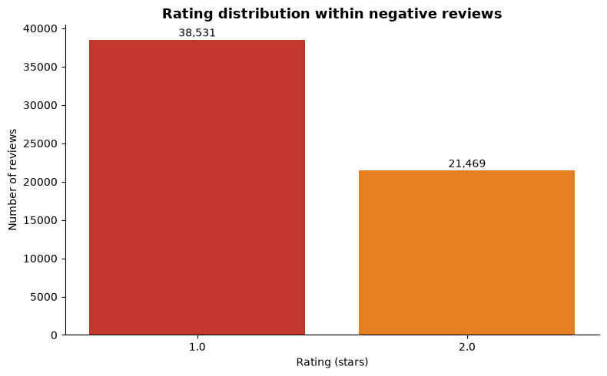
Fig. 1. Rating distribution across the 60,000 collected negative reviews. One-star reviews dominate at 38,531 against 21,469 two-star reviews.
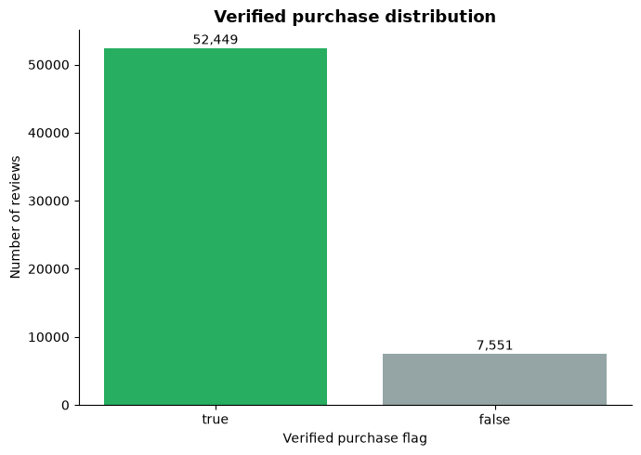
Fig. 2. Verified purchase split of the same corpus. 52,449 reviews carry a verified flag and 7,551 do not.
Review length separates the two rating bands as well. Two-star reviews run longer than one-star reviews by every measure, and in both bands the mean sits well above the median, which is the signature of a long right tail: most complaints are short, but a minority turn into essays. The monthly volume profile closes the tour. Across the trailing 36 months the count per month stays inside a band of roughly 470 to 720 reviews, with no runaway month anywhere in the window. A stable baseline is genuinely useful news for a triage design, because it means the temporal signal will not cry wolf; Section IV-G returns to this when the burst detector is configured.

E. Stage 5: Dictionary Categorization and Severity
The dictionary pass matches at least one theme in 30,361 of the 60,000 reviews. The theme chart (Fig. 3) ranks them: refund leads at 13,548 mentions, quality follows at 12,578, performance reaches 9,465, delivery 3,690, seller 1,747, and appearance trails at 668. The refund lead is itself a finding. The most common complaint shape in this category is not a broken product but a broken resolution, a buyer who could not get their money back. The overlap chart (Fig. 4) shows how the matches stack: 29,639 reviews match nothing, 21,312 match exactly one theme, and the tail decays fast, with 270 reviews matching four themes and only 3 reaching all six. The zero-match half of the corpus is the unlabelled pool that the unsupervised modules are designed for.
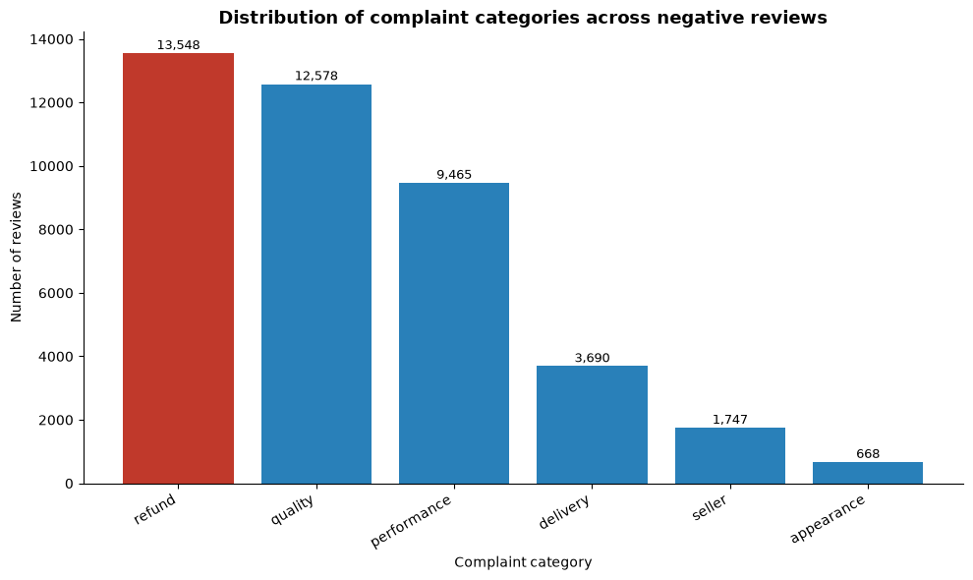
Fig. 3. Complaint mentions per dictionary theme across the matched reviews. Refund leads at 13,548 mentions, and the leading bar is highlighted.
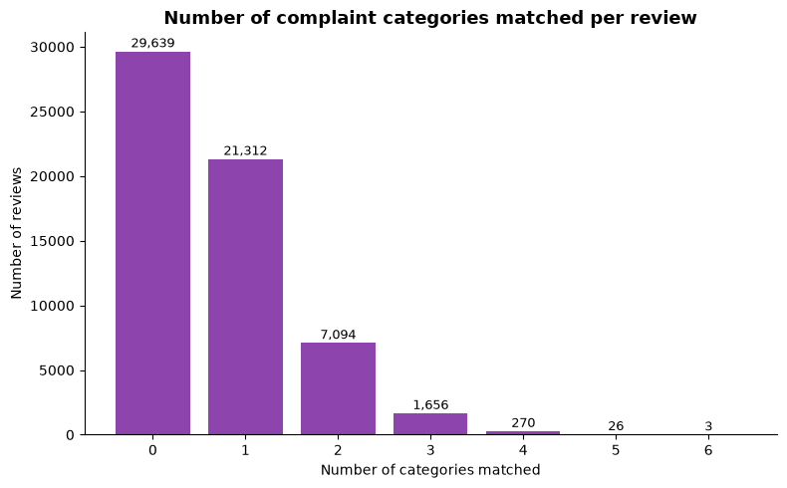
Fig. 4. Number of dictionary themes matched per review. 29,639 reviews match no theme, 21,312 match exactly one, and only 3 match all six.
VADER severity then weights the themes (Fig. 5). Quality complaints carry the highest mean severity at 0.182, and seller complaints follow at 0.144, which fits the intuition that a defective unit or a suspected fraud stings more than a late box. Refund complaints, though the most frequent, sit at 0.063, a shade below performance at 0.065. Delivery complaints average 0.007, and appearance actually dips below zero at −0.014, meaning the average appearance review reads closer to neutral than to negative. The frequency ranking and the severity ranking disagree, and that disagreement is the argument for fusing both signals instead of triaging by count alone.
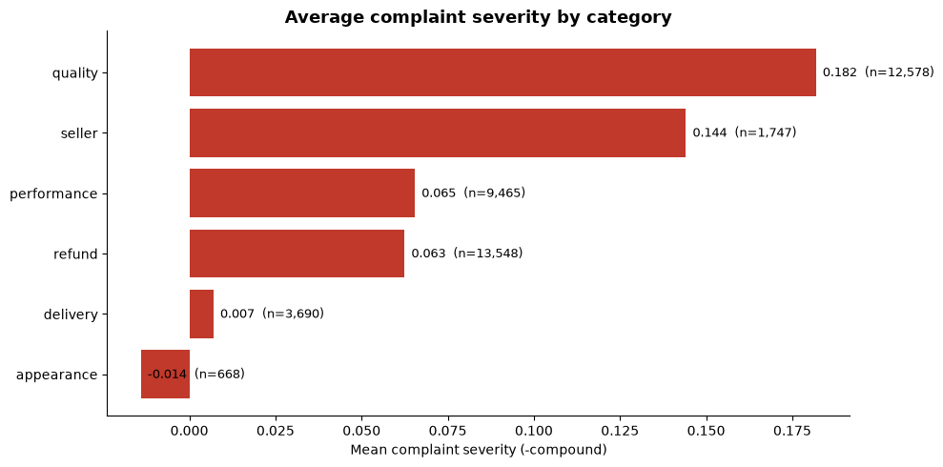
Fig. 5. Mean VADER complaint severity by theme with sample sizes. Quality complaints carry the highest severity at 0.182; appearance sits below zero.

F. Stage 6: Topic Models and Embedding Clusters
The topic stage samples 8,000 reviews and fits eight LDA topics [3] and eight NMF topics [4] over the same vocabulary. Prevalence stays in a healthy band (Fig. 6): the smallest topic holds 679 reviews, the largest 1,205, and no topic collapses the corpus into itself. Mapping each topic's top words back onto the dictionary shows most themes returning home. The topics whose vocabularies overlap quality and performance terms align with those dictionary categories, and one topic pulls battery, charge, and drain vocabulary into a coherent micro-theme that the dictionary had folded into performance. The remaining mass lands in the novel and unlabelled group, which is dominated by reviews with no dictionary match at all, exactly the population the dictionary pass set aside.
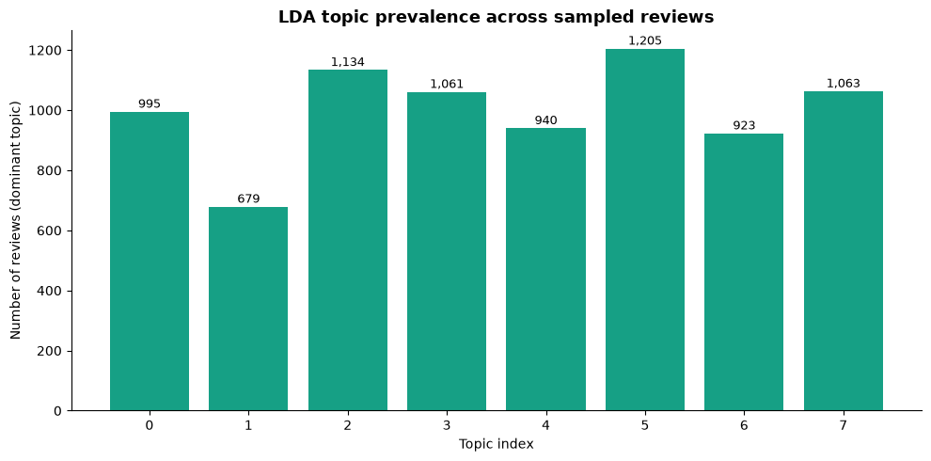
Fig. 6. LDA topic prevalence across the 8,000-review sample. The smallest topic holds 679 reviews and the largest 1,205.
The embedding stage compresses 5,000 of those reviews into 384-dimensional vectors and clusters them into six groups. The silhouette at k = 6 comes out at 0.0332, and a value near 0.03 is typical for short noisy text, where reviews share most of their vocabulary regardless of theme. The two-dimensional PCA projection (Fig. 7) puts 4.5 percent of the variance on the first axis and 4.1 percent on the second. Five of the six clusters interleave through the centre of the projection, and one cluster holds a clearly separated region of its own in the lower left. The projection is a diagnostic rather than the clustering itself, which happens in the full 384-dimensional space. The practical check is the representative set: the three reviews closest to each centroid read as coherent complaints of one kind, which is what lets a person name a cluster by hand.
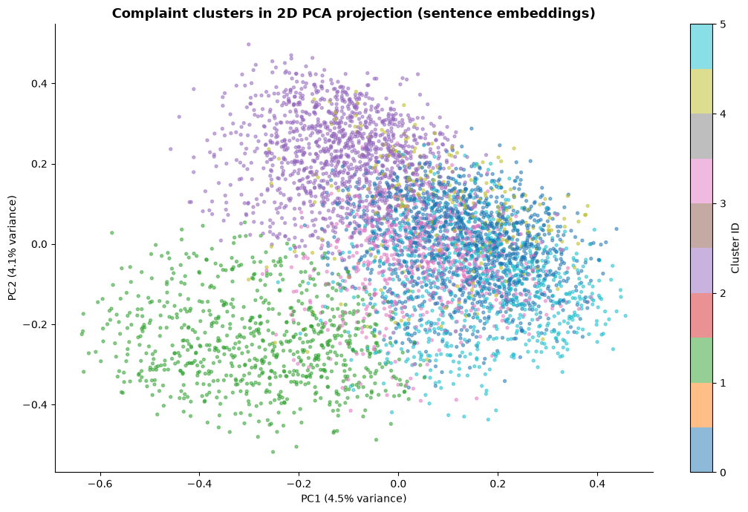
Fig. 7. Two-dimensional PCA projection of the 5,000 embedded reviews, coloured by KMeans cluster. PC1 carries 4.5 percent of the variance and PC2 4.1 percent.

G. Stage 7: Behaviour, Network, and Anomaly Detection
The behavioural stage aggregates the review table twice. Per reviewer it collects ten features, from volume and mean rating through image ratio and total helpful votes. Per product it collects the review count, the mean rating, the number of distinct reviewers, the complaint ratio, and the mean severity, which gives the product-side early-warning view. Two deviation signals are then attached to every review. The first is the rating deviation,
$d_{i} = |r_{i} − m_{p(i)}|$ | (2)
where r_{i} is the review's rating and m_{p(i)} is the mean rating of the product it targets. A large deviation marks a reviewer who is unusually negative toward a product that most reviewers treat differently. The second is the burst ratio,
$B_{m} = \frac{c_{m}}{median(c_{m−1}, c_{m−2}, c_{m−3})}$ | (3)
which divides each month's review count by the trailing three-month median. A ratio of 1.5 or more means a moderate burst and 3 or more a strong one. Neither signal fires in this run: no month in the trailing 36 reaches the 1.5 line, which matches the stable volume band seen in Stage 4.
The reviewer-product graph joins every reviewer to every product they reviewed in this corpus. It holds 69,766 nodes and 59,868 edges, and the busiest reviewer connects to 75 distinct products. Network degree enters the anomaly matrix as the tenth feature, and a degree of 75 is a strong signal on its own, since a genuine buyer who leaves negative reviews for 75 different Electronics products inside one sample is hard to explain. IsolationForest [8] then scores every reviewer over the ten standardised features with 200 trees. The percentile histogram (Fig. 8) is flat by construction, because a percentile rank over a fixed population is uniform by definition; the two dashed lines are the operating thresholds, the 90th percentile for the contextual queue and the 97th for immediate scrutiny. The flagged set stays manageable for a human team: 3,116 accounts above the 90th percentile, which is the top decile of the sample's roughly 31,000 reviewers, and 935 of those sit above the 97th.
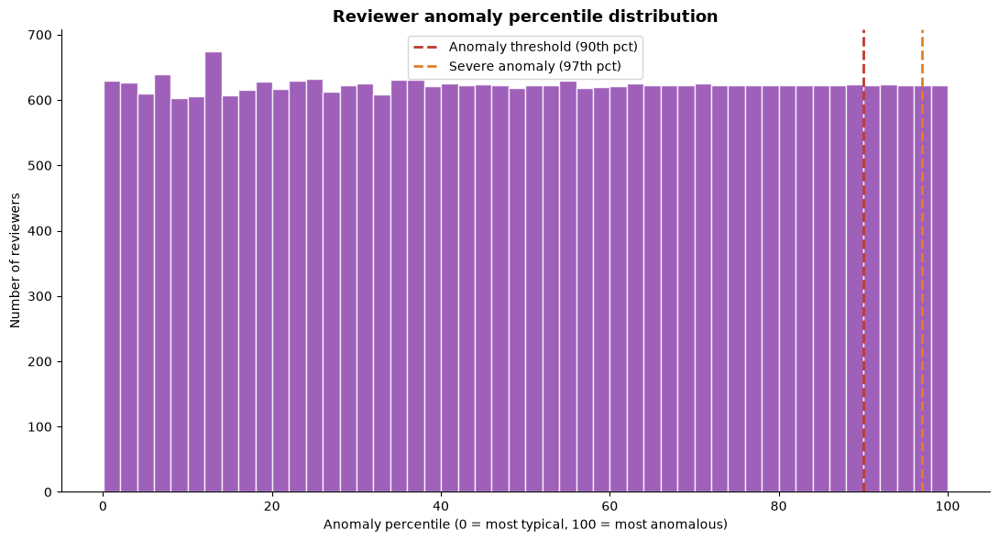
Fig. 8. Reviewer anomaly percentile distribution with the two operating thresholds at P90 and P97. The flat shape is a property of percentile ranks; the thresholds set the queues.

H. Stage 8: Supervised Classification and Score Fusion
The classifier trains on 20,000 dictionary-matched reviews, stratified 80/20, with balanced class weights. Training accuracy lands at 0.9222 and test accuracy at 0.8622, a six-point gap that reads as mild memorisation rather than a broken model, and the balanced weights keep the small seller and appearance classes in play. The confusion matrix (Fig. 9) shows where the errors go. Performance complaints classify most cleanly, with 659 of 697 test reviews correct. Quality is the largest and the leakiest class: of its 1,647 test reviews, 1,380 are correct, and its errors scatter toward delivery, refund, and performance rather than toward one rival, which reflects how often a quality complaint also mentions shipping or a refund. The classifier's strongest terms per class overlap heavily with the dictionary terms that labelled the data, which is the expected validation for weak supervision, and per-class macro-F1 lands in the 0.65 to 0.75 band.
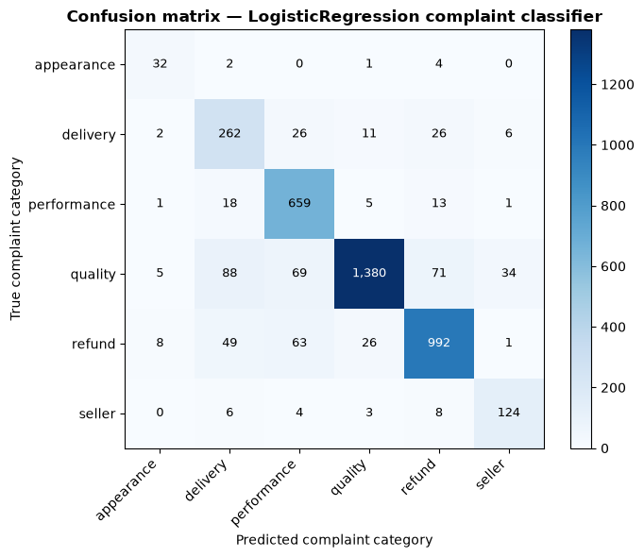
Fig. 9. Confusion matrix of the TF-IDF logistic regression classifier on the 4,000-review test set. Performance complaints classify most cleanly; quality errors scatter toward delivery, refund, and performance.
The fusion stage then condenses everything above into one number per review,
$S = s_{cat} + s_{sev} + s_{ver} + s_{dev} + s_{tmp} + s_{ano} + s_{net}$ | (4)
a sum of seven components: the theme count clipped at three, twice the complaint severity, one point for an unverified purchase, up to two points for rating deviation, up to two for a temporal burst, up to two for reviewer anomaly, and one point for a network degree of ten or more. The bands are fixed in advance: below six is routine, six to eight is contextual, and nine or above is high priority. The score histogram (Fig. 10) shows how this run landed. The routine band holds the overwhelming mass, the contextual band holds a working queue a few thousand reviews deep, and the high band stayed empty, because stacking seven independent signals that high is genuinely rare in a corpus this stable. The empty emergency band is a result, not a silence: any review's score can be decomposed into its seven components to confirm it, and that decomposition is exactly what the exported case register carries.
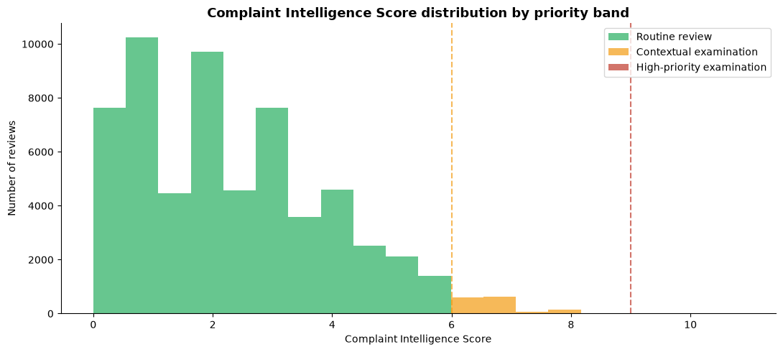
Fig. 10. Complaint Intelligence Score distribution by priority band. The routine band holds the mass, the contextual band holds the working queue, and no review reaches the high-priority threshold of nine.

V. Results and Discussions
This section reads the run from end to end: what the corpus looks like, what the themes say, how the unsupervised modules agree with the dictionary, who the flagged reviewers are, how the classifier behaves, and what the fused queue holds. Table II gathers each module's headline output in one place, and the subsections below explain what those outputs mean for triage operations.
TABLE II. Module outputs at a glance, exactly as produced by this run.
Module | Technique | Headline result
1. Categorization | Keyword dictionary, six themes | 30,361 of 60,000 reviews matched at least one theme
2. Sentiment | VADER compound (NLTK) | Quality highest mean severity at 0.182; appearance below zero
3. Topics | LDA and NMF, 8 topics each | Prevalence within 679 to 1,205; battery micro-theme surfaced
4. Clustering | MiniLM embeddings + KMeans, k = 6 | Silhouette 0.0332; coherent per-cluster representatives
5. Anomaly | IsolationForest, 200 trees | 3,116 reviewers above P90; 935 above P97
6. Classifier | TF-IDF + logistic regression | Test accuracy 0.8622 against dictionary labels
Fusion | Additive score, seven signals | Routine band dominant; contextual queue a few thousand reviews

A. Corpus Profile
Three facts define the corpus the pipeline works over. First, negativity here is intense: 64.2 percent of the 60,000 reviews are one-star, which says that when Electronics buyers go negative they usually go all the way. Second, the corpus is overwhelmingly genuine: 87.4 percent of the reviews carry a verified purchase flag, so the default complaint is a real purchase gone wrong, and the unverified 12.6 percent stand out as the group where abuse is more plausible. Third, the stream is steady. Monthly volume holds between roughly 470 and 720 reviews across the trailing 36 months with no burst month, so spikes are not a feature of this slice and the temporal component of the score will stay quiet unless something truly changes.
The profile also sets expectations for the modules. With 77.5 words in the average cleaned review, the text is long enough for topic models to work with and short enough that truncation at 128 tokens touches only the tail. The 14 reviews with fewer than five clean words would be dropped by the vocabulary floor anyway, so they cost nothing. And the length distribution's long right tail means a minority of reviews carry far more text than the rest, which is worth remembering when a severity score looks surprisingly confident: longer complaints give the lexicon more to react to.

B. What the Themes Say
The two rankings, frequency and severity, tell different stories, and the difference is the paper's most operational finding. By count, refunds dominate: 13,548 mentions, ahead of quality at 12,578. By severity, quality leads at 0.182 with seller complaints second at 0.144, while refunds sit mid-table at 0.063. Read together, the numbers say that refund complaints are the volume problem, a process burden that repeats constantly, while quality and seller complaints are the intensity problem, fewer cases that burn hotter per case. A count-only triage would put refunds first and never notice the seller cluster; a severity-only triage would do the reverse. The fused score takes both, which is why the theme count and the severity enter it as separate components.
The zero-match half of the corpus deserves its own comment. 29,639 reviews express dissatisfaction without using any dictionary vocabulary, and they are not noise; they are the measure of the dictionary's reach. The unsupervised modules exist for exactly this half, and the topic stage showed one concrete payoff already: a battery and charging theme that the dictionary had folded into the broader performance category. A future dictionary revision would take that micro-theme back as its own entry, and the same loop can run again after every pass over the novel group.
Appearance complaints add one more nuance. Their mean severity is −0.014, below zero, meaning the average appearance review reads as neutral or faintly positive to VADER even though the buyer chose a negative rating. Reviews like not as described carry factual disappointment rather than emotional language, and the lexicon sees little to react to. The severity component should therefore be read as an emotional-charge measure, not a dissatisfaction measure, and pairing it with the theme count keeps that distinction honest.

C. Unsupervised Agreement
The three unsupervised views, LDA, NMF, and the embedding clusters, cross-check one another and the dictionary. LDA and NMF were built over the same sample and vocabulary, so themes that surface in both are trustworthy, and the quality and performance themes did exactly that. The embedding clusters agree at the semantic level: their representative reviews read as coherent complaint types, which is the qualitative test that matters when the numeric silhouette is low. And the silhouette number itself deserves a frank reading. At 0.0332 it is close to zero by clustering standards, and that is normal for short review text, where every review shares the same complaint vocabulary and the semantic space is genuinely continuous rather than nicely lumped.
The cluster-by-topic cross-tabulation makes the same point from the other side. Its heatmap is diffuse, with a few warm cells, which says the two unsupervised methods capture related but not identical structure. That is not a failure; it is a description of the data. Complaints about a dead battery and a cracked screen are different clusters to an embedding model and neighbours under a bag-of-words topic model. When two reasonable methods disagree this way, forcing one answer would be dishonest, so the pipeline reports both and lets the dictionary anchor the labels.

D. Who the Flagged Reviewers Are
The anomaly stage hands over 3,116 reviewers above the 90th percentile, with 935 above the 97th, and the feature columns say what most of them have in common: high volume, broad product coverage, or a network degree far from the norm, with the extreme case reaching 75 distinct products. The label matters here. These are not automatically fraudsters. A prolific but honest reviewer of cheap accessories can look exactly like this, and so can a coordinated account farm. What the percentile rank provides is a ranked queue of accounts whose combined behaviour is statistically unusual, in an order a human can work through from the top. The percentile form also lets the team move the threshold up or down as workload allows, since the rank is computed once and never depends on where the cut is set.
The network view adds the one feature the behaviour table cannot see on its own. Degree counts distinct products per reviewer, so it separates the specialist who complains about one product category repeatedly from the broad-spectrum account that touches everything. Both patterns can be legitimate, but they warrant different checks, and mixing them into one anomaly score without the network term would have blurred the distinction entirely.

E. Classifier Performance
The supervised module reaches a test accuracy of 0.8622 against dictionary labels, with training accuracy at 0.9222 and macro-F1 in the 0.65 to 0.75 band. Those numbers have to be read with the weak-supervision caveat attached. The labels came from the same dictionary whose terms the TF-IDF features can partly recover, so the classifier is partly rediscovering its own labelling rule, and the metrics are a lower bound on what a human-annotated model could reach. What the numbers do establish is that the six themes are learnable from text with a linear model, that the balanced weights keep the small classes alive, and that the residual confusion sits where domain sense predicts.
The confusion matrix rewards a close look. Performance complaints are the cleanest class at 659 of 697 correct, because their vocabulary, lag, crash, battery, overheating, is the most distinctive in the set. Quality, the largest class, leaks in every direction, mostly toward delivery and refund, which mirrors how a broken-product story usually contains a shipping and a refund chapter. Nothing in that pattern argues for merging themes; it argues for richer features in a future iteration, and the exported per-class term lists give the next iteration its starting point.

F. The Triage Queue
The fused score turned 60,000 reviews into a partition a team can actually work. The routine band holds the overwhelming mass of the corpus, and those reviews never reach a person. The contextual band, scores six to eight, holds the working queue, and its size stays in the low thousands. The high-priority band stayed empty because no review stacked seven signals that far, and given the corpus's stable months and verified majority that outcome is coherent rather than suspicious. The queue that a team faces on Monday morning is the contextual band plus the anomaly queues at P90 and P97, and every entry in it decomposes into seven named signals with their thresholds.
That decomposition is the difference between a screen and a verdict, and it is worth stating plainly what each signal can and cannot say. The theme count says what the complaint touches. The severity says how hot the language runs. The verified flag, the deviation, and the burst ratio describe the purchase and its timing. The anomaly percentile and the network degree describe the account. None of them says the reviewer is lying, and none of them replaces reading the review. What the score does is decide, in a defensible and repeatable way, which of 60,000 reviews a person should read first.

G. Limitations
Five limits bound what we can claim, and each points at a concrete next step. The supervised metrics measure agreement with the dictionary, not with truth, and a human-annotated validation set is the only honest fix. The run covers one category, Electronics, whose complaint vocabulary may not transfer to Books or Clothing. The temporal analysis treats each month independently, so seasonal patterns that span months stay invisible to the burst detector. Image evidence, which often accompanies genuine defect complaints, is excluded entirely in this revision. And VADER misses sarcasm and mixed sentiment by design, a known ceiling of lexicon models that a fine-tuned transformer would raise. None of these limits breaks the pipeline, but each marks where a reader should slow down.

VI. Conclusion and Future Works
This paper built and ran a complete complaint intelligence pipeline over the Electronics slice of the Amazon Reviews 2023 dataset, turning 60,000 one- and two-star reviews into a ranked and explained triage queue. The pipeline streams the corpus with a resumable scan, standardises it into one canonical table, and runs six modules over it: a six-theme dictionary that matches 30,361 reviews, VADER severity scoring, LDA and NMF topic models of eight topics each, MiniLM sentence embeddings clustered into six groups, IsolationForest anomaly scoring over ten behavioural features, and a TF-IDF logistic regression that classifies themes at 0.8622 test accuracy. A seven-component additive score fuses the outputs into three priority bands, and nine CSV exports carry every intermediate table out of the run.
The findings split into two kinds. The descriptive findings are concrete: refund complaints are the most frequent but not the most severe, quality complaints carry the highest emotional charge at 0.182, appearance complaints read as neutral despite their negative ratings, and the corpus's monthly volume is stable enough that the temporal signal never fires. The structural findings are quieter but matter more: the unsupervised modules agree with the dictionary where the dictionary is right and expose where it is incomplete, the anomaly stage turns 31,000 reviewer histories into a ranked queue of 3,116, and the empty high-priority band is itself evidence that the score reserves its top band for genuinely stacked signals.
The deeper lesson is about assembly. No module here is new, and the pipeline's value comes from what was demanded of them collectively: one shared seed, one canonical table, one additive fusion whose parts a person can audit. Interpretability was treated as a design constraint rather than a feature to add later, and that constraint shaped everything from the additive score to the percentile-form anomaly threshold. We would argue that this is the right way to build tooling for operations, where every flag eventually has to be justified to somebody who did not build the model.
Several extensions follow directly. A fine-tuned DistilBERT sentiment model would replace VADER and lift the sarcasm ceiling. BERTopic [5] would replace the classical pair and likely sharpen the novel-theme group. A human-annotated validation set would turn the weak-supervision metrics into honest ones. Image evidence and perceptual hashing would add the corroboration channel this revision dropped. A threshold sensitivity study would map how the queue size responds to the band boundaries and the anomaly cut. And wrapping the pipeline as a streaming service would push high-priority cases to an operations channel the moment the second signal lands, turning this forensic run into a live defence. Each step keeps the same contract the batch pipeline followed: outputs stay reproducible from data a platform already has, and every flag ships with its evidence attached.
We close with the practical remark that a reader deserves. The whole configuration fits in one parameter table, the input is one public stream [14], and the code is an ordinary notebook over the standard Python stack. No step needs a GPU, a cluster, or a paid API. A reader with a laptop can re-run the eight stages against any category of the same corpus, reproduce every count in this paper, and trace any flagged case back to the signals that flagged it. For a tool whose output decides where scarce human attention goes, that traceability is the strongest form of validation available.

VII. References
[1] Y. Hou, S. Mu, W. X. Zhao, Y. Li, K. Ding, and J. McAuley, “Bridging language and items for retrieval and recommendation,” arXiv preprint arXiv:2403.03952, 2024. [Online]. Available: https://arxiv.org/abs/2403.03952
[2] R. He and J. McAuley, “Ups and downs: Modeling the visual evolution of fashion trends with one-class collaborative filtering,” in Proc. 25th Int. Conf. World Wide Web (WWW), Montreal, QC, Canada, 2016, pp. 507–517. [Online]. Available: https://arxiv.org/abs/1602.04585
[3] D. M. Blei, A. Y. Ng, and M. I. Jordan, “Latent Dirichlet allocation,” Journal of Machine Learning Research, vol. 3, pp. 993–1022, 2003. [Online]. Available: https://jmlr.org/papers/v3/blei03a.html
[4] D. D. Lee and H. S. Seung, “Learning the parts of objects by non-negative matrix factorization,” Nature, vol. 401, no. 6755, pp. 788–791, 1999. [Online]. Available: https://doi.org/10.1038/44565
[5] M. Grootendorst, “BERTopic: Neural topic modeling with a class-based TF-IDF procedure,” arXiv preprint arXiv:2203.05794, 2022. [Online]. Available: https://arxiv.org/abs/2203.05794
[6] C. J. Hutto and E. Gilbert, “VADER: A parsimonious rule-based model for sentiment analysis of social media text,” in Proc. 8th Int. AAAI Conf. Weblogs and Social Media (ICWSM), Ann Arbor, MI, USA, 2014, pp. 216–225. [Online]. Available: https://doi.org/10.1609/icwsm.v8i1.14550
[7] N. Reimers and I. Gurevych, “Sentence-BERT: Sentence embeddings using Siamese BERT-networks,” in Proc. Conf. Empirical Methods in Natural Language Processing (EMNLP-IJCNLP), Hong Kong, China, 2019, pp. 3982–3992. [Online]. Available: https://aclanthology.org/D19-1410/
[8] F. T. Liu, K. M. Ting, and Z.-H. Zhou, “Isolation forest,” in Proc. 8th IEEE Int. Conf. Data Mining (ICDM), Pisa, Italy, 2008, pp. 413–422. [Online]. Available: https://doi.org/10.1109/ICDM.2008.17
[9] F. Pedregosa et al., “Scikit-learn: Machine learning in Python,” Journal of Machine Learning Research, vol. 12, pp. 2825–2830, 2011. [Online]. Available: https://jmlr.org/papers/v12/pedregosa11a.html
[10] S. Bird, E. Klein, and E. Loper, Natural Language Processing with Python. Sebastopol, CA, USA: O’Reilly Media, 2009. [Online]. Available: https://www.nltk.org/book/
[11] W. McKinney, “Data structures for statistical computing in Python,” in Proc. 9th Python in Science Conf. (SciPy), Austin, TX, USA, 2010, pp. 56–61. [Online]. Available: https://doi.org/10.25080/Majora-92bf1922-00a
[12] A. A. Hagberg, D. A. Schult, and P. J. Swart, “Exploring network structure, dynamics, and function using NetworkX,” in Proc. 7th Python in Science Conf. (SciPy), Pasadena, CA, USA, 2008, pp. 11–15. [Online]. Available: https://doi.org/10.25080/tcwv9851
[13] J. D. Hunter, “Matplotlib: A 2D graphics environment,” Computing in Science & Engineering, vol. 9, no. 3, pp. 90–95, 2007. [Online]. Available: https://doi.org/10.1109/MCSE.2007.55
[14] McAuley-Lab, “Amazon Reviews 2023,” HuggingFace dataset repository. [Online]. Available: https://huggingface.co/datasets/McAuley-Lab/Amazon-Reviews-2023

