CODE
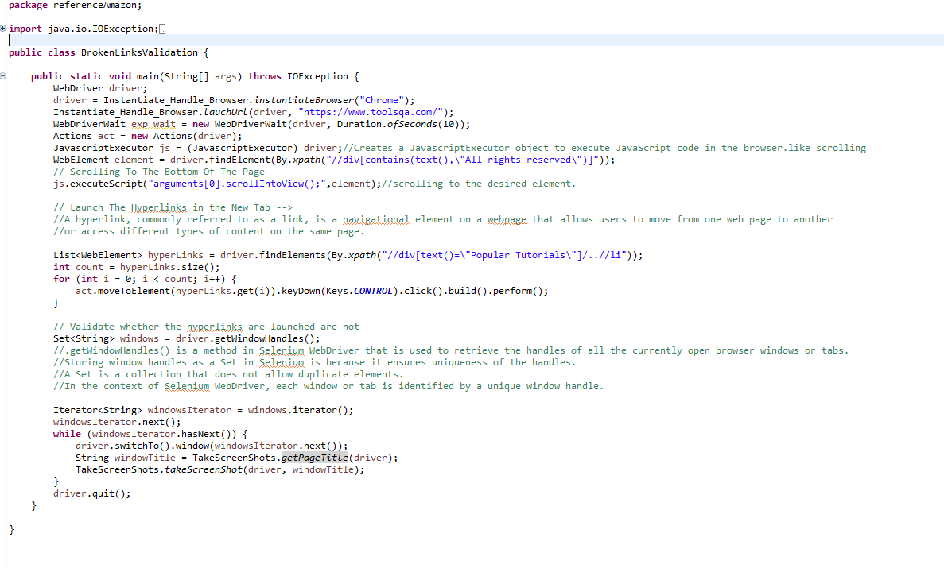
Explanation
1. Class Name: `BrokenLinksValidation`
- This is the main class that contains the main method. The purpose is to validate hyperlinks on a webpage.
2. WebDriver and Browser Handling:
- `WebDriver driver;`: Declares a variable for WebDriver.
- `Instantiate_Handle_Browser.instantiateBrowser ("Chrome");`: Initiates a Chrome browser using a method from the `Instantiate_Handle_Browser` class.
- `Instantiate_Handle_Browser.lauchUrl (driver, "https://www.toolsqa.com/");`: Launches a specified URL on the browser.
3. Wait Handling:
- `WebDriverWait exp_wait = new WebDriverWait (driver, Duration.ofSeconds(10));`: Creates a WebDriverWait object for explicit waits with a timeout of 10 seconds.

4. User Actions Handling:
- `Actions act = new Actions (driver);`: Creates an Actions object for performing user actions like mouse movements and keyboard events.

5. JavaScript Executor:
- `JavascriptExecutor js = (JavascriptExecutor) driver; `: Creates a JavascriptExecutor object to execute JavaScript code in the browser.

6. Locating an Element:
- `WebElement element = driver.findElement (By.xpath ("//div[contains(text(),\"All rights reserved\")]"));`: Locates a WebElement using an XPath expression.

7. Scrolling:
- `js.executeScript ("arguments[0].scrollIntoView();", element);`: Scrolls to the specified element using JavaScript.

8. Handling Hyperlinks:
- `List<WebElement> hyperLinks = driver.findElements (By.xpath ("//div [text () =\"Popular Tutorials\"]/..//li"));`: Finds a list of hyperlinks using XPath.
- `act.moveToElement (hyperLinks.get (i)).keyDown (Keys.CONTROL).click ().build ().perform (); `: Opens each hyperlink in a new tab by simulating a CTRL+Click action.
9. Validating Hyperlinks and Taking Screenshots:
- `Set<String> windows = driver.getWindowHandles (); `: Retrieves window handles.
.getWindowHandles() is a method in Selenium WebDriver that is used to retrieve the handles of all the currently open browser windows or tabs

WHY SET ?
- Storing window handles as a Set in Selenium is because it ensures uniqueness of the handles.
- A Set is a collection that does not allow duplicate elements.
- In the context of Selenium WebDriver, each window or tab is identified by a unique window handle.

- `driver.switchTo ().window (windowsIterator.next ());`: Switches to a new window.
- `String windowTitle = TakeScreenShots.getPageTitle (driver); `: Gets the title of the current window.
- `TakeScreenShots.takeScreenShot (driver, windowTitle); `: Takes a screenshot of the current window.

10. Closing the Browser:
- `driver.quit ();`: Closes the browser.
This code snippet demonstrates automating actions like scrolling, opening hyperlinks, and capturing screenshots using Selenium WebDriver.
( Instantiate_Handle_Browser and TakeScreenShots )are Ui_common_methods in framework

