Adonay Tesfamichael
IT-214-006
Fitness Company
In this ERD you will find a description of a fitness company’s trainers and customers relationship. With this relationship you will be able to match trainers and customer at the right place.
Relationship strength:
- Weak
- Both are Mandatory
TRAINER is assigned to CUSTOMER (1:1)
- Surrogate ID become there wasn’t any good given primary key.
CUSTOMER is trained by TRAINER (1:M)
- Surrogate ID become there wasn’t any good given primary key.
Cardinality:
- TRINER (1,1)
- CUSTOMER (0,1)
ERD
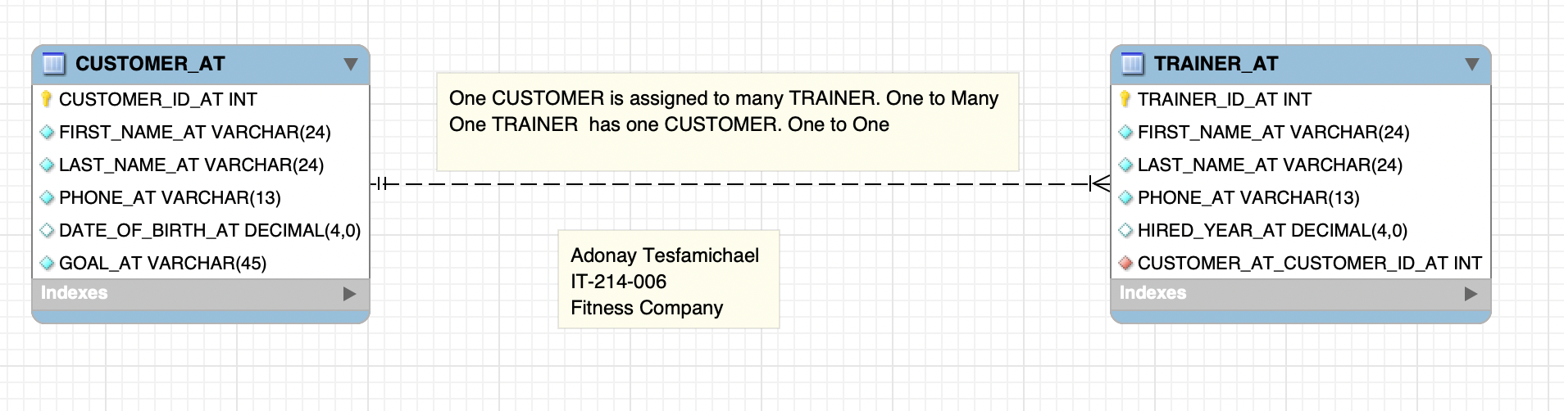
TRAINER
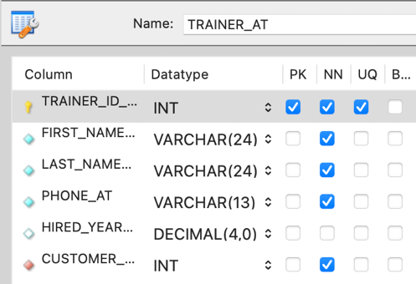

CUSTOMER
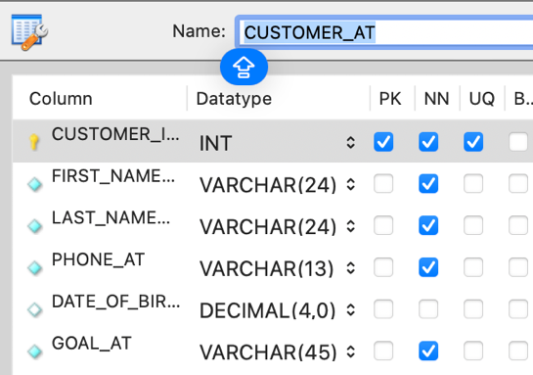

RELATIONSHIP
