Adonay Tesfamichael
IT-214-006
Soccer league

The soccer league company is trying to compare each soccer league year and save their information. With this diagram the league can keep track of every team in the clubs, throughout the year.

The main entities are:
- SEASON: all seasons in the league (name, registration start date, registration end date, season start date, season end date, year)
- Surrogate PK: ID_AT
attribute | Domain | Simple/Composite | Single/Multi | Required/Optional | Unique/Duplicated
ID_AT | INT | SIMPLE | SINGLE | REQUIRED | UNIQUE
NAME | VARCHAR (6) | SIMPLE | SINGLE | REQUIRED | DUPLICATED
REGISTRATION_START_DATE | DATE | SIMPLE | SINGLE | REQUIRED | DUPLICATED
REGISTRATION_END_DATE | DATE | SIMPLE | SINGLE | REQUIRED | DUPLICATED
SEASON_START_DATE | DATE | SIMPLE | SINGLE | REQUIRED | DUPLICATED
SEASON_END_DATE | DATE | SIMPLE | SINGLE | REQUIRED | DUPLICATED
YEAR | DECIMAL (4,0) | SIMPLE | SINGLE | REQUIRED | DUPLICATED

- DIVISION: all divisions in the league (age, sex, rank, email, phone)
- Surrogate PK: ID_AT
- FK: SEASON_AT_ID_AT references the pk ID_AT in the entity SEASON
attribute | Domain | Simple/Composite | Single/Multi | Required/Optional | Unique/Duplicated
ID_AT | INT | SIMPLE | SINGLE | REQUIRED | UNIQUE
AGE | VARCHAR (6) | SIMPLE | SINGLE | REQUIRED | DUPLICATED
SEX | VARCHAR (5) | SIMPLE | SINGLE | REQUIRED | DUPLICATED
RANK | INT | SIMPLE | SINGLE | REQUIRED | DUPLICATED
EMAIL | VARCHAR (25) | SIMPLE | SINGLE | REQUIRED | UNIQUE
PHONE | VARCHAR (12) | SIMPLE | SINGLE | REQUIRED | UNIQUE

- CLUB: all clubs in the league (name, email, phone, abbreviation)
- Surrogate PK: ID_AT
attribute | Domain | Simple/Composite | Single/Multi | Required/Optional | Unique/Duplicated
ID_AT | INT | SIMPLE | SINGLE | REQUIRED | UNIQUE
NAME | VARCHAR (20) | SIMPLE | SINGLE | REQUIRED | DUPLICATED
EMAIL | VARCHAR (25) | SIMPLE | SINGLE | REQUIRED | DUPLICATED
PHONE | VARCHAR (12) | SIMPLE | SINGLE | REQUIRED | DUPLICATED
ABBREVIATION | VARCHAR (5) | SIMPLE | SINGLE | OPTIONAL | DUPLICATED

- TEAM: all teams in the league (birth year, sex, name, email, phone)
- Surrogate PK: ID_AT
- FK: CLUB_AT_ID_AT references the pk ID_AT in the entity CLUB
attribute | Domain | Simple/Composite | Single/Multi | Required/Optional | Unique/Duplicated
ID_AT | INT | SIMPLE | SINGLE | REQUIRED | UNIQUE
BIRTH_YEAR | VARCHAR (6) | SIMPLE | SINGLE | REQUIRED | DUPLICATED
SEX | VARCHAR (5) | SIMPLE | SINGLE | REQUIRED | DUPLICATED
NAME | VARCHAR (21) | SIMPLE | SINGLE | REQUIRED | UNIQUE
EMAIL | VARCHAR (25) | SIMPLE | SINGLE | REQUIRED | DUPLICATED
PHONE | VARCHAR (12) | SIMPLE | SINGLE | REQUIRED | DUPLICATED

- REGISTRAION: all registrations in the league (registration date)
- Surrogate PK: ID
- FK: DIVISION_AT_ID_AT references the pk ID_AT in the entity DIVISON
- FK: TEAM_AT_ID_AT references the pk ID_AT in the entity TEAM
attribute | Domain | Simple/Composite | Single/Multi | Required/Optional | Unique/Duplicated
ID_AT | INT | SIMPLE | SINGLE | REQUIRED | UNIQUE
REGISTRAION_DATE | DATE | SIMPLE | SINGLE | REQUIRED | DUPLICATED

The main relationship are:
SEASON has DIVISIONS
- One to many relationships because in each season the league has several divisions.
TEAM is assigned to CLUB
- One to many relationships because a club has MANY teams, and a team belongs to only ONE club.
TEAM is registered to DIVISION
- Many to many relationships because one team is assigned to a given division, while a division has many teams
- BRIDGE: REGISTRATION keeps the history of the team’s membership.
- TEAM registers for division REGISTRATION
- DIVISION takes the teams REGISTRATION
ERD PICTURES

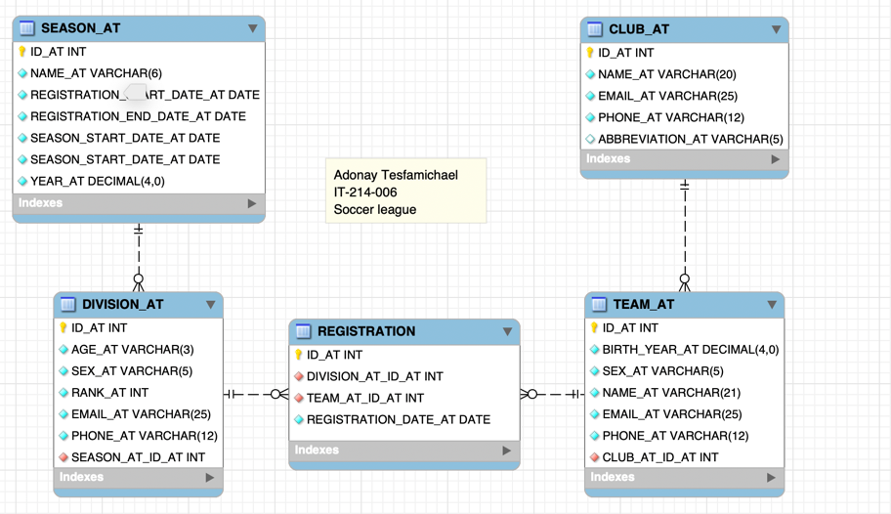

SEASON
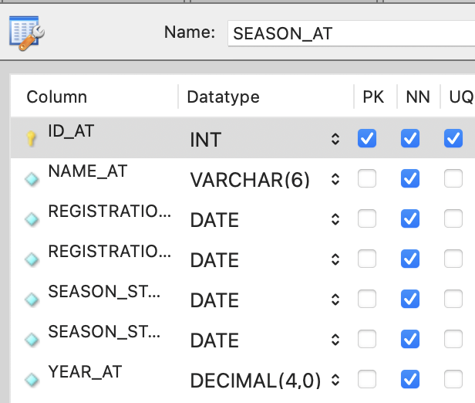
DIVISION
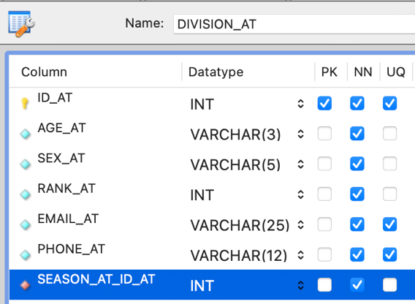
CLUB
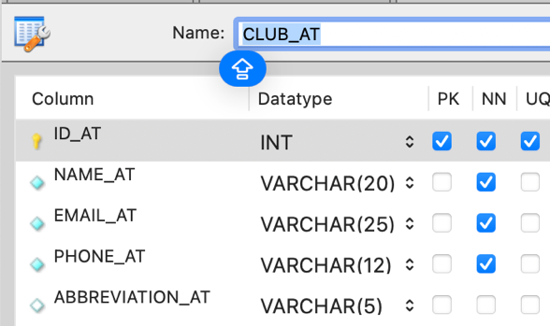

TEAM
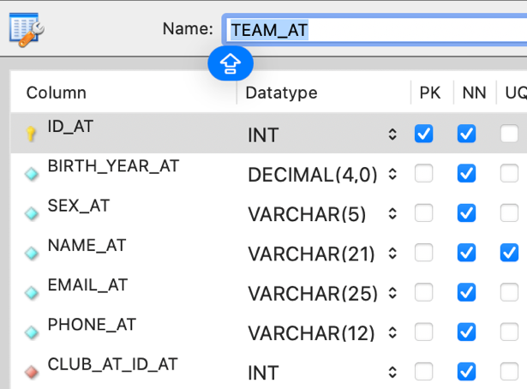
REGISTRATION
