Adonay Tesfamichael
IT-214-006
Hierarychy Design
This is a database that describes a disjoint hierarchy of medical company. This ERD has 4 entities, which explains an employee information, each employee has a. type of role, like being a doctor, nurse or a staff.

The main entities are:
- EMPLOYEE: HAVE TYPE OF EMLOYEE ROLES, (DOCTER, NURSE AND STAFF)
  - Surrogate PK: ID_AT
attribute | Domain | Simple/Composite | Single/Multi | Required/Optional | Unique/Duplicated
ID_AT | INT | SIMPLE | SINGLE | REQUIRED | UNIQUE
NAME | VARCHAR(50) | COMPOSITE | SINGLE | REQUIRED | DUPLICATED
FIRST_NAME_AT | VARCHAR(25) | SIMPLE | SINGLE | REQUIRED | DUPLICATED
LAST_NAME_AT | VARCHAR(25) | SIMPLE | SINGLE | REQUIRED | DUPLICATED
SSN_AT | VARCHAR(11) | SIMPLE | SINGLE | REQUIRED | UNIQUE
PHONE_AT | CHAR(12) | SIMPLE | SINGLE | REQUIRED | DUPLICATED
TYPE | CHAR(1) | SIMPLE | SINGLE | REQUIRED | DUPLICATED

- DOCTOR:
  - Surrogate PK: N/A
  - FK: EMPLOYEE_AT_ID_AT references the pk ID_AT in the entity EMPLOYEE_AT
attribute | Domain | Simple/Composite | Single/Multi | Required/Optional | Unique/Duplicated
EMAIL_AT | VARCHAR(25) | SIMPLE | SINGLE | REQUIRED | DUPLICATED
SPECIALTY_AT | VARCHAR(20) | SIMPLE | SINGLE | REQUIRED | DUPLICATED
MEDICAL_SCHOOL_AT | VARCHAR(30) | SIMPLE | SINGLE | REQUIRED | DUPLICATED

- NURSE:
  - Surrogate PK: N/A
  - FK: EMPLOYEE_AT_ID_AT references the pk ID_AT in the entity EMPLOYEE_AT

attribute | Domain | Simple/Composite | Single/Multi | Required/Optional | Unique/Duplicated
PROGRAM_COMPLETED_AT | VARCHAR(30) | SIMPLE | SINGLE | REQUIRED | DUPLICATED

- STAFF:
  - Surrogate PK: N/A
  - FK: EMPLOYEE_AT_ID_AT references the pk ID_AT in the entity EMPLOYEE_AT
attribute | Domain | Simple/Composite | Single/Multi | Required/Optional | Unique/Duplicated
ROLE_AT | CHAR(21) | SIMPLE | SINGLE | REQUIRED | DUPLICATED

ERD PICTURES

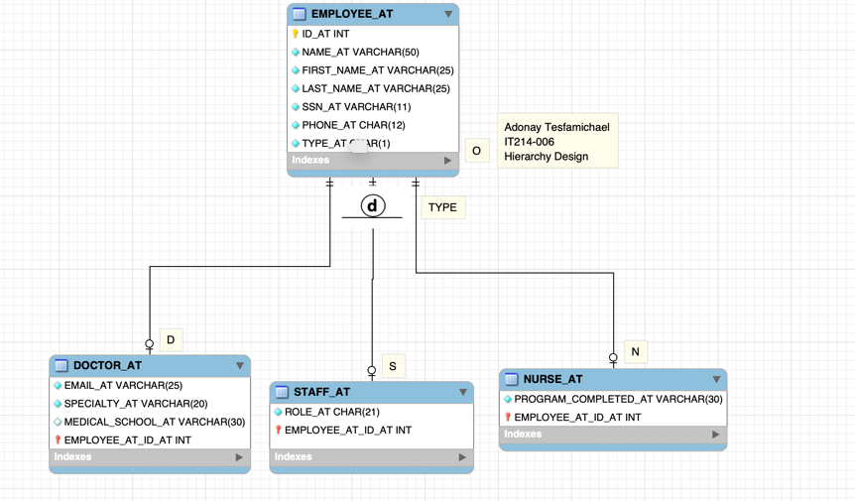
EMPLOYEE
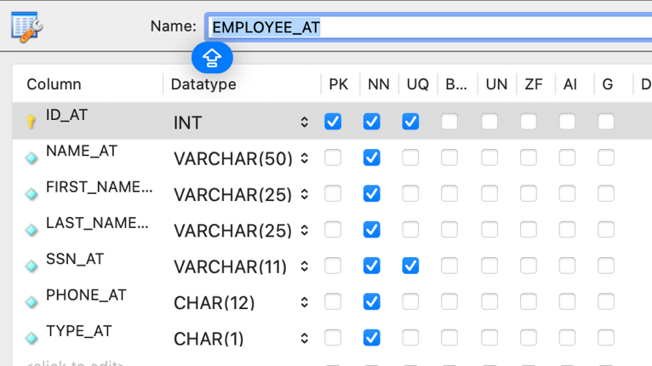

DOCTOR
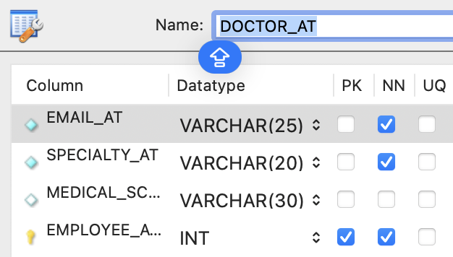
NURSE
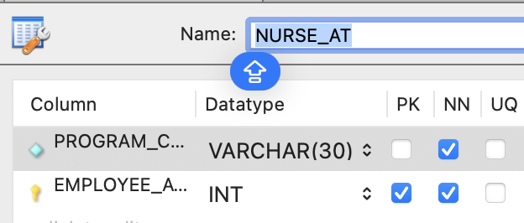
STAFF

