S1
Adonay Tesfamichael
IT214-006

Task 1 - ERD Model
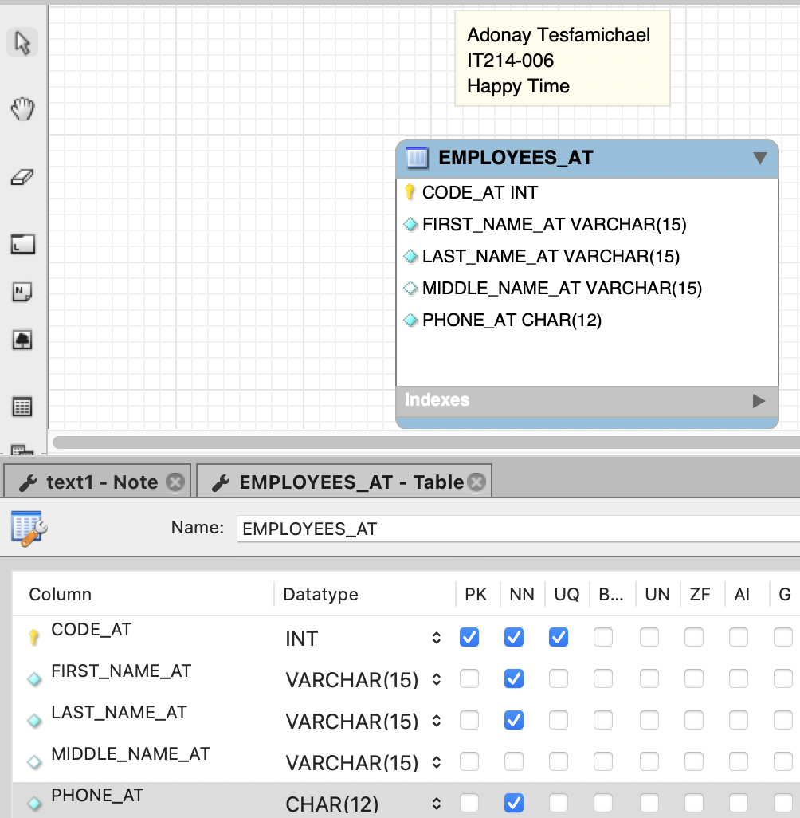

To clear up any confusion with the schemas that are from the next assignment. I have taken this class before, last semester!!! I didn't get the score I wanted, that's why I'm retaking this class.
Task 2 - Create database
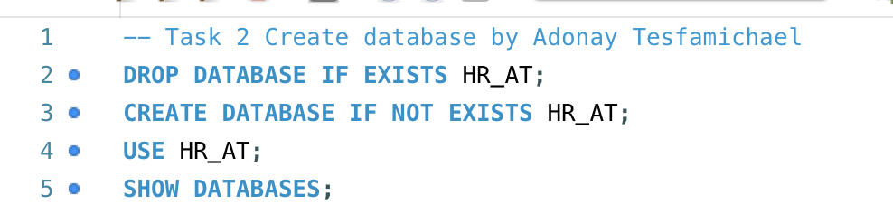
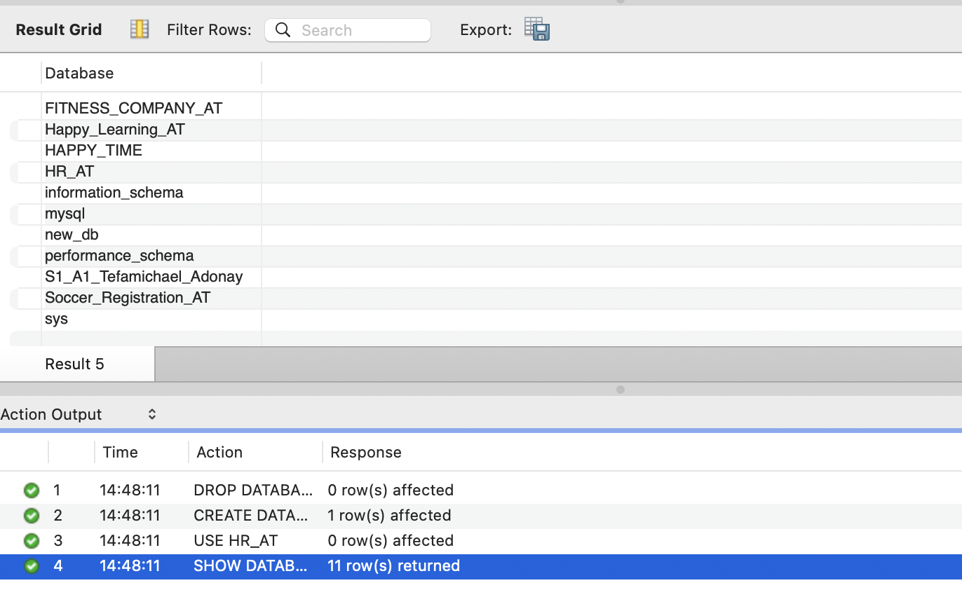

Task 3 - Create tables
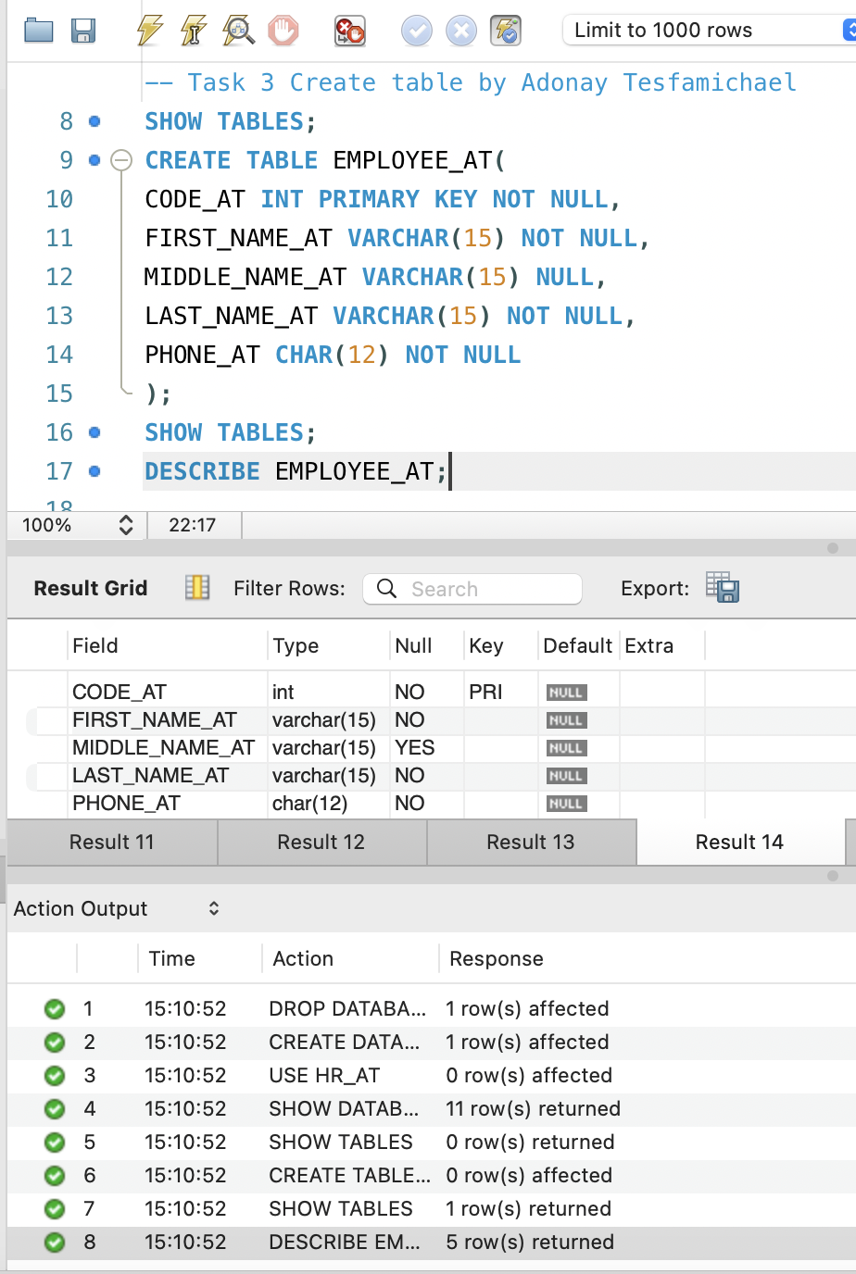

Task 4 - Add Data
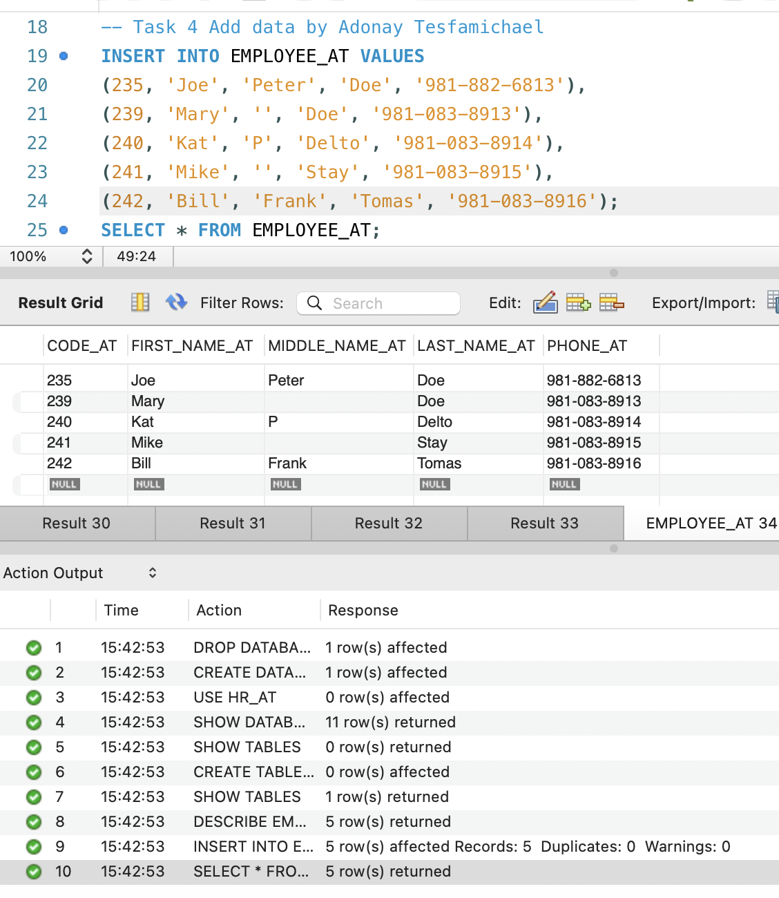
Task 5 - Query the data
