S2
Adonay Tesfamichael
IT214-006
Task1 - ERD Model
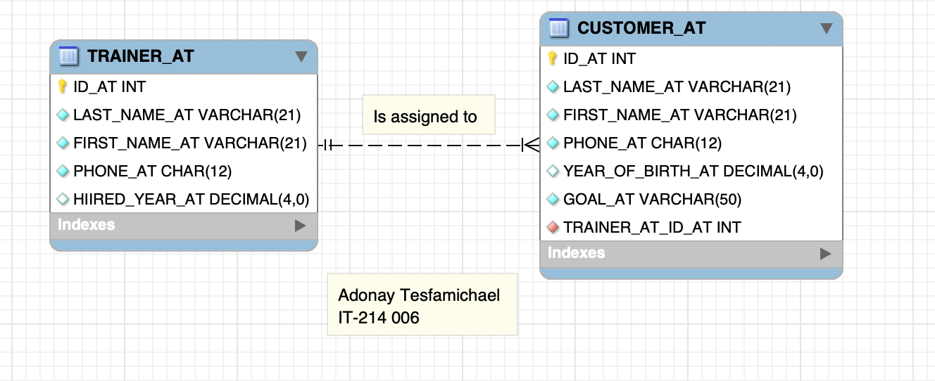

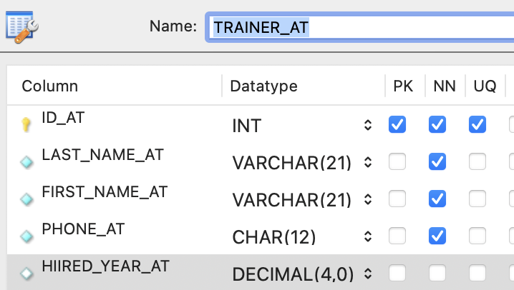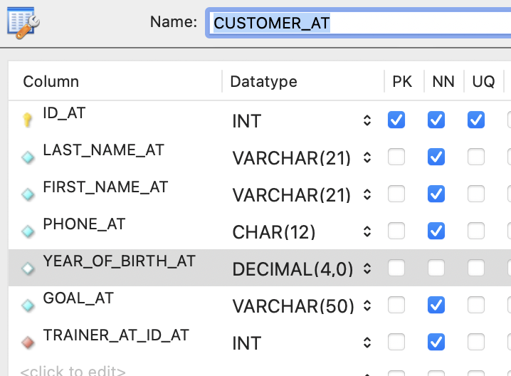

Task2 - Create database by Adonay Tesfamichael
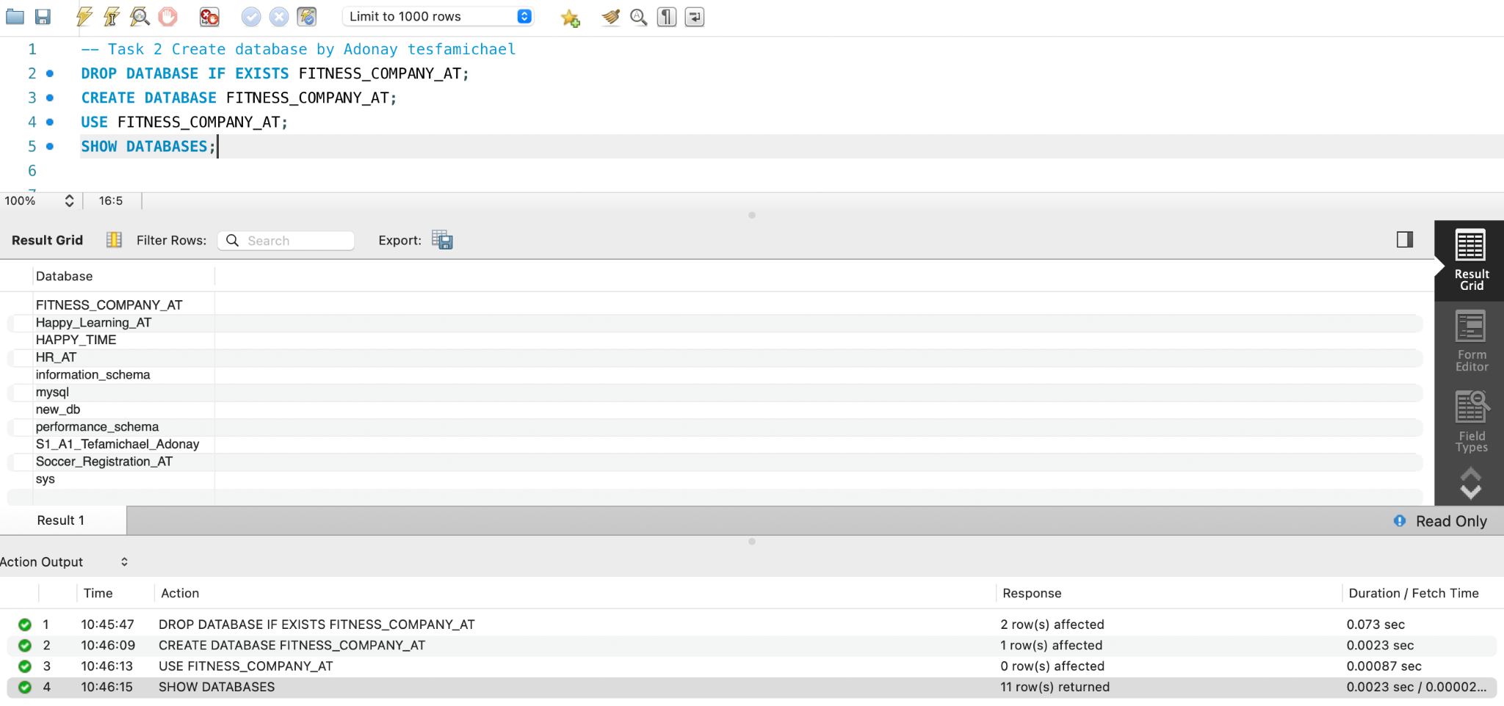

Task3 - Create table by Adonay Tesfamichael
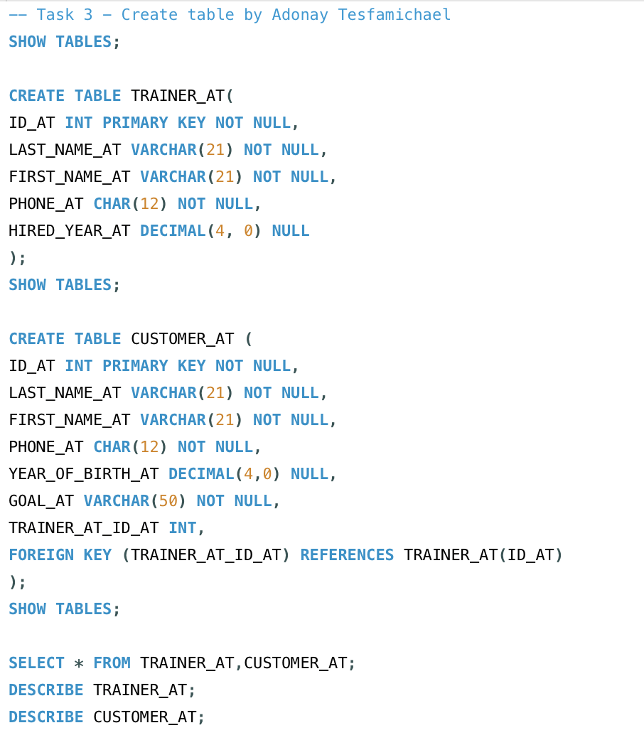
TRAINER CUSTOMER
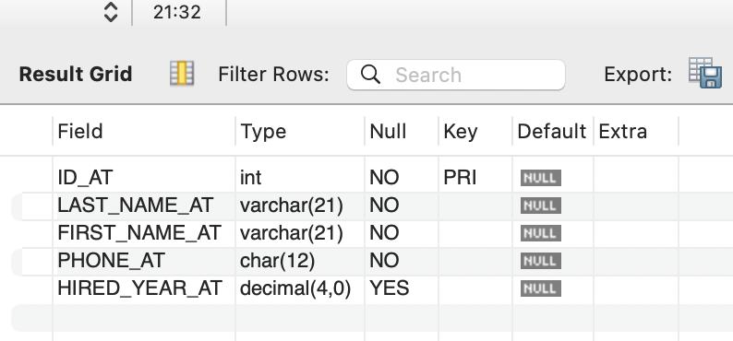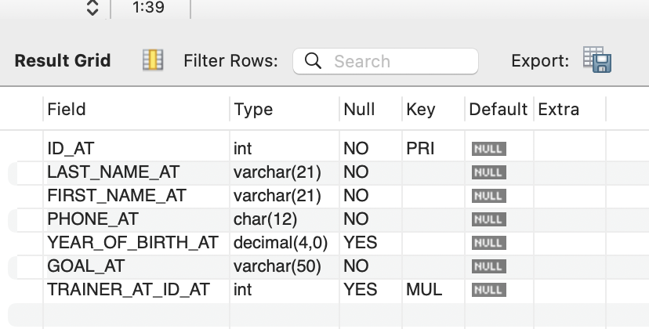
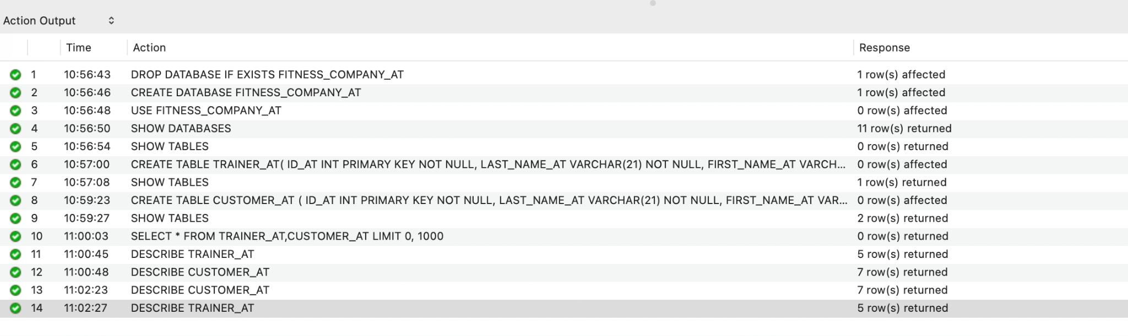

Task4 - Add data by Adonay Tesfamichael
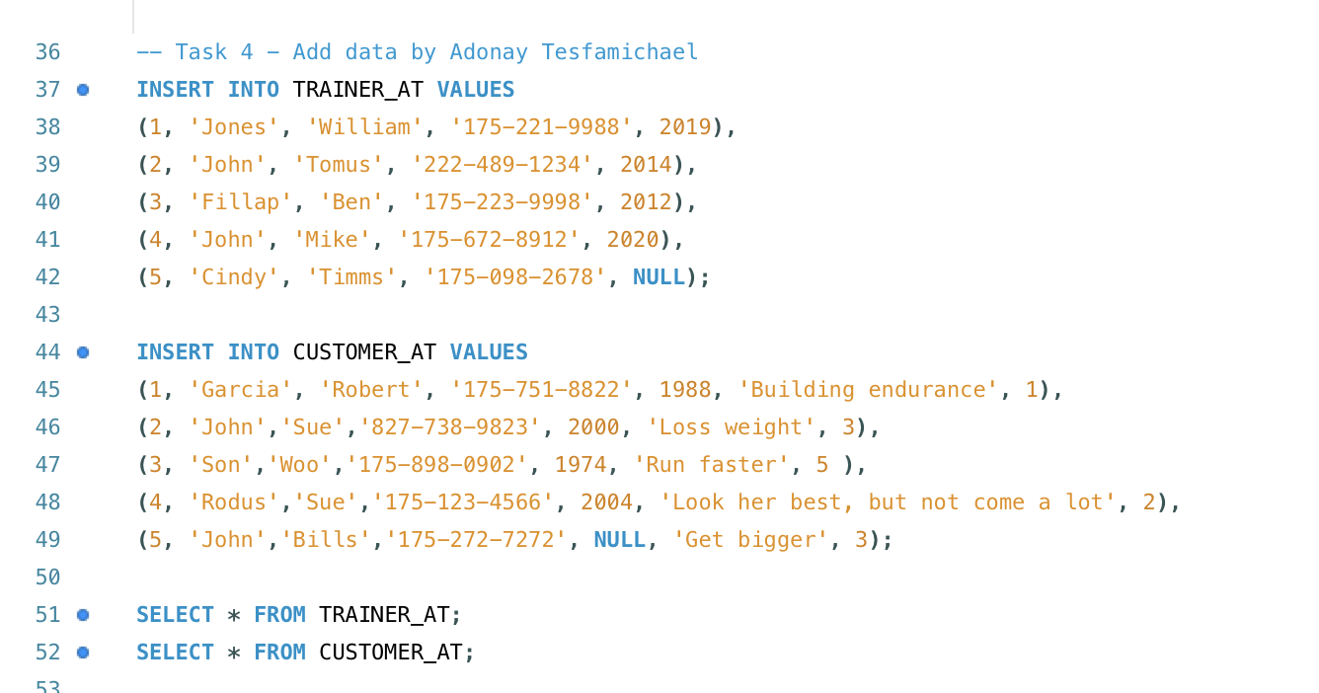
Trainer
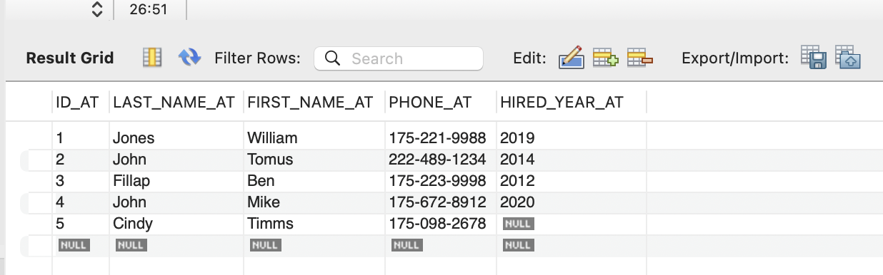
Customer
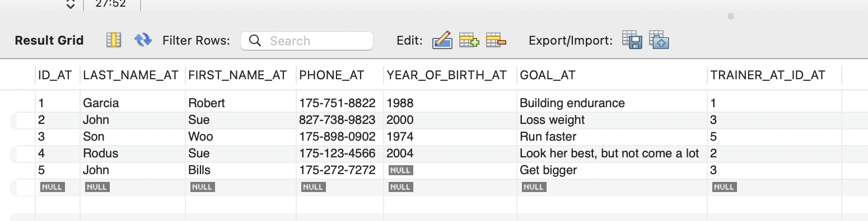

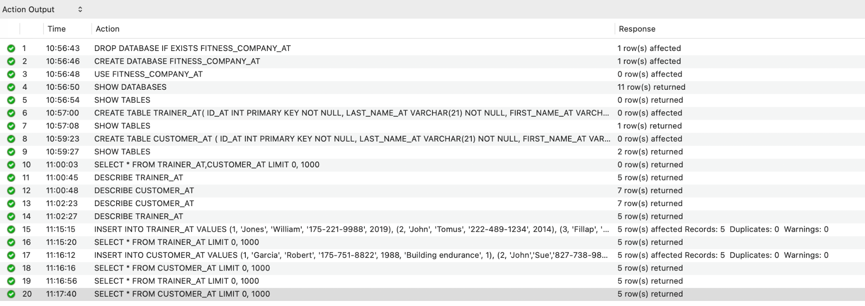
Task5
- For each assignment, list the first and last names for both the trainer and the customer. Use suggestive names for the columns in the result.
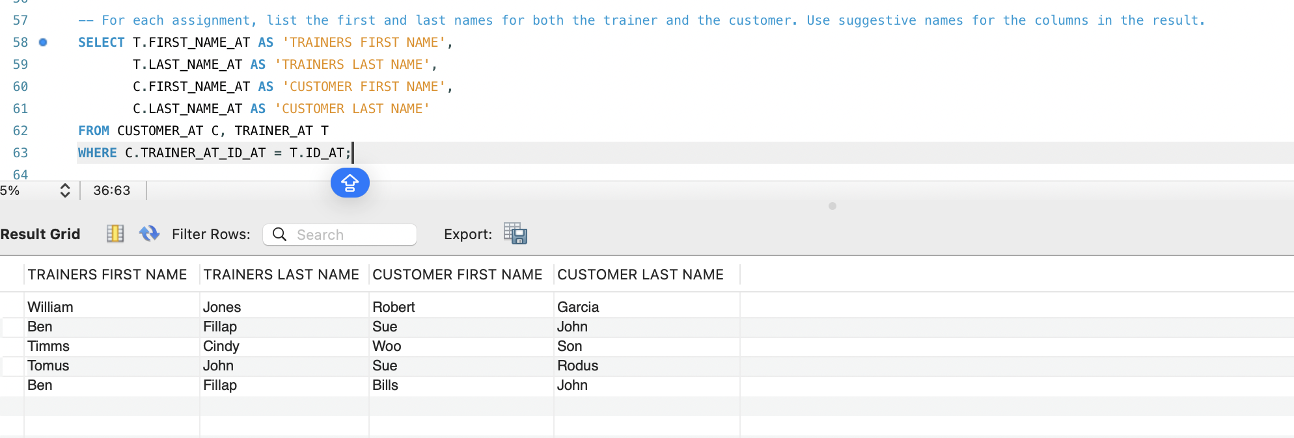
- Pick the ID for the third trainer you defined in the database. List the full names (FIRST SPACE LAST) for all the customers of the selected trainer (in one column named "Customer").

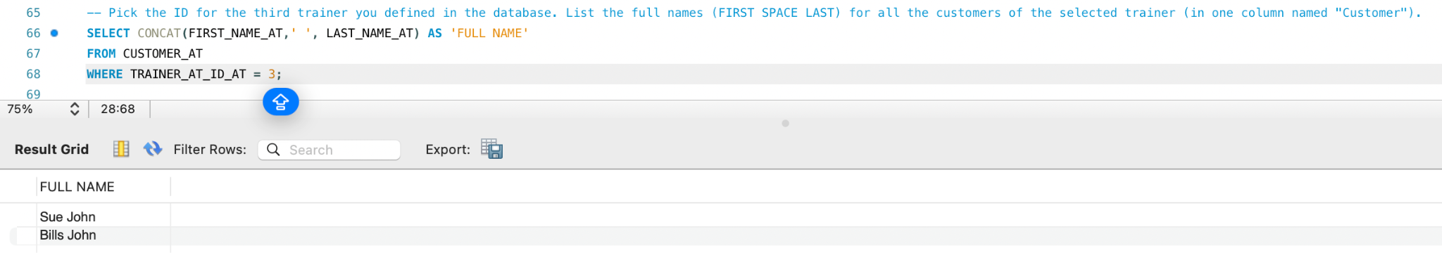
- List the full names (FIRST SPACE LAST)for the trainer and customers (in two columns named "Trainer" and "Customer"), for which the customer first name is "Sue"
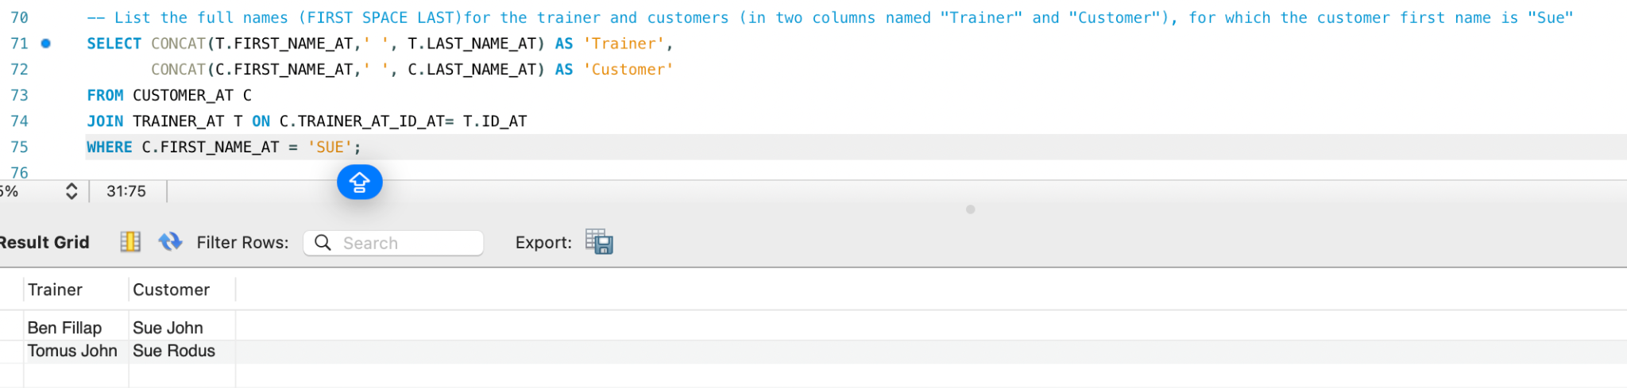

- List the names for the trainers in the format (LAST COMMA SPACE FIRST) hired after 2015 and the full names of their customers. Show the result in two columns named "Trainer" and "Customer".

