Adonay Tesfamichael
IT214-006
Happy learning
This diagram shows a school structure. It is designed to show how the school operates and has all the information from the students, school, teachers and parents.

Conceptual Design:

For this diagram the main entities we are creating are the STUDENT, TEACHER, CLASS, PARENT. For our first relationship we have the TEACHER_AT to CLASS_AT
Which is many to many (M:M) because one teacher can be in many classes and a class can have many teachers and this relationship is held by a bridge called ASSIGNMENT_AT, which holds FK: CLASS_AT_CODE_AT and TEACHER_AT_ID_AT. Next one is the PARENT_AT to STUDENT_AT which is a many to many (M:M) relationship because students can have more than one parent and parents can have more than one kid and this relationship is held by a bridge called RELATIONSHIP, which is holding FK: STUDENT_AT_ID_AT and PARENT_AT_ID_AT. We also have the STUDENT_AT to CLASS_AT which is many to one (M:1) because a class can have many kids and kids can only be in one class time. We also have three new entities LUNCH_ORDER_AT, LUNCH_ITEM_AT and ORDER_ITEM_AT. LUNCH_ORDER_AT has a (1:M) relationship to the STUDENT_AT with a FK: STUDENT_AT_ID_AT. Last relation is between LUNCH_ORDER_AT and LUNCH_ITEM_AT that is M:M which has a bridge called ORDER_ITEM_AT.

Entities Analysis:
- STUDNET_AT
  - This entity shows the students information table.
  - For this entity since there is no PK given we will use a surrogate key ID_AT and the foreign key is CLASS_AT_CODE_AT which comes from CLASS_AT ID CODE_AT.

Attribute Name | Domain & Size | Simple/  Composite | Single/  Multi-value | Required/  Optional | Unique/  Duplicated
ID_AT | INT | Simple | Single | Required | Unique
FIRST_NAME_AT | VARCHAR(15) | Simple | Single | Required | Duplicated
MIDDLE_NAME_AT | VARCHAR(15) | Simple | Single | Optional | Duplicated
LAST_NAME_AT | VARCHAR(15) | Simple | Single | Required | Duplicated
NICK_NAME_AT | VARCHAR(10) | Simple | Single | Required | Duplicated
DATE_OF_BIRTH_AT | DATE | Simple | Single | Required | Duplicated
ADDRESS_AT | VARCHAR(55) | Composite | Single | Required | Duplicated
CITY_AT | VARCHAR(15) | Simple | Single | Required | Duplicated
ZIPCODE_AT | DECIMAL(0,5) | Simple | Single | Required | Duplicated
STREET_AT | VARCHAR(35) | Simple | Single | Required | Duplicated
CLASS_AT_CODE_AT | VARCHAR(2) | Simple | Single | Required | Duplicated

- PARENT_AT
  - This entity shows the parent/guardian information table.
  - For this entity since there is no PK given, we will use a surrogate key ID_AT and there is no foreign key
Attribute Name | Domain & Size | Simple/  Composite | Single/  Multi-value | Required/  Optional | Unique/  Duplicated
ID_AT | INT | Simple | Single | Required | Unique
FIRST_NAME_AT | VARCHAR(15) | Simple | Single | Required | Duplicated
LAST_NAME_AT | VARCHAR(15) | Simple | Single | Required | Duplicated
MIDDLE_NAME_AT | VARCHAR(15) | Simple | Single | Optional | Duplicated
HOME_PHONE_AT | CHAR(13) | Simple | Single | Optional | Duplicated
MOBILE_PHONE_AT | CHAR(13) | Simple | Single | Required | Duplicated
WORK_PHONE_AT | CHAR(13) | Simple | Single | Optional | Duplicated
EMAIL_AT | VARCHAR(30) | Simple | Single | Optional | Duplicated
RELATION_AT | VARCHAR(20) | Simple | Single | Required | Duplicated

- CLASS_AT
  - This entity shows the class information table.
  - For this entity the primary key is the CODE_AT and there is no foreign key

Attribute Name | Domain & Size | Simple/  Composite | Single/  Multi-value | Required/  Optional | Unique/  Duplicated
CLASS_CODE_AT | VARCHAR(2) | Composite | Single | Required | Unique
AGE_LEVEL_AT | VARCHAR(7) | Simple | Single | Required | Duplicated
COLOR_AT | VARCHAR(5) | Simple | Single | Required | Duplicated
ROOM_NUMBER_AT | INT | Simple | Single | Required | Duplicated
PHONE_NUMBER_AT | CHAR(13) | Simple | Single | Required | Duplicated
DIRECTION_AT | VARCHAR(160) | Simple | Single | Optional | Duplicated
CAPACITY_AT | INT | Simple | Single | Required | Duplicated

- TEACHER_AT
  - This entity shows the teacher information table.
  - For this entity since there is no PK given, we will use a surrogate key ID_AT and there is no foreign key

Attribute Name | Domain & Size | Simple/  Composite | Single/  Multi-value | Required/  Optional | Unique/  Duplicated
ID_AT | INT | Simple | Single | Required | Unique
FIRST_NAME_AT | VARCHAR(15) | Simple | Single | Required | Duplicated
LAST_NAME_AT | VARCHAR(15) | Simple | Single | Required | Duplicated
MIDDLE_NAME_AT | VARCHAR(15) | Simple | Single | Optional | Duplicated
HOME_PHONE_AT | CHAR(13) | Simple | Single | Required | Duplicated
WORK_EMAIL_AT | VARCHAR(30) | Simple | Single | Required | Duplicated
PERSONAL_EMAIL_AT | VARCHAR(30) | Simple | Single | Optional | Duplicated
COLLEGE_AT | VARCHAR(50) | Simple | Single | Optional | Duplicated
HIGHEST_DEGREE_AT | VARCHAR(5) | Simple | Single | Required | Duplicated
DEGREE_AREA_AT | VARCHAR(25) | Simple | Single | Required | Duplicated
- RELATIONSHIP_AT
  - This entity shows the relationship between Student & Parent. Since the relationship between Student and Parent is M:M we create a bridge called RELATIONSHIP to connect them.

Attribute Name | Domain & Size
STUDENT_AT_ID_AT | INT
PARENT_AT_ID_AT | INT

- ASSIGNMENT_AT
  - This entity shows the relationship between Class & Teacher. Since the relationship between Class and Teacher is M:M we create a bridge called ASSIGNMENT to connect them.

Attribute Name | Domain & Size
CLASS_AT_CODE_AT | INT
TEACHER_AT_ID_AT | INT

- LUNCH_ORDER_AT
  - This entity shows the Order information table.
  - For this entity since there is no PK given, we will use a surrogate key ID_AT and there is a FK: STUDENT_AT_ID_AT references STUDENT_AT(ID_AT)
Attribute Name | Domain & Size | Simple/  Composite | Single/  Multi-value | Required/  Optional | Unique/  Duplicated
ID_AT | INT | Simple | Single | Required | Unique
QUANTITY_AT | INT | Simple | Single | Required | Duplicated
DATE_AT | DATE | Simple | Single | Required | Duplicated
STUDENT_AT_ID_AT | INT | Simple | Single | Required | Duplicated

- LUNCH_ITEM_AT
  - This entity shows the item information table.
  - we will use a primary key ID_AT, no foreign key
Attribute Name | Domain & Size | Simple/  Composite | Single/  Multi-value | Required/  Optional | Unique/  Duplicated
CODE_AT | INT | Simple | Single | Required | Unique
ITEM_NAME_AT | VARCHAR(26) | Simple | Single | Required | Duplicated
CALORIES_AT | INT | Simple | Single | Required | Duplicated
- ORDER_ITEM_AT
- This entity shows the relationship between LUNCH_ORDER_AT & LUNCH_ITEM_AT. Since the relationship between LUNCH_ORDER and LUNCH_ITEM is M:M we create a bridge called ORDER_ITEM_AT to connect them.
Attribute Name | Domain & Size
LUNCH_ORDER_AT_ID_AT | INT
LUNCH_ITEM_AT_CODE_AT | INT

Relationship Analysis:
- TEACHER_AT to CLASS_AT
  - We use a bridge : ASSIGNMENT_AT
    - TEACHER has class ASSIGNMENT (1:M)
    - CLASS has teacher ASSIGNMENT (1:M)
  - M:M because one teacher can be in many classes and one class can have many teachers.
  - The straight is weak because both entities exist independently, not relying on each other.
  - TEACHER(total) because teachers get assigned to a class and CLASS ( total) because all classes have teachers.
  - No special cardinality
  - FK: The ASSIGNMENT table holding the CLASS_AT_CODE_AT reference to the class entity and TEACHER_AT_ID_AT reference to the teacher entity
- PARENT_AT to STUDENT_AT
  - We use a bridge: RELATIONSHIP_AT
    - PARENT has student RELATIONSHIP (1:M)
    - STUDENT has parent RELATIONSHIP (1:M)
  - M:M because students can have more than one parent and parents can have more than one kid
  - The strength is strong because each student is connected to a parent or a caretaker
  - They are both total because they both need each other
  - No special cardinality
  - FK: The RELATIONSHIP table holding the STUDENT_AT_ID_AT reference to the student entity and PARENT_AT_ID_AT reference to the parent entity
- STUDENT_AT to CLASS_AT
  - STUDENT enrolls in CLASS
  - One CLASS contains many STUDENTS, and one STUDENT is enrolled in one CLASS at a time. No bridge
  - The straight is weak because both entities exist independently, not relying on each other.
  - CLASS ( partial) because all the classes might not have kids sometimes, and STUDENTS (total) because a student needs to be always enrolled in a class.
  - No special cardinality
  - FK: CLASS_AT_CODE_AT reference to the CLASS entity
- STUDENT_AT & LUNCH_ORDER_AT
  - STUDENT_AT orders LUNCH_ORDER_AT
  - 1:M Each student can order one lunch every day, and lunch can be ordered many times every day for many days
  - The straight is weak, because a student might not order lunch.
  - Both is partial because there might not be an order somedays to have a menu
  - FK: STUDENT_AT_ID_AT references STUDENT_AT(ID_AT)
- LUNCH_ORDER_AT & LUNCH_ITEM_AT
  - We use a bridge: ORDER_ITEM_AT
    - LUNCH_ORDER_AT has lunch item ORDER_ITEM_AT(1:M)
    - LUNCH_ITEM_AT has lunch order ORDER_ITEM_AT(1:M)
  - M:M because one order may have up to 4 items and each item will be shows on orders
  - The straight is strong because an order can’t be placed without items
  - They are both total because they both need each other
  - FK: The ORDER_ITEM_AT table holding the LUNCH_ORDER_AT_ID_AT reference to the LUNCH_ORDER_AT entity and LUNCH_ITEM_AT_CODE_AT reference to the LUNCH_ITEM_AT entity
Entity Relationship Diagram:

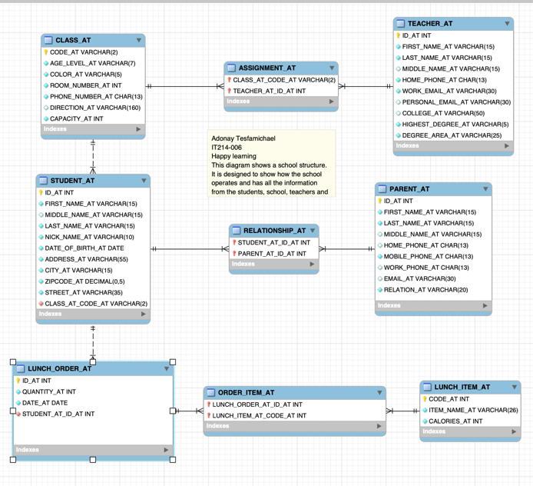
TEACHER_AT
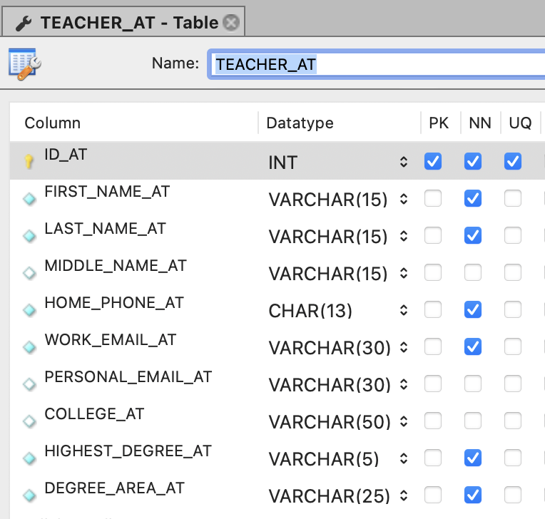
STUDENT_AT
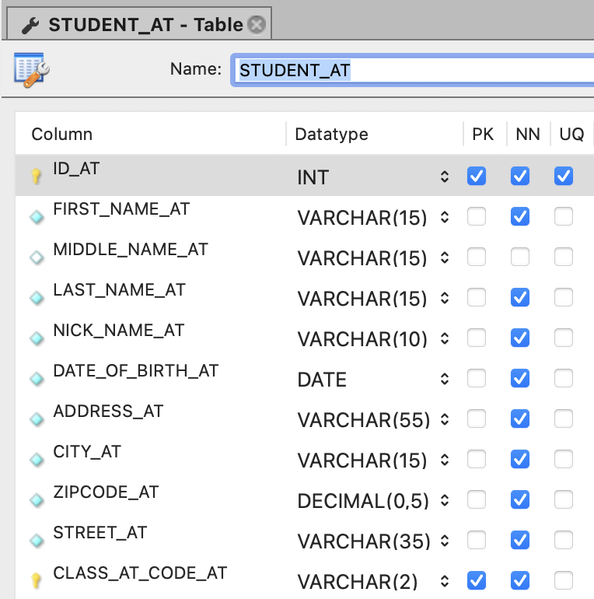
PARENT_AT
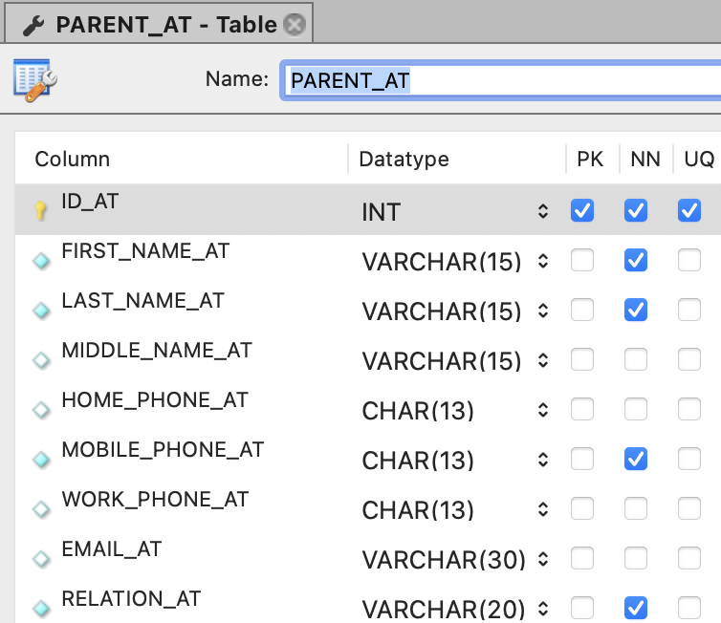

CLASS_AT

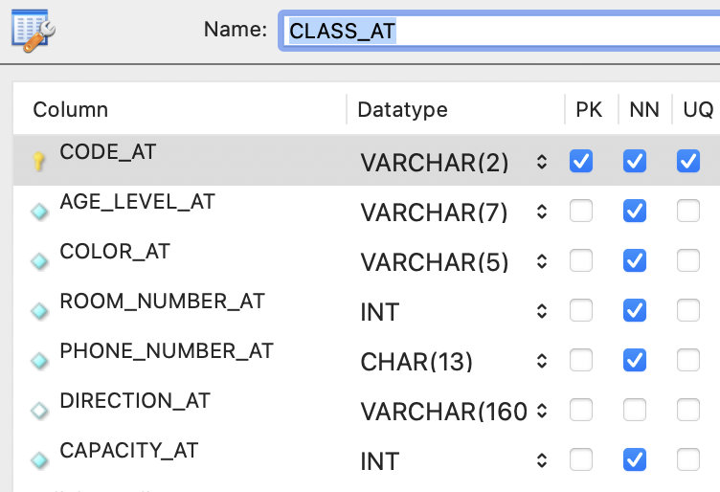

BRIDGE: RELATIONSHIP_AT
- (STUDENT & PARENT)
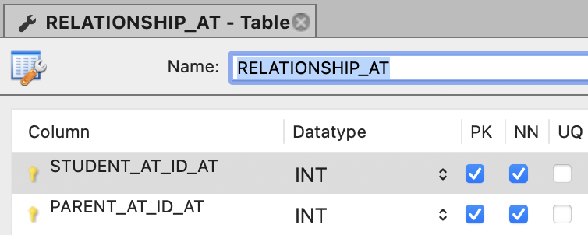

BRIDGE: ASSIGNMENT_AT
- (CLASS & TEACHER)
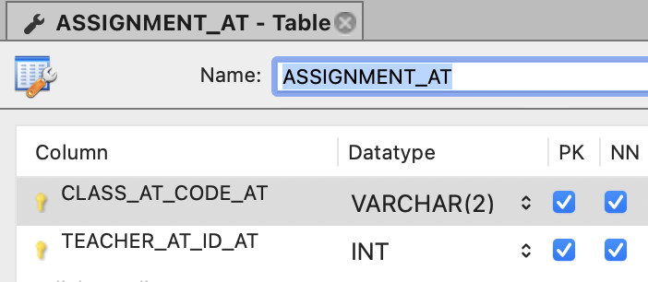

LUNCH_ORDER_AT
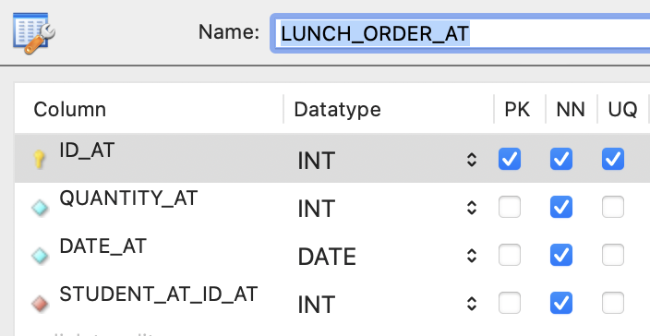
BRIDGE: ORDER_ITEM_AT
- (LUNCH_ORDER & LUNCH_ITEM)
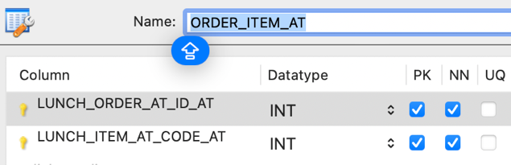

LUNCH_ITEM_AT
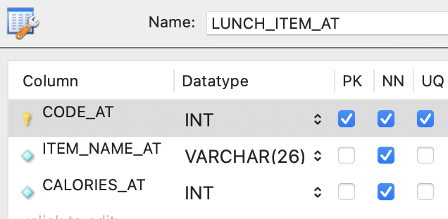
Task 2 - Create database

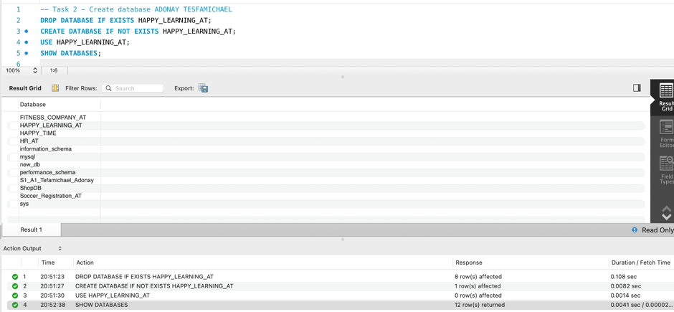

Task 3 - Create Table
TEACHER

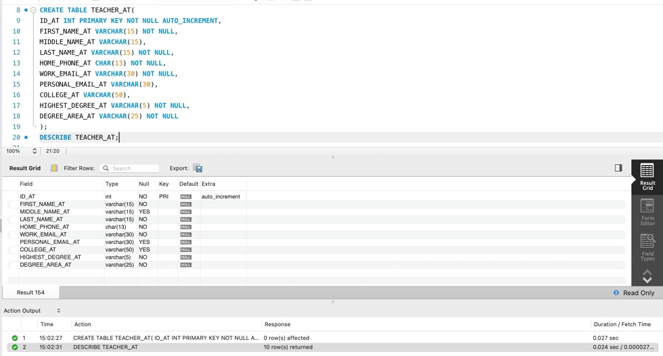
CLASS
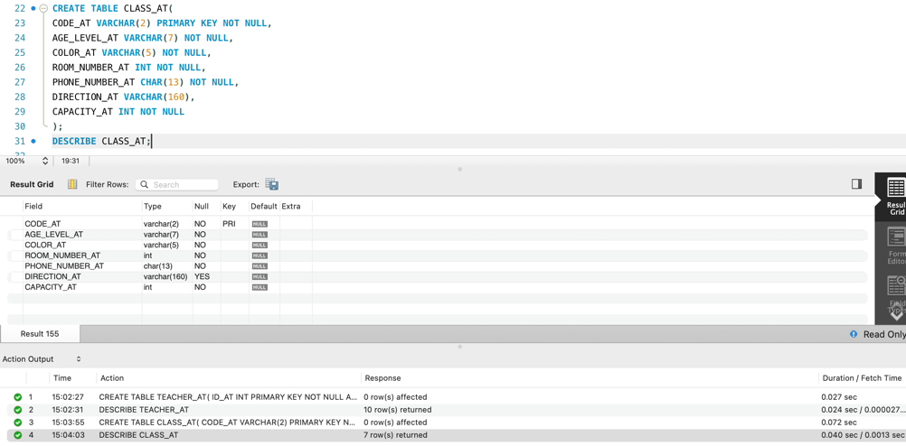
ASSIGNMENT
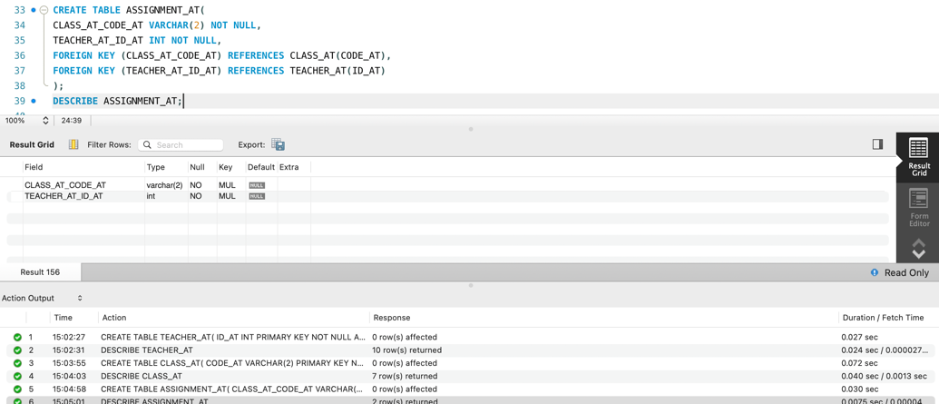

STUDENT
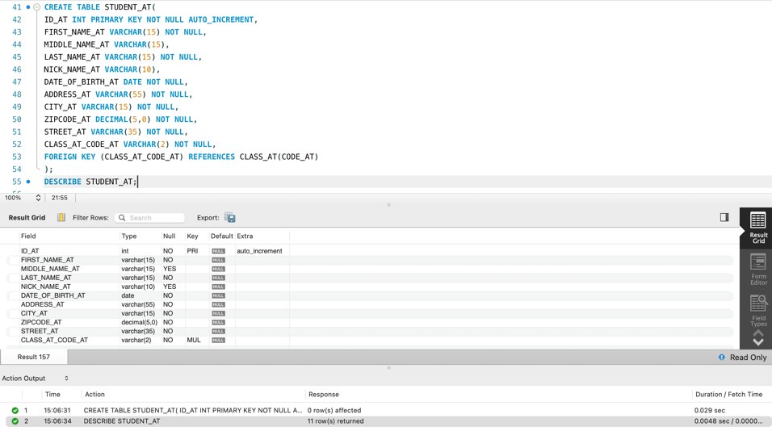
PARENT
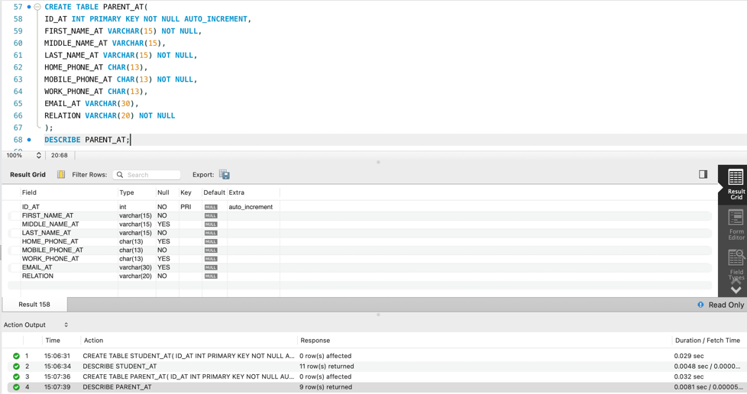
RELATIONSHIP
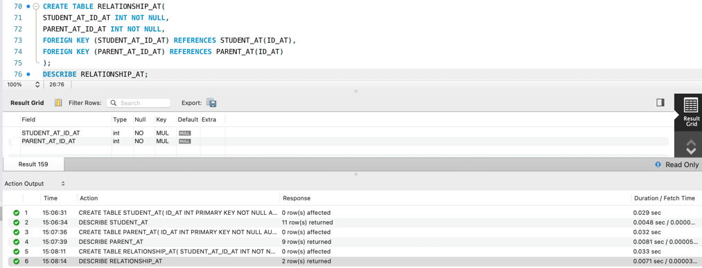

LUNCH_ORDER_AT
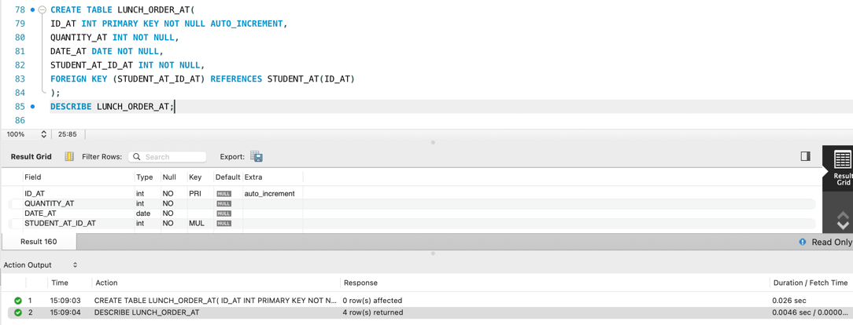
LUNCH_ITEM_AT
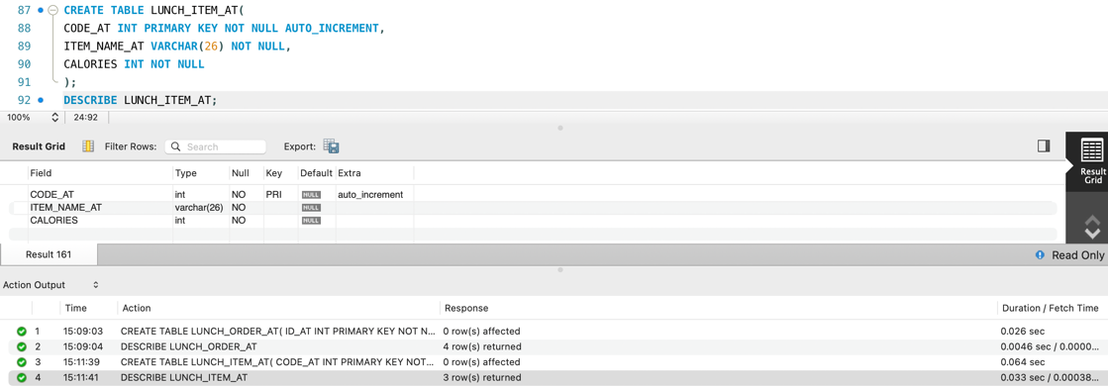
ORDER_ITEM_AT
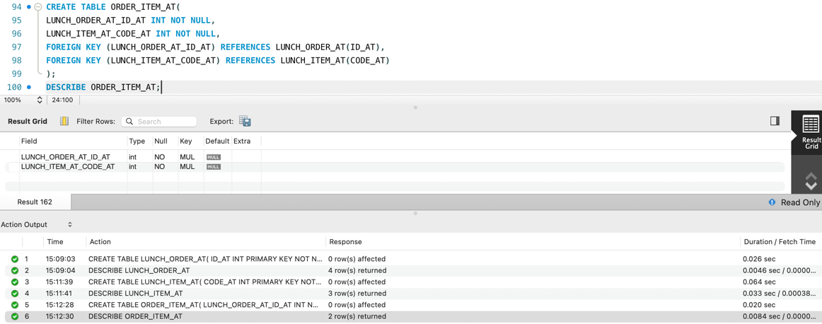
Task 4 - Add data
TEACHER
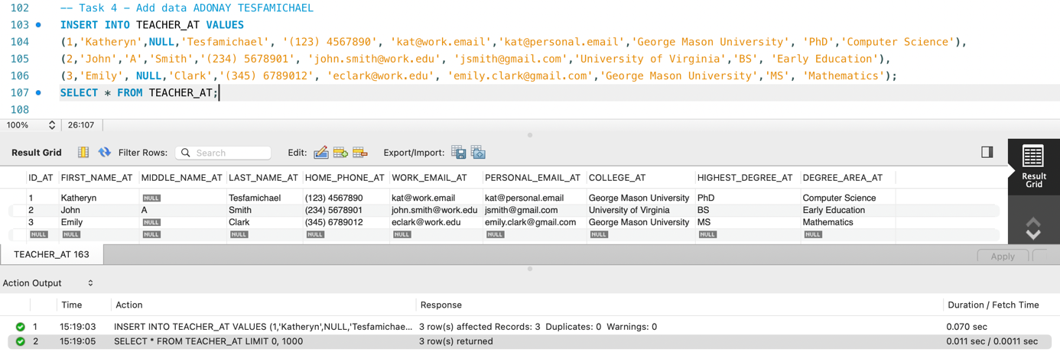
CLASS
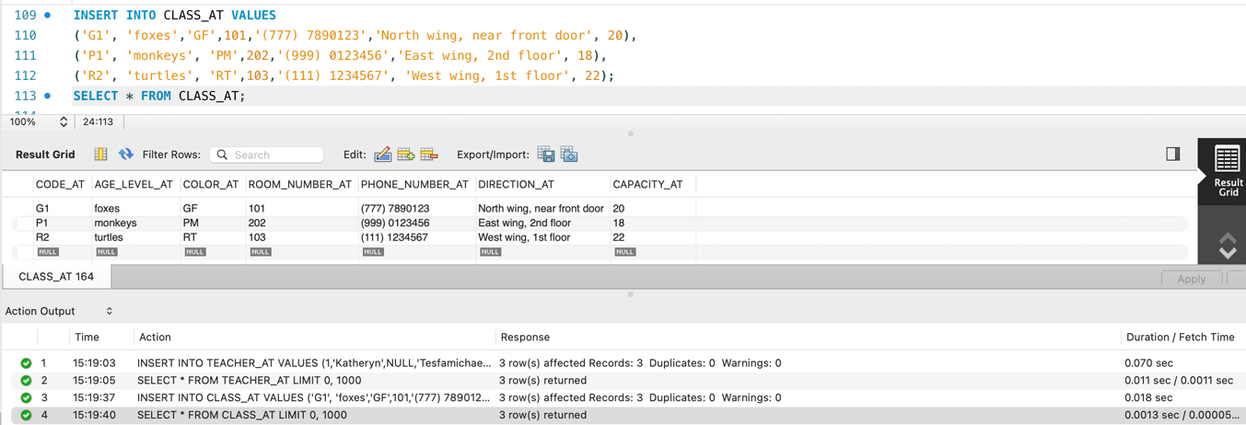
ASSIGNMENT
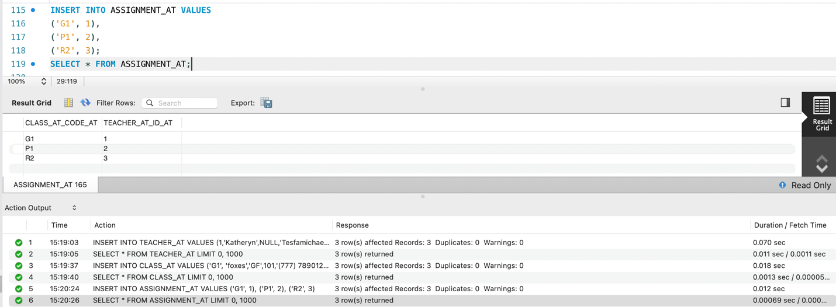
STUDENT
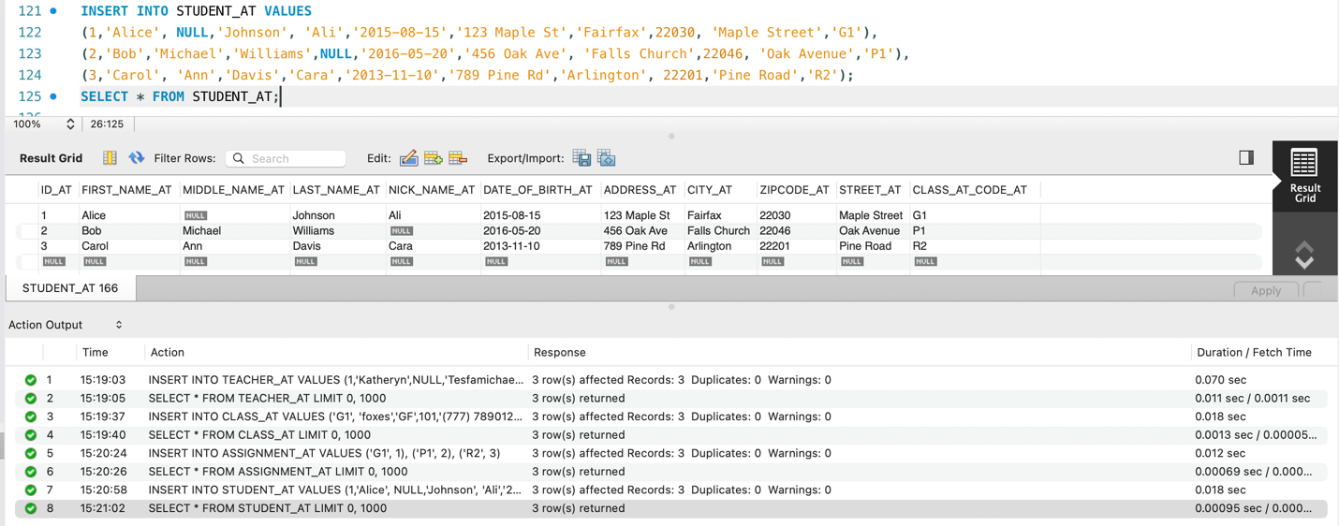

PARENT
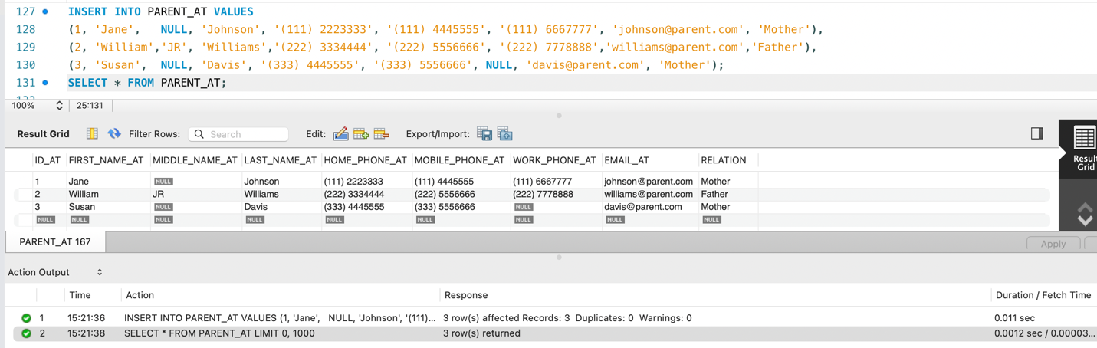
RELATIONSHIP
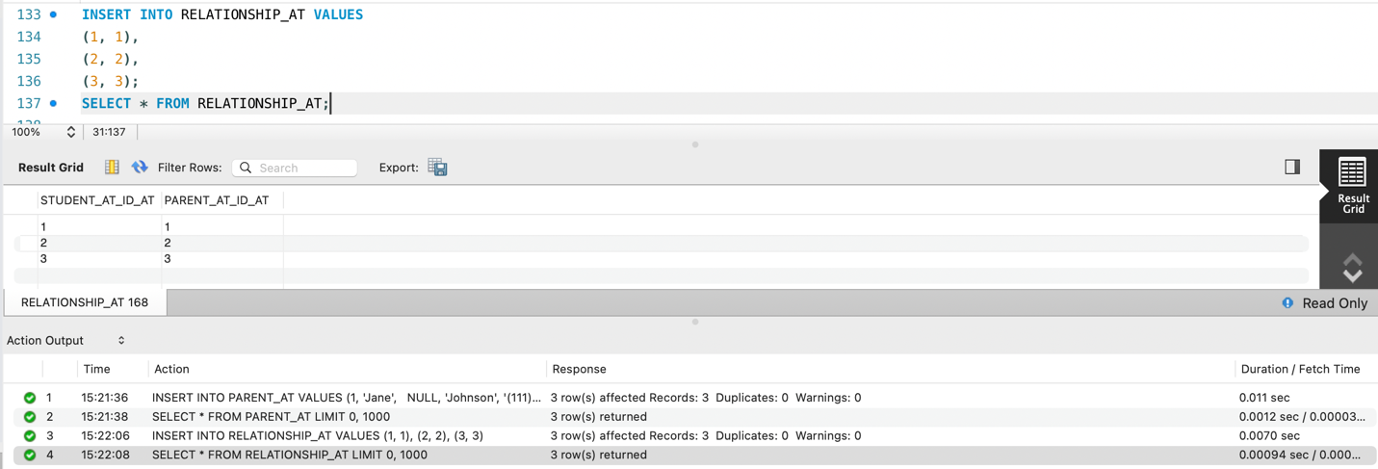
LUNCH_ITEM_AT
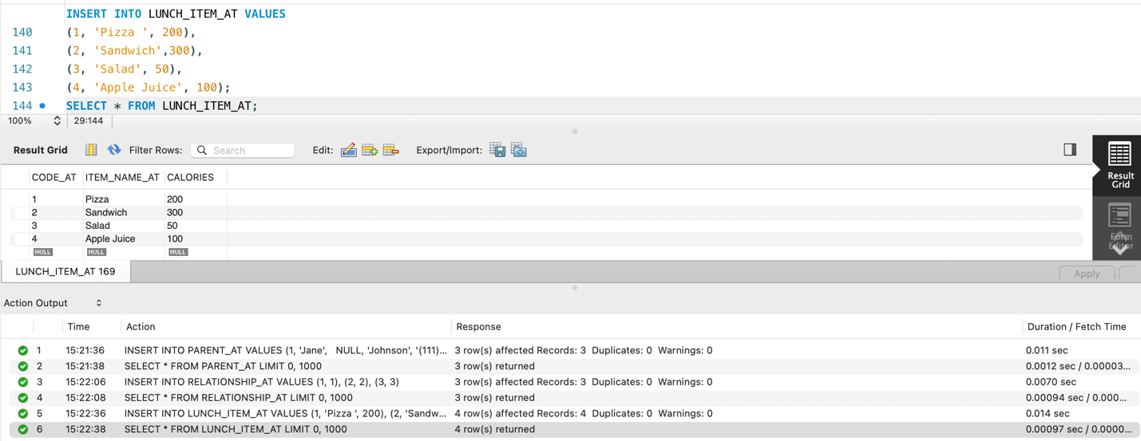

LUNCH_ORDER_AT
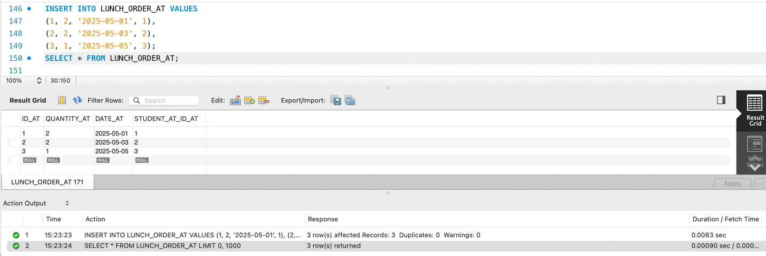
ORDER_ITEM_AT
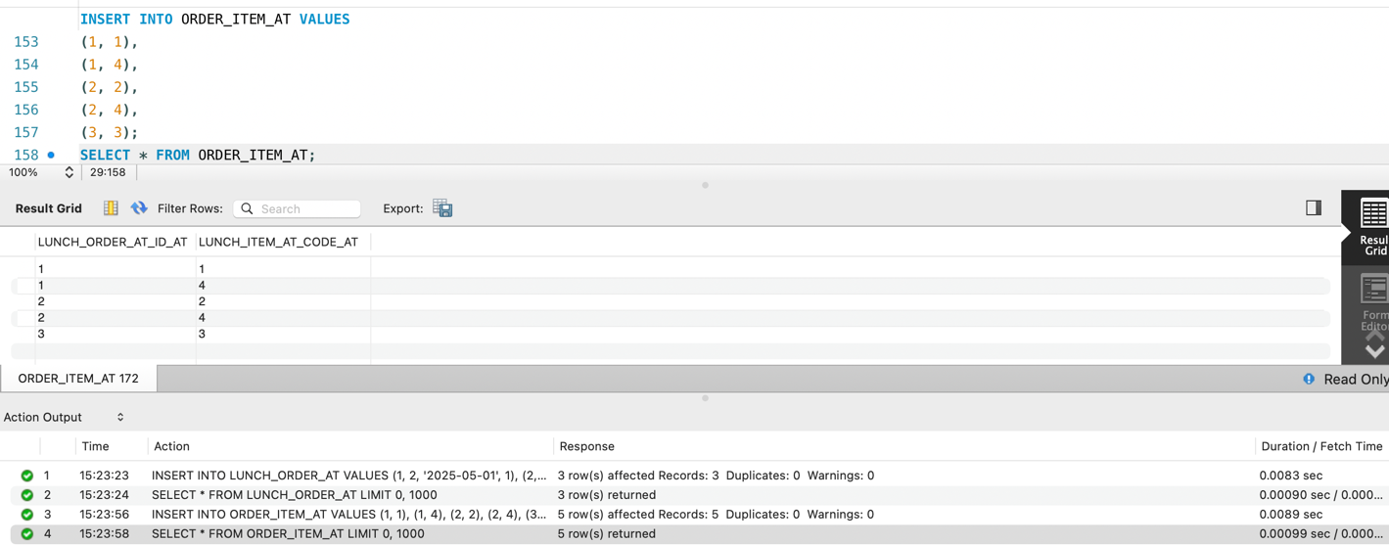
Task 5 Query the data

