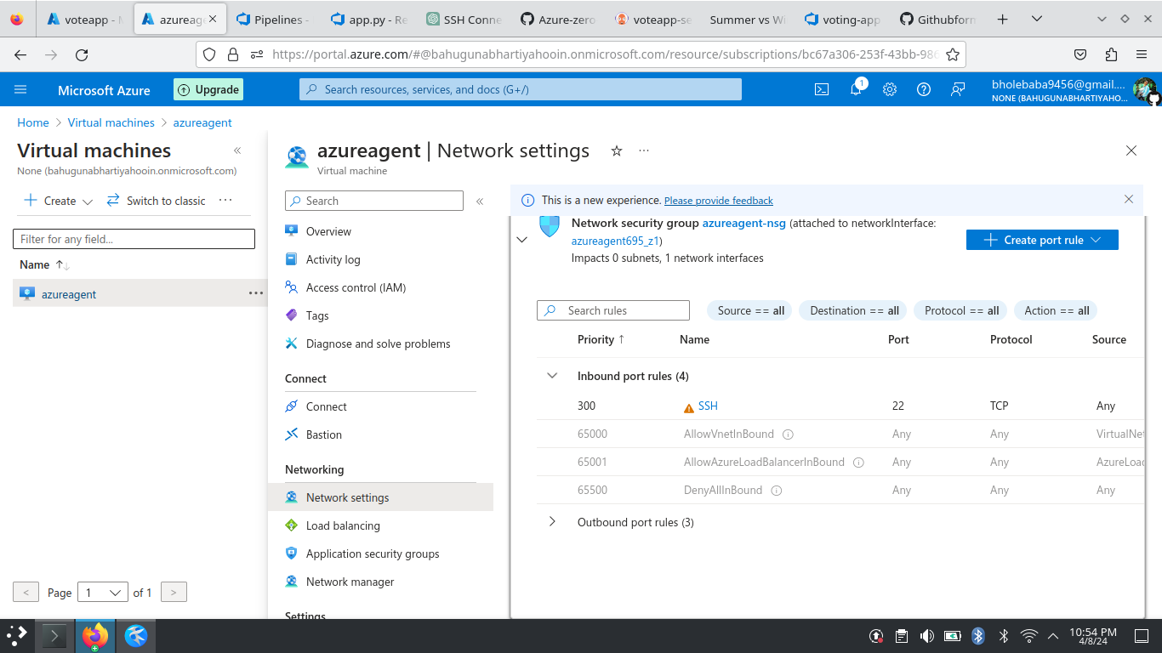
Virual machine created for running Azure Pipilens.
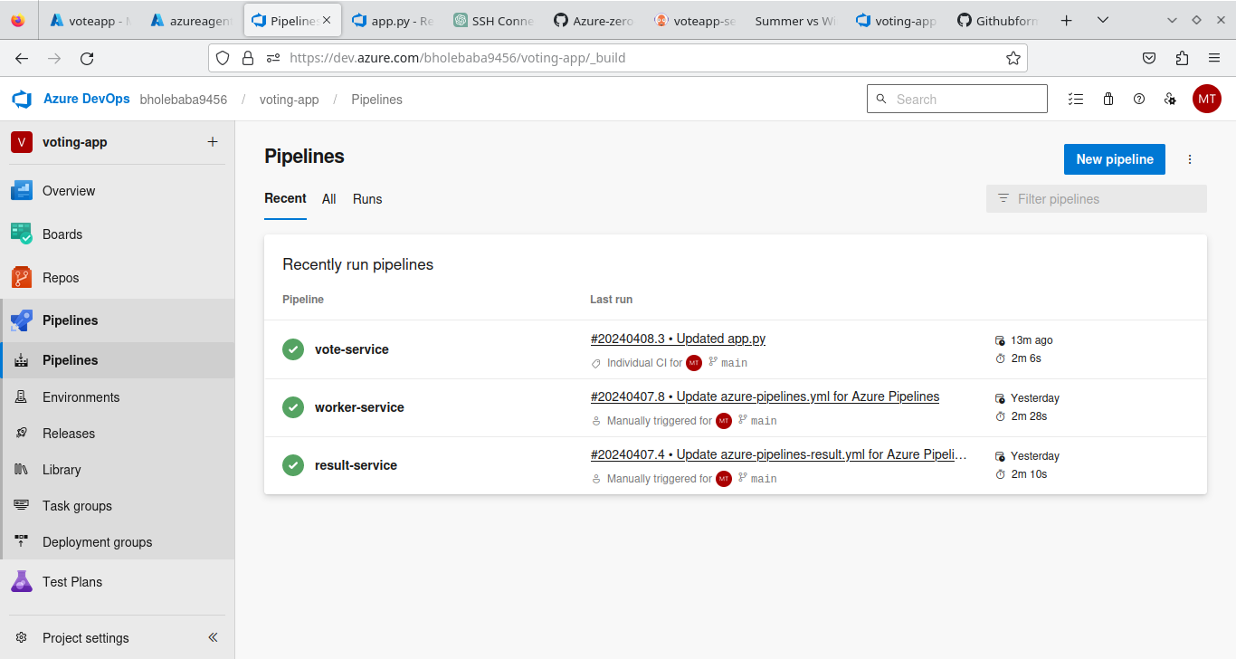
These are the three microservices running as a pipiline which is taking code from azure repo.
Below is the azure repo content---
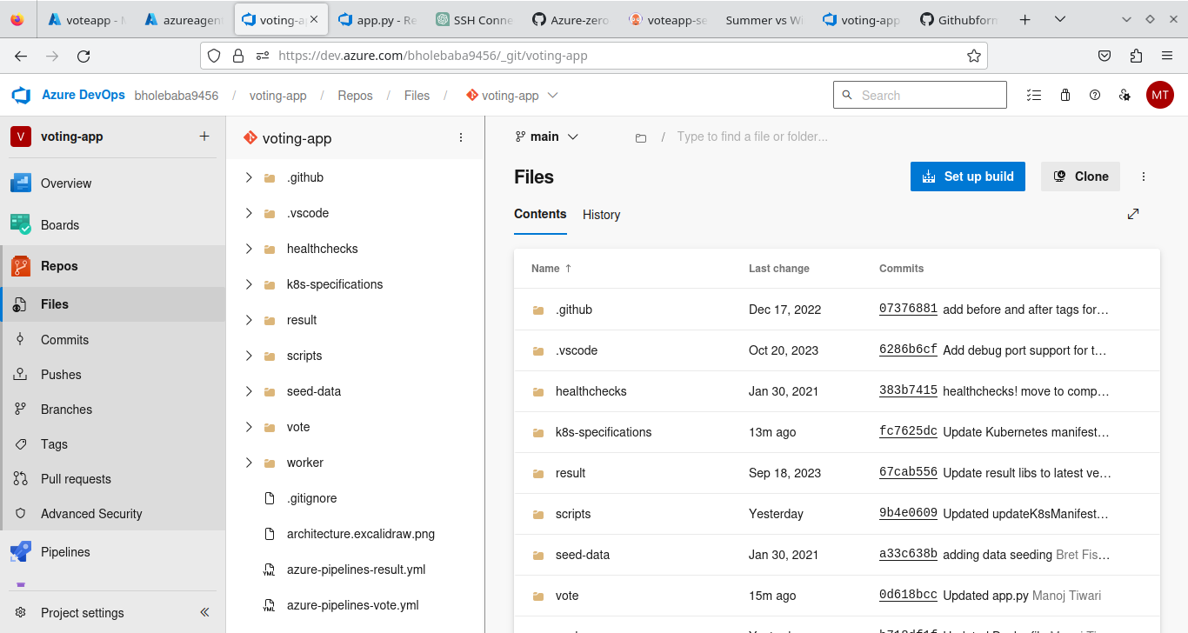

below is the azure ragistry where pushing all the images:
below is the azure managed kubernetes service where deploying our application:
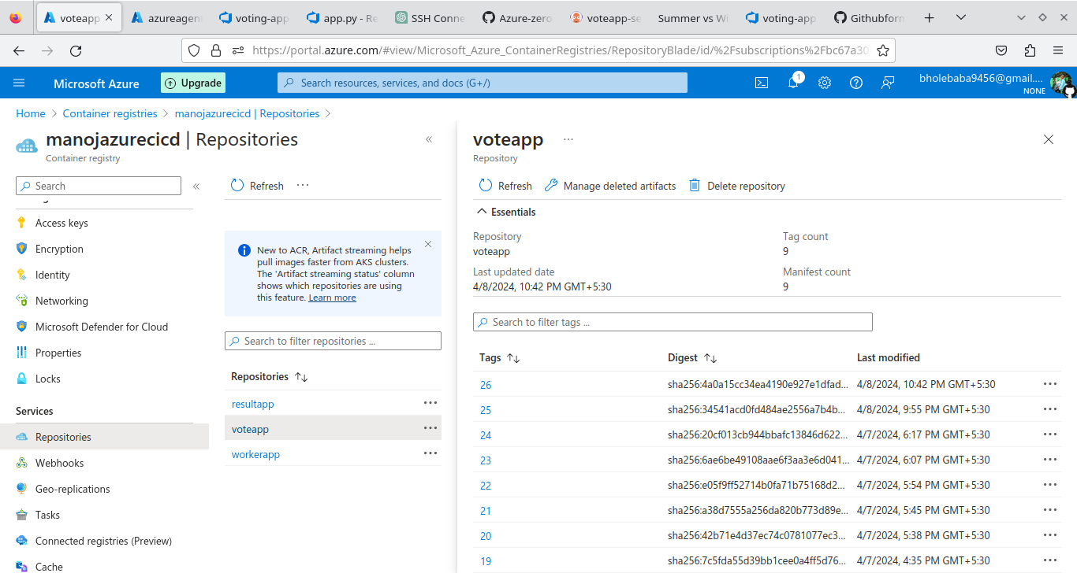
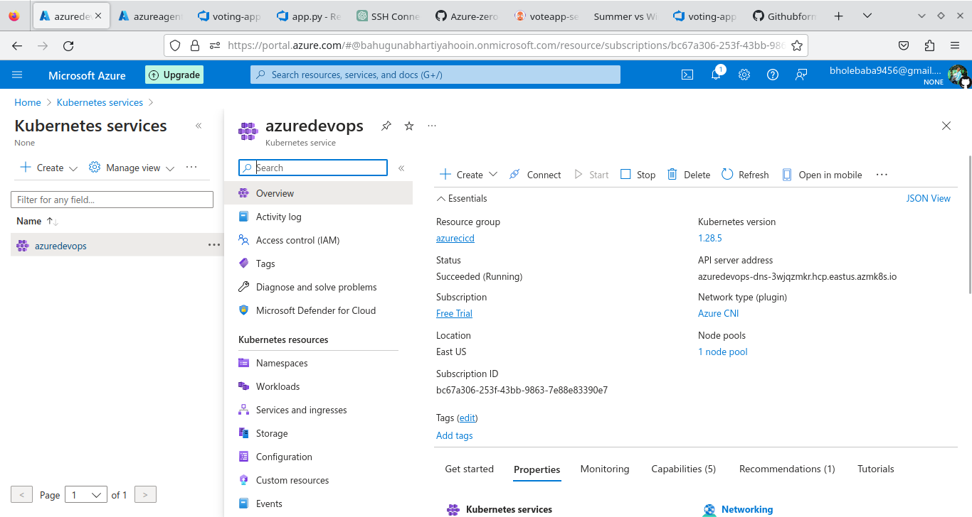
below is the virtual machine scale set which we have configured inside our cluster here we have selected 1 node minimum and 2 is maximum.
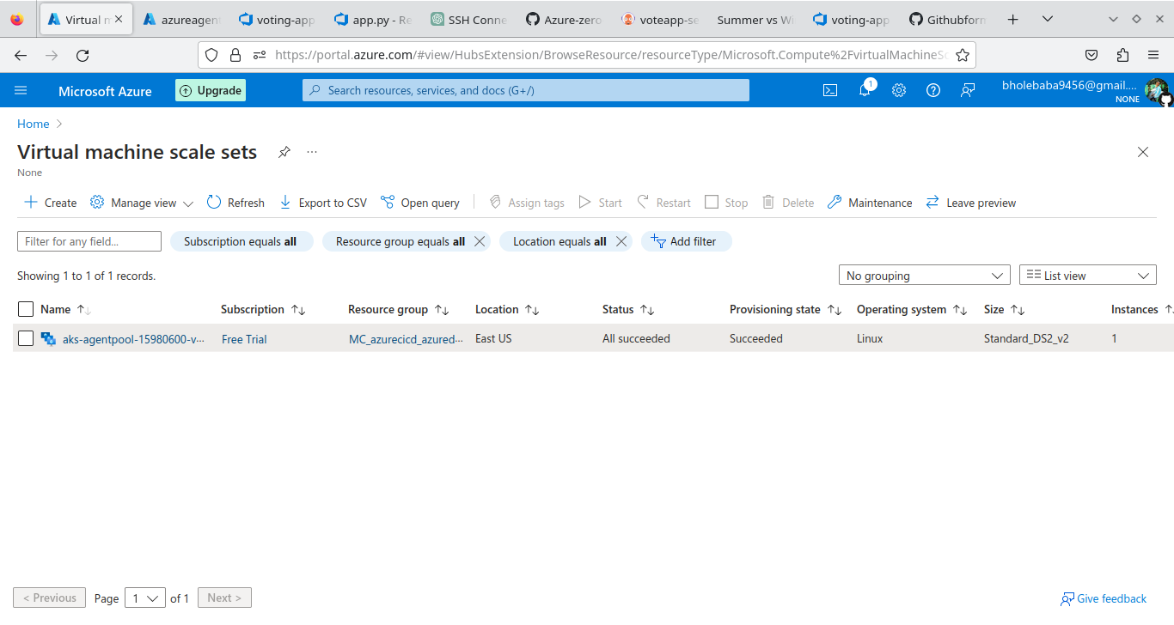
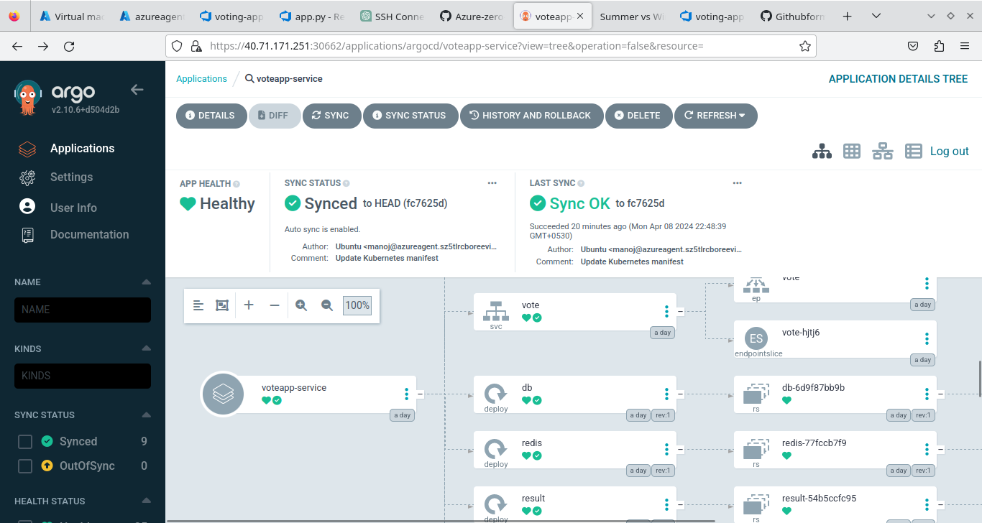
Below is the argocd interface which we have manually installed inside our kubernetes cluster after conneting to it with azure cli.
For pick up the changes and update the image to the deployement file we are using a shell script and then argocd read the image from menifest file then deploy it.

Below is the shell script which we are using for updating the menifest file which new image whenever a new commit happens or pipeline triggers:
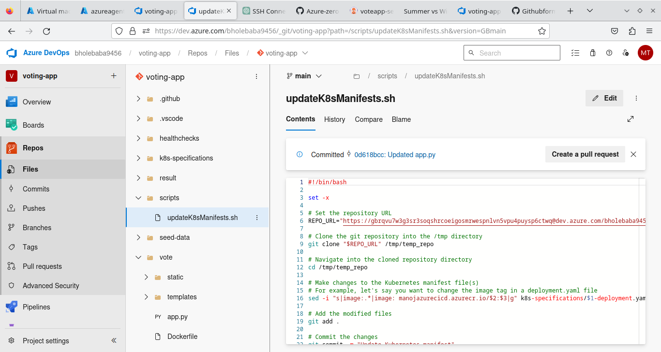
at the end this is our voting application which is successfully deployed in our AKS.
