## Abstraction

* Abstract classes are class that contains one or more abstract methods.
* Abstract method is a method that is declared but no implementation
* Abstract classes cannot be instantiated and require subclasses to provide implementation for the abstract methods.
* Subclasses of an abstract class in python are not required to implement abstract method of the parent class.
* In order to create abstract class and abstract method, require to import “ABC” and “abstractmethod” from ABC module.

When try to instantiate the abstract class and call, error will throw

Call the abstract class via a subclass.

Note: when the abstract class contains two abstract methods, the subclass is trying to call one abstract method, error will be thrown stating “Can't instantiate abstract class B with abstract method <name of the abstract method that not included>”. If try that abstract class with another subclass, object can be created to instantiate the class.

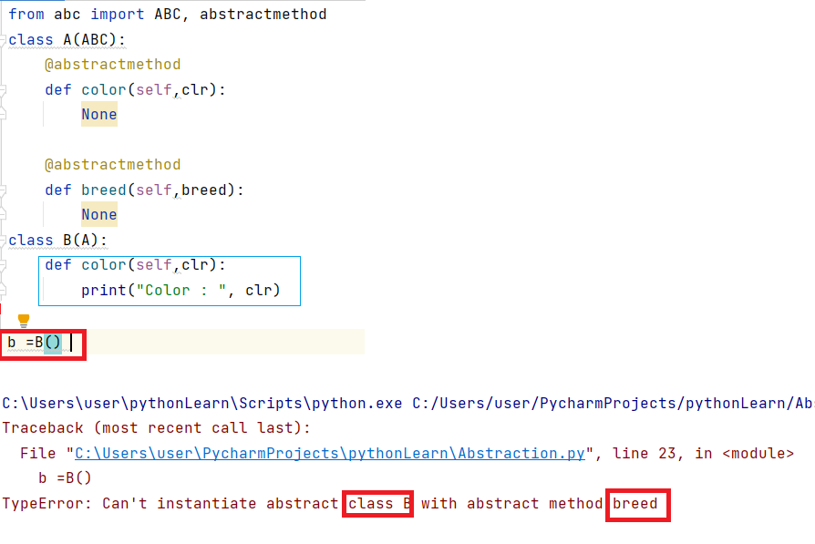

With another subclass (C) with not implemented abstract method (breed) in class B

