## Encapsulation

In an Object Oriented Python Program, you can restrict access to methods and variables. This can prevent the data from being modified by accident and is known as encapsulation. Encapsulation can be achieved using private variables and private methods.

Class with a public variable, can call within and outside the class

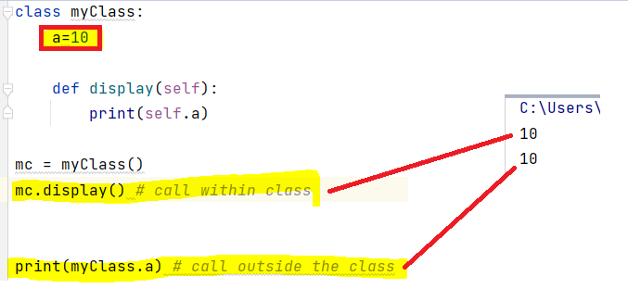

Class with a private variable (starts from __) , can call only inside the class but not call outside the class and throw error.

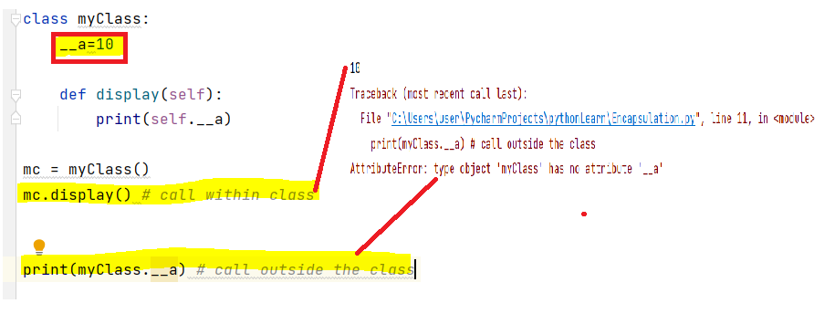

Class with a public method, can call within and outside the class and Class with a private method (starts from __) , can call only inside the class method but not call outside the class and throw error.

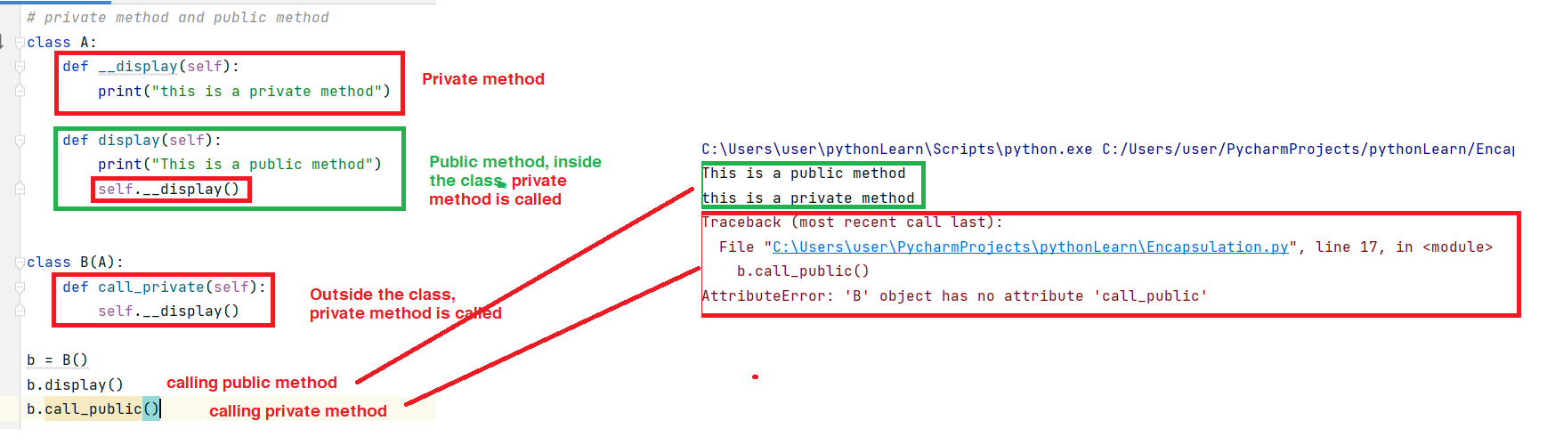

Modify the private variable by indirectly.

