## File Handling

Python has several functions for creating, reading, updating, and deleting files.

Open() – takes two arguments, filename and mode. There are four different methods (modes) for opening a file.

"r" - Read - Default value. Opens a file for reading, error if the file does not exist

"a" - Append - Opens a file for appending, creates the file if it does not exist

"w" - Write - Opens a file for writing, creates the file if it does not exist

"x" - Create - Creates the specified file, returns an error if the file exists

"t" - Text - Default value. Text mode

"b" - Binary - Binary mode (e.g. images)

## Write() – content will be written in the file

Output:

## Read([5])— Read and Return specified number of characters from the file

## 

## Read()— Read entire contents of the file

## Readline () — returns the next line of the file

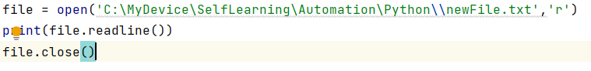

## Readlines()—read all the lines of the file and display in array list.



## A—Append the file

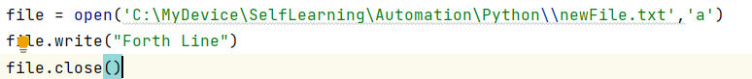

## Loop

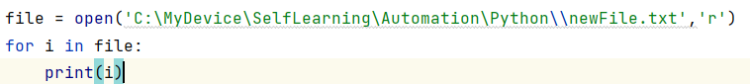

rstrip(): This function strips each line of a file off spaces from the right-hand side.

lstrip(): This function strips each line of a file off spaces from the left-hand side.

Close()— close the file

Delete a file — To delete a file, you must import the OS module, and run its os.remove() function

## Check if File exist

import os  
if os.path.exists("demofile.txt"):  
 os.remove("demofile.txt")  
else:  
  print("The file does not exist")

## Delete Folder

To delete an entire folder, use the os.rmdir() method:

import os  
os.rmdir("myfolder")