## Inheritance

Allows to inherit all the methods and properties of another class to a particular class.

* **Parent Class /Super Class/ Base Class** is the class being inherited from.
* **Child Class/Sub Class/Derived Class** is the class that inherits from parent class.

## Types of Inheritance

* Single : one child class inherits one parent class
* Multi-Level : both child class and child class of child class inherit parent class
* Hierarchical : two different child classes inherit one parent class
* Multiple : one child class inherits two parent classes
* Hybrid : combination of Hierarchical and Multiple

## Single Inheritance

### Create a Parent Class

Create a class named Person, with firstname and lastname properties, and a printname method

### Create a child class

Create a class named Student, which will inherit the properties and methods from the Person class, and then execute the printname method. Use the **pass** keyword when you do not want to add any other properties or methods to this child class.

## Multi-level Inheritance

## Hierarchical Inheritance

## Multiple Inheritance

## Hybrid Inheritance

## Add the __init__() Function

__init__() function is called automatically every time when the class is being used to create a new object.

If want to use this function to the child class instead of “pass”, the child class will no longer inherits the parent __init__() function. Because child __init__() function overrides the parent __init__() function.

To keep the inheritance from parent class, parent’s __inti__() function need to add under the child __init__() function by calling to the parent __init__() function with child properties.



## Use the super() Function

Python also has a super() function that will make the child class inherit all the methods and properties from its parent.

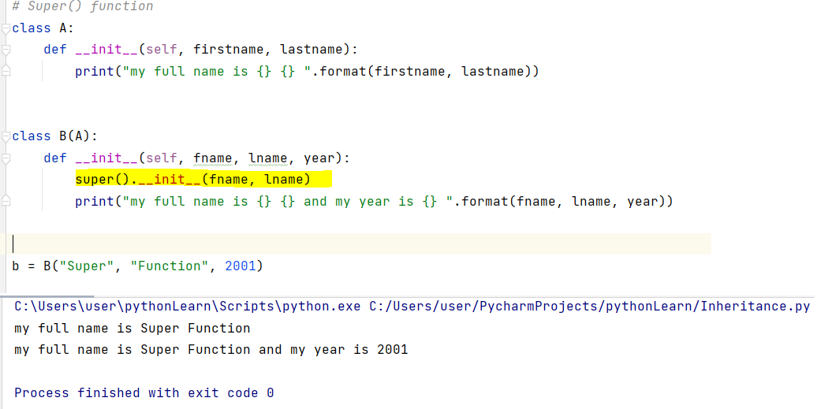By using the super() function, you do not have to use the name of the parent element as well as the “self” keyword, it will automatically inherit the methods and properties from its parent.

Add Method to child class and call properties from parent class

