## Modules

File creating with methods or functions or variables and save with.py extension is called as a module.

Module can create in many ways. Only using functions or or only using variables or only using methods or mixing all.

**Create Modules with different functions**

Create two modules with functions and call them from another file by

* importing only modules,
* importing Module’s Functions Separately,
* importing * Module’s Functions at once,

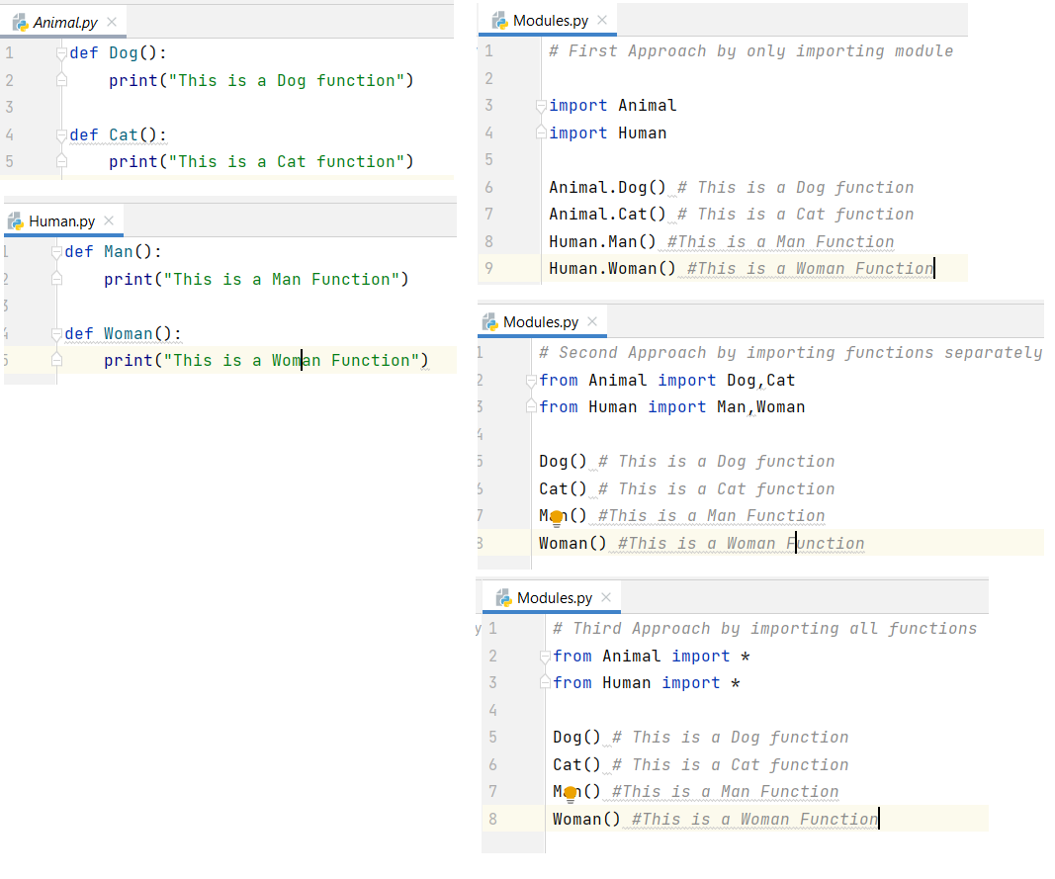

**Create Modules with same functions**

Import the module one after calling relevant function. Otherwise, the function will be executed based on the latest import.

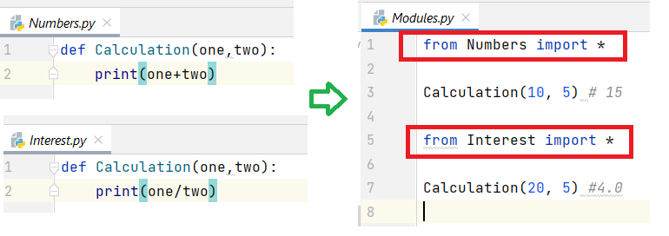

**Create Modules with different class methods**

Create two modules with class methods and call them from another file by

* importing only modules,
* importing Module’s class

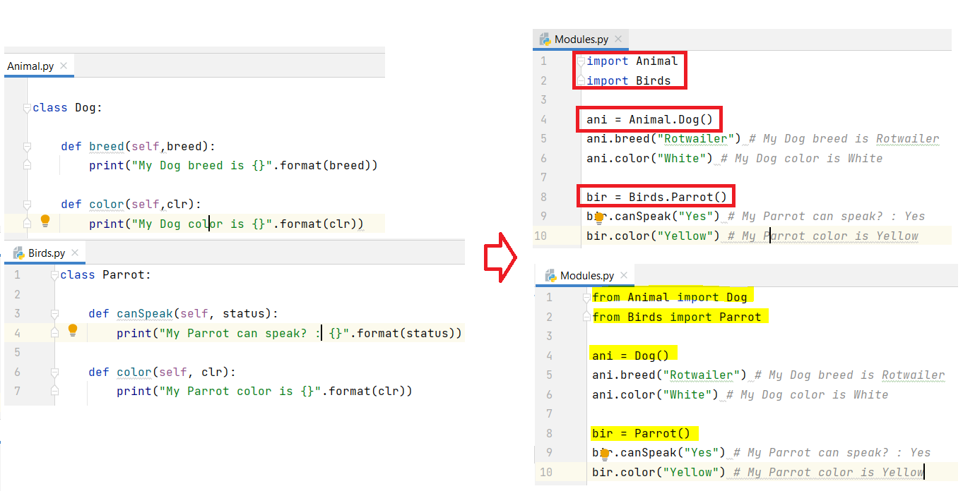

## Creating Module with Variables

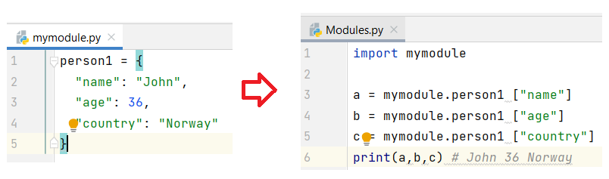

## Renaming Module

You can create an alias when you import a module, by using the as keyword:

Create an alias for “mymodule” called mm

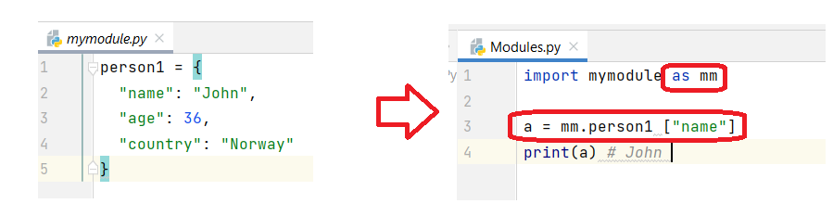

## Using the dir() Function

List all the functions available in a module use this built-in function.

