## Polymorphism

This concept can be achieved through Overriding and Overloading concepts.

Sometimes an object comes in many types or forms. If we have a button, there are many different draw outputs (round button, check button, square button, button with image) but they do share the same logic: onClick().

We access them using the same method. This idea is called **Polymorphism**.

## Method Overriding

Override means having two methods with same name but doing different tasks. It means that one of the methods, overrides the other.

i.e., if there is any method in the superclass and a method with the same name in a subclass, then by executing the method with sub class object, the method of the subclass will be executed.

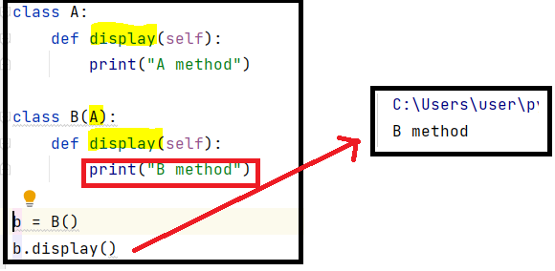

## Method Overloading

In python, method can be defined with single or multiple parameters, and it can be called in many ways.

Simplified meaning is, same method can be executed in different ways based on the inputs.

