What is a Jenkins Pipeline?  
Ans:

*This is the user-defined block, which includes all of the processes like build, test, and deploy. It is a set of all JenkinsFile stages. This block contains all of the stages and steps. It's a collection of stages and steps that make Jenkins easier to use for integrating and implementation of****continuous delivery pipelines****.****Syntax:***

pipeline{

// stages

//steps

}

## What is Jenkins Node? Ans:

*A machine on which Jenkins runs is called Jenkins Node.****Syntax of node block:***

node{

}

## What is Jenkins Stage? Ans:

*This block includes a pipeline with a series of steps. In other words, a stage is where the build, test, and deploy stages all come together. A stage block is a visual representation of the Jenkins pipeline process. Consider the following example for multiple stages, each of which performs a particular task:*

[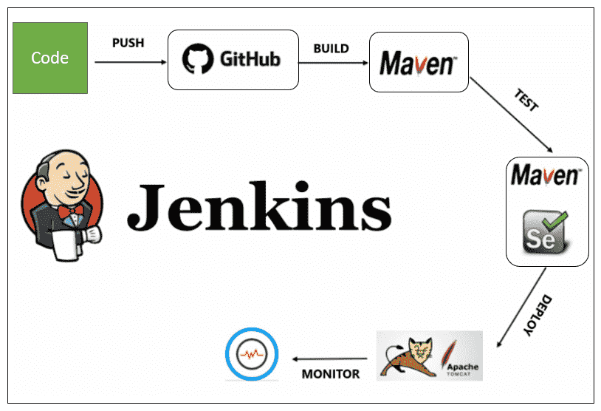](https://www.techgeeknext.com/img/cicd/jenkins/jenkins-pipeline.PNG)

pipeline {

any agent

stages {

stage ('Build') {

//step...

}

stage ('Test') {

//step...

}

stage ('Deploy') {

//step...

}

stage ('Monitor') {

//step...

}

}

}

## What is Steps in Jenkins? Ans:

*A step is a single task that performs a specific task at a specific time. A pipeline is made up of a set of steps that are specified within a stage block.*

pipeline {

any agent

stages {

stage ('Build') {

steps {

echo 'Started build phase...'

}

}

}

}

## What is the use of JenkinsFile in Jenkins tool? Ans:

*JenkinsFile is a text file, used to define Jenkins Pipeline steps. JenkinsFile can be used to implement pipelines as code, and this can be described using a DSL (Domain Specific Language). You may use JenkinsFile to write down the steps needed to run a Jenkins Pipeline.*

## What is Jenkins Job DSL? Ans:

*Jenkins Job DSL (Domain Specific Language) is a plugin that enables us to programmatically define jobs with relatively little effort. The Jenkins job DSL plugin was designed to make job management easier.*