Name a few Git commands with their function.

* Git config - Configure the username and email address
* Git add - Add one or more files to the staging area
* Git diff - View the changes made to the file
* Git init - Initialize an empty Git repository
* Git commit - Commit changes to head but not to the remote repository

### What does git pull origin master do?

The git pull origin master fetches all the changes from the master branch onto the origin and integrates them into the local branch.

git pull = git fetch + git merge origin/ master

### Difference between git fetch and git pull.

|  |  |
| --- | --- |
| Git Fetch | Git Pull |
| The Git fetch command only downloads new data from a remote repository. | Git pull updates the current HEAD branch with the latest changes from the remote server. |
| It does not integrate any of these new data into your working files. | Downloads new data and integrate it with the current working files. |
| Command - git fetch origin  git fetch --all | Tries to merge remote changes with your local ones.  Command - git pull origin master |

### What do you understand about the Git merge conflict?

A [Git merge conflict](https://www.simplilearn.com/tutorials/git-tutorial/merge-conflicts-in-git) is an event that occurs when Git is unable to resolve the differences in code between the two commits automatically.

Git is capable of automatically merging the changes only if the commits are on different lines or branches.

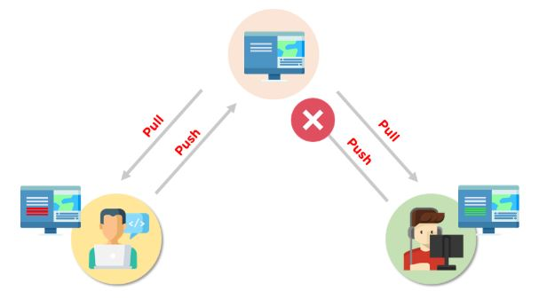

How do you resolve conflicts in Git?

Here are the steps that will help you resolve conflicts in Git:

* Identify the files responsible for the conflicts.
* Implement the desired changes to the files
* Add the files using the git add command.
* The last step is to commit the changes in the file with the help of the git commit command

### What is the functionality of git ls-tree?

The git ls-tree command is used to list the contents of a tree object.

### What is the process to revert a commit that has already been pushed and made public?

There are two processes through which you can revert a commit:

1. Remove or fix the bad file in a new commit and push it to the remote repository. Then commit it to the remote repository using:

git commit –m “commit message”

2. Create a new commit to undo all the changes that were made in the bad commit. Use the following command:

git revert <commit id>

### How is a bare repository different from the standard way of initializing a Git repository?

|  |  |
| --- | --- |
| Standard way | Bare way |
| You create a working directory with the git init command. | Does not contain any working or checked out copy of source files. |
| A .git subfolder is created with all the git-related change history. | Bare repositories store git revision history in the root folder of your repository instead of the .git subfolder. |

### What is Git stash?

Let’s say you're a developer and you want to switch branches to work on something else. The issue is you don’t want to make commits in uncompleted work, so you just want to get back to this point later. The solution here is the Git stash.

Git stash takes your modified tracked files and saves it on a stack of unfinished changes that you can reapply at any time. To go back to the work you can use the stash pop.

### What does the git reset --mixed and git merge --abort commands do?

git reset --mixed is used to undo changes made in the working directory and staging area.

git merge --abort helps stop the merge process and return back to the state before the merging began.

How do you find a list of files that has been changed in a particular commit?

The command to get a list of files that has been changed in a particular commit is:

git diff-tree –r {commit hash}

* -r flag allows the command to list individual files
* commit hash lists all the files that were changed or added in the commit.

### What is the use of the git config command?

The git config command is used to set git configuration values on a global or local level. It alters the configuration options in your git installation. It is generally used to set your Git email, editor, and any aliases you want to use with the git command.

### If you recover a deleted branch, what work is restored?

The files that were stashed and saved in the stashed index can be recovered. The files that were untracked will be lost. Hence, it's always a good idea to stage and commit your work or stash them.