Route 53 Important Topics

1.Dynamic DNS Update with Lambda when IP Change of an EC2

EC2 Public IP change => Lambda Triggers to Update => DNS record

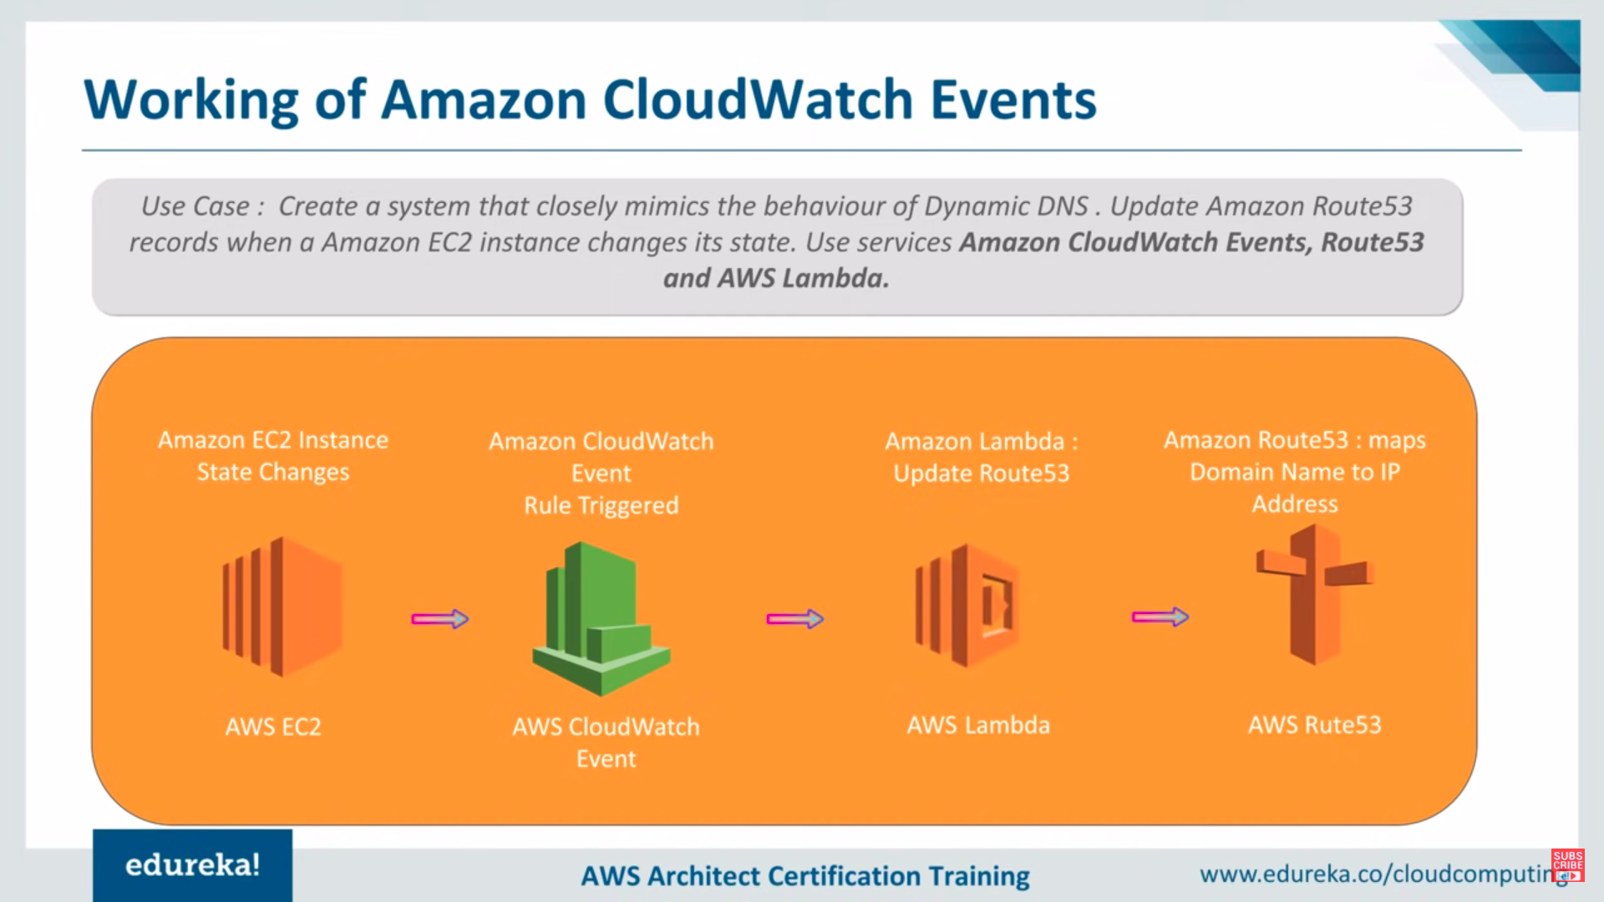

2. Whenever an EC2 Instance Created or deleted or change its state => Lambda Triggers => Updates changes in Route 53 Record

