Cloud watch Imp Topics

3. Cloud watch Components OR Concepts to gain

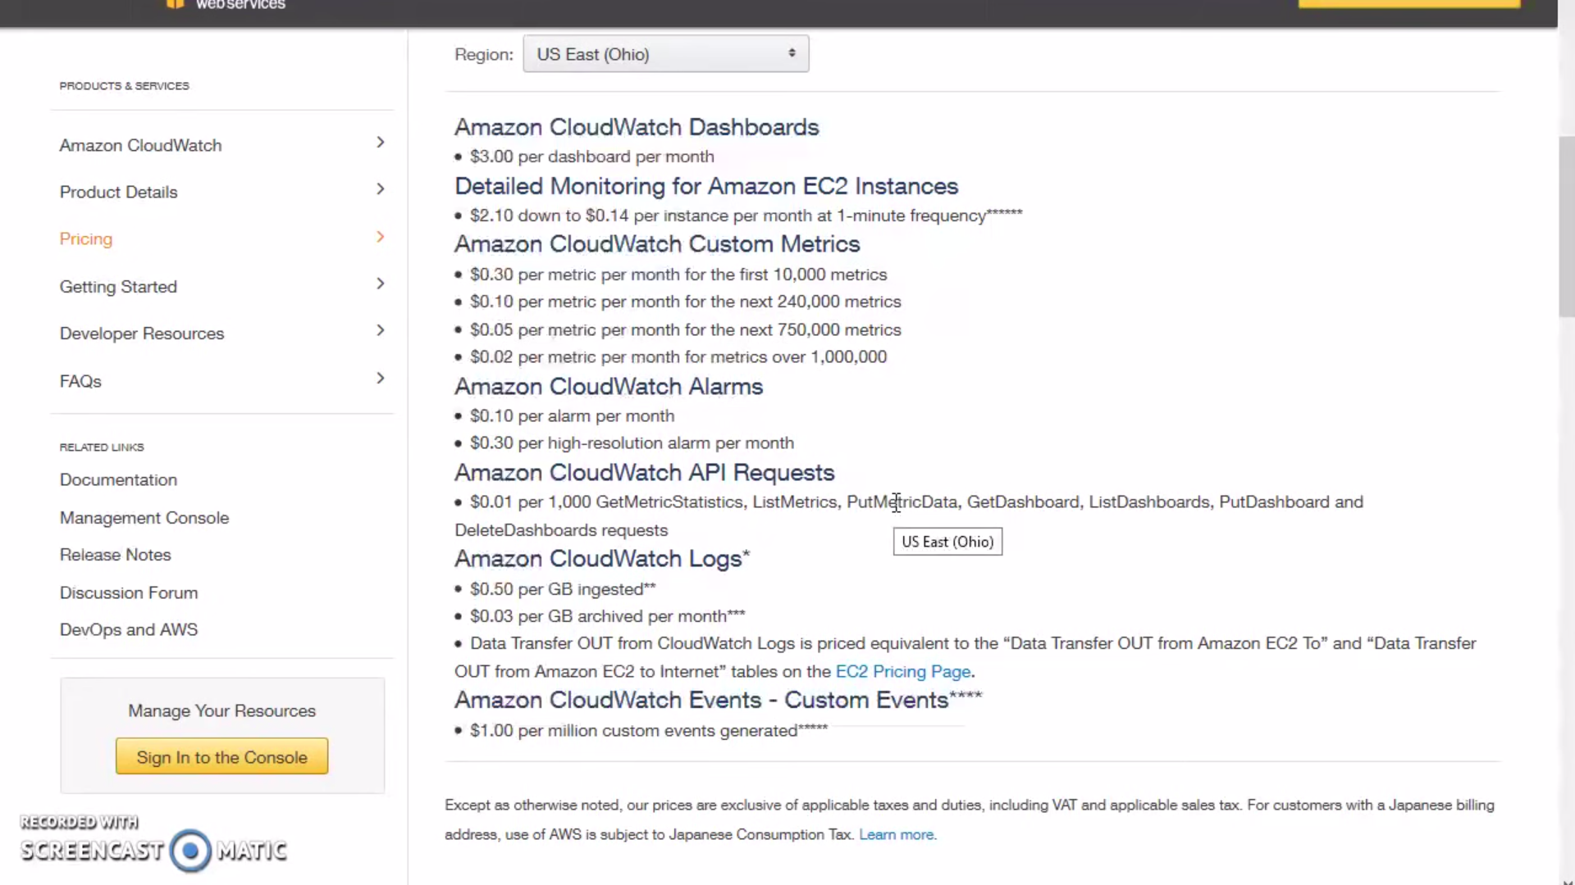

4. Cloud watch integration

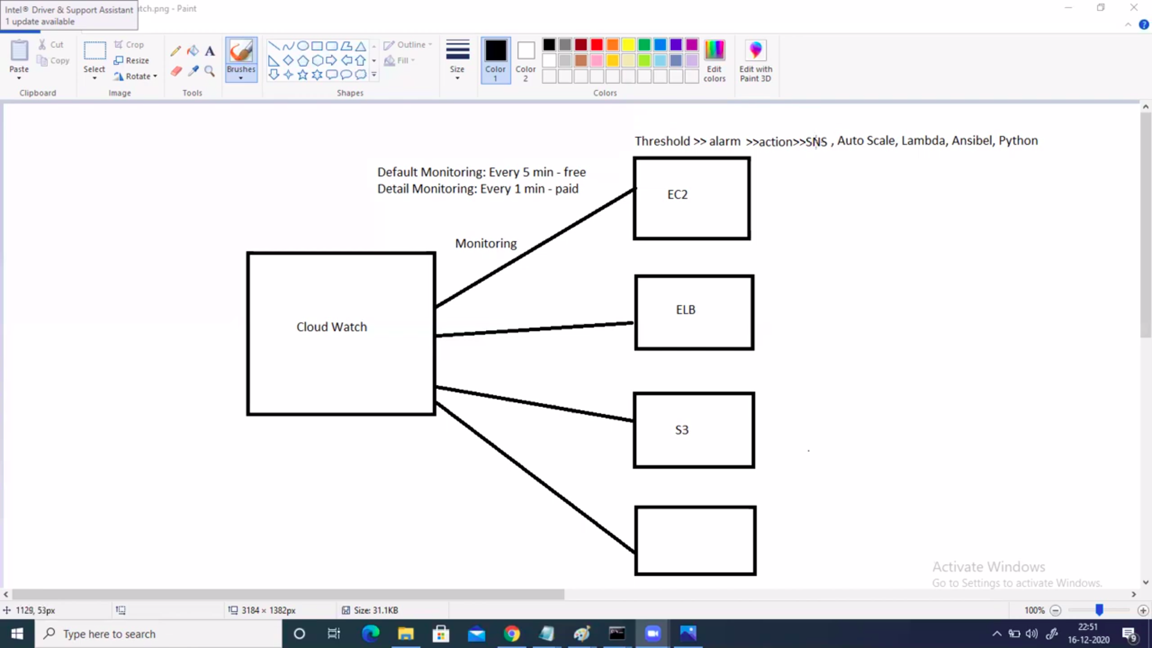

5. Cloud watch Action Steps:

Plan=Chose the matrices,
Do = Implement the matrices in Cloud watch /Cloud formation
Check = Check the resulting monitoring
Act = DO the improvements = merge into your AWS Infrastructure

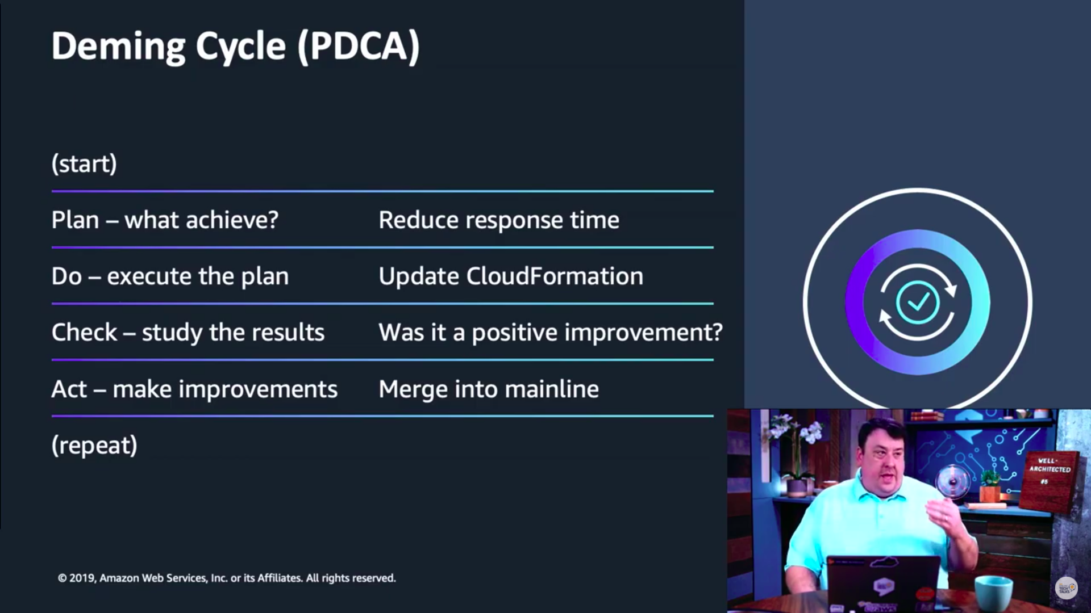

5. in Text chart in the dashboard we can run playbooks = Actions against alarms

