TABLE OF CONTENTS

1.INTRODUCTION

  - Literature Survey

2. SOFTWARE REQUIREMENTS SPECIFICATION
2.1 Functional Requirements
2.1.1 Module Description
2.1.2 Functional Requirements

2.2 Non-functional Requirements

2.2.1 Performance requirements

2.2.2 Design constraints

2.2.2.1 Hardware Requirements

      - Software Requirements

      - Logical Database Requirements

2.3 Specific Requirements

2.3.1 Interface Requirements

2.3.2 Development Environment Requirments

2.3.2.1 Eclipse IDE

      - MySql Administrator

2.4 Software Architecture

3. SYSTEM DESIGN

3.1 UML Diagrams
3.1.1 Use Case Diagrams

3.1.2 Class Diagram

3.1.3 State Transition Diagram

3.1.4 Component Diagrams

3.1.5 Deployment Diagram

3.2. Database Design

3.2.1 Admin Table

3.2.2 Company Table

3.2.3 Employee Table

3.2.4 Project Table

4. SYSTEM IMPLEMENTATION

4.1 Servlets

4.2 Hypertext Transfer Protocol (HTTP)

4.3 JAVA Database Connectivity (JDBC)

4.4 Structured Query Language (SQL)

4.5 Modules
4.5.1 Employee Module Implementation
4.5.2 Report Module Implementation:
4.5.3 Company Module Implementation:
4.5.4 Project Module Implementation:

5. TESTING

5.1 Employee Module
5.2 Company Module
5.2 Report Module
5.3 Screen Shots
CONCLUSION
REFERENCES

1.INTRODUCTION

A Human Resources Management System (HRMS) or Human Resources Information System (HRIS) refers to the systems and processes at the intersection between human resource management (HRM) and information technology.

The HR centre is a powerful application designed to allow companies to streamline their human resource tasks and manager their employees more efficiently:
Employee and Company Information
Employee Time, Attendance, and Leave Request
HR Documentation Management (i.e. insurance forms, W-2’s etc.)

The HR Centre includes a comprehensive employee information database, where employers can information, work information, beneficiary information, and more for each employee.

HRMS develops a software application that supports the application specific to the HR Automation in an intranet specific to a company there by allowing the interaction of all the employees pertaining to that organization. It keeps track of all the other departments related to that organization like marketing, development etc.

HRMS allow the HR of an organization to update the employee details whenever there is a change in the employee profile pertaining to that organization. It brings on to a string the employee specification suggestions and makes them sure to post their requirements to the HR.

This project can be used to identify an employee in the organization. The project maintains the details of the entire employee. Each employee is given with different employee Id.

The function of human resources (HR) departments is generally administrative and common to all organizations. Organizations may have formalized selection, evaluation, and payroll processes. Efficient and effective management of "human capital" progressed to an increasingly imperative and complex process. The HR function consists of tracking existing employee data which traditionally includes personal histories, skills, capabilities, accomplishments and salary. To reduce the manual workload of these administrative activities, organizations began to electronically automate many of these processes by introducing specialized human resource management systems. HR executives rely on internal or external IT professionals to develop and maintain an integrated HRMS.

1.1 Literature Survey

- EXISTING SYSTEM

The HR Administration falls short of controlling the employee’s activities in analyzing his/her strengths and weakness. The decision for appraisal of assigning next project to the employee or to train him/her to enhance the skills – where lies with proper projection. He is not provided with the detailed project information done or to be assigned based on Application / Verticals.

DRAWBACKS IN EXISTING SYSTEM

- Need of extra manual effort.
- It used to take much time to find any employee
- Not very much accurate.
- Danger of losing the files in some cases.

(b) PROPOSED SYSTEM

Decision in assigning proper skilful hands for the project is an important issue in
HR Module. The HR Administrator should report with the personal holding the necessary skills required for the project assignment. The decision in making analysis about the employee’s skills is a prime important before booting in.

The proposed system of HR Module is the right software to be incorporated into the Automation of HR Software for helping the organization needs with respect to skillful Human Resource.

The proposed system provides detail general information about the employee along with Educational, Certification, Skill and Project details. It enhances the HR Management in adding, viewing and updating employees’ details and generates various reports regarding employee’s skill and experience. Suggestions and Grievances posted by the employees are upheld for taking care of the necessary steps in forwarding company’s obligation.

ADVANTAGES OF PROPOSED SYSTEM

- Very fast and accurate.
- No need of any extra manual effort.
- No fever of data loss.
- Just need a little knowledge to operate the system.
- Doesn’t require any extra hardware device.

2. SOFTWARE REQUIREMENTS SPECIFICATION
2.1 Functional Requirements
2.1.1 Module Description
The list of modules incorporated with “Human Resource Management System” is

Employee Information Module

This module deals with the management of the employee information such as the personal details name, qualification, skill, experience, login id, password, etc., Importance of modules in any software development side is we can easily understand what the system we are developing and what its main uses are. At the time of project we may create many modules and finally we combine them to form a system person, so that it can be easily added to the database with any duplication of the data.

Company Information Module

This module deals with the management of the company information such as company name, year of establishment and other details like address, website, contact number, etc.

Project Management Module

This module deals with the management of the projects related with the employee like -projects that were past dealt, current projects in his account, etc.

Payroll Module

The payroll module automates the pay process by gathering data on employee time and attendance, calculating various deductions and taxes, and generating periodic pay checks and employee tax reports. Data is generally fed from the human resources and time keeping modules to calculate automatic deposit and manual check writing capabilities. This module can encompass all employee-related transactions as well as integrate with existing financial management systems.

Time and Attendance Module

The time and attendance module gathers standardized time and work related efforts. The most advanced modules provide broad flexibility in data collection methods, labor distribution capabilities and data analysis features. Cost analysis and efficiency metrics are the primary functions.

Media and Benefits

The benefits administration module provides a system for organizations to administer and track employee participation in benefits programs. These typically encompass insurance, compensation, profit sharing and retirement.

Reports Module

This module is specified for the purpose of the report generation for the HR on desired requests. The reports are generated in the form of graphs like bar graphs, histograms and even in the form of pie-charts.

2.1.2 Functional Requirements

In this section, we will explain the major functions of HRMS along with the data flow. So the major functionality of the project such as authentication mechanism, personal data processing, recruitment, report, and graphical user interface unit will be explained step by step.

Authentication

Login | User can login to the HRMS system with his/her username and password.
Logout | Users can logout from the HRMS system.
Login Failure | I If the user does not exist in the database or the user did not get authorized by  HRMS admin yet.

Authorization

User role check | After logging in, the user role will be checked from the database and the user interface will be created according to that role/roles.
Display | User with defined roles can display the content of the database. Being more specific, employee can only view his/her personal information. Manager can see not only his/her personal information but also employees’ information who are working under his/her coverage. Admin and HR can display their personal information and all employees’ information.
Edit | A user with employee role can edit his/her specific personal information. Manager can only edit employees’ personal information that is under his/her coverage except user role type. HR can edit all employees’ information except user role type. Admin can edit all information related to all employees’ including their user role type.
Search | User with manager role type can search the content of database for the employees who are under his/her coverage. HR and admin roles can search all the employees’ information in the database. Search feature works on specific keywords showing employees ‘characteristics, peculiarities, skills, features, and etc. For example, HR wants to find employees who are well trained in “Java Programming Language”. He/she will write the specific keyword in the search bar and press the available search button. Afterwards, he/she will find a list of all the employees’ who know “Java Programming Language”.
Report | This feature is basically used to filter the contents of the search mechanism. For instance, as we mentioned in the above search feature. The HR wants to get a report of some specific employees who know “java programming Language”. The list of employees obtained from the result of search feature he/she can get the specific report by selecting the corresponding checkbox available for each employee. Or a manager role type can get a report of some or all employees’ who are working under his/her coverage by selecting the checkbox. Except employee role type, all other role types such as admin, HR, and manager can use this feature.
Update authentication | This feature can be used only by admin role type. Admin can update the role type of a specific user. For example, an employee got promotion and his role type will be changed from employee role to manager role.  Admin will be able to update this authentication mechanism.

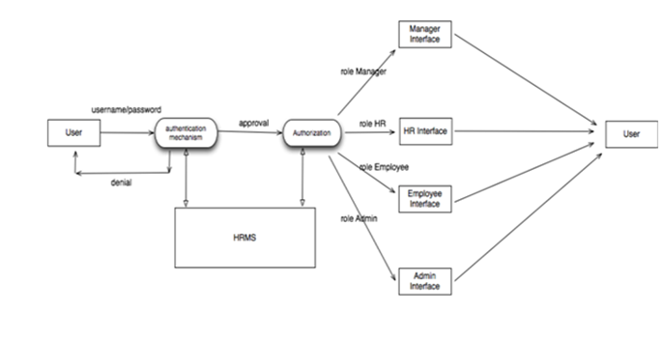Process Data

Display | User with defined roles can display the content of the database. Being more specific, employee can only view his/her personal information. Manager can see not only his/her personal information but also employees’ information who are working under his/her coverage. Admin and HR can display their personal information and all employees’ information.
Edit | A user with employee role can edit his/her specific personal information. Manager can only edit employees’ personal information that is under his/her coverage except user role type. HR can edit all employees’ information except user role type. Admin can edit all information related to all employees’ including their user role type.
Search | User with manager role type can search the content of database for the employees who are under his/her coverage. HR and admin roles can search all the employees’ information in the database. Search feature works on specific keywords showing employees’ characteristics, peculiarities, skills, features, and etc. For example, HR wants to find employees who are  well trained in “Java Programming Language”.  He/she will write the specific keyword in the search bar and press the available search button. Afterwards, he/she will find a list of all the employees’ who know “Java Programming Language”.
Report | This feature is basically used to filter the contents of the search mechanism. For instance, as we mentioned in the above search feature.  The HR wants to get a report of some specific employees who know “java programming Language”. The list of employees obtained from the result of search feature he/she can get the specific report by selecting the corresponding checkbox available for each employee. Or a manager role type can get a report of some or all employees’ who are working under his/her coverage by selecting the checkbox. Except employee role type, all other role types such as admin, HR, and manager can use this feature.
Update authentication | This feature can be used only by admin role type. Admin can update the role type of a specific user. For example, an employee got promotion and his role type will be changed from employee role to manager role.  Admin will be able to update this authentication mechanism.

2.2 Non-functional Requirements

2.2.1 Performance requirements

The number of the online user of the HRMS can be estimated as 50 at most.
There is no restriction on the number of the users to be added to the database.

Reliability
The software shall be extensively tested so that the reliability of the software can be determined under exceptional inputs and abnormal circumstances.

Maintainability
The software shall be designed keeping in mind that certain features may be required to be added in the future and/or design formats may be needed to be changed according the evolution of the educational institute that this software is being designed for.

Portability
Java programs can execute in any environment for which there is a Java run-time system. (JVM).They can be run on any platform (Linux, Window, and Mac).Java programs can be transferred over World Wide Web (e.g. applets).The software shall be platform independent. All of the code is platform independent.

2.2.2 Design constraints

2.2.2.1 Hardware Requirements

Operating System : Windows 2003, XP, 7 or 8
Hard Drive : 250 GB

Network Speed : 100 Mbp

2.2.2.2 Software Requirements

- Since HRMS application is a web-based application, internet connection must be established.
- The HRMS software will be used on PCs and will function via internet or intranet in any web browser.
- The HRMS application interface will be developed by Java (J2EE) frameworks
- The HRMS software will support JDK environment.
- The HRMS software personal database model will support MYSQL environment as DBMS.
- The HRMS will run on any platform supporting JDK technology.
- Application will run on 256MB or higher of RAM.

    - Logical Database Requirements

- Types of information used by different functions are numeric, alpha numeric and date type.
- The Database is used for every function as all functions update/retrieve data from the database
- Integrity constraints have been imposed on the database and the DBMS shall check these constraints on every function.
- The data shall be retained by the database as long as the administrator desires.
- The database shall be configured to backup automatically every day.

2.3 Specific Requirements

2.3.1 Interface Requirements

All the users will see the same page when they enter HRMS. This page asks the users for a username and a password. After being authenticated, the users will see the interface containing the information of the first tab of the user role types. This interface includes different tabs according to their role types determined by administrator during the authentication phase.

A user may have more than one role. Such a user, who has more than one role, will be able to see all the tabs that are related to his/her role types. These tabs can be named as; Personal Data Tab, Employee List Tab, Add New Employee Tab, Add New User Tab, Manage Users Tab, Users List Tab and Arrange Roles Tab.

Users who have employee role have authorization to see only Personal Data Tab, HR role gives the user a right to see Employee List Tab and Add New Employee Tab. Manager role gives the authorization to see only Manager Tab. The Admin role gives user right to see User List Tab and Arrange Roles Tab. These authorizations are default ones but an admin can change these authorizations by Arrange Roles Tab.

2.3.2 Development Environment Requirments

2.3.2.1 Eclipse IDE

- Eclipse IDE will be used for developing the HRMS web-based interface and itrelation to person database module.

- Eclipse is a multi-language software development envirnoment comprising an integrated development environment(IDE) and an extesible plug-in system. It is written mostly in Java and can be used to develop applications in Java and, by means of various plug-ins, other programming languages including Ada, C, C++, COBOL, Perl, PHP, Python, R,Ruby(including on Rails framework), Scala, Clojure, Groovy, and Scheme. It can be used to develop packages for the software Mathematica. The IDE is often called Eclipse JDT for Java programming language, Eclipse ADT (Ada Development Toolkit) for Ada, Eclipse CDT for C/C++, and Eclipse PDT for PHP.

- Eclipse is an open source community, whose projects are focused on building an opendevelopment platform comprised of extensible frameworks, tools and runtimes for building.deploying and managing software across the lifecycle.

- The Eclipse community is a not-forprofit, corporation who are members of the Eclipse community hosts the Eclipse projects and helps develop an open source community and an wolrd of complementary products and services.

2.3.2.2 MySql Administrator

- MySql Administrator or Microsoft SQL Server will be used to create, manage, and optimize the person database module.
- MySQL is a relational database management system(RDBMS)[7] that runs as a serverproviding multi-user access to a number of databases. The SQL phrase stands for Structured Query Language.
- The MySQL development platform has made its source code available under the terms of use of the GNU General Public License.
- Open source free-software projects use MySQL if it is required a full-featured database management system. Several paid editions are available for commercial use, and offer additional functionality. MySQL is also used in may high-profile, large-scale World WideWeb products, includeing Wikipedia, Goolge, Facebook, and Twitter.

  - Software Architecture

The HRMS follows the client-server architecture. Clients and servers exchange messages in a request-response messaging pattern: The client sends a request, and the server returns a response. This exchange of messages is an example of inter-process communication. To communicate, the computers must have a common language, and they must follow rules so that both the client and the server know what to expect.
The client uses the HTML and JavaScript languages to construct the GUI. The server consists of the database where the entire data related is stored and queried. The servlets are used in the server side to extend the capabilities of the server.

The following diagram illustrates the links between various components involved in this system:

HTML AND JAVASCRIPT

CLIENT SERVER
SERVLETS
DATABASE
JAVA

3. SYSTEM DESIGN

The design of a system produces the details that state how a system meet the requirements identified during system analysis. System specialists often refer to this stage as logical design, in contrast to the process of developing program software, which is referred to as physical design.

When the requirements document for the software to be developed is available the design activity begins. The main aim of design process is to produce a model or representation of the system, which can be used later to bind the system. The produced model is called design of the system. A system design is a top down approach to minimize complexity and make a problem manageable by subdivided it into smaller segments.

The most changing phase of the system development of life cycle is system design. It refers to the technical specification that will be applied in implementing the candidate system. The design phase is a translation from user oriented document to document oriented to programmers. The potential objects are thoroughly analyzed. Class hierarchies are to check whether the system is behaving the way it has to. There after the classes are individually tested and subsequently they are integrated from the overall system. This level focuses on deciding which modules are needed for system the specifications for those modules and how these modules are that interconnected.

3.1 UML Diagrams
3.1.1 Use Case Diagrams

Overall System

Login
HR
Project Management
Employee Information Maintenance
Delivering Reports
Company Information
Maintenance

Payroll Management

USER
Media and Benefits
EMPLOYEE

HR
Time and Attendance
MANAGER

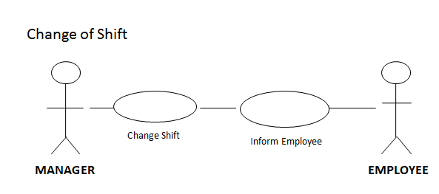

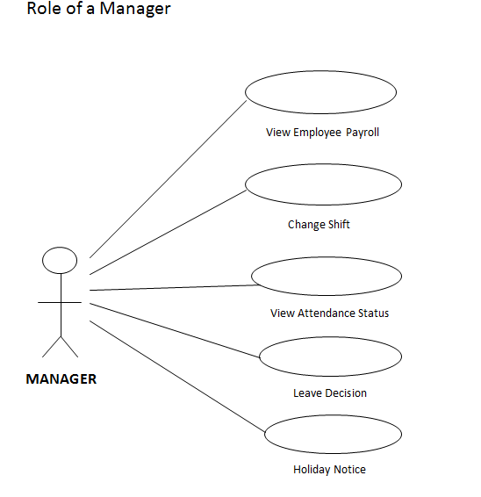

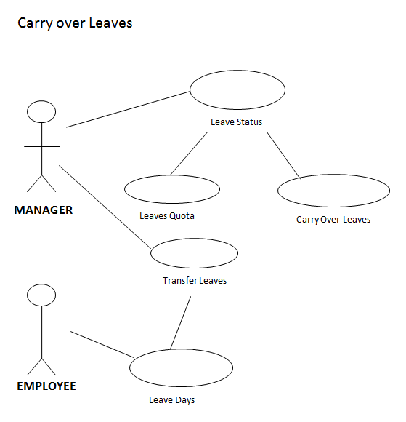

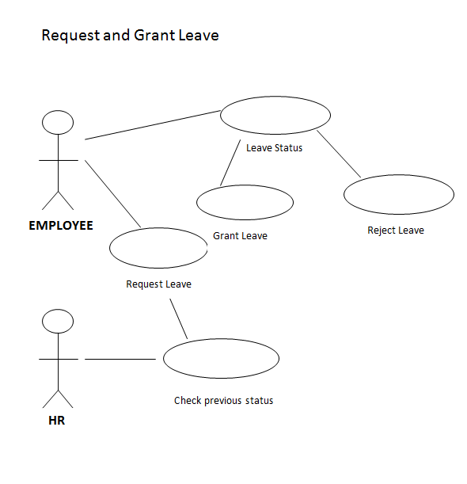

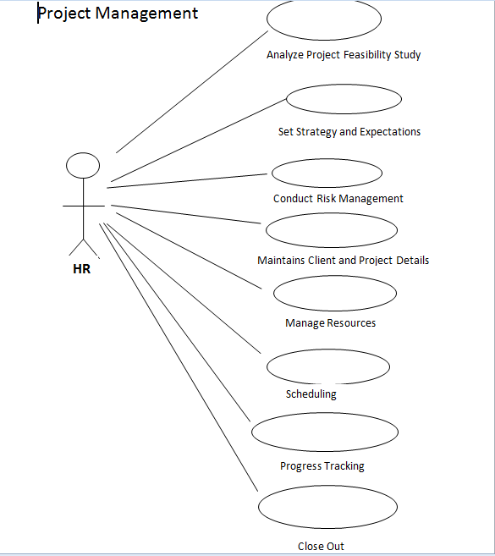

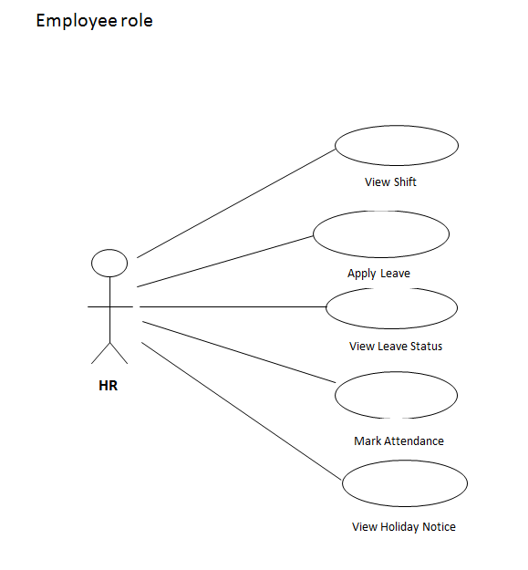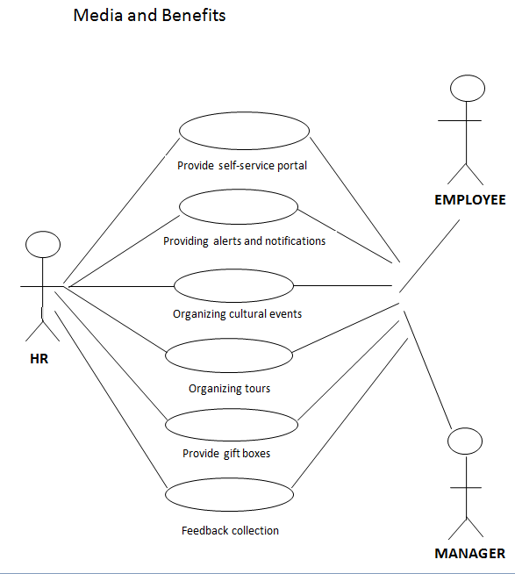

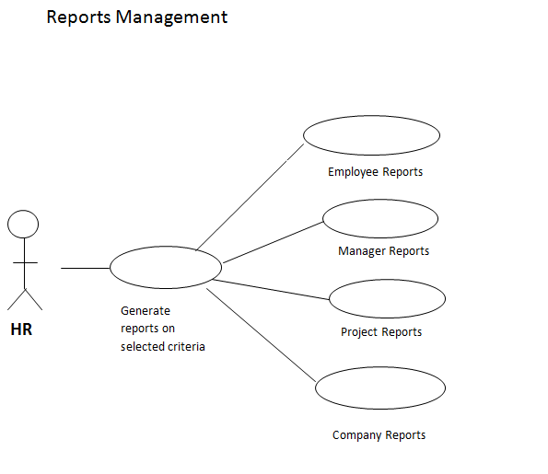

3.1.2 Class Diagram

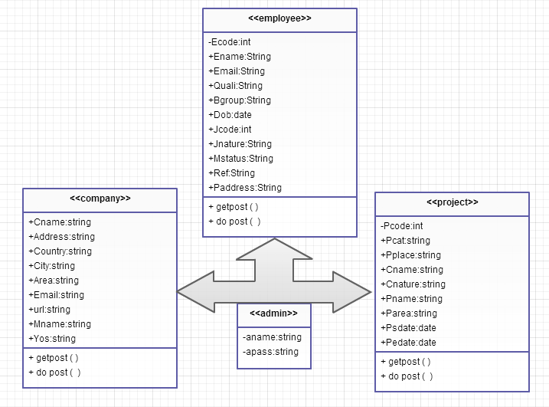

3.1.3 State Transition Diagram

Creation of New User

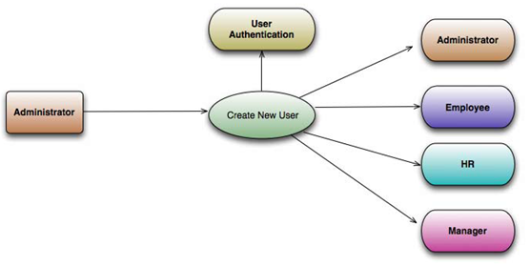

Overview

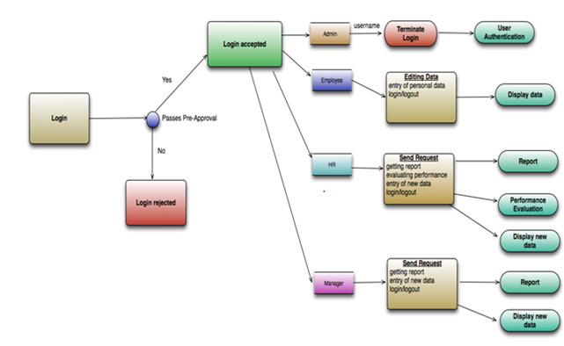
3.1.4 Component Diagrams

Overview

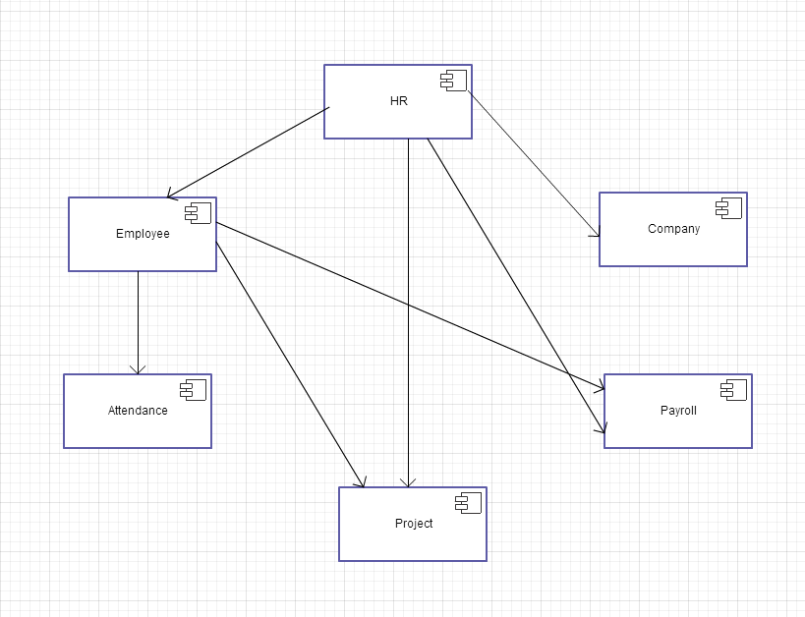

Payroll

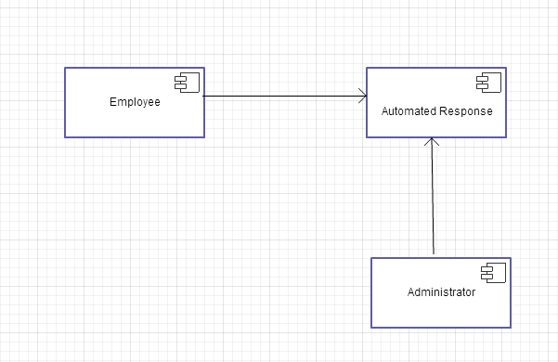

3.1.5 Deployment Diagram

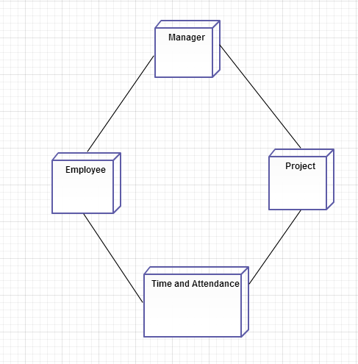

3.2. DATABASE DESIGN

3.2.1 Admin Table

Field Name | Data Type
Adminname | Text
Adminpwd | Text

3.2.2 Company Table

Field name | Data type
Cname | Text
Address | Text
Country | Text
City | Text
Area | Text
Phone | Number
Email | Text
url | Text
Mname | Text
Yos | Text

3.2.3 Employee Table

Field name | Data type
Ecode | Number
Ename | Text
Email | Text
Quali | Text
Bgroup | Text
Dob | Text
Jcode | Number
Jnature | Text
Mstatus | Text
Ref | Text
Paddress | Text

3.2.4 Project Table

Field name | Data type
Pcode | Number
Pcat | Text
Pplace | Text
Cname | Text
Cnature | Text
Pname | Text
Parea | Text
Psdate | Text
Pedate | Text

4. SYSTEM IMPLEMENTATION

After proper testing and validation, the question arises whether the system can be implemented or not. Implementation includes all those activities that take place to convert from the old system to the new. The new system may be totally new; replacing an existing module or automated system, or it may be major modification to an existing system. In either case proper implementation is essential to provide a reliable to provide a reliable system to meet organization requirements.

4.1 Servlets

- Overview

Servlets extend the request-response-oriented servers, such as Java-enabled Web servers. For example, a servlet can retrieve data from an HTML form and applying the business logic used to update an underlying database. We know that applets are used in browsers. Similarly servlets are for deploying on the server. The Servlet API assumes nothing about the server’s environment or protocol. Therefore, a servlet can be embedded in many different servers.
Client System

HTTP Server
Servlet

Product Database

- Uses
A Servlet can handle multiple requests concurrently. This property allows servlets to support many systems and requests concurrently. Servlets can be used to balance load among several servers that mirror the same content, and to partition a single logical service over several servers. Thus servlets can also be used to forward requests.

- Web Servers
A Web server receives the request it then springs into action. Depending on the type of request, the web server might look for a web page or it might execute program on the server, usually, as discussed earlier, CGI script or an advanced server-side program.

- The Servlet API
The two packages that contain the code to build the Servlets are
1. javax.servlet, and
2. javax.servlet.http

The javax.servlet package
The javax.servlet package contains a number of interfaces and classes that establish the framework in which servlets operate. The ServletRequest and ServletResponse are also very important.
- The ServletRequest interface is used to read data from a client request.
- The ServletResponse interface is used to write data to a client response.

The Servlet Interface

All servlets must implement the Servlet interface. GenericServlet must implements the Servlet and ServletConfig interface. HttpServlet extends GenericServlet. It is commonly used to servlets that receives and process HTTP requests.

GenericServlet

ServletConfig

Servlet

HttpServlet

The ServletRequest Interface
The server implements the ServletRequest interface. It enables the servlet to obtain information about a client request

- The parameter of the names passed by the client, and the names of the remote host that made the request.
- Servlets use methods such as the HTTP POST and PUT methods in an InputStream such as ServletInputStream, to get data from clients that use application protocols

The HttpServletRequest interface contains methods for accessing HTTP-specific header information.

The ServletResponse Interface
The ServletResponse interface is implemented by the server. It enables to obtain information about a client response

- It allows the Servlet to set the content length.
- The Servlet can send the reply data which writer writes through an output stream such as ServletOutputStream.

The HttpResponse interface contains methods that allow the Servlet to manipulate HTTP-specific header information.

4.2 Hypertext Transfer Protocol (HTTP)

The Hypertext Transfer Protocol (HTTP) is used as an application-level protocol for distributed, collaborative, hypermedia information systems. A feature of HTTP is the typing and negotiation of data representation, allowing systems to be built independently of the data being transferred. The HTTP protocol is a request/response protocol.

The javax.servlet.http Package
The javax.servlet.http package contains several interfaces and classes that are commonly used by Servlet developers.

Http Request and Responses
The Http Requests and Responses contains in two arguments
- An HttpServletRequest is used to enables Servlets to read data from an HTTP request.
- An HttpServletResponse is used to enables Servlets to write data to an HTTP response.

HttpServletRequest Object
An HttpServletRequest Object enables to access the data from the client.
- The getParameter method returns the value of a named parameter and similarly the getParameterValues method returns an array of values for the named parameter.
- The getReader method returns the BufferedReader to use to read the data.
- The getInputStream method returns the ServletInputStream to use to read the data.

HttpServletResponse Objects
An HttpServletResponse object provides the HTTP method to return the data to the user.
- The getWriter method returns a Writer.
- The getOutputStream method returns the ServletOutputStream.

HTTP Header Data
The HTTP header data means to access Writer or OutputStream. For example, the GET and POST for HTTP requests to which the service method includes
- The handling for GET requests returns to doGet, Conditional GET and HEAD requests.
- The handling for POST requests returns to doPost.
- The handling for PUT requests returns to doPut.
- The handling for DELETE requests returns to doDelete.

Life Cycle of Servlet
Each Servlet has the same life cycle

- Sever loads and initializes the servlets calls the init () method.
- The sever handles zero or more client requests calls the service () method.
- The server removes the servlets calls the destroy () method.

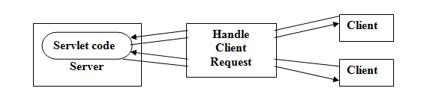

4.3 JAVA Database Connectivity (JDBC)
JDBC And ODBC In JAVA
Most popular and widely accepted database connectivity called Open Database Connectivity (ODBC) is used to access the relational databases. It offers the ability to connect to almost all the databases on almost all platforms. Java applications can also use this ODBC to communicate with a database. Then why do we need JDBC? There are several reasons:
ODBC API was completely written in C language and it makes an extensive use of pointers. Calls from Java to native C code have a number of drawbacks in the security, implementation, robustness and automatic portability of applications.
ODBC is hard to learn. It mixes simple and advanced features together, and it has complex options even for simple queries.
ODBC drivers must be installed on client’s machine.

Architecture of JDBC
JDBC Architecture contains three layers
Application Layer: Java program that wants to get a connection to a database. It needs the information from the database to display on the screen or to modify the existing data or to insert the data into the table. It tries to find the appropriate driver by iterating through all the available drivers, which are currently registered with Device Manager. After finding out the right driver, it connects the application to appropriate database.
JDBC Application
Driver Manager
JDBC Drivers

Driver Manager: The layer is the backbone of the JDBC architecture. Driver Manager manages the set of Java Database Connectivity (JDBC) drivers that are available for an application to use. Applications can use multiple JDBC drivers concurrently if necessary. Each application specifies a JDBC driver by using a Uniform Resource Locator (URL). By passing a URL for a specific JDBC driver to the Driver Manager, the application informs the Driver Manager about which type of JDBC connection should be returned to the application.

JDBC Driver layers: This layer accepts the SQL calls from the application and converts them into native calls to the database and vice-versa. A JDBC Driver is responsible for ensuring that an application has consistent and uniform m access to any database.

When a request is received by the application, the JDBC driver passes the request to the ODBC driver; the ODBC driver communicates with the database, sends the request, and gets the results. The results will be passed to the JDBC driver and in turn to the application. So, the JDBC driver has no knowledge about the actual database, it knows how to pass the application request o the ODBC and get the results from the ODBC.

The JDBC and ODBC interact with each other, how? The reason is both the JDBC API and ODBC are built on an interface called “Call Level Interface” (CLI). Because of this reason, the JDBC driver translates the request to an ODBC call. The ODBC then converts the request again and presents it to the database. The results of the request are then fed back through the same channel in reverse.

4.4 Structured Query Language (SQL)

SQL (Pronounced Sequel) is the programming language that defines and manipulates the database. SQL databases are relational databases; this means simply the data is store in a set of simple relations. A database can have one or more table. You can define and manipulate data in a table with SQL commands.

You use the data definition language (DDL) commands to creating and altering databases and tables.

You can update, delete or retrieve data in a table with data manipulation commands (DML). DML commands include commands to alter and fetch data.

The most common SQL commands include commands is the SELECT command, which allows you to retrieve data from the database.

4.5 Modules

The implementation of the various modules describing the various classes in Human Resources Management System:

Program Name | Program Description
New User Sign | This program helps to get the Personnel Information Details (i.e.) getting the information of Customer’s name, his password, sex, contact address etc.
User Login | Selects the name and password from the stored details of the database using SQL query.

4.5.1 Employee Module Implementation

This module contains the following classes:

- Admins: This class is used to authenticate the administrator and the authenticated admin can log in.
- Empadd: This class is used to add a new employee to the company if the employee doesn’t exist.
- Empdelete: This class is used to delete an existing employee
- EmpEdit: This class is used to modify and update any existing employee’s details.
- EmpManage: This class is used for management of employee details.
4.5.2 Company Module Implementation:
This module contains the following classes:

- CompAdd: This class is used to add a new company details if it doesn’t exist.
- CompDelete: This class is used to delete an existing company details taking company name as reference.
- CompEdit: This class is used to modify and update any existing Company’s details.
- CompManage: This class is used for management of company details.
4.5.3 Report Module Implementation:

This module contains the following classes:

- EmpReport: This class updates the performance of the employee and stores it.
- CompReport: This class stores the reports given to the particular company.
- ProjReport: This class is used to update the timely reports on project status. Let the option to proceed further details about the onshore or the off shore projects.
4.5.4 Project Module Implementation:

This module contains the following classes:

- EmpReport: This class updates the performance of the employee and stores it.
- CompReport: This class stores the reports given to the particular company.
- ProjReport: This class is used to update the timely reports on project status. Let the option to proceed further details about the onshore or the off shore projects.

5. TESTING

Unit Testing is done throughout. All the modules are tested and exceptions are mentioned if any unexpected outcomes occur. All the input fields are validated.

5.1 Employee Module :

Following table gives the test cases when employee module is tested.

Test Case ID | Test Case Name | Input | Actual Result | Expected Result | Status | Comments/Remarks
01 | Admin Login | User ID and password in database | Login successful. | Login successful. | PASS | _
02 | Admin Login | Non-existing User ID and password | Incorrect details. Please re-enter. | Incorrect details. Please re-enter. | PASS | _
03 | Add Employee | Give emp details. | Successfully added | Successfully added | PASS | -
04 | Add Employee | Give emp details | Employee already exists. | Employee already exists. | PASS | -
05 | Add Employee | Give emp details | Data source not found | Successfully added | FAIL | -
06 | Add Employee | Give emp details | Driver not found | Successfully added | FAIL | -
07 | Delete Employee | Give emp number. | Record deleted | Record deleted | PASS | -
08 | Delete Employee | Give emp number. | Data source not found | Record deleted. | FAIL | -

5.2 Company Module
Following table gives the test cases when company module is tested.

Test Case ID | Test Case Name | Input | Actual Result | Expected Result | Status | Comments/Remarks
01 | Add Company | Enter company name | Company added successfully | Company added successfully | PASS | _
02 | Add Company | Enter company name | Company Name Already Exist, Please Try Again | Company Name Already Exist, Please Try Again | PASS | _
03 | Add Company | Enter company name | Data Source not found | Company added successfully | FAIL | -
04 | Add Company | Enter company name | Driver not found. | Company added successfully | FAIL | -
05 | Delete Company | Enter company name | Record deleted | Record deleted | PASS
06 | Delete Company | Enter company name | Data source not found | Record deleted | FAIL

5.2 Report Module

Following table gives the test cases when report module is tested.

Test Case ID | Test Case Name | Input | Actual Result | Expected Result | Status | Comments/Remarks
01 | Add project | Enter project code | Project details are stored | Project details are stored | PASS | _
02 | Add Project | Enter project code | Project code Already Exist, Please Try Again | Project details are stored | PASS | _
03 | Add Project | Enter project code | Data Source not found | Project details are stored | FAIL | -
04 | Add Project | Enter project code | Driver not found. | Project details are stored | FAIL | -
05 | Delete Project | Enter project code | Record deleted | Record deleted | PASS | -
06 | Delete Project | Enter project code | Data source not found | Record deleted | FAIL | -
07 | Edit Project | Enter project code | Record updated | Record updated | PASS | -
08 | Edit Project | Enter project code | Data source not found | Record updated | FAIL | -
09 | Project view | Enter project code | Display project details | Display project details | PASS | -
10 | Project view | Enter project code | Data not found | Data not found | PASS

5.3 Screen Shots

The following table gives the databases in Mysql,tables in Mysql and describes ‘admin’ table: field and its types.

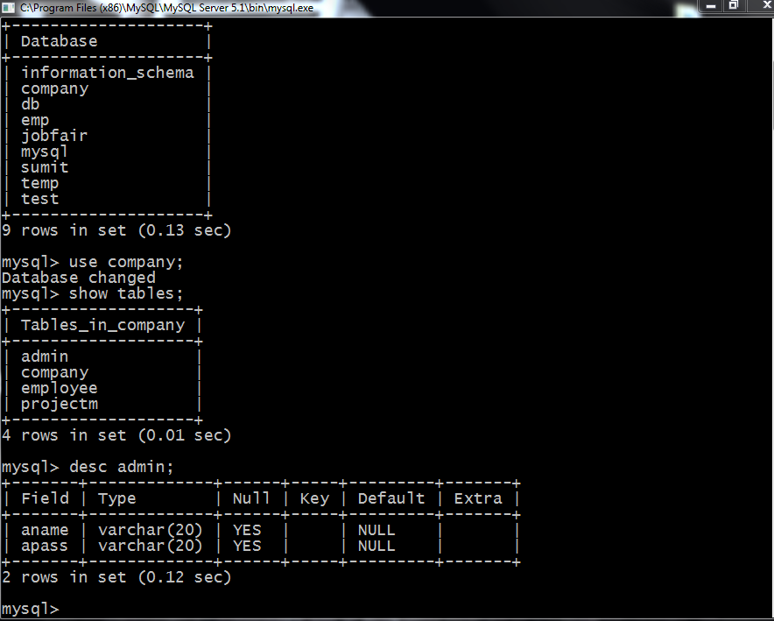

The following table shows the details in the admin table and also describes table ‘company’.
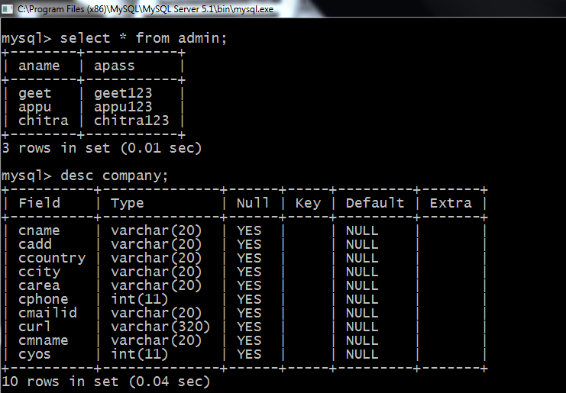
The following figure describes the employee and project table.

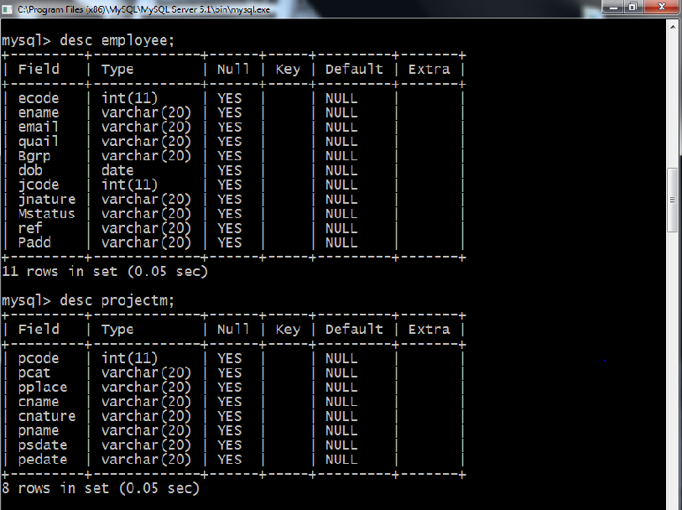

Home page :

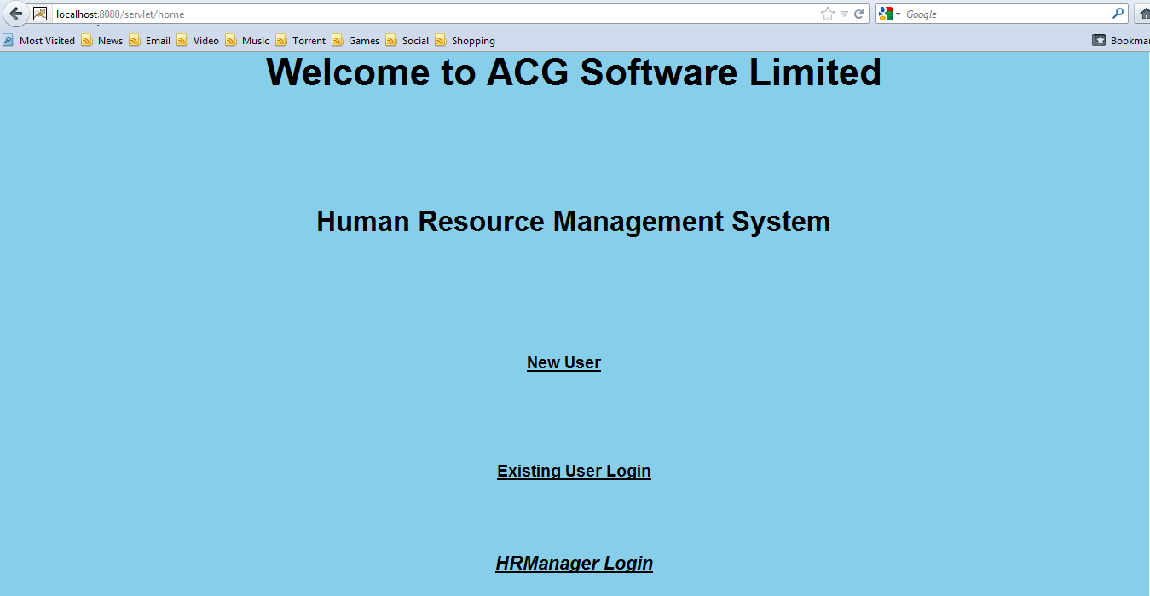

Admins login form :

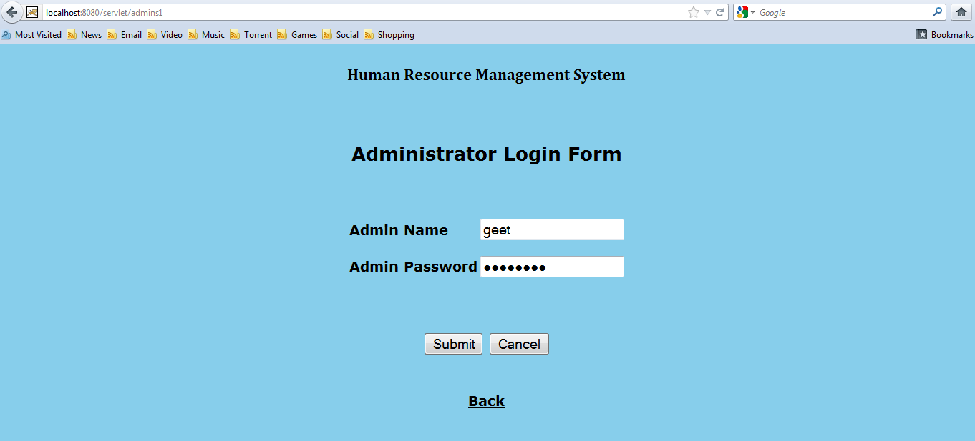

Admins module’s page after admin login :

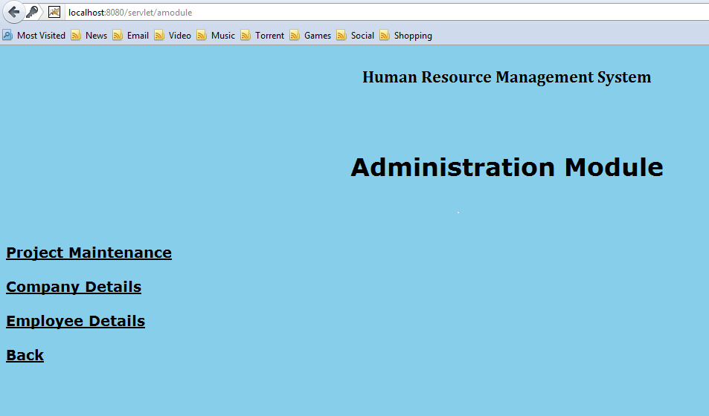

Non admin access:

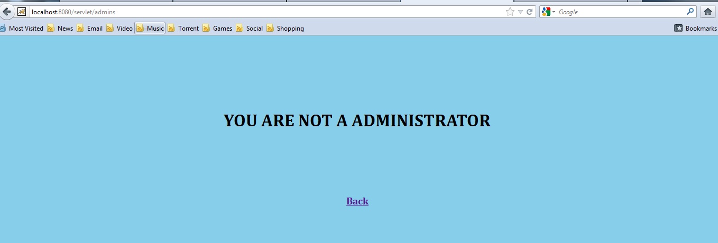

Company page:

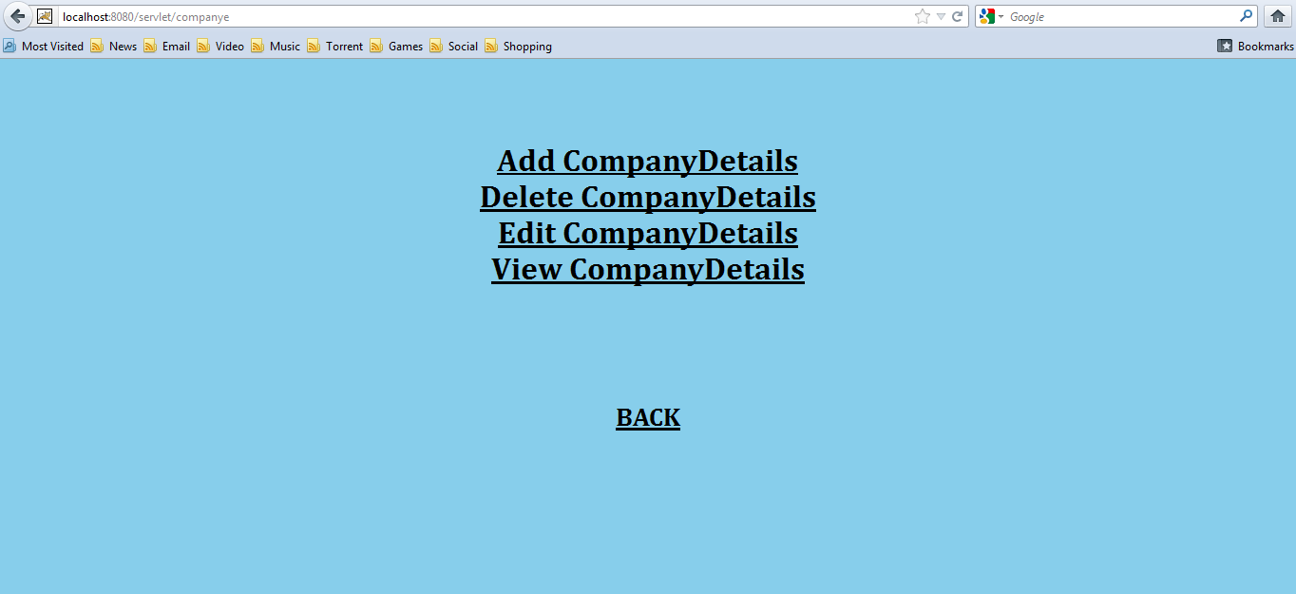

Company form page :

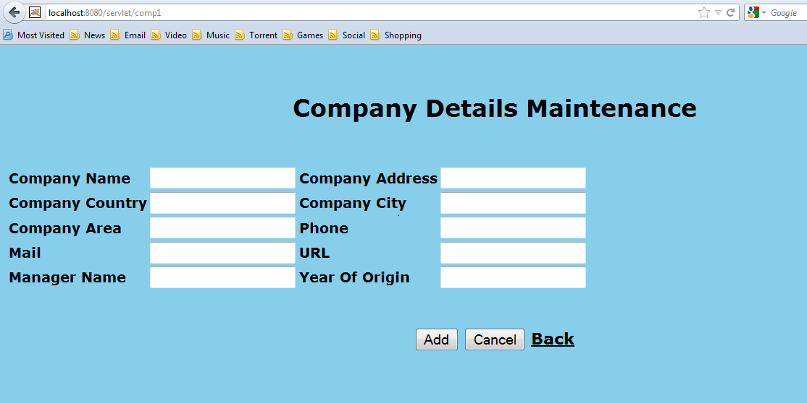

Exception for driver connection :

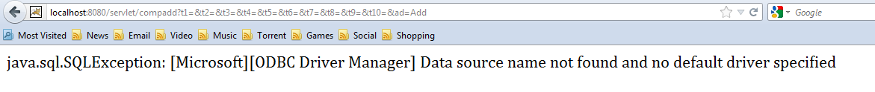

Edit company details page :

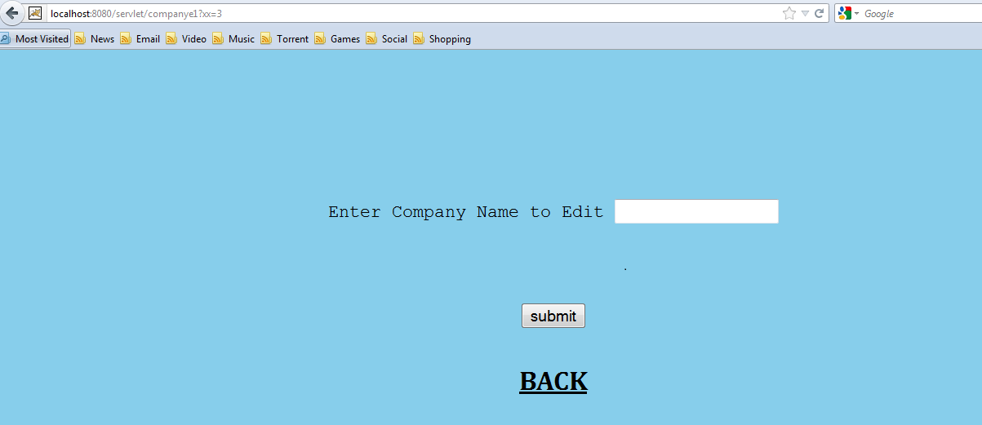

Project module page :

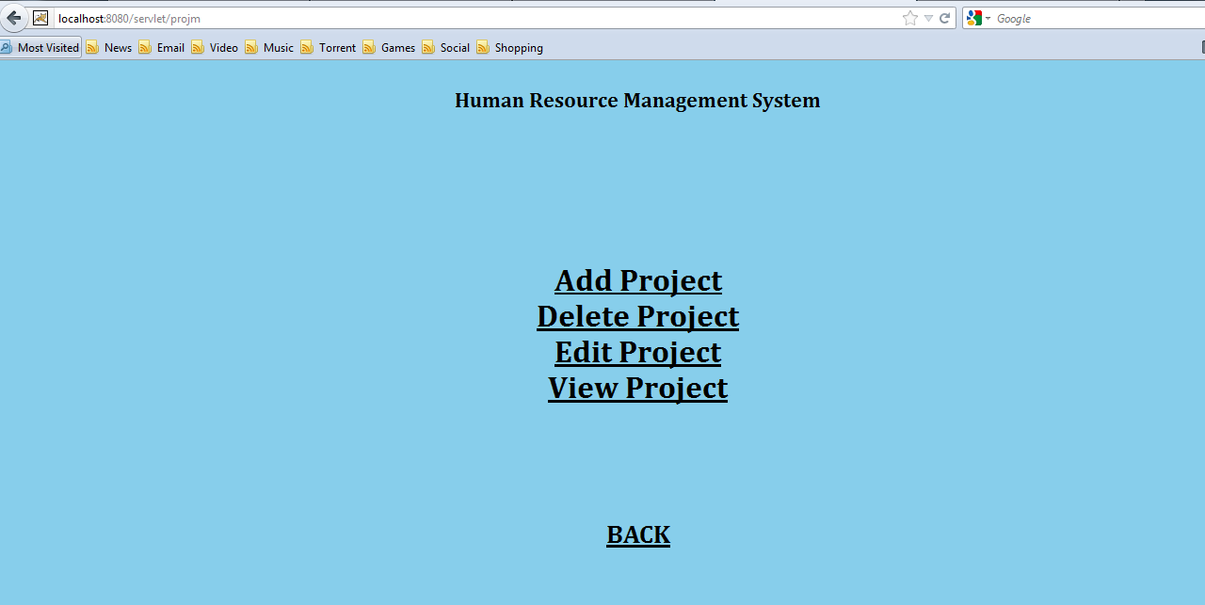

Project details form :

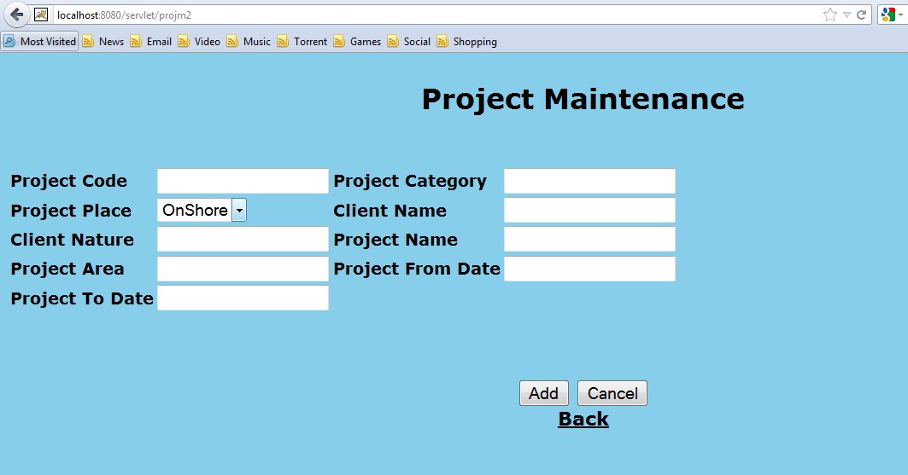

Project editing page :

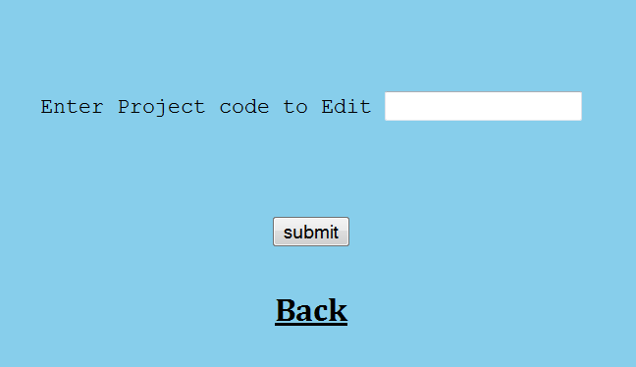

Conclusion

This document states the design level approach taken by the InnovaSoft Team for the project HRMS. After giving a basic information about what the HRMS is, the document briefly describes the problem and the solution we proposed to the problem with the figures to visualize better and steps taken to solve the problem. In other words this document introduces the technical details of the HRMS.
In the first part of the technical design, the major functions needed to develop an HRMS are introduced. Later on, these major functions and their sub-functions are visualized with the use case diagrams.
In the second part, user interfaces are described in a detailed manner with figures.
Lastly,data modules and their relationships are discussed.
To conclude, this document constitutes a base for the development of an HRMS.

References

- Roger S. Pressman, Software Engineering A Practitioner’s Approach. Tata McGraw Hill, Sixth Edition, 2010.
- Ian Sommerville, Software Engineering. Pearson Education, Eighth Edition,
- Herbert Schildt, Java: The Complete Reference. Tata McGraw Hill, Seventh Edition, 2011.
- Raghu Ramakrishnan and Johannes Gehrke, Database Management Systems. McGraw Hill, Third Edition, International Edition, 2003.
- Grady Booch, James Rumbaugh and Ivar Jacobson, The Unified Modeling Language User Guide. Pearson Education, Twelfth Impression, 2012.
- Robert W. Sebesta, Pragramming The World Wide Web. Pearson Education, Fourth Edition, Eighth Impression.
- Marty Hall and Larry Brown, Core Servlets and Java Server Pages Volume 1: Core Technologies. Pearson Education, Second Edition.
- Boris Beizer, Software Testing Techniques. Dreamtech Press, Second Edition, 2009.
- dev.mysql.com/doc/refman/5.1/en/
[10] IEEE Std 830-1998: IEEE Recommended Practice for Software Requirements Specifications
[11]http://www.webdunia.net/CaseStudy/internal_caseStudies/CaseStudy RMS2.pdf
[12] http://www.ibm.com/developerworks/rational/library/769.html
[13] http://www.cs.iusb.edu/thesis/SLingareddy_thesis.pdf
[14] http://en.wikipedia.org/wiki/Eclipse_(software)
[15] http://www.eclipse.org/org/
[16] Robin Schumacher, Arjen Lentz. "Dispelling the Myths". MySQL AB. Retrieved 2007-02-10.
[17] "What is MySQL, MySQL 5.1 Reference Manual". MySQL AB. Retrieved 2011-08-26.

