Client: TheGenericGamingStore

CS 3410: Database Project
Team Members: Jackson Hainey, Ryan Woods

2. Table of Contents
1. Cover Page 0
2. Table of Contents 1
3. Executive Summary 1
4. ER Diagram 1
5. Relational Schema 2
6. CRUD Matrix 3
7. Data Dictionary 3
8. Table Descriptions 5
9. Database Tables (Access Screenshots with Data) 6
10. Design Tables (Access Design View Screenshots) 6
11. Queries 6
12. References 6

3. Executive Summary
TheGenericGameStore needs a relational database to replace its current system for inventory, sales, and customer records. The project builds a database to manage game inventory (titles, platform, price, stock), record sales with payment methods, and track customer profiles. The database uses IE Crow’s Foot ER Ntation in Microsoft Access, with tables like Game, Customer, Transaction, and ReceiptDetail linked via keys. A data dictionary and CRUD matrix define data roles, and Access queries/forms support tasks like recording sales and checking inventory.
The system will be used by Store Staff (Sales Associates and Inventory Managers), who will manage day-to-day tasks like updating stock levels, processing sales, and recording payments. Store Owners/Managers will oversee the system by generating reports, monitoring inventory, and analyzing customer trends. Customers, while Nt direct users, will benefit from accurate inventory tracking, faster checkout processes, and purchase history visibility. The project will include a data dictionary, CRUD matrix, and SQL queries to ensure data consistency and efficient operations.

4. ER Diagram
- 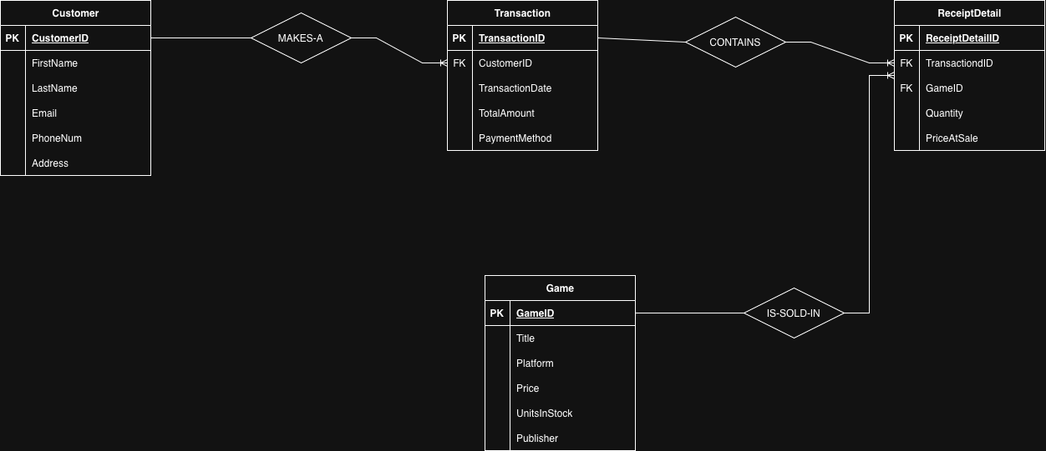

5. Relational Schema
Customer (
CustomerID (PK)
FirstName
LastName
Email
PhoneNum
Address
)
Transaction (
TransactionID (PK)
CustomerID (FK)
TransactionDate
TotalAmount
PaymentMethod
)
Game (
GameID (PK)
Title
Platform
Price
UnitsInStock
Publisher
)
ReceiptDetail (
ReceiptDetailID (PK)
TransactionID (FK)
GameID (FK)
Quantity
PriceAtSale
)
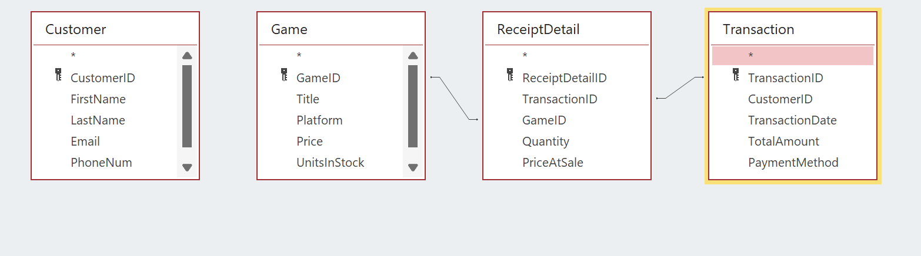

6. CRUD Matrix
 | Customer | Transaction | Game | ReceiptDetail
Customer | CRUD | R
Transaction | R | CRUD | R | CR
Game |  |  | CRUD
ReceiptDetail |  | R | R | CRUD

7. Data Dictionary
Attribute | Table | Required | Unique | FK | PK | Reference Table | Data Type
CustomerID | Customer | Y | Y | N | Y | NF | AutoNumber
FirstName | Customer | Y | N | N | N | NF | Short Text
LastName | Customer | Y | N | N | N | NF | Short Text
Email | Customer | N | N | N | N | NF | Short Text
PhoneNum | Customer | N | N | N | N | NF | Short Text
Address | Customer | Y | N | N | N | NF | Short Text
TransactionID | Transaction | Y | Y | N | Y | NF | AutoNumber
CustomerID | Transaction | Y | N | Y | N | Customer | Number
TransactionDate | Transaction | Y | N | N | N | NF | Date/Time
TotalAmount | Transaction | Y | N | N | N | NF | Currency
PaymentMethod | Transaction | Y | N | N | N | NF | Short Text
GameID | Game | Y | Y | N | Y | NF | AutoNumber
Title | Game | Y | N | N | N | NF | Short Text
Platform | Game | Y | N | N | N | NF | Short Text
Price | Game | Y | N | N | N | NF | Currency
UnitsInStock | Game | Y | N | N | N | NF | Number
Publisher | Game | Y | N | N | N | NF | Short Text
ReceiptDetailID | ReceiptDetail | Y | Y | N | Y | NF | AutoNumber
TransactionID | ReceiptDetail | Y | N | Y | N | Transaction | Number
GameID | ReceiptDetail | Y | N | Y | N | Game | Number
Quantity | ReceiptDetail | Y | N | N | N | NF | Number
PriceAtSale | ReceiptDetail | Y | N | N | N | NF | Currency

8. Table Descriptions
- Customer: Stores customer profiles, including FirstName, LastName, Email, PhoneNum, and Address.
- Transaction: Records sales data, including TransactionID, CustomerID, PaymentMethod, TransactionDate, and TotalAmount.
- Game: Tracks game inventory, including Title, Platform, Price, UnitsInStock, and Publisher.
- ReceiptDetail: Links games to transactions, recording Quantity and PriceAtSale.

9. Database Tables (Access Screenshots with Data)

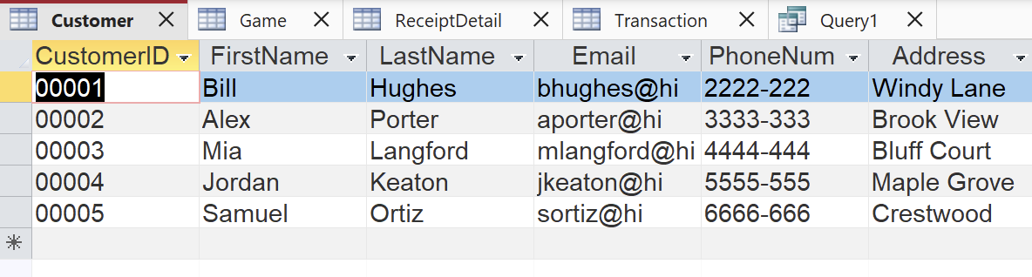

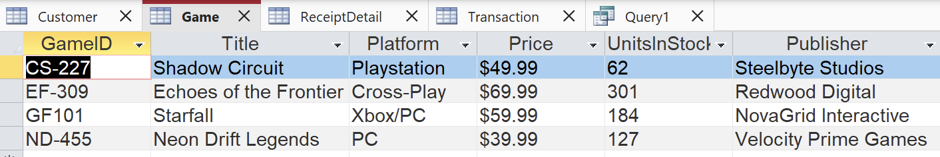

10. Design Tables (Access Design View Screenshots)
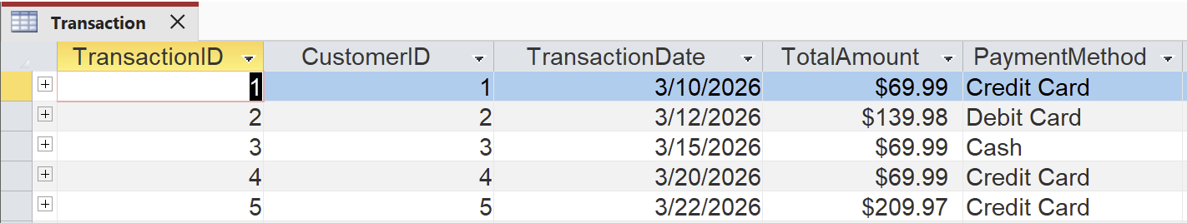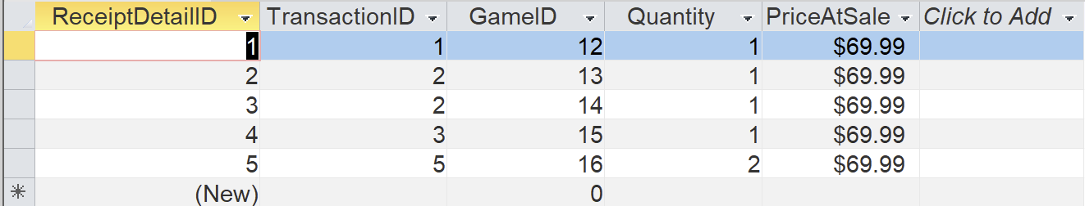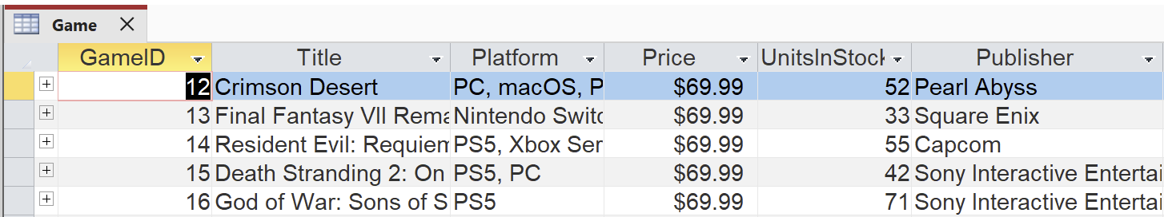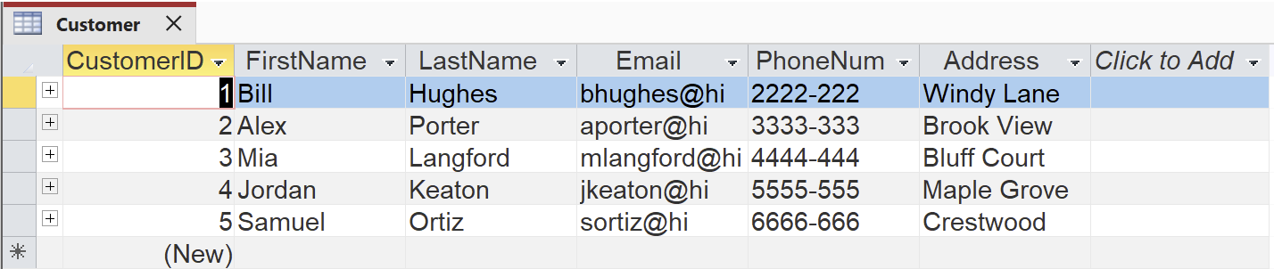

11. Forms and Queries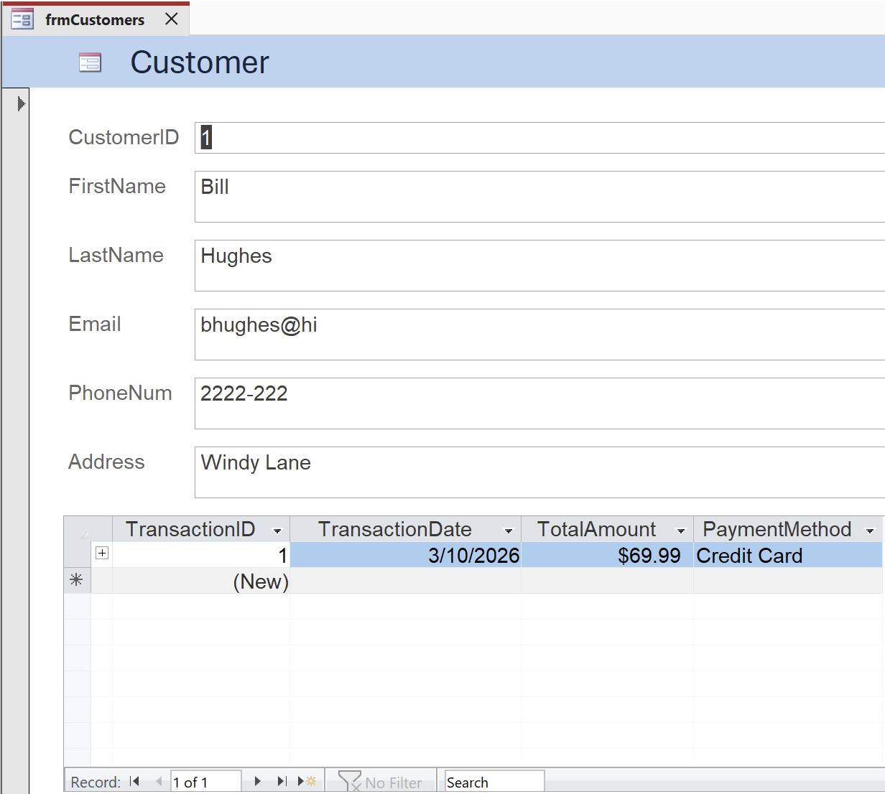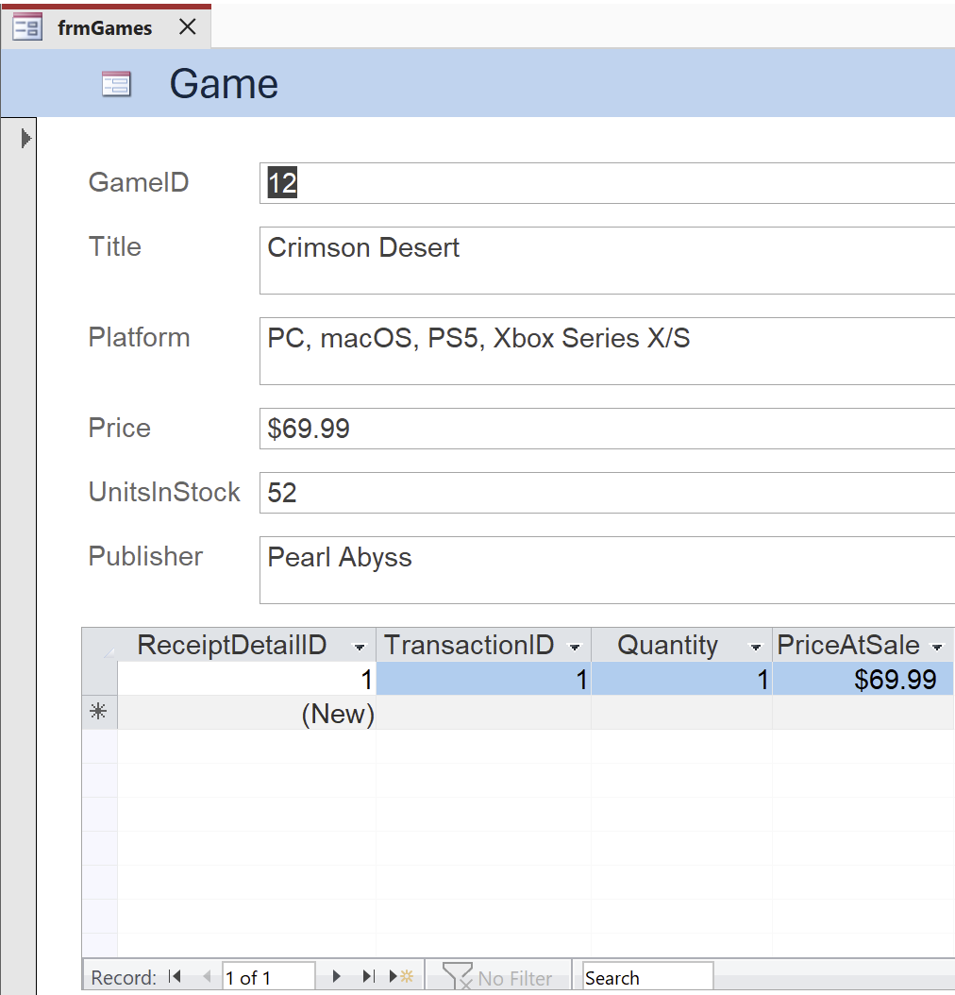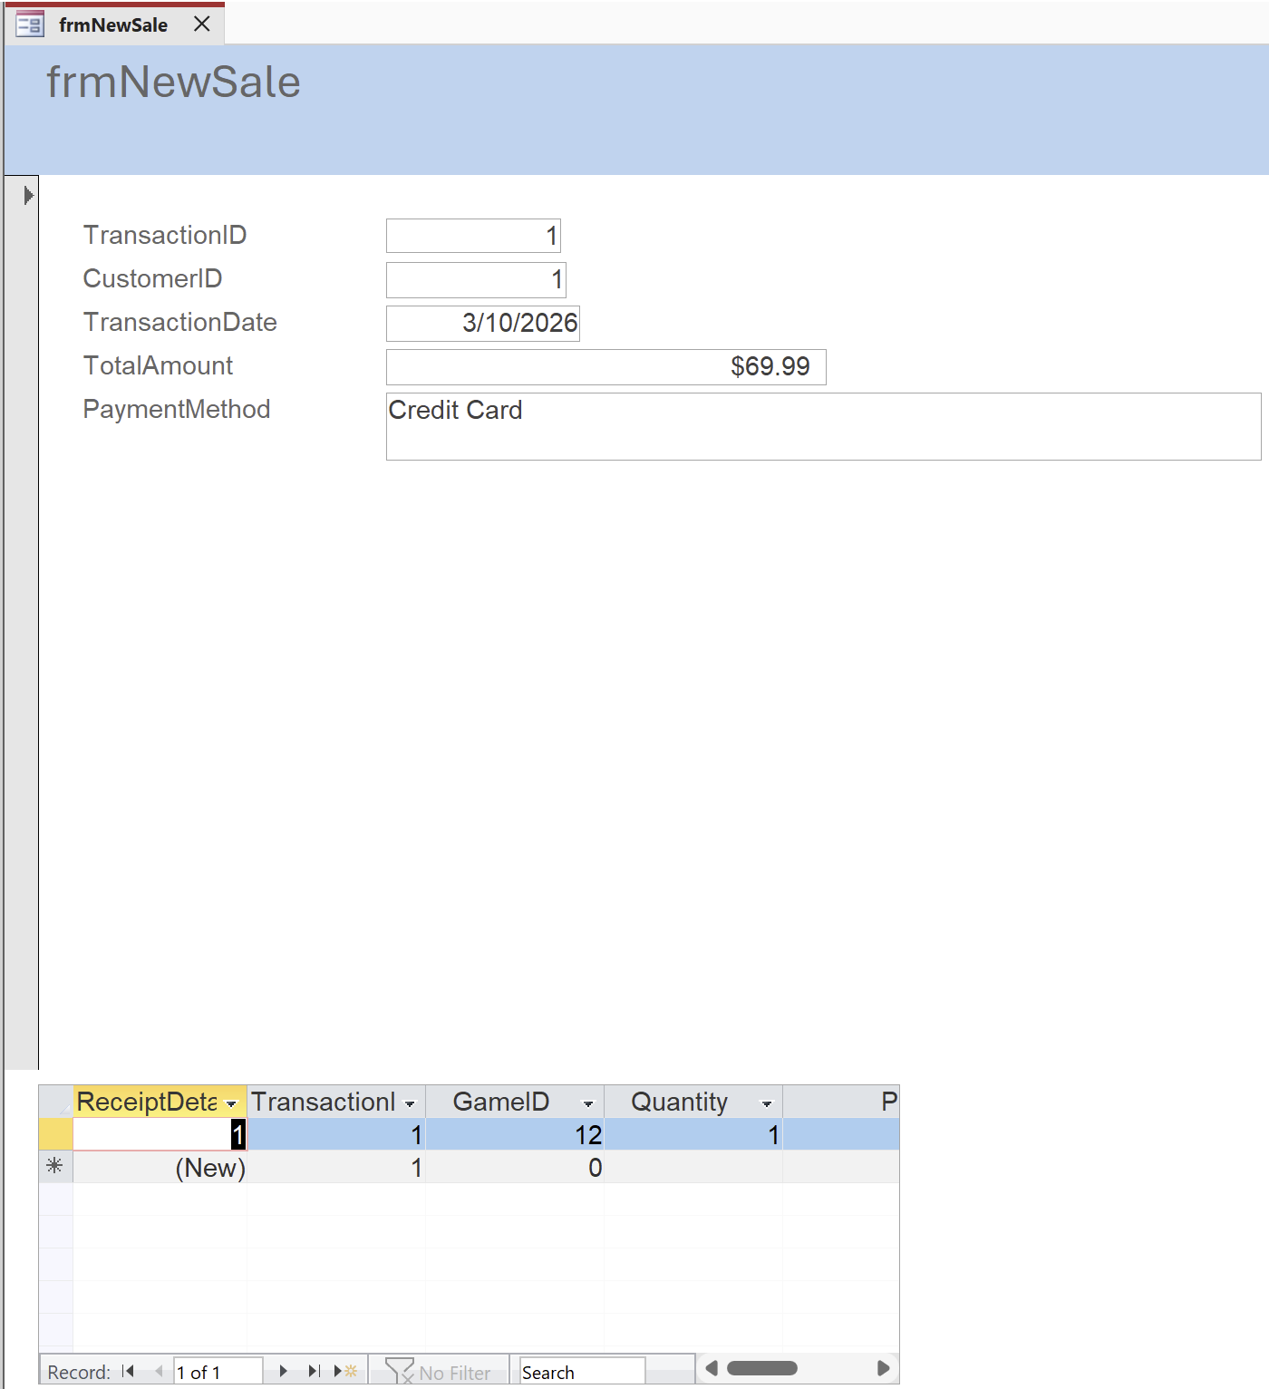
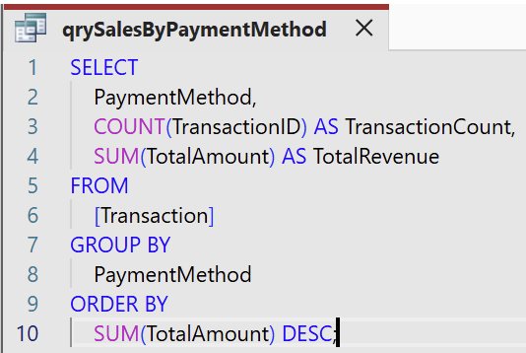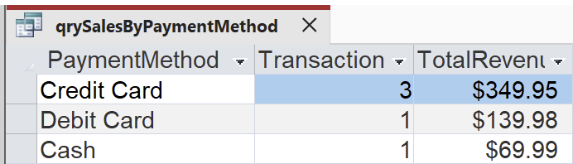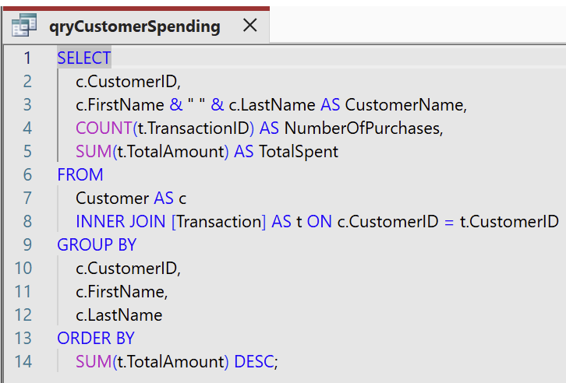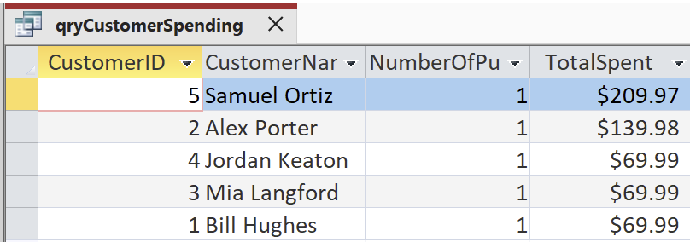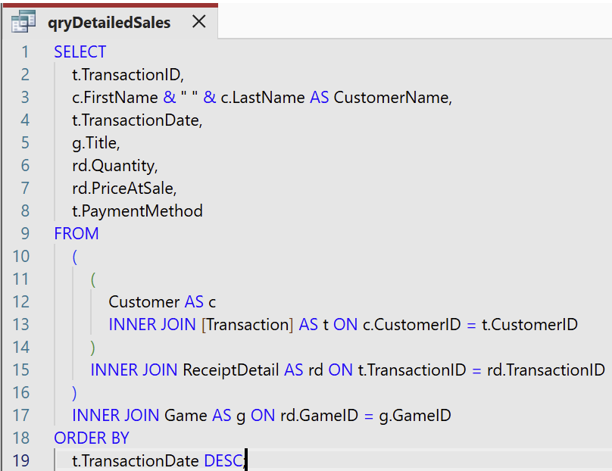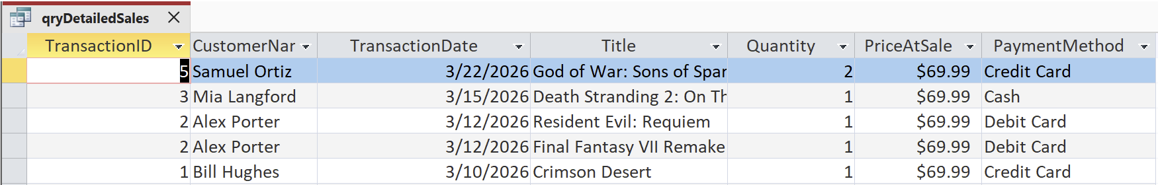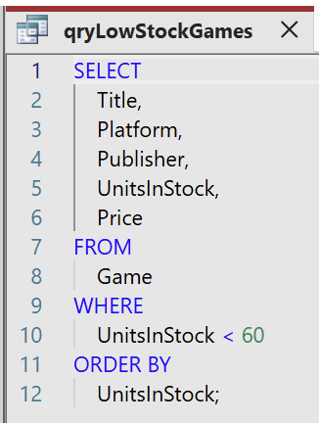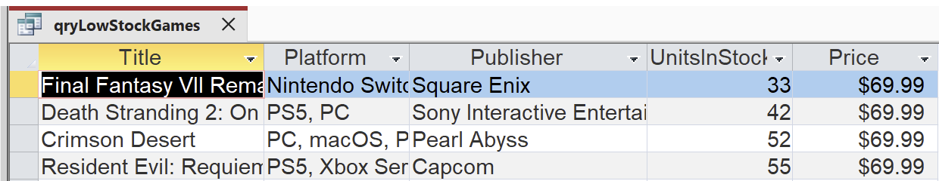

12. References
- Kroenke, D. M., Auer, D. J., Vandenberg, S. L., & Yoder, R. C. (2022). Database processing: Fundamentals, design, and implementation (16th ed.). Pearson.

