PART 1 LISTENING

**Example**

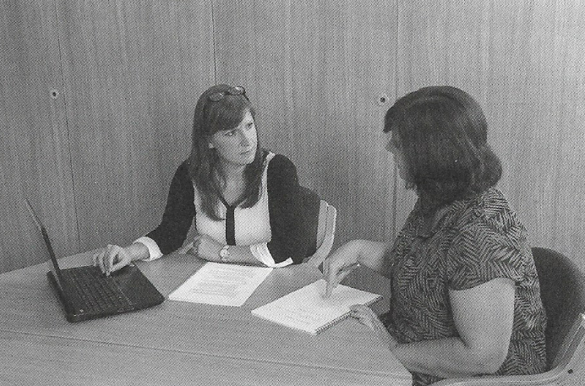

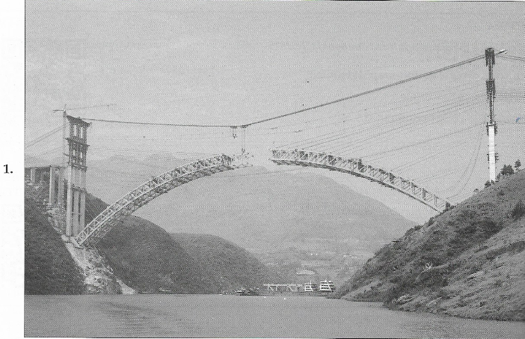

|  |  |  |  |
| --- | --- | --- | --- |
| A | B | C | D |

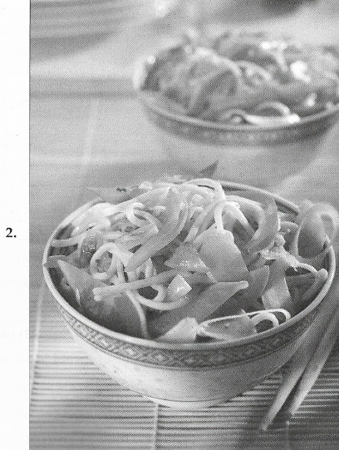

|  |  |  |  |
| --- | --- | --- | --- |
| A | B | C | D |

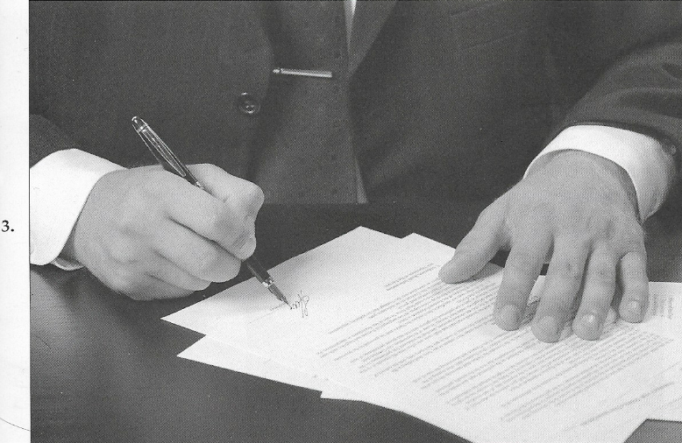

|  |  |  |  |
| --- | --- | --- | --- |
| A | B | C | D |

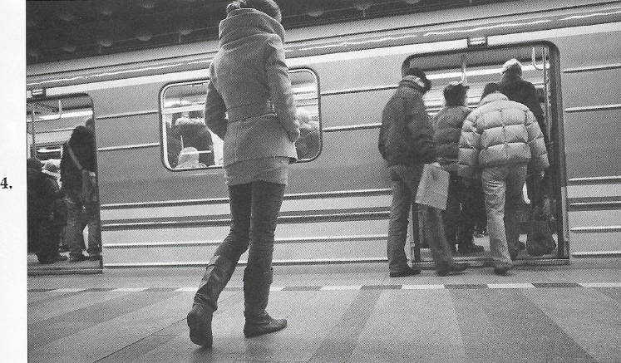

|  |  |  |  |
| --- | --- | --- | --- |
| A | B | C | D |



|  |  |  |  |
| --- | --- | --- | --- |
| A | B | C | D |



|  |  |  |  |
| --- | --- | --- | --- |
| A | B | C | D |

PART 2 LISTENING

7 A B C

8 A B C

9 A B C

10 A B C

11 A B C

12 A B C

13 A B C

14 A B C

15 A B C

16 A B C

17 A B C

18 A B C

19 A B C

20 A B C

21 A B C

22 A B C

23 A B C

24 A B C

25 A B C

26 A B C

27 A B C

28 A B C

29 A B C

30 A B C

31 A B C

PART 3 LISTENING

32 Who is complaining?

A the boss

B the temporary secretary

C the office doctor

D the sick secretary

33 Where is the sick secretary now?

A in the office

B in the hospital

C at home

D at a nursing home

34 How long has he been there?

A one day

B two days

C five days

D one week

35 Where does this conversation take place?

A at a hotel

B at an airport

C at a luggage store

D at a travel agency

36 What is the reason for the woman’s visit to Mumbai?

A education

B tourism

C personal

D business

37 Where does the man ask the woman to do?

A look for her suitcases

B show her business card

C stand by the door

D open her bags

38 Where was this appliance probably installed?

A in the office

B in the appliance shop

C in the Laundromat

D in the kitchen

39 Who installed it?

A the plumber

B the man

C the woman

D the woman’s brother

40 What does the woman say about the installation?

A it was hard to figure out

B it caused a big mess

C it took just a few hours

D it was interesting to watch

41 When was the survey carried out?

A this week

B last week

C last month

D three months ago

42 What does the woman imply about hockey?

A she enjoys watching it

B she plays it frequently

C she knows a lot about it

D she did not watch it during the Olympics

43 What percentage of the population watched the games at any one time?

A 3 percent

B 13 percent

C 30 percent

D 33 percent

44 What does the man advise the woman to do?

A see a doctor

B go to school

C use good shoes

D jog every morning

45 Where does the man go jogging?

A in the park

B at the race course

C behind a school

D near the pool

46 Where does the woman say about the man’s jogging plans?

A he goes too early in the morning

B he jogs far too long at a time

C he shouldn’t go alone

D he should find a nicer place to jog

47 Where did the woman put the newspaper this morning?

A in the break room

B in the front office

C on Mr. Chen’s desk

D by the door

48 Who borrowed the newspaper?

A the office assistant

B the office manager

C the delivery person

D Mr. Chen’s fiancé

49 What does Mr Chen want to do?

A borrow a newspaper

B hire an office manager

C read the financial news

D find out the soccer scores

50 When is inventory always taken?

A every Tuesday

B two times a week

C after the holidays

D when the woman returns to vacation

51 How long does inventory take?

A two days

B four days

C fourteen days

D forty-two days

52 What does the shop sell?

A clothes

B shoes

C books

D office supplies

53 Which of the following would the woman most likely invest in?

A land & houses

B gold & silver

C stocks

D artwork

54 When will the woman make a decision about her investment?

A when the risk is greater

B when her banker tells her what to do

C In a couple of months

D when the market goes up

**55** What happened to the man?

A he sold his house

B he got rich

C he lost money

D he bought some artwork

**56** What do the speakers say about the chairman’s visit?

A their preparation for it are incomplete

B it is unusual to get such a visit

C it will take the whole morning

D they are really looking forward to it

**57** What do the speakers say about the chairman’s personality?

A he is very strict

B he values organization

C he gets along well with people

D he always enjoys surprises

**58** What does the woman mean when she says “you can say that again Tom”?

A she agrees that it is important to prepare for the visit

B she wants to be sure everyone knows about the visit

C she thinks Tom should speak with chairman

D she wants Tom to repeat what he said

|  |
| --- |
| **Massage price List**  Head & Neck $25  Back & Shoulders $25  Foot $20  Whole Body $60 |

**59** Why does the man need a massage?

A he has a sports injury

B his doctor recommended it

C he exercised too much at the gym

D he was moving heavy things around

60 What does the man say about massages?

A he gets massages frequently

B he hasn’t had a massage in a long time

C massages cured his foot problems

D massages help feel younger

**61** Look at the graphic. How much will the man probably pay?

A $20

B $25

C $50

D $60

**Happy Time Luncheonette Coupon**

Free soda for two

Free dessert

Half-price appetizer

10 % off the Weight-Gainer Special

* choose one of the above

* offer valid through July 1st

**62** What does the woman imply about the café?

A she has never been there before

B it is her favorite place to eat

C the staff there is very nice

D it is a popular place

63 Look at the graphic. For which item will the couple most likely use the coupon?

A 10% off the Weight-Gainer Special

B half price appetizer

C free soda for two

D free dessert

64 What does the man say he will do?

A walk through the park

B drive directly to the café

C wait for the woman at the café

D meet the woman at her office

65 How many times have postal rates been raised this year?

A once

B twice

C three times

D four times

66 What still costs the same to mail?

A letters

B postcards

C packages

D magazines

67 What will the woman do next?

A pick up her mail

B wait for the man

C write a check

D mail a postcard

68 How long has the new employee been at his job?

A two days

B four days

C one week

D a few months

69 What is he good at?

A accounting practices

B giving support

C his schoolwork

D getting along with others

70 What does he need?

A a credit card

B more training

C a larger office

D some friends

PART 4 LISTENING

71 What does the speaker say about the weather in April?

A it was cool and wet

B it was most cloudy

C it was very pleasant

D it was unusually dry

72 What advice does the speaker give listeners?

A wear warm clothing today

B carry an umbrella this week

C walk every day

D stay inside

73 What will happen tomorrow?

A bikes will be on sale

B there will be a race

C it will be hot and sunny

D there will be a barbecue

74 Who made the report to the police?

A schoolchildren

B a flier

C two residents

D two reporters

75 What caused the report?

A some fliers were identified

B spaceships were sighted

C two men flew in space

D an investigation took place

76 How often does this happen?

A once a week

B twice a week

C once a year

D twice a year

77 Why did Roger make a call?

A to find out Sarah’s opinion of the play

B to invite Sarah to see the play with him

C to ask Sarah to pick the tickets

D to tell Sarah where the theater is

78 What does Roger imply about the play?

A it’s not well-known

B it’s very popular

C it has a fast moving plot

D it opened several weeks ago

79 When does Roger want to see the play?

A today

B tomorrow

C this weekend

D next week

80 What is the announcement about?

A hiring of City Hall staff

B a job available for a teacher

C an opening on the school board

D employment at the public library

81 Who can apply for the position?

A any adult city resident

B current city employees

C people with a college degree

D people with at least two years’ experience.

82 How can someone apply for the job?

A submit an application to the City Clerk

B attend a group interview at City hall

C register for the Smithtown job fair

D send in a résumé

83 Where would this announcement be heard?

A at a theater

B on an airplane

C at a restaurant

D on a boat

84 What are listeners asked NOT to do?

A sell things

B make phone calls

C remain seated

D keep speaking

85 Where is smoking permitted?

A nowhere

B in the lobby

C in the seating area

D outside the building

86 What event is being announced?

A a speech by the Mayor

B a concert by high school students

C a music school graduation ceremony

D an operating ceremony for a new high school

87 Where can tickets be purchased?

A at the mayor’s office

B at the auditorium

C through the mail

D on the internet

88 How many seats are available?

A 100 exactly

B a little more than 100

C almost 500

D more than 500

89 What part of the shaver is made of stainless steel?

A the blades

B the surface

C the case

D its face

90 In what directions do the blades move?

A back and forth

B up and down

C in a circle

D sideways

91 How much does the shaver cost?

A $5.95

B $14.95

C $45.95

D $95.00

92 Why did the speaker make the call?

A to change part of an order

B to reschedule an event

C to ask about prices

D to cancel an order

93 What event is the speaker planning?

A an awards banquet

B a business meeting

C a birthday party

D a wedding

94 What does the speaker mean when she says: “the amount is not an issue”?

A the cost is not important

B the quantity of food is satisfactory

C the number of guests might change

D the size of the room is not a problem

**BOARDING ASSIGNMENT**

|  |  |
| --- | --- |
| FLIGHT Hashtag — Wikipédia | GATE |
| FLTHashtag — Wikipédia 146 | 19 |
| FLTHashtag — Wikipédia 172 | 90 |
| FLTHashtag — Wikipédia 8050 | 5B |
| FLTHashtag — Wikipédia 27 | 9B |
| FLTHashtag — Wikipédia 400 | 14A |

95 Where is the speaker?

A New York

B Dallas-Forth Worth

C on flight 400

D in the ticket office

96 Why are the two passengers being called?

A to change flights

B to apologize for the inconvenience

C to offer better seats

D to collect their personal items

97 Look at the graphic. Flight 400 will share the new gate assignment with which aircraft?

A flight 146

B flight 172

C flight 8050

D flight 27

|  |
| --- |
| **AGENDA**  **Staff meeting – October 10**  Miranda Little………………………………….Budget Report  Jae Sun Lee……………………………………. Publicity Campaign  Amber Peters………………………………….Recruiting  Li Lu………………………………………………..Payroll Issues |

98 What does the speaker apologize for?

A the late start time

B the size of the room

C the cancellation of the meeting

D the absence of one of the speakers

99 How often is the staff meeting held?

A once a week

B twice a month

C once a month

D twice a year

100 Look at the graphic. Which topic will be presented first?

A budget report

B publicity campaign

C recruiting

D payroll issues

PART 5 READING

101 Before they get packaged, shipped and sold, we test all of our children’s toys for safety __________ durability.

A nor  
B as well as   
C but  
D or

102 _________ Harrison’s Hair Salon had closed for renovations two months earlier, none of its staff believed they would have a job to come back to.

A although  
B while  
C the  
D when

103 While the presentation ___________, a camera crew was recording it for a local news story.

A was being made  
B has been made   
C was making  
D made

104 If the postage is incorrect, the package _________ to the sender and a small fee will be charged.

A was returned   
B is going to return  
C will be returned  
D returns

105 Management ___________ looked into the matter, nevertheless, you were right in coming to me.

A has already   
B still has  
C has still   
D has yet

106 Since Mr. Carlo enrolled in night classes, he has _________ a knowledgeable trainee.

A looked into  
B brought about  
C turned into   
D broken into

107 The clerk inadvertently let the folder _________ and the winners’ photograph was exposed before the announcement.

A drop  
B dropped  
C to drop  
D dropping

108 Mia and Hubert want the travel plans _______ before the seat sale ends and the tickets sell out.

A to arrange  
B will arrange   
C arranged  
D arrange

109 She was hardworking and competent, _______, she had no trouble being recommended.

A namely  
B yet  
C moreover  
D thus

110 They thought the project would be a great success; _______; it failed to promote interest.

A thus  
B yet  
C as a result  
D finally

111 If you ever need an emergency contact number for someone, the ________ department keeps a file on each employee.

A personnel  
B persons  
C personal  
D personable

112 The trucks had not been inspected, ______ the drivers took them out anyway.

A and  
B so  
C and so  
D but

113 ____________ you file a formal complaint, make sure you have at least one or two people who are willing to back you up.

A as   
B while   
C before  
D after

114 A workers strike could lead _______ a settlement with management.

A from  
B to  
C at  
D with

115 We want to improve our ability to compete _______ our largest rival.

A with  
B of  
C about  
D for

116 too offset the taxes we owe, the accountant advised ___________ a charitable foundation.

A catching on  
B going over  
C filling out   
D setting up

117 Buy top quality even if it _________ something not currently in vogue.

A were   
B is  
C was   
D be

118 As soon as the money _________ invested, the project will begin.

A is  
B will be  
C is going to be  
D has been

119 These contracts will encourage the growth of a more competitive banking structure ___________.

A always  
B two years ago  
C in the next year  
D sometimes

120 Management relies __________ on its ongoing review of the loan portfolio.

A predominance   
B predominantly  
C predominant  
D predominated

121 These tables show only our domestic operations, __________ there is no reason to forward them to our international clients.

A moreover  
B consequently  
C nevertheless   
D yet

122 Anyone who is unable to attend the staff meeting should let the department head know in _________.

A advice   
B adventure   
C advertise   
D advance

123 The program is designed to improve competitive strength; __________, it should increase the potential for higher earnings.

A nevertheless  
B meanwhile  
C namely  
D accordingly

124 Financing has come chiefly from _________ sources, namely two of ours employees’ relatives.

A internalizing   
B internal   
C intern   
D internalized

125 Our volume of sales made our team ___________ to the top one percent of sales worldwide.

A advanced  
B advance  
C advancing  
D advancement

126 To avoid errors using the new coding system, you should ________ before beginning to code.

A find it out  
B take it up   
C look it over  
D move it away

127 Even in a snowstorm that shut down half of the city, our delivery service got all of our packages ________ on time.

A deliver  
B delivering

C to deliver  
D delivered

128 if we __________ the plans carefully, we would not have erred so seriously.

A had studied   
B study  
C studied  
D were studying

129 In ten years about half of the decline _________ attributable to write-offs.

A will be  
B has been

C would be  
D are

130 Net sales in the current year _________ nine percent higher than the previous year.

A had been   
B are

C will be   
D were

PART 6 READING

Questions 131 to 134 refer to the following notice

**Notice to library users**

The community room is now ___131_____ to local groups for meetings, workshops, or social events. The room is located on the basement level and is large enough to accommodate groups of up to 25 people.

If your group would like to book this room, _____132_____ at the circulation desk for a reservation form. _____133_____. You can also find a reservation form on our website at metlibrary.mbfl.gov/reserve. You can also phone the Public Information Office of the library. Please be advised that _____134_____ of the Community Room is free but no group may reserve it more often than once per month.

131

A suitable B directed C available D welcome

132

A can ask B asking C to ask D ask

133

A These may be submitted up to one month in advance of your event.   
B The Community Room was founded by a special grant from the city.

C Many groups find it convenient to hold their meetings at the library.  
D You can get information about all library programs at the circulation desk.

134

A use B user C using D useful

Questions 135 to 138 refer to the following memo



**Memorandum**

To: All staff

From: J. Colman, Director

Subject: this month’s meeting

As you are all aware, we have many ___135_____ items to discuss at this month staff’s meeting. We have several new projects coming up. Tina and Bon will be outlining their plans for expanding the product line.

There will be several decisions to meet that need to be made in a timely manner. Because of the unusually long _____136_____, I expect the meeting to go longer than normal. However, I also expect everyone to stay for the entire meeting, so please plan your schedules accordingly. In an event, it is _____137_____ that we end later than 5.30. _____138_____.

135

A numerous B pressing C ordinary D scarce

136

A agenda B series C period D interval

137

A dislike B likeable C likeness D unlikely

138

A Our staff meetings take place on Friday afternoons at 1.00 and usually end by 4.00.   
B Our staff meetings are an important opportunity for everyone to discuss business issues together.

C I regret any inconvenience this may cause and thank you in advance for your cooperation.

D It is our hope that everyone will consider joining us this month.

Questions 139 to 142 refer to the following letter

**Dear Neighbor,**

Are you tired ___139_____ looking at overgrown hedges and weedy flower beds? Worry no more!

We, at Luscious Landscapes are here to help you keep your lawn and garden looking _____140_____ very best. We mow, trim, prune and mulch everything on your property. Furthermore, if you are considering _____141_____ your gardens, we can help you design additional flower beds and do the planting for you. We have many years of experience and are ready to go to work for you. _____142_____.

From,

Your friends at **Luscious Landscapes**

139

A in B to C at D of

140

A its B our C your D their

141

A maintaining B stretching C expanding D inflating

142

A We hope you will accept our invitation to visit our gardens soon.   
B Contact us today for a free appointment to discuss your gardening needs.

C your garden is on our schedule for the beginning of next week.

D We enjoy looking at our garden and believe it has really beautified the neighborhood.

Questions 143 to 146 refer to the following instructions

**How to use your super Brewer Office Coffeemaker**

Your new super Brewer Office Coffeemaker is so easy to use. ___143_____. Your coffeemaker comes with two measuring scoops. The small one measures enough coffee grounds for one cup at a time, _____144, the large one measures enough for five cups at a time. Fill the filter basket with correct _____145_____ of coffee grounds. Next pour water into the reservoir. Press the “on” button and let the machine _____146_____ the rest of the work for you. Your coffeemaker will keep your coffee hot and fresh all day long.

143

A If you are not satisfied with this product, you can return it for a full refund.   
B Hot coffee is a drink that is enjoyed by people all over the world.

C Just follow these steps to brew perfect coffee every time.

D Most offices prefer to use this brand of coffeemaker.

144

A when B although C since D while

145

A number B amount C type D size

146

A do B does C will do D is doing

PART 7 READING

Questions 147 - 148 refer to the following bulletin

**Reservations**: reservations are required for all club, custom-class and sleeping car accommodations. Reservation for coach travel are required on all trains designated as “All-reserved trains”. Seating in trains with unreserved coach service is not guaranteed. A time limit for purchase of tickets is assigned when reservations are made. If tickets are not purchased within this period, reservations are canceled. A service charge is assessed if reservations are canceled less than 30 minutes prior to departure or if not canceled.

**Times at station**: Passengers should be at their boarding stations at least 30 minutes prior to departure. If a train should arrive late, every effort is made to depart as soon as possible. In such cases, the length of time the train remains in the station may be less than shown in the timetable.

147 Where are reservations NOT required?

A in all club cars B in some coach cars

C in custom-class car D in sleeping cars

148 When is a fee charged?

A when reserving a seat B when boarding the train

C when reservations aren’t canceled D when riding in the club car

Questions 149 - 150 refer to the following text message

**ROB BURTON 11/28/19 10.45 AM**

I’m leaving my office now so I’ll be there soon. Just one thing. Which bus did you say I should take?

**CHARO LOPEZ 11/28/19 10.46 AM**

Number 35. You can catch it on Main Street.

**ROB BURTON 11/28/19 10.46 AM**

In front of the bank?

**CHARO LOPEZ 11/28/19 10.47 AM**

No! That’s the wrong line. Bus 35 stops at the corner of Main and Henri streets. Make sure it says: “Downtown”

**ROB BURTON 11/28/19 10.47 AM**

Got it. Also, I’m bringing all the designs with me. You said you wanted to see all 3 versions, right?

**CHARO LOPEZ 11/28/19 10.48 AM**

Right! It’s easier to decide if we can see them altogether.

**ROB BURTON 11/28/19 10.48 AM**

Agreed. I’ll be there in a bit. I’m looking forward to seeing your new office.

149 At 10.47, what does Mr. Burton most likely mean when writes; “Got it”?

A he can see a bust stop B he has found a bus schedule

C he has his bus fare ready D he understands which bus to take

150 What is suggested about Mr. Burton?

A he’s Ms. Lopez’s boss B he has never been to Ms. Lopez’s before

C he rides the buses regularly D he works downtown

Questions 151 - 152 refer to the following advertisement

For rent: beautiful sunny two-room unit on first floor of professional building. Convenient downtown location, close to shops and transportation. One-street parking. Six-month or one-year lease. $2,200 / month incl. utilities except phone and internet. Open house this Wednesday, 2.00 – 4.00 pm

151 What is for rent?

A an office B a house C a shop D an apartment

152 What is probably included in the rent?

A phone and internet B a parking space C a storage area D electricity

Questions 153 - 154 refer to the following advertisement

ADMISSION Ticket # 3467542

Fletcher Gallery of Art & Culture Purchase date: 5/2

Friday, May 2

Gallery closes at 5.00 pm

Adult admission $20

Ticket good for admission on above date plus one free repeat visit within 7 days.

Ticket does not include admission to concerts or other special programs.

153 What is the ticket for?

A concert B museum C theatre D tour

154 What is true about the ticket?

A it can be used twice B it admits two people

C it has a discounted price D it must be bought ahead of time

Questions 155 - 157 refer to the following article

Springerland Toys has announced that the company will be constructing a new manufacturing facility on the outskirts of Willmott. The news has been received favorably for the most part by local residents. New jobs are already being generated for the construction phase of the project. And many positions will be open once the facility is up and running. According to a company spokesperson, this will be at the beginning of next year. Springerland Toys is one of the country’s leading manufacturer of toys and games.

While most residents are excited about the employment opportunities, the Springerland facility will bring, there has also been some opposition expressed. Local environmental groups are concerned about the impact the construction will have on the local ecology, specifically a wetland area that borders on the site. A protest demonstration took place yesterday in from of the City Hall. Activists say they hope this action will raise awareness about the damages the project can cause. For its part, Springerland says it has obtained all the necessary permits and is following environmental protection laws.

155 What is this article mostly about?

A jobs creation B a new factory

C the local economy D environment activism

156 What is scheduled to happen early next year?

A a factory will open B construction will begin

C protests will be organized D a company will stop operations

157 What are activists concerned about?

A the size of the new factory B salaries of factory employees

C harm to the local environment D the construction methods used

Questions 158 - 160 refer to the following email

From: Customer Service

To: Robert Reynolds

Subject: Your order

Date: January 24

Dear Mr. Reynolds,

Your order has been partially shipped. The following item was not included in the shipment:

#496-21 Striped V-neck sweater, size XL

Unfortunately, we no longer have this item in stock and have been unable to get more form the manufacturer. _ [1] _. Your credit card has not been charged for this item. _ [2] _. Please click here to see our suggested alternatives. If you order one of the suggested alternative, we will not charge for shipping. _ [3] _. However you must make your order within 30 days. Please call our customer service office at 800-555-4649 and a customer service representative will place your order without shipping charges. _ [4] _. Remember to have your credit card information ready when you call.

Thank you for being a Modern Closet customer.

Sincerely,

Modern Closet Customer Service.

158 Why was the sweater not included in the shipment?

A Mr. Reynolds didn’t indicate a preferred color

B Mr. Reynolds didn’t pay the shipping charges

C the sweater s not available anymore

D a credit card is no longer valid

159 What is Mr. Reynolds recommended to do?

A place a new order B contact a manufacturer

C wait 30 days to receive a shipment D provide a different credit card number

160 In which of the following positions marked [1], [2], [3], and [4] does the following sentence best belong?

“We do not have several similar items in stock, however.”

A [1] B [2] C [3] D [4]

Questions 161 - 163 refer to the following email

From: Susan Ireland

To: Renee Powers, Human Resources Manager

Subject: Evaluation of Franklin Group “Meetings” Seminar

Renee,

As you know, I attended the Franklin Group “Meetings” Seminar last week. It was well worth the time spent, and I believe it should be made available to all supervisory employees.

The complete title is “Improving the Effectiveness of Business Meetings.” There are two formats available: a public seminar or a kit for in-house presentations. The cost for attending the seminar is $35 per person. The kit costs $500 and has enough material to train 50 employees.

Obviously, purchasing the kit is more cost-effective and after attending the seminar I feel that I am sufficiently prepared to run an in-house workshop.

Therefore, I would recommend purchasing the Franklin Group “Meetings” kit to help our managers and supervisors hold more efficient meetings. I brought back some literature from the seminar that I will send to your office today.

If you like this idea, please contact me so that we can discuss possible dates for the workshop.

Thanks,

Susan

161 What amount did Ms. Ireland pay to attend the seminar?

A $10 B $35 C $70 D nothing

162 What does Ms. Ireland suggest?

A that the company buys the kit B that all employees attend the seminar

C that the HR manager train employees D that managers and supervisors hold more frequent meetings

163 What will Ms. Ireland send to Ms. Powers?

A a copy of her calendar B sample presentation kits

C information about the seminar D a list of managers and supervisors

Questions 164 - 167 refer to the following letter

3515 Massachusetts Avenue SE

Washington DC 10019

March 10, 2020

Human Resources Director

Canyon Roadrunners Store

4985 Cactus Boulevard

Santa Fen NM 87501

Dear Human Resources Director,

I am writing to recommend most highly James Proctor, formerly of La Plata, Maryland, who has applied for a position in your company.

I have known Mr. Proctor for approximately three years. During this time, I supervised his performance as a clerk in the sporting goods section of the Minnesota Avenue branch of Morris’s Department Store in Washington DC. Mr. Proctor is an honest, hardworking, and reliable employee. He dealt with customers in a knowledgeable, professional and friendly manner. He was always patient an rarely let even the most trying customers or the situation get the better of him. In addition, he works well independently and is certainly capable of supervising other employees. In fact he was close to being promoted to a managerial position when he left the company.

We at Morris Department Store will miss him but understand that personal goals have taken him to New Mexico and we wish him all the best in his future endeavors there. I can confidently predict that you will be very satisfied with his performance at your company. If you have any questions, you can contact me at the above address.

Sincerely,

*Alonso Wann*

Alonso Wann

Manager, Sporting Goods

164 What is the purpose of the letter?

A to ask for a job B to offer employment

C to provide a reference D to make a personal introduction

165 What is indicated about Mr. Proctor?

A he is not very dependable B he needs constant supervision

C he is qualified to be a manager D he has a university degree

166 In what does Mr. Proctor get a job?

A gourmet foods B stereo equipment C plants &flowers D athletic equipment

167 Where might Mr. Proctor get a job?

A Santa Fe, New Mexico B Washington DC

C La Plata, Maryland D The Minnesota Avenue branch of Morris’s

Questions 168 - 171 refer to the following online chat discussion

**Jim Baxter Today 2.33 pm**

Remember what I said in our last staff meeting?

**Kendall Clark Today 2.34 pm**

About Lockford’s push for employees’ health and wellness?

**Jim Baxter Today 2.36 pm**

Right. I have just received a memo explaining the details. His main point is that we should have fun together while getting exercise.

**Kendall Clark Today 2.37 pm**

All right, I can get behind that. How are we going to go about this exactly?

**Jim Baxter Today 2.41 pm**

I’m copying and pasting this from the memo. Give me a minute.

**Jim Baxter Today 2.42 pm**

First you can receive a discount on membership at Siler Wave Gym by presenting your employee ID card. Here are several levels of membership available. Whichever level you chose you are entitled a 25% off the normal fee.

**Jim Baxter Today 2.43 pm**

In addition we have contracted with a personal trainer on a part-time basis. Mr. Park will be available by appointment to work with you in designing an exercise routine that is suited to your individual abilities and needs.

**Jim Baxter Today 2.43 pm**

Finally on the second Saturday of September we will sponsor a company field day. Staff members can choose to complete in a running relay race. A sin-up sheet will be posted soon.

**Jim Baxter Today 2.43 pm**

That’s it. What do you think?

**Kendall Clark Today 2.46 pm**

I’m really excited. But I do wish the managers had asked for our opinions.

**Jim Baxter Today 2.47 pm**

What would you change?

**Kendall Clark Today 2.50 pm**

The field day. Most people don’t want to spend a weekend day with coworkers. I don’t think many people will go.

**Jim Baxter Today 2.50 pm**

Good point! But the vent fits the new policy’s theme 100%.

168 What is the memo about?

A a recent staff meeting B upcoming company events

C the best ways to stay fit and healthy D a company program to support fitness activity

169 At 2.37 pm, what does Kendall mean when she writes: “I can get behind that”?

A she will move backwards B she wants to make a purchase

C she supports Jim’s ideas D she will turn around

170 Who is Mr. Park?

A a gym owner B a friend of Kendall’s

C an exercise expert D a Lockford staff member

171 What does Kendall say about the field day event?

A she thinks it will not be popular B she will not be available that day

C she hopes the manager will participate D she is interested I competing in the race

Questions 172 - 175 refer to the following online chat discussion

June Kim

Human Resources Director

The starling company

PO box 10

White Cloud, MO 65779

Dear Ms. Kim,

_ [1] _. I am a recent graduate of Colman University and am currently seeking employment. The Starling Company is at the top of my list of companies I would love to work for.

_ [2] _. As a student I majored in business administration with a minor in business economics. I also for the university newspaper and wrote a column about business, which the paper ran weekly for three years. _ [3] _. In addition I worked for the summers in a row as an intern at Pixie, Inc. I also learned that marketing is my passion so I am currently seeking an entry-level position in that field.

I hope you will consider me for any positions you may have open in your marketing department. _ [4] _. I am enclosing my résumé and two letters of references from previous employers. I look forward to hearing from you soon.

Sincerely,

Jason Rodriguez

Jason Rodriguez

Enclosures

172 Why did Jason write the letter?

A to ask for a job B to give a reference

C to offer employment D to request information

173 What did Jason study in college?

A journalism B business C marketing D political science

174 The word “ran” in paragraph 2, line 3, is closest in meaning to:

A raced B published C operated D traveled

175 In which of the following positions marked [1], [2], [3], and [4] does the following sentence best belong?

“I believe I have a great deal to offer your company.”

A [1] B [2] C [3] D [4]

Questions 176 - 180 refer to the following magazine article and email message

This year, fewer people went to movie theaters, opting to watch DVDs or stream movies at home instead. The reason? Watching movies at home is much cheaper than shelling out for tickets and snacks for an entire family at a movie theater. At today’s prices, a single trip to the local movie theater can cost a family of four upwards of $60.

Owners of movie theaters are understandably nervous. “This is serious because our profits this year are 25% lower than last year”, says Perry Scott of the London Cinema at Notting Hill. “We are working on improving the situation.”

As the cost for running a movie theater increases, many theaters have decided not tot raise their ticket prices. Instead they charge more for snacks, increasing prices by an average of 50%. This is one of their biggest sources of revenue. Also theaters encourage customers to buy their tickets online by offering them free drinks, food, posters or t-shirts. This brings added revenue through the small service fee attached to online orders. Also, to encourage moviegoers, some theaters offer cheaper tickets on Wednesday, which is usually the day with the fewest customers.

Still the movies themselves are the reasons that most people come to the theater. Some movie are made to watch on a large screen. That’s something you can only do at the movie theater and it won’t change. At least for now.

**From**: Alexia Burns

**To**: Earl Hutton

**Subject**: Ideas to increase ticket sales

Earl,

We should try some of the ideas from this article. Our profits this year are just like Scott’s. Increasing the price on snacks is an excellent idea. However I would start by increasing it by 20% less that they recommend. Second, we can encourage our customers to buy their tickets online by offering an incentive. Most of the article’s ideas are too expensive. But I think we could manage the first one. I also like the idea of cheaper tickets on certain days but I would try Thursday rather than Wednesday, as that’s our slowest day. Let me know what you think.

Alexia

176 Why did fewer people go to Movie Theater this year?

A the screens in theaters are too large B DVDs are better quality

C it costs less to watch movies at home D theaters don’t show family movies

177 Who is Perry Scott?

A a movie theater owner B Alexia Burn’s business partner

C a snack salesman D a movie critic

178 By how much does Alexia want to increase snack prices

A 25% B 30% C 50% D 70%

179 What does Alexia suggest giving to online ticket purchasers?

A drinks B food C posters D t-shirts

180 On which does Alexia want to offer cheaper tickets

A Monday B Tuesday C Wednesday D Thursday

Questions 181- 185 refer to the following magazine email message and letter

**From**: Choi Min

**To**: Head Office

**Date**: July 4, 2020

Dear Min,

Thank you for your letter dated July 1 regarding your heavy workload. I was unaware that you were feeling so much pressure this past summer. I guess it all started after Lee quit and you had to take on most of his responsibilities.

Unfortunately we are not in the position to offer you a raise at this time. Because of low sales this year, no one, including management, will be getting a salary review this September. The popularity of home shopping is causing a lot of competition for retailers in North Jeolla.

I am confident that with your marketing expertise, we will be able to increase our sales next year. By next September, Geum jewelers will begin opening on the weekend and will be looking for a marketing director. Overtime hours will be available. We will probably offer this position to you when the time comes.

Thank you for your patience,

Moon

Choi Min

89-83-ga

Pungnam-dong Wansan-gu

Jeonju, Jeollabuko

South Korea

Kim Moon

Floor Manager

1298-9

Beommul 1 dong

Suseong gu, Taegu

South Korea

July, 17, 2021

Dear Kim Moon,

This is my official resignation from my position as sales supervisor at Geum jewelers. I have enjoyed working for you for the past two years. Unfortunately, I cannot continue to support my family on the salary your company offers. I have taken a consulting position at another jewelry store closer to my home. I will continue to work for Geum jewelers for the next two weeks. This should give you enough time to find my replacement.

Thank you for your kind reference letter. I wouldn’t have gotten this new job without it. Good luck next year. I will track of your online job postings and may even reapply when that new position becomes available.

Sincerely,

Choi Min

Choi Min

181 Why did Kim write this email?

A he was responding to Choi’s request

B he was convincing Choi to quit

C he was asking Choi to accept a promotion

D He was thanking Choi for a job well done

182 Why did Choi feel that he was being underpaid?

A he was putting in many overtime hours B he was working every weekend

C he was taking his work home with him D he was doing the work of two people

183 Why can’t Kim give Choi a higher salary?

A the salary is going out of business B the global jewelry industry is in trouble

C Geum jewelers had low sales this year D Choi hasn’t proven that he is a hard worker

184 What position did Choi hold at Geum jewelers?

A sales supervisors B floor manager C marketing director D jewelry consultant

185 What does Choi say he might do newt year?

A apply to be Geum jewelery’s marketing director B call Lee to ask for his job back

C ask his old boss for a reference letter D do some consulting work for Kim

Questions 186- 190 refer to the following invoice, payment letter and email

**Payday Now**

Invoice: 6

Due date: Feb 9, 2021

To:

Online Wizardry

P.O. Box 65719

Amherst, MA 01004

From:

Ari Gupta

ABC 4U

10 Rehaja Centre

4800, Darussalam Road

Andheri East

BOMBAY 400009

Details of service:

Ari’s monthly column: 300 words @$.50 / word $150

Special feature: 715 words @$1 / word $715

Editing: 6 hours @$20 / hour $120

___________________________________________________________________________

TOTAL $985

Thank you

Ari Gupta

NEW: please send payments using PAYDAY NOW. Click here to sign up if you are not a PAYDAY NOW user yet.

** Ari Gupta no longer accepts credit card payments or checks. His late policy remains at 2% interest for every 7 days a payment is overdue.

**Payday Now**

|  |  |  |  |  |
| --- | --- | --- | --- | --- |
| Send money | Request money | Account history | Payment details | Member services |

User: 8890789

You have received a NEW payment through PAYDAY NOW.

Payment details

Amount: $1,004.70

From: Mike Wallace

To: Ari Gupta

Note: thank you for your work this month, Ari. Sorry this payment is a week late. My accountant is away this week and I forgot about your invoice. I added 2 % to your bill to cover the late fees. I like this new payment format. I think it will make it easier on both of us, and I prefer not to use my credit card anyway.

*This client is NOT a verified *PAYDAY NOW* user. We will hold onto these funds for 5-7 business days or until they clear from the sender’s bank account.

Decide what you will do with these funds.

* Deposit into my bank account
* Hold in my *PAYDAY NOW* account
* Forward to another *PAYDAY NOW* user

**NEVER** give out your *PAYDAY NOW* password!

**From**: Mike wallace

**To**: Ari Gupta

**Subject**: short article

Hi Ari,

I was thinking I could use a 200-word piece o the subject of global warming. Would you have the time and interest to do a short piece like this? We’re working on a feature article about the impact of global warming on coastal cities. It will include photos and first-hand stories from people who live near the sea. What we’d like you to do is write a short introduction. Having your name on the article would really help sell the magazine. Let me know if this is something you would be interested in. I’d need to need by tomorrow.

Mike

186 Assuming Ari charges his “Monthly Column” price, how much will the Global Warming Introduction cost?

A $50 B $100 C $200 D $20/hour

187 When did Mike Wallace pay his bill?

A before the due date B on Feb 9th

C 5 days after the due date D about 1 week

188 How much did Mike Wallace add to his bill for the late fee?

A $19.70 B $120.00 C $715.00 D $1,004.70

189 How much does Mike Wallace feel about Gupta’s new payment plan?

A he thinks it is convenient B he wants more information about it

C he thinks the fees are too high D he’d prefer to use another form of payment

190 When can Gupta access his funds?

A as soon as he wants to

B after the money processes out of his client’s account

C when he becomes a *PAYDAY NOW* user

D within five to seven days of sending out his invoice

Questions 191- 195 refer to the following webs pages and customer survey

**Rental wheels online**

Are you looking for a rental car agency in Asia? Let *Rental Wheels Online* do the work for you. Simply type I your dates and times and the type of vehicle you need. In one minute or less, we will provide you with up to 100 rental car choices.

Search location: Hong Kong

Rental agency: Find me the best deal

Pick up date: Friday, April 1, 2021 Pick up time: 5 P.M.

Drop off date: Friday, April 8, 2021 Drop off time: 9 A.M.

Pick up location: Hong Kong international airport

Vehicle: Minivan (7 seats)

Special requests: child car seat (20 lbs and up)

**Click here** to check rates and availabilities for this inquiry. Look at the special discount offers for each agency before you make your final decision.

**Rental wheels online**

You have chosen the following rental agency and car.

Rental agency: HK Mobiles

Vehicle: Station Wagon (6 seats)

Other: Forward facing child seat

Pick up date: Friday, April 1, 2021

Drop off date: Friday, April 8, 2021

Important customer information:

HK Mobiles is located 5 kms form the Hong Kong airport. A free shuttle service is available from the arrivals level of the airport. Ask for information at the airport services desk. To receive your 20% off coupon, you must return your rental car within 6 days.

The agency requires a credit card deposit. To cancel your reservation, please call the agency at least 10 days prior to your pick-up date. Your deposit will not be returned if you do not cancel your reservation.

To proceed with the booking, click **YES**

**Click here** to cancel this booking and review other options.

**HK MOBILES customer satisfaction survey**

Excellent Good Average Poor

**Customer** x

**Service**:

**Agency** x

**Location**:

**Vehicle** x

**Cleanliness**:

**Attention** **to** x

**Detail**:

**Customer feedback**: overall I am satisfied with my experience renting a vehicle from HK Mobiles. I chose HK Mobiles because they offered the lowest price for my needs. The location of the rental agency was conveniently located near the airport. The vehicle was clean but not spotless. We found a coffee cup under the seat and some cigarettes butts in the ashtray. I did, however, request a car child seat, but when I arrived to pick up the vehicle, there was none. The staff was quite helpful and did everything they could to correct the mistake within fifteen minutes.

191 Why did the customer HK Mobiles a “poor” mark on the survey?

A the car had left over garbage inside

B the price was unreasonable

C the child seat was the wrong style

D the staff was helpful but could not fix the problem

192 Which of the following did the customer NOT specify in his inquiry?

A the type of vehicle B the pick-up place

C the rental agency D the drop-off time

193 Why did the customer most likely change the drop-off time?

A to receive the 20% off discount B to benefit from the shuttle service

C to avoid paying a deposit D to get a bigger vehicle

194 What is HK Mobiles?

A a rental agent on the Arrivals level

B a shuttle service offered by the airport

C the type of vehicle the customer selected

D an agency near the Hong Kong airport

195 Which of the following does this customer require?

A a vehicle that seats seven B a car seat for a small child

C a minivan or truck D a car for seven days

Questions 196- 200 refer to the following webs pages and customer survey

**Are you a go-getter?**

**Self-motivated?**

**Hungry to earn a buck?!?**

If so, we want you! **DHB Enterprises** is a BRAND-NEW start up in the local region and eagerly searching for new recruits to help us EXPAND our market share.

We OFFER HIGH COMPENSATION!!

FREE JOB TRAINING!!

NO EXPERIENCE NECESSARY!!

If interested, contact Amark Ludzki at: **aml@aml.com**

Dear Mr. Ludzki,

My name is Sam Baldivia. I recently saw your job post advertising for new hires to help expand your business locally.

I am currently unemployed, but hungry for work. I have had some sales experience and I am comfortable talking with complete strangers about unique business opportunities should I feel the product I am selling is worthy. I am able to work well alone and with a team. I usually know what needs to be done and how to do it efficiently. I am fast learner and I work successfully under pressure.

I’d be interested to come in for an interview to find out more about this opportunity. Please contact me if you are interested in my candidacy.

I look forward to hearing from you.

Regards,

Sam Baldivia

Mr. Baldivia,

Thank you kindly for your response to our ad. As mentioned DHB Enterprises is a new company in the region and we are looking to capture a large share of the existing insurance market. Effective sales skills will be the key to your success.

You need not worry about knowledge of insurance products, DHB Enterprises will start training you right away! DHB Enterprises will get you licensed to sell all of our products within the first 180 days of your hire date. After completing our training course, you will then be required to pass a licensing exam. Upon successful completion of the licensing exam, you will be allowed to go out and start making large commissions for yourself.

I can arrange to meet you for an interview on next Wednesday at 2 pm. This will be the first of three interviews.

Thank you.

Amark Ludzki

Vice President

DHB Enterprises

196 What business is DHB Enterprises in?

A employment agency B training consultants

C public relations D insurance sales

197 The word “compensation” in line 7 of the ad is closest in meaning to?

A trade B salary C improvement D satisfaction

198 Why did Mr. Baldivia write the letter?

A to offer employment to someone B to find out if there is a job opening

C to express interest in applying for a job D to enquire about job requirements

199 What is indicated about Mr. Baldivia?

A he is a team leader B he prefers to work alone

C he talks easily with strangers D he is good at public speaking

200 When can a new hire at DHB Enterprises begin working?

A after passing a test B at the end of the training course

C any Wednesday D right away