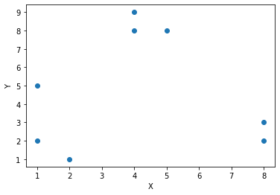PART 1

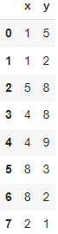

Image 1.1 Initial Data Coordinates Image 1.2 Initial Data Scatterplot

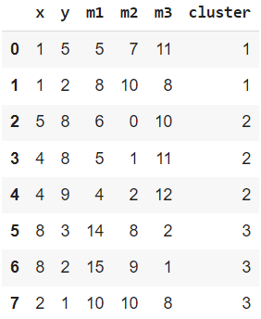

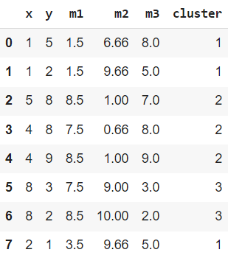

Image 1.3 First calculation of cluster assignment Image 1.4 Second calculation of cluster assignment

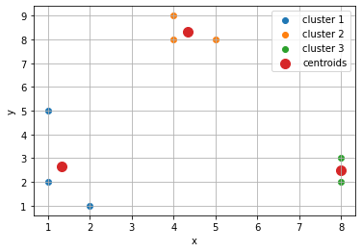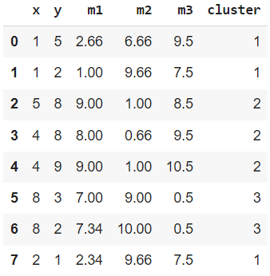

Image 1.5 Last calculation of cluster assignment Image 1.6 Data scatterplot with final clusters

PART 2

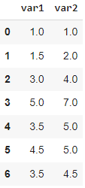

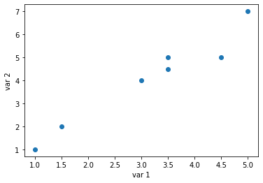

Image 2.1 Initial data Image 2.2 Initial scatterplot

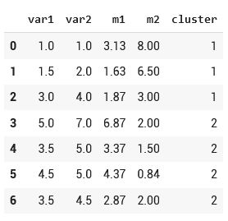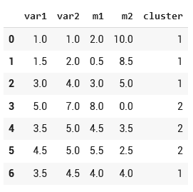

Image 2.3 First calculation of cluster assignment Image 2.4 Second calculation of cluster assignment

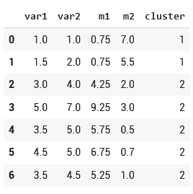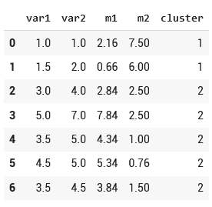

Image 2.5 Third calculation of cluster assignment Image 2.6 Last calculation of cluster assignment

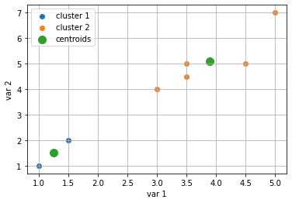

Image 2.7 Data scatterplot with final clusters