Fraud Management Module — Professional Build Plan
🧠 1. Objectives
Design a system that can:
- Detect fraud in real-time (during transaction)
- Detect fraud post-transaction (monitoring)
- Allow operators to act quickly (block / investigate)
- Provide audit + traceability

🧱 2. High-Level Architecture
ATM/POS → Switch (jPOS)
↓
Fraud Engine
(Rules + Scoring)
↓
┌──────────┼──────────┐
↓ ↓ ↓
Decision Alerts DB Audit Log
(allow/deny) ↓
UI (Fraud Module)

⚙️ 3. Core Components
3.1 Fraud Engine (Backend)
Types of checks:
✅ Rule-based engine (Phase 1 — must-have)
- Velocity checks
- Amount thresholds
- Country mismatch
- BIN risk
- Terminal anomalies
✅ Scoring engine (Phase 2 — advanced)
- Assign risk score (0–100)
- Combine multiple signals

3.2 Real-Time Decision Hook (CRITICAL)
Inside your switch flow:
- Before sending transaction → run fraud checks
- Return:
  - ✅ APPROVE
  - ⚠️ FLAG (approve but alert)
  - ❌ DECLINE

🧩 4. Fraud UI Module (New Menu)
Add new menu:
Fraud
├── Dashboard
├── Alerts
├── Transactions (Flagged)
├── Rules
├── Blacklist
├── Cases

🖥️ 5. UI Screens Design

📊 5.1 Fraud Dashboard
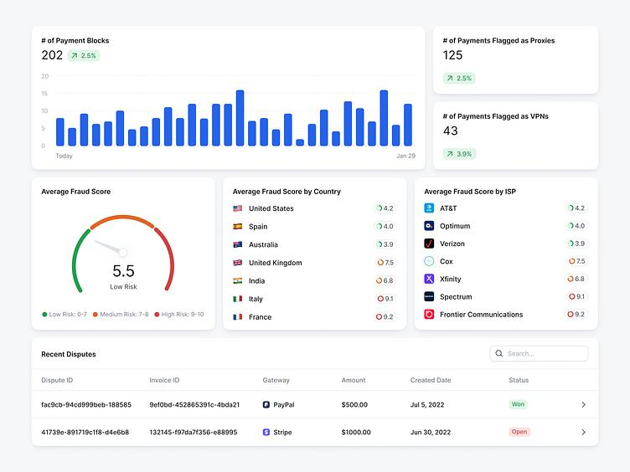
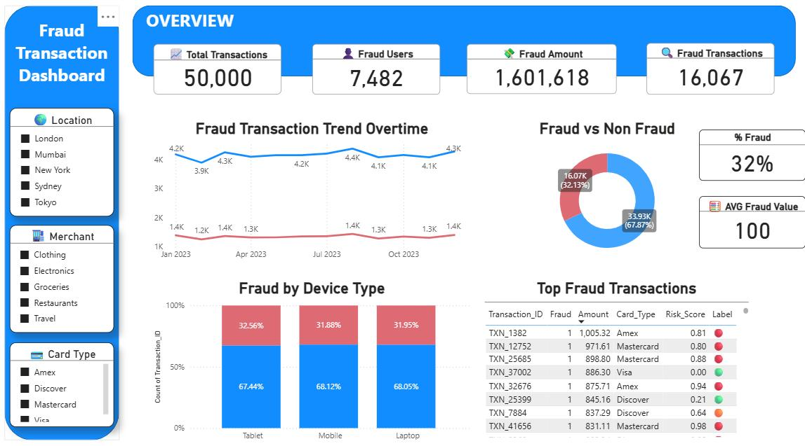
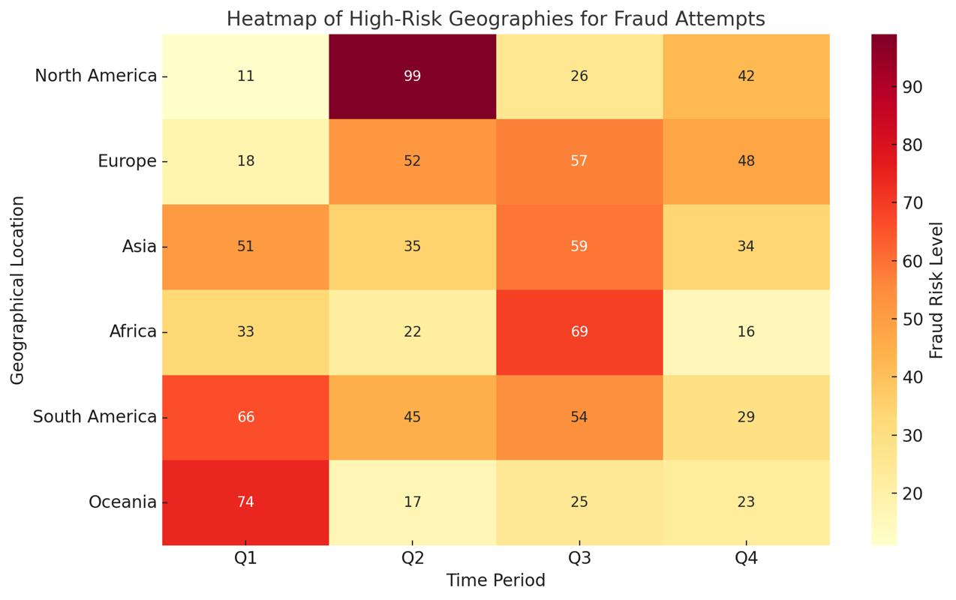
7
محتوى:
- Total suspicious transactions
- High-risk alerts (last 24h)
- Fraud rate %
- Top risky BINs / terminals
- Heatmap (time vs volume)

🚨 5.2 Alerts شاشة (MOST IMPORTANT)
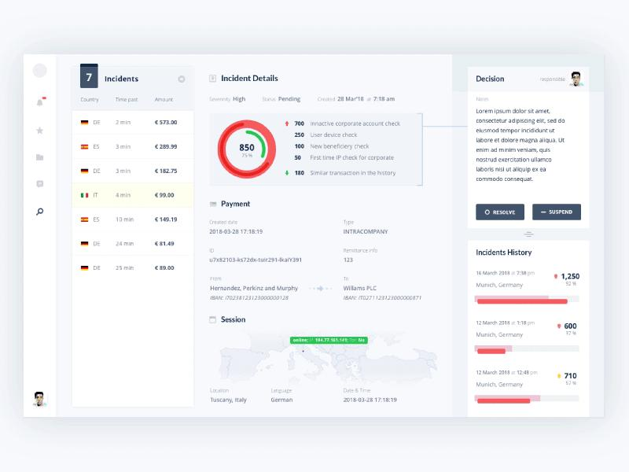
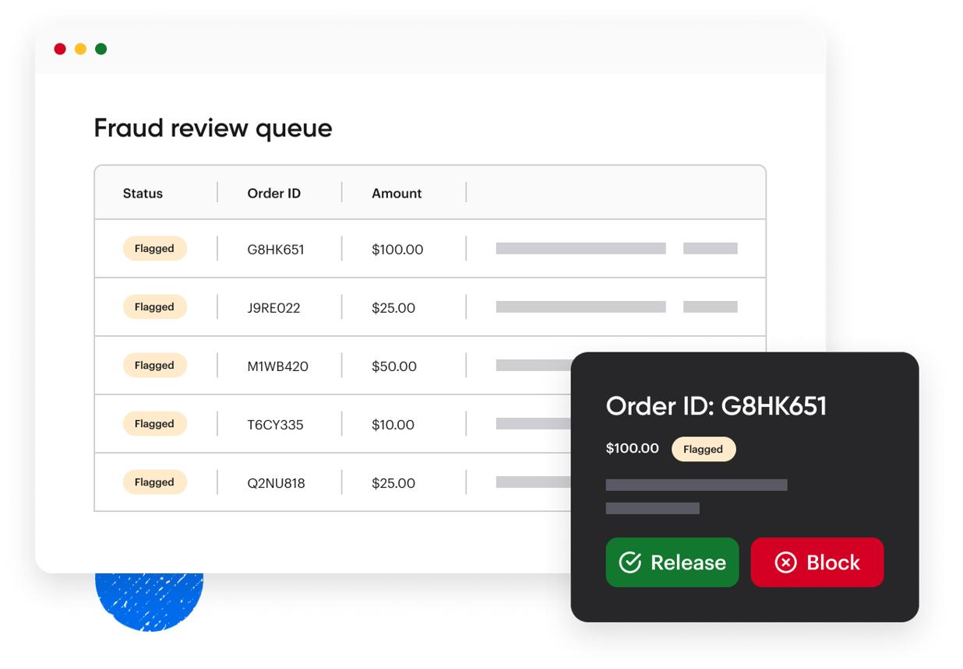
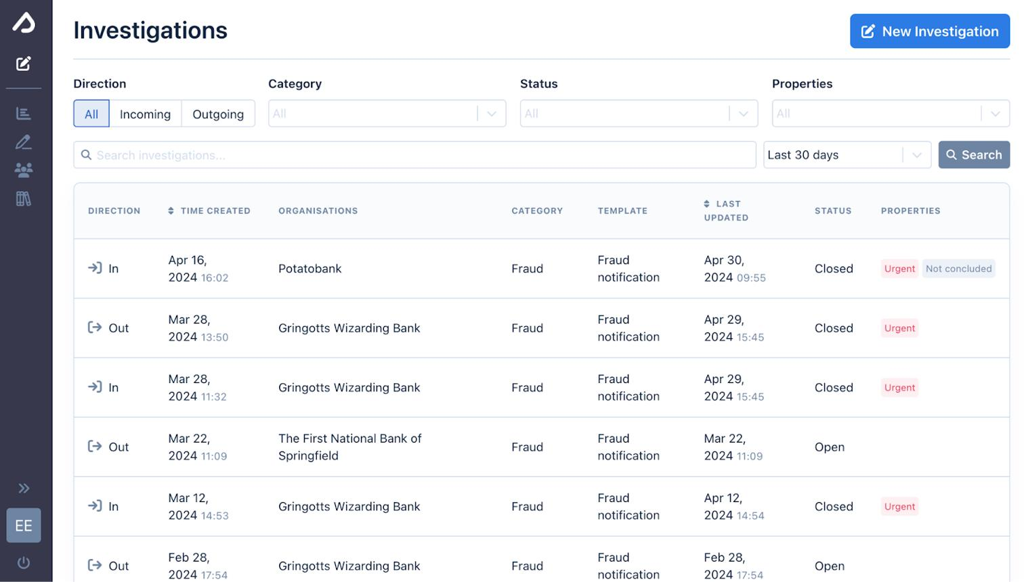
7
Table Columns:
- Time
- PAN (masked)
- Amount
- Rule triggered
- Risk score
- Status (NEW / REVIEWED / BLOCKED)
- Priority (HIGH / MEDIUM / LOW)
Actions:
- Approve
- Block card
- Escalate
- Assign to user

📄 5.3 Flagged Transactions
- Same as Transactions screen
- With:
  - Risk score
  - Triggered rules
  - Fraud tags

⚙️ 5.4 Rules Management
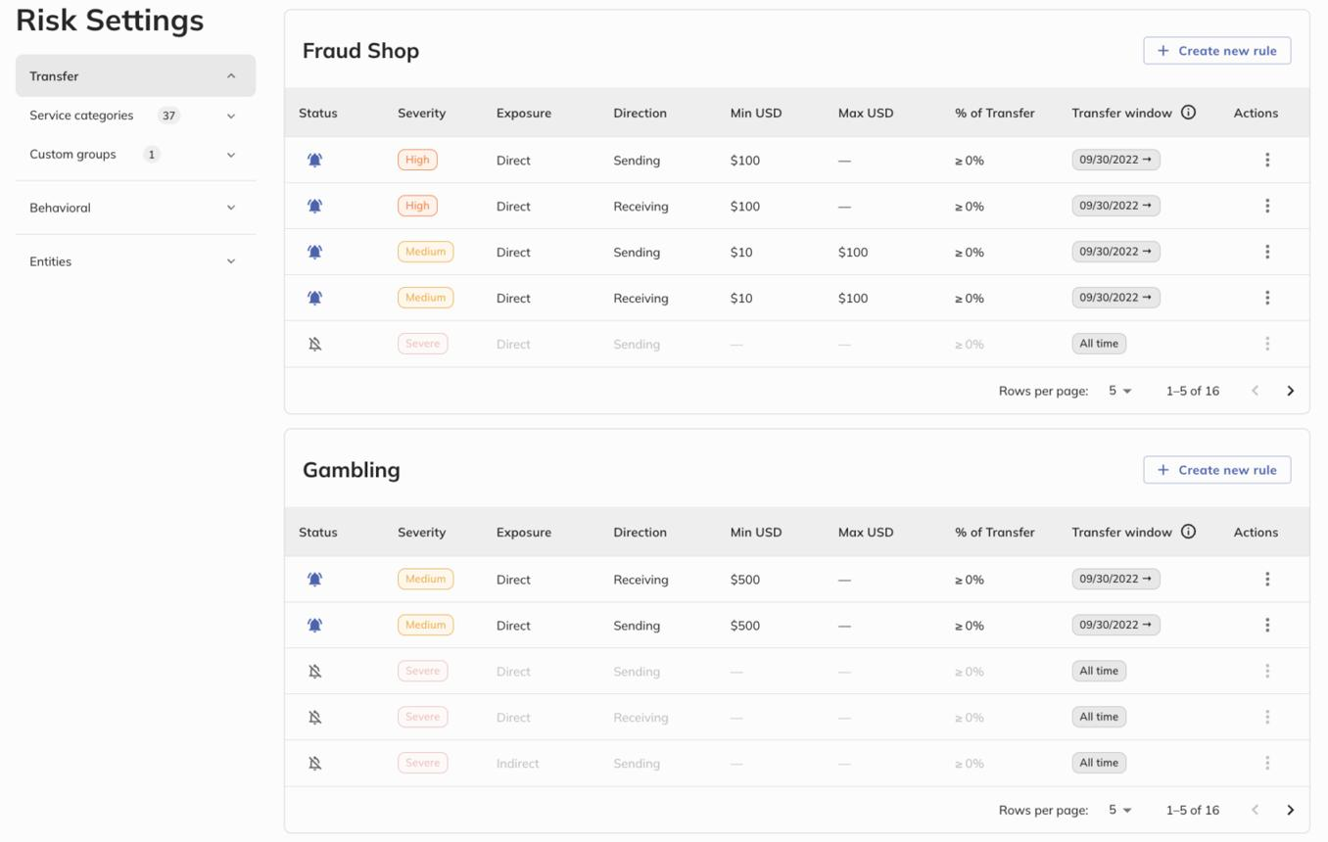
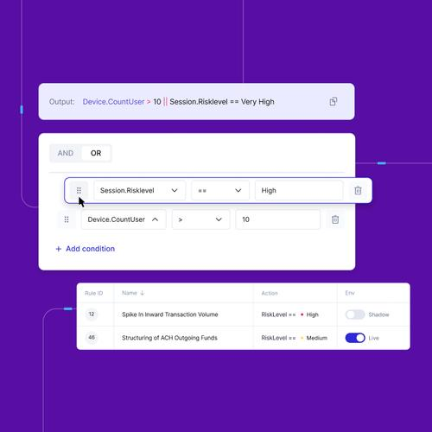
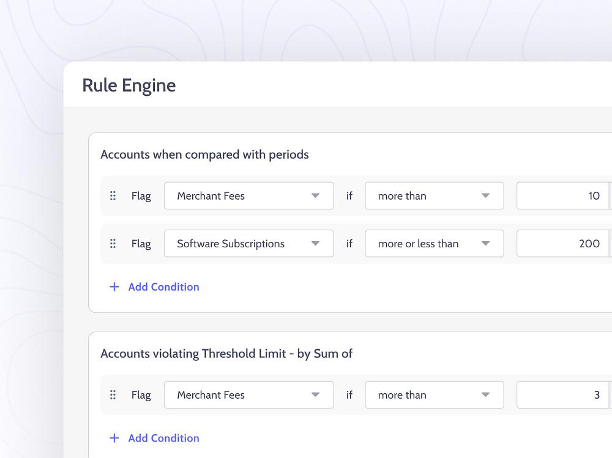
6
Example Rules:
Rule | Condition
Velocity | >5 tx in 60 sec
Amount | > 50,000 EGP
Geo | country != last country
BIN | high-risk BIN list
UI Features:
- Enable/Disable rule
- Set threshold
- Set severity
- Link to action (alert / block)

⛔ 5.5 Blacklist / Watchlist
- PAN blacklist
- Terminal blacklist
- BIN blacklist
Actions:
- Add / Remove
- Expiry date
- Reason

🗂️ 5.6 Case Management (Advanced but powerful)
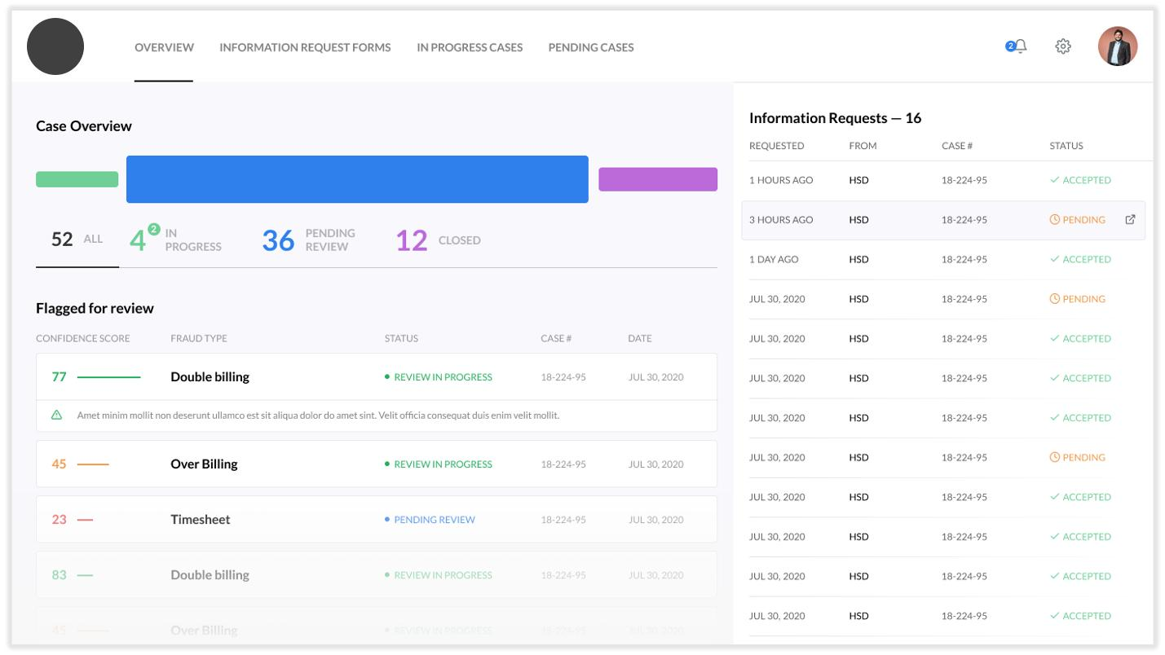
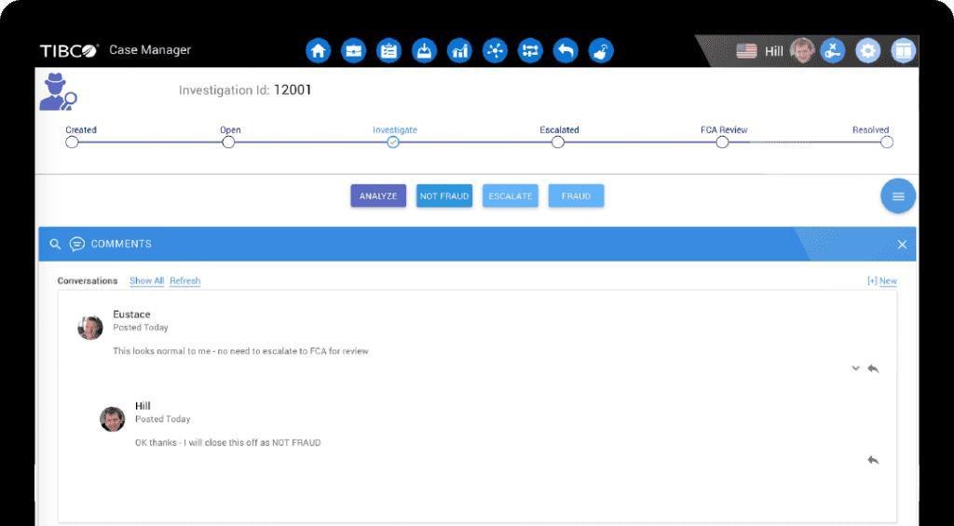
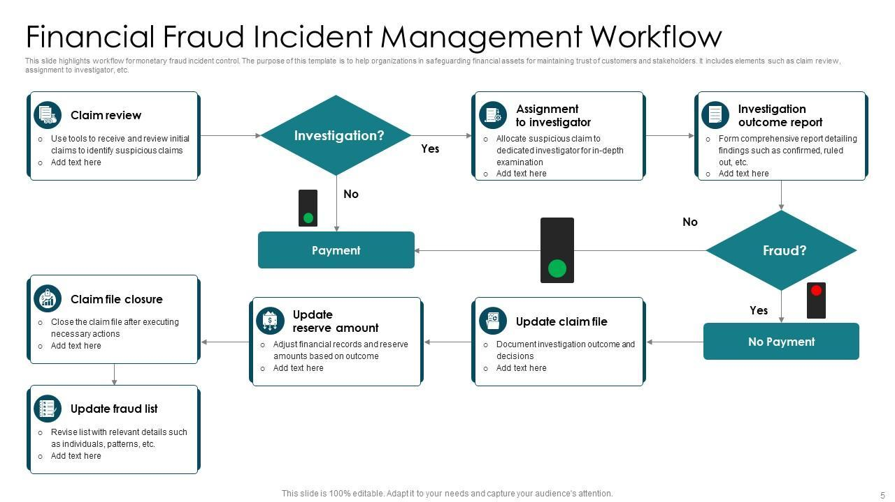
6
Features:
- Create case from alert
- Assign to analyst
- Add notes
- Timeline of actions

🔌 6. Backend APIs (Design)
Alerts
GET /fraud/alerts
POST /fraud/alerts/{id}/action
Rules
GET /fraud/rules
POST /fraud/rules
PUT /fraud/rules/{id}
Blacklist
GET /fraud/blacklist
POST /fraud/blacklist
Fraud Check (Switch Integration)
POST /fraud/check

🧪 7. Fraud Rules Examples (READY TO IMPLEMENT)
🔁 Velocity Rule
if count(tx by PAN in last 60 sec) > 5 → HIGH
🌍 Geo Rule
if country != last_country → MEDIUM
💰 Amount Rule
if amount > threshold → HIGH
🏧 Terminal Rule
if terminal in blacklist → BLOCK

🧱 8. Database Tables
fraud_alerts
- id
- tx_id
- rule_id
- risk_score
- status
- created_at
fraud_rules
- id
- name
- condition
- threshold
- enabled
blacklist
- type (PAN / BIN / TERMINAL)
- value
- reason
fraud_cases
- id
- alert_id
- assigned_to
- status

🚀 9. Implementation Roadmap
Phase 1 (MVP — 1–2 weeks)
- Rule engine (basic)
- Alerts table
- Fraud dashboard
- Blacklist
Phase 2
- Risk scoring
- Advanced rules UI
- Case management
Phase 3
- Machine learning (optional)
- Behavior profiling
- Device fingerprinting

⚠️ Reality Check
If you skip fraud:
- You’ll detect issues after money is gone
- Not acceptable in:
  - ATM switch
  - Card processing
  - Fintech systems

🧠 Final Verdict
Your current system = Switch Monitoring Tool
After this plan = Real Payment Fraud Platform

If you want next step, I can:
- Map this directly into your current React UI structure
- Or build backend fraud engine (Python / Java for jPOS integration)

